Supplementary Information
Table of contents
Supplementary Table S1: Overview of the fungal strains used in this study.
Supplementary Table S2: The overall dereplicated compounds in this study.
Supplementary Figure S1: Cluster F represents the nodes of detected miyakamides.
Supplementary Figure S2: The nodes with dark red outline represent the species-specific metabolites, which are only produced by Aspergillus aspearensis.
Supplementary Figure S3: High resolution MS/MS spectra of aflatoxins at 20 eV.
Supplementary Figure S4: High resolution MS/MS spectra of ochratoxins at 20 eV.
Supplementary Figure S5: High resolution MS/MS spectra of cyclopiazonic acids at 20 eV.
Supplementary Figure S6: High resolution MS/MS spectra of aflatrems and aflavinines at 20 eV.
Supplementary Figure S7: High resolution MS/MS spectra of fumifungins at 20 eV.
Supplementary Figure S8: High resolution MS/MS spectra of tenuazonic acids at 20 eV.
Supplementary Figure S9: High resolution MS/MS spectra of aspergillicins at 40 eV.
Supplementary Figure S10: High resolution MS/MS spectra of miyakamides at 20 eV.
Supplementary Figure S11: High resolution MS/MS spectra of some representative metabolites at 20 eV.

Table S1. Overview of the fungal strains used in this study.
Series | Species | Isolate number
Flavi | Aspergillus sojae | IBT 21650
Flavi | A.pipericola | IBT 24628
Flavi | A.oryzae | IBT 28103
Flavi | A.flavus | IBT 29624
Flavi | A.cerealis | IBT 32067
Flavi | A.austwickii | IBT 32076
Flavi | A.subflavus | IBT 33354
Flavi | A.aflatoxiformans | IBT 3651
Flavi | A.parasiticus | IBT 27186
Flavi | A.arachidicola | IBT 27190
Flavi | A.minisclerotigenes | IBT 27196
Flavi | A.sergii | IBT 32293
Flavi | A.transmontanensis | IBT 32313
Flavi | A.novoparasiticus | IBT 32314
Kitamyces | A.pseudotamarii | IBT 21090
Kitamyces | A.caelatus | IBT 21091
Kitamyces | A.tamarii | IBT 27182
Kitamyces | A.pseudocaelatus | IBT 27191
Nomiarum | A.pseudonomius | IBT 27864
Nomiarum | A.nomius | IBT 5054
Nomiarum | A.luteovirescens | IBT 23536
Alliacei | A.alliaceus | IBT 13376
Alliacei | A.vandermerwei | IBT 13865
Alliacei | A.albertensis | IBT 14317
Alliacei | A.neoalliaceus | IBT 33356
Leporum | A.leporis | IBT 3609
Leporum | A.aspearensis | IBT 34544
Leporum | A.hancockii | IBT 35031

Table S2. The overall dereplicated compounds in this study. The compounds highlighted in green color are dereplicated by the GNPS library. The compounds marked with asterisk are found by the in-house library reseach; and the compounds highlight in yellow are the important mycotoxins for which standards have been used for generation of reference spectra for molecular network analysis.
Compounds number | Network clusters | Compounds name | Molecular Formula | m/z | Mass (MFG*)
1 | Aflatoxins | aflatoxin B1* | C₁₇H₁₂O₆ | 313.0707 | 312.0634
2 | Aflatoxins | aflatoxin B3* | C₁₆H₁₄O₆ | 303.0864 | 302.0791
3 | Aflatoxins | aflatoxin G1* | C₁₇O₇H₁₂ | 329.0655 | 328.0586
4 | Aflatoxins | aflatoxin GM2 | C₁₇O₈H₁₄ | 347.0762 | 346.0689
5 | Aflatoxins | O-methylsterigmatocystin | C₁₉O₆H₁₄ | 339.0872 | 338.079
6 | Aflatoxins | Dihydroaflatoxicol | C₁₆O₇H₁₂ | 317.0657 | 316.0583
7 | Ochratoxins | Ochratoxin A* | C₂₀H₁₈ClNO₆ | 404.0898 | 403.0826
8 | Ochratoxins | Ochratoxin B* | C₂₀NO₆H₁₉ | 370.1291 | 369.1218
9 | Ochratoxins | Ochratoxin beta | C₁₁H₁₀O₅ | 223.0605 | 222.0528
10 | Ochratoxins | CTKSE9855 | C₂₀H₁₉NO₇ | 386.1239 | 385.1162
11 | Cyclopiazonic acids | Cyclopiazonic acid * | C₂₀N₂O₃H₂₀ | 337.1552 | 336.148
12 | Cyclopiazonic acids | Speradine A* | C₂₁N₂O₄H₂₂ | 367.1656 | 366.1585
13 | Cyclopiazonic acids | 2-oxo-cyclopiazonic acid | C₂₀N₂O₄H₂₀ | 353.1502 | 352.1423
14 | Cyclopiazonic acids | 3-OH-speradine A | C₂₁N₂O₅H₂₂ | 383.161 | 382.1529
15 | Cyclopiazonic acids | speradine F | C₂₂N₂O₆H₂₆ | 415.186 | 414.1791
16 | Fumifungins | Fumifungin* | C₂₂H₄₁NO₇ | 432.2953 | 431.288
17 | Fumifungins | Sphingofungin B | C₂₀H₃₉NO₆ | 390.2854 | 389.2777
18 | Fumifungins | Sphingofungin C | C₂₂H₄₁NO₇ | 432.2965 | 431.2883
19 | Fumifungins | Sphingofungin D | C₂₂H₄₁NO₇ | 432.2969 | 431.2883
20 | Aflatrems | Aflatrem* | C₃₂NO₄H₃₉ | 502.2956 | 501.2881
21 | Aflatrems | Paspalinine* | C₂₇NO₄H₃₁ | 434.2328 | 433.2255
22 | Aflatrems | Paspaline | C₂₈NO₂H₃₉ | 422.3057 | 421.2981
23 | Aflatrems | Hydroxypaspalinine | C₂₇H₃₁NO₅ | 450.2272 | 449.2202
24 | Aflatrems | Penerpenes | C₂₇H₃₁NO₅ | 450.2276 | 449.2202
25 | Aflatrems | Asperindoles | C₂₉NO₆H₃₃ | 492.2390 | 491.2321
26 | Aflavinines | 14-hydroxyaflavinine | C₂₈NO₂H₃₉ | 422.3051 | 421.2981
27 | Aflavinines | Aflavinine | C₂₈NOH₃₉ | 406.3098 | 405.3032
28 | Aflavinines | Dihydroxyaflavinine | C₂₈NO₃H₃₉ | 438.3004 | 437.2930
29 | Tenuazonic acids | Tenuazonic acid* | C₁₀NO₃H₁₅ | 198.1128 | 197.1055
30 | Tenuazonic acids | Valine-tenuazonic acid* | C₉H₁₃NO₃ | 184.0964 | 183.0891
31 | Aspergillicins | Aspergillicin A | C₃₈N₆O₉H₅₆ | 763.4004 | 740.4109
32 | Aspergillicins | Aspergillicin B | C₃₇N₆O₉H₅₄ | 749.384 | 726.3952
33 | Aspergillicins | Aspergillicin C | C₃₇N₆O₈H₅₄ | 733.3905 | 710.4003
34 | Aspergillicins | Aspergillicin G | C₃₈N₆O₈H₅₆ | 747.4066 | 724.416
35 | Aspergillicins | Aspergillicin E/F | C₃₉N₆O₉H₅₈ | 777.4161 | 754.4265
36 | Miyakamides | Miyakamide A1*/A2* | C₃₁N₄O₃H₃₂ | 509.2551 | 508.2482
37 | Miyakamides | Miyakamide B1*/B2 | C₃₁N₄O₄H₃₂ | 525.2497 | 524.2431
38 | Miyakamides | Miyakamide analogues with Valine | C₂₇N₄O₃H₃₂ | 461.2552 | 460.2474
39 | Miyakamides | aspergillamide A/B | C₂₈H₃₄N₄O₃ | 497.2533 | 474.2631
40 | Miyakamides | Oryzamide A1/A2 | C₂₈N₄O₄H₃₄ | 513.2481 | 490.258
41 |  | Ditryptophenaline* | C₄₂N₆O₄H₄₀ | 693.3192 | 692.3117
42 |  | aspergillic acid* | C₁₂N₂O₂H₂₀ | 225.16 | 224.1527
43 |  | desertorin A* | C₂₂H₁₈O₈ | 411.1075 | 410.1002
44 |  | desertorin B | C₂₃H₂₀O₈ | 425.1238 | 424.1158
45 |  | Ergokonin B* | C₂₈H₄₂O₅ | 481.2924 | 458.3032
46 |  | 13-Dehydroxypaxilline* | C₂₇H₃₃NO₃ | 420.2532 | 419.2459
47 |  | Kojic acid* | C₆O₄H₆ | 143.0338 | 142.0265
48 |  | Phytosphingosine* | C₁₈H₃₉NO₃ | 318.3001 | 317.2928
49 |  | (-)-Canadensolide* | C₁₁O₄H₁₄ | 211.0966 | 210.0892
50 |  | Chrysogine* | C₁₀N₂O₂H₁₀ | 191.0816 | 190.0743
51 |  | Parasiticolide A* | C₂₆O₈H₃₀ | 493.1838 | 470.1946
52 |  | ustilaginoidin C* | C₂₈O₁₂H₁₈ | 547.0878 | 546.0804
53 |  | Sterigmatocystin | C₁₈H₁₂O₆ | 325.0707 | 324.0623
54 |  | Lovastatin / mevinolin | C₂₄H₃₆O₅ | 427.2460 | 404.2563
55 |  | Lovastatin acid | C₂₄H₃₈O₆ | 445.2563 | 422.2668
56 |  | Lovastatin analogue | C₂₄H₄₀O₆ | 447.2723 | 424.2825
57 |  | TMC-95A | C₃₃N₆O₁₀H₃₈ | 679.2733 | 678.2649
58 |  | Deacetylparasiticolide A | C₂₄H₂₈O₇ | 429.1910 | 428.1835
59 |  | Heptelidic acid | C₁₅O₅H₂₀ | 281.1387 | 280.1311
60 |  | Flavacol | C₁₂N₂OH₂₁ | 209.1650 | 208.1576
*This column shows that the results was found by the Generate Formulas algorithm (MGF) in MassHunter.

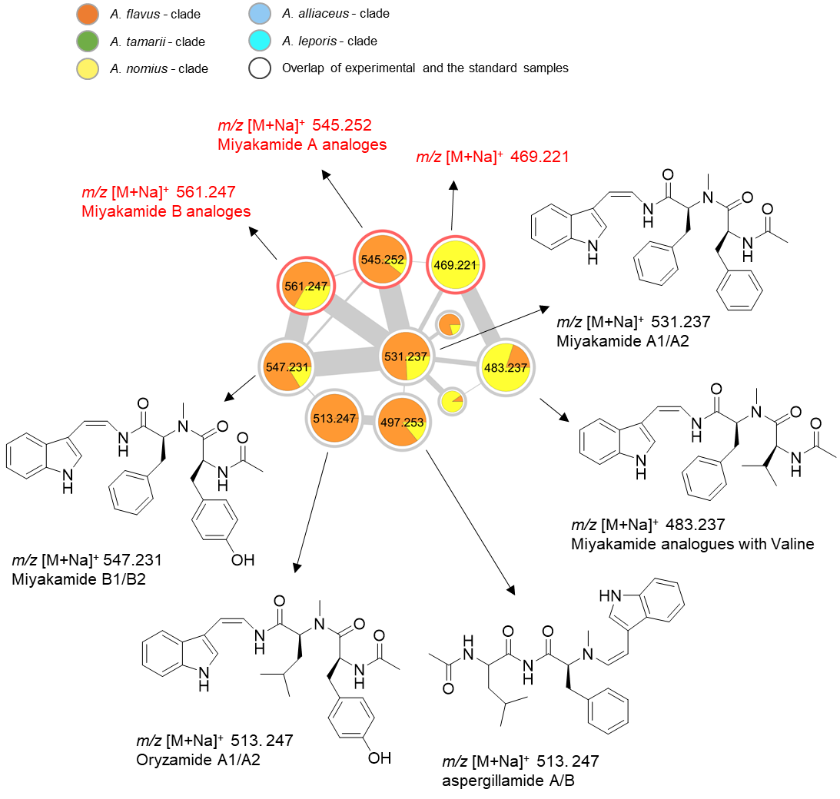
F
Figure S1. Cluster F represents the nodes of detected miyakamides. The nodes with red outline represent the potentially novel compounds.
In the cluster F (Figure S1), Miyakamides were dereplicated manually. They were first isolated from the cultured broth of Aspergillus flavus strain and showed inhibitory activity against brine shrimp. The map of molecular network shows that Miyakamide A1/A2 is produced by A. sojae, A. nomius, A. parasitiicus, A. novoparasiticus and A. transmontanensis, and that Miyakamide B1/B2 is produced by A. sojae, A. nomius, A. novoparasiticus and A. transmontanensis. In addition, the node of miyakamide A (m/z 531) is connected to the precursor mass of m/z 483 with the cosine score of 0.74, a difference of 48 amu less than miyakamide A, suggests the presence of a valine fragment instead of a phenylalanine fragment in the molecule. This is confirmed by checking fragmentation patterns of both compounds. Moreover, Oryzamide A1/A2 and aspergillamide A/B were also identified in MN.

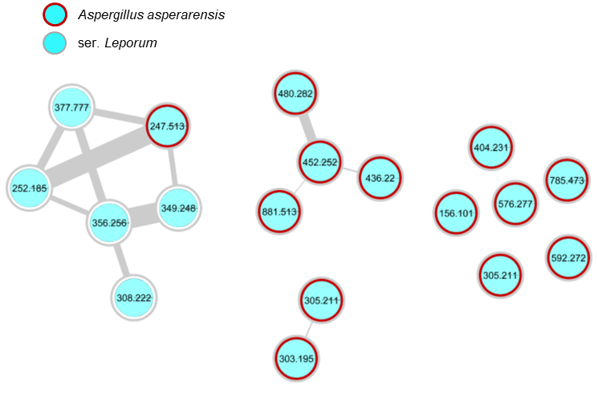
Figure S2. The nodes with dark red outline represent the species-specific metabolites, which are only produced by Aspergillus aspearensis; the nodes with gray outline represent the series-specific metabolites, which are only produced by series Leporum.

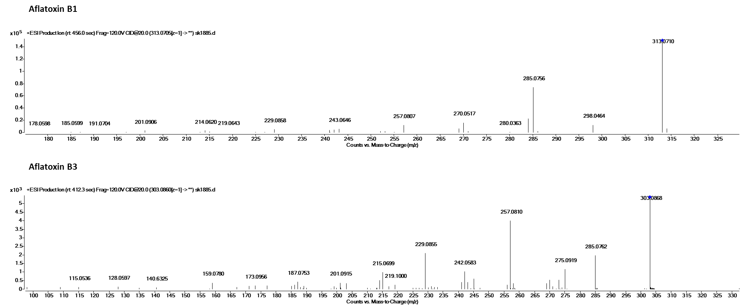
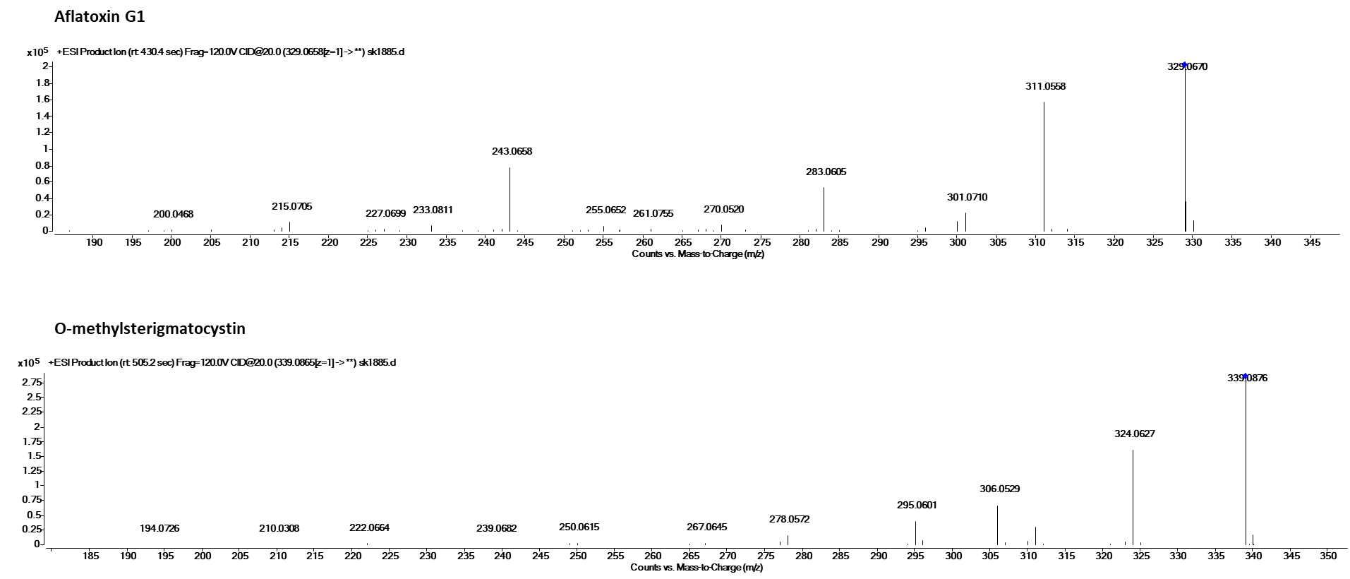
Figure S3. High resolution MS/MS spectra of aflatoxins at 20 eV.

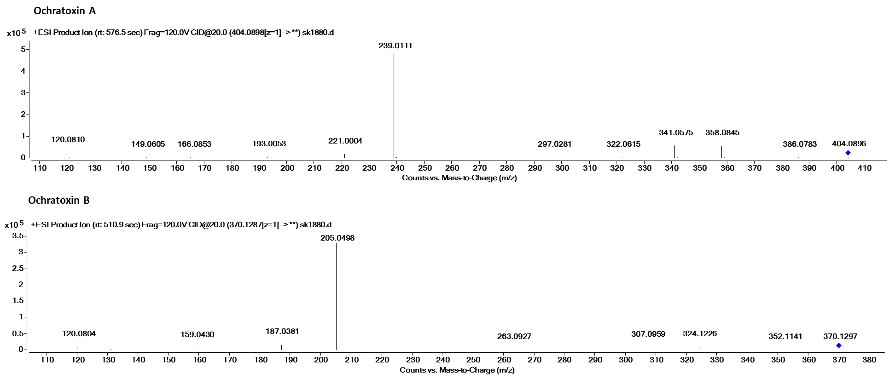
Figure S4. High resolution MS/MS spectra of ochratoxins at 20 eV.

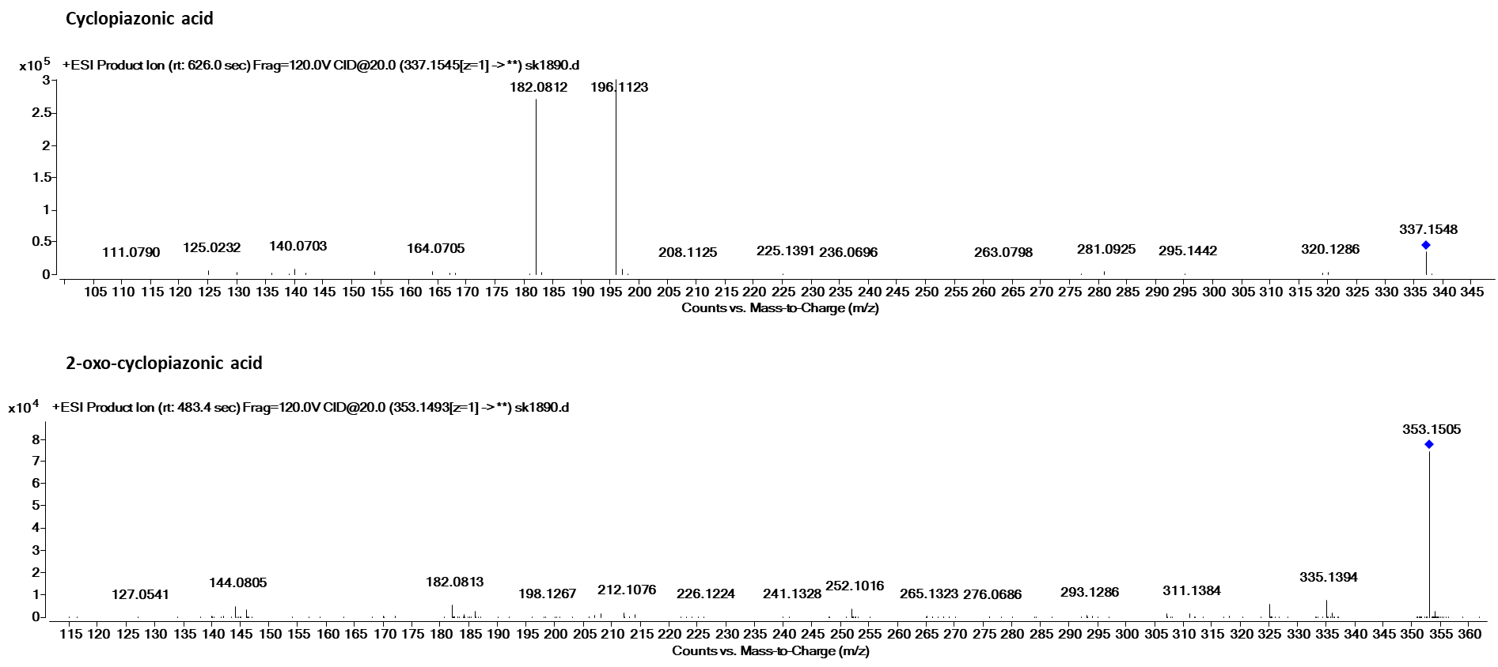

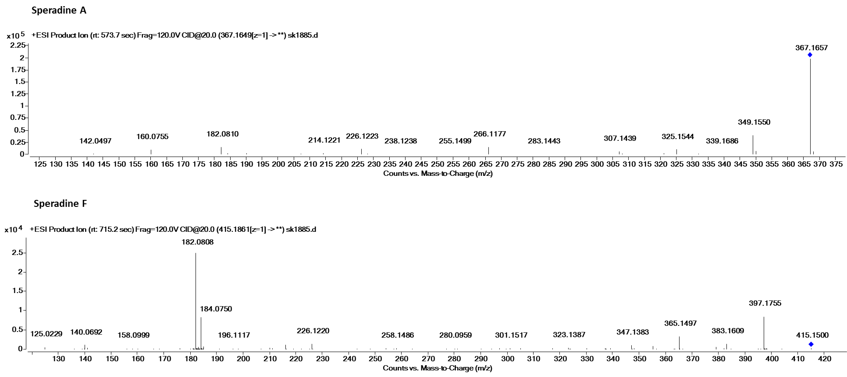
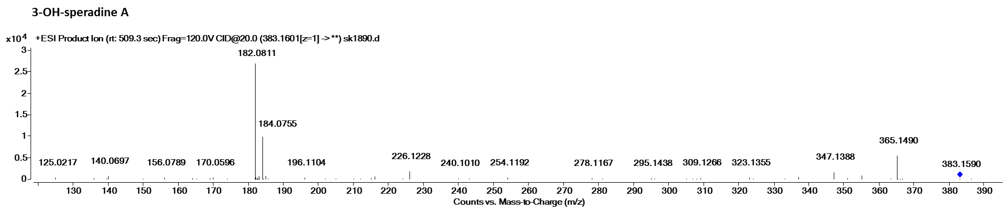
Figure S5. High resolution MS/MS spectra of cyclopiazonic acids at 20 eV.

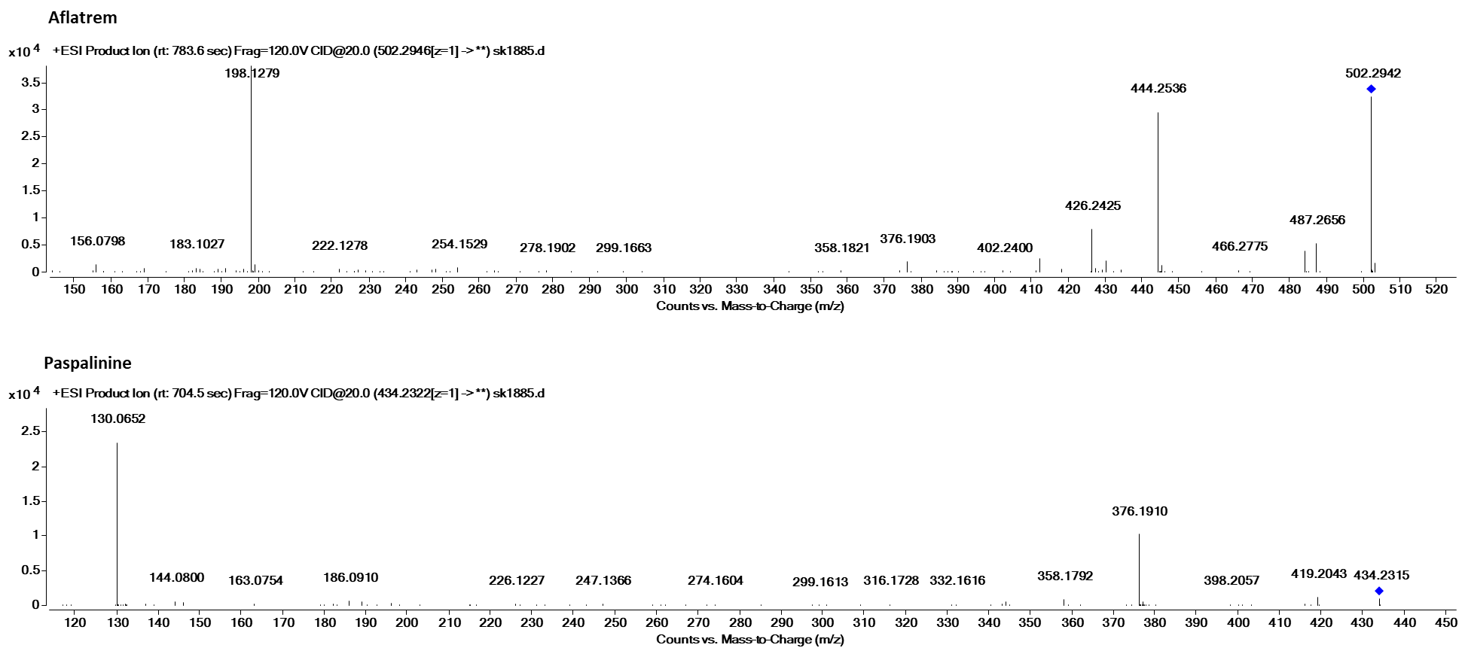
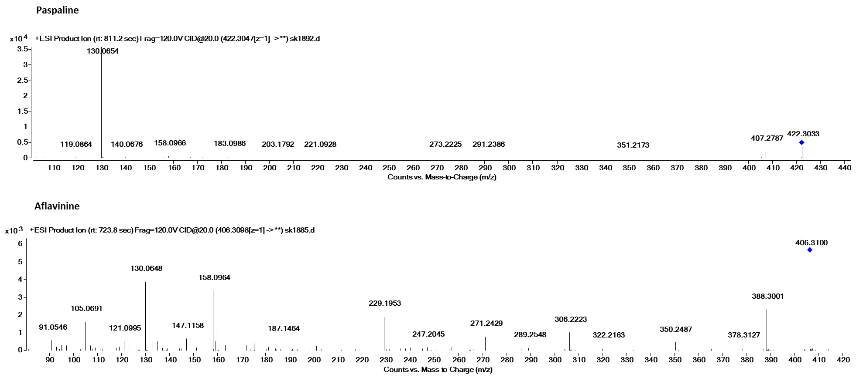
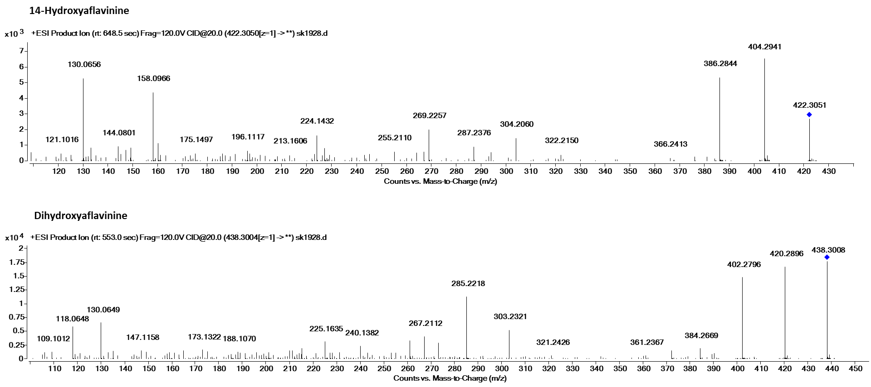
Figure S6. High resolution MS/MS spectra of aflatrems and aflavinines at 20 eV.
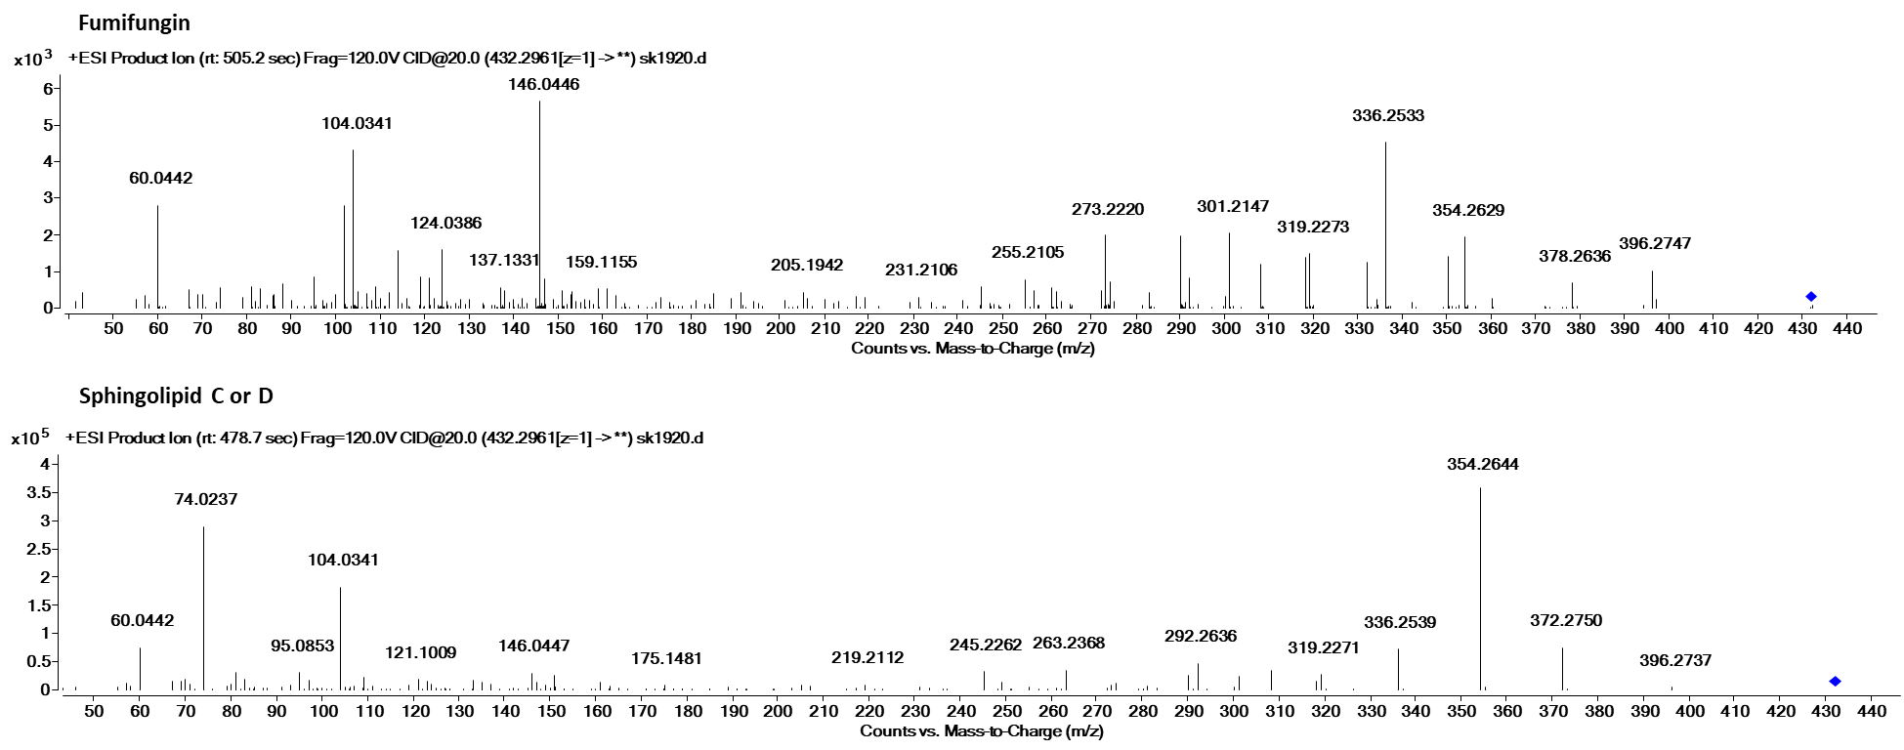
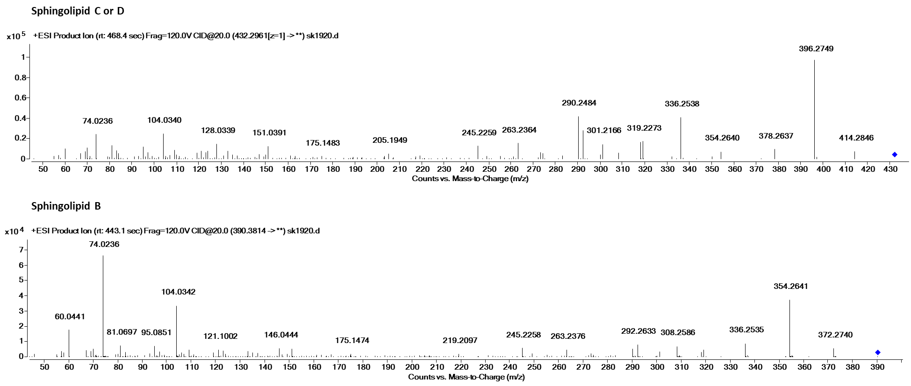
Figure S7. High resolution MS/MS spectra of fumifungins at 20 eV.

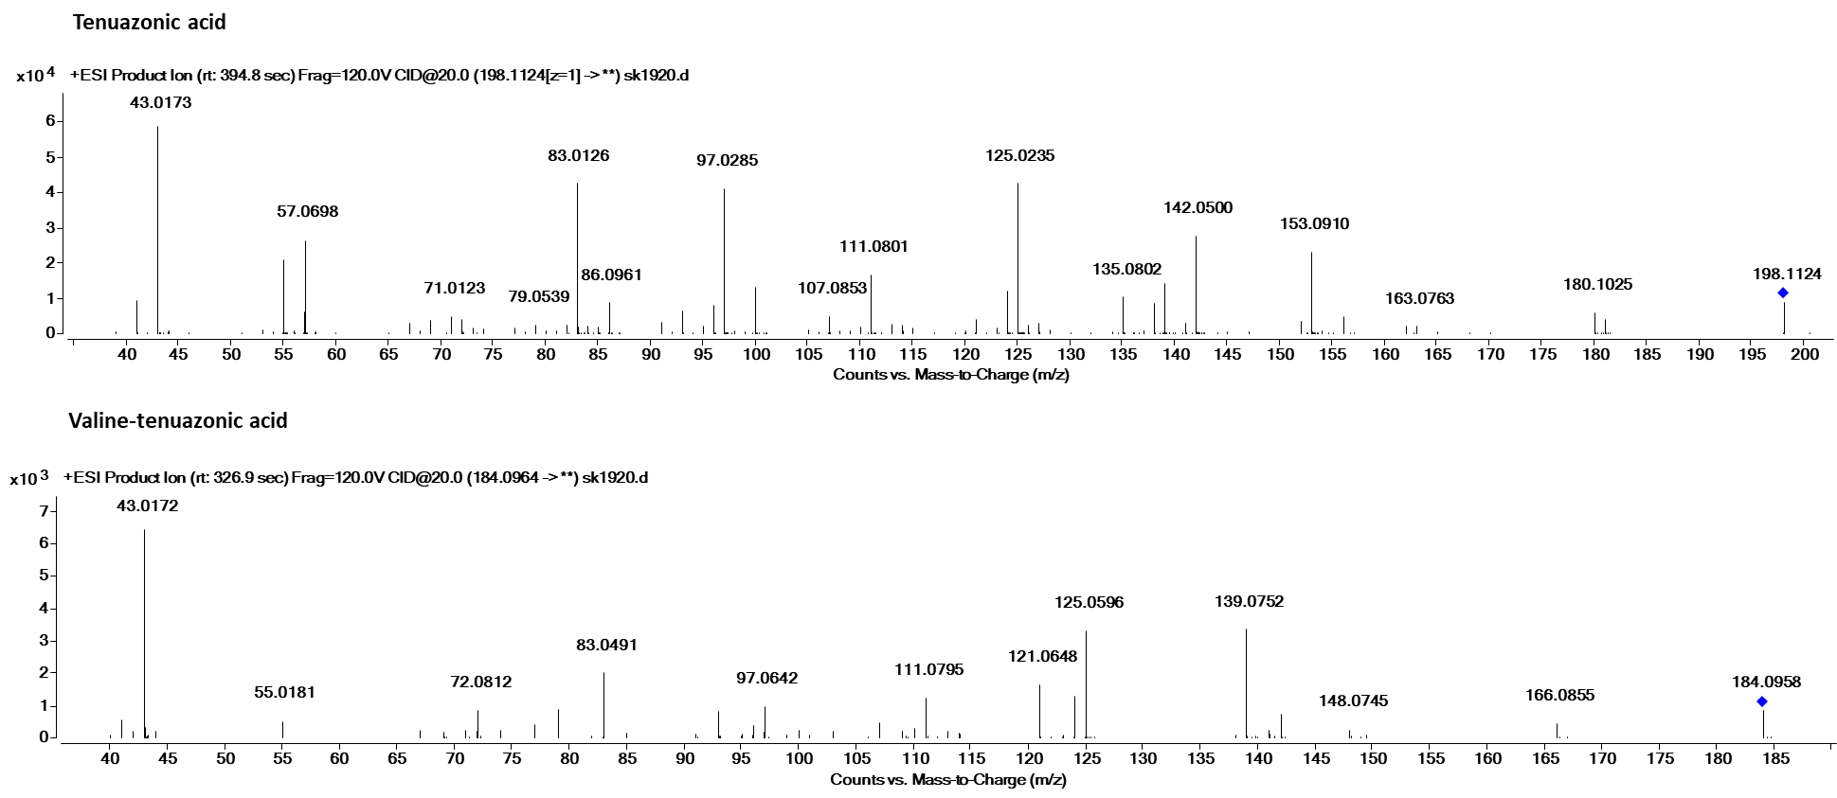
Figure S8. High resolution MS/MS spectra of tenuazonic acids at 20 eV.

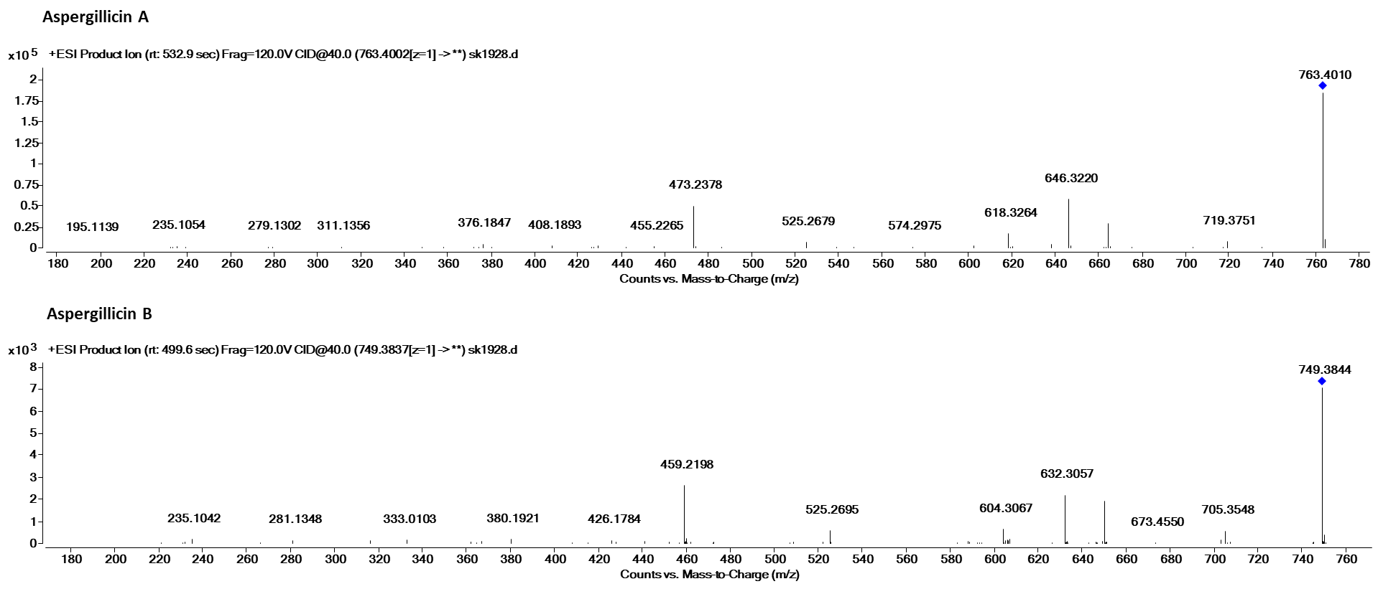

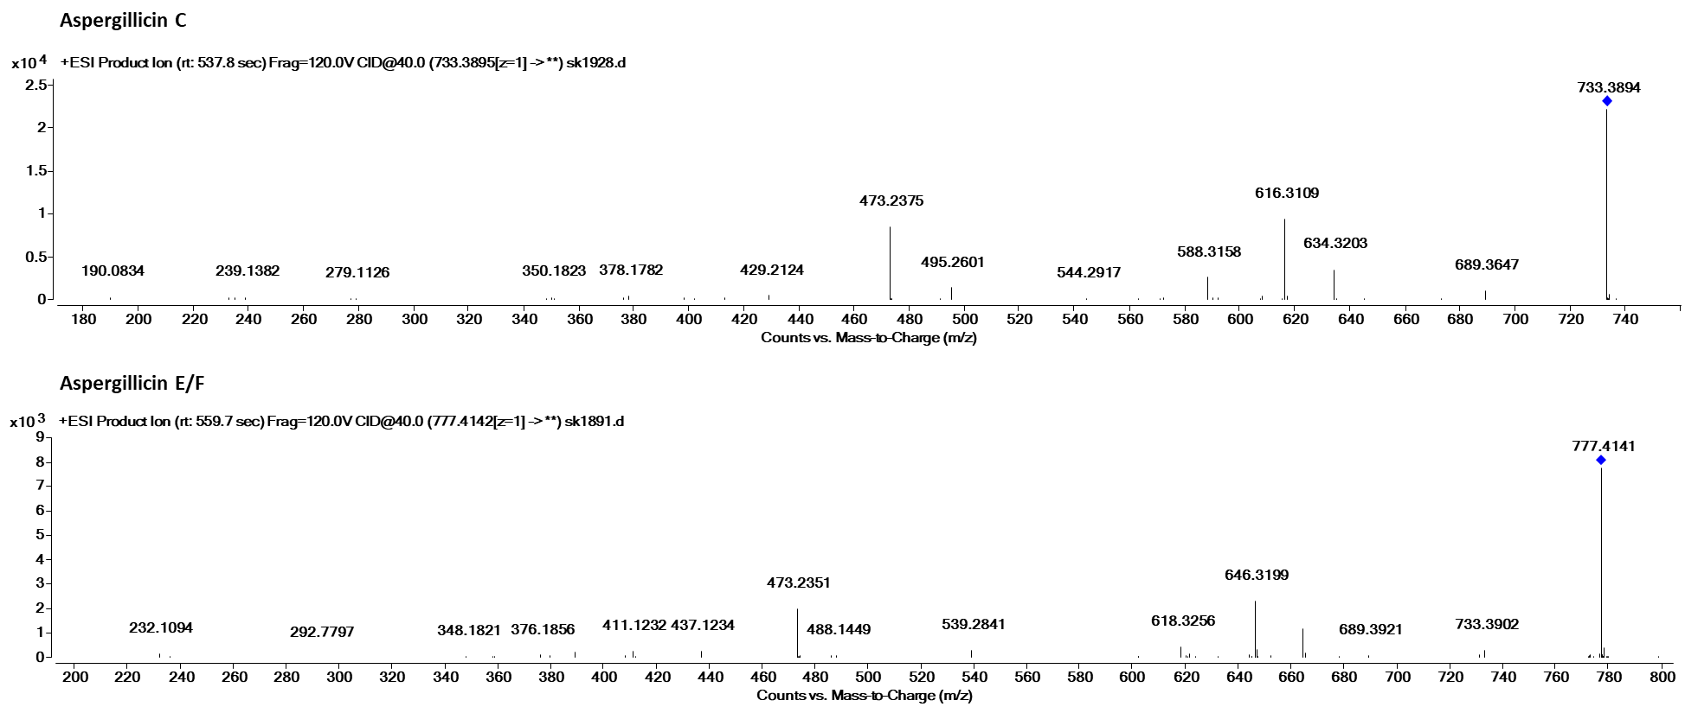
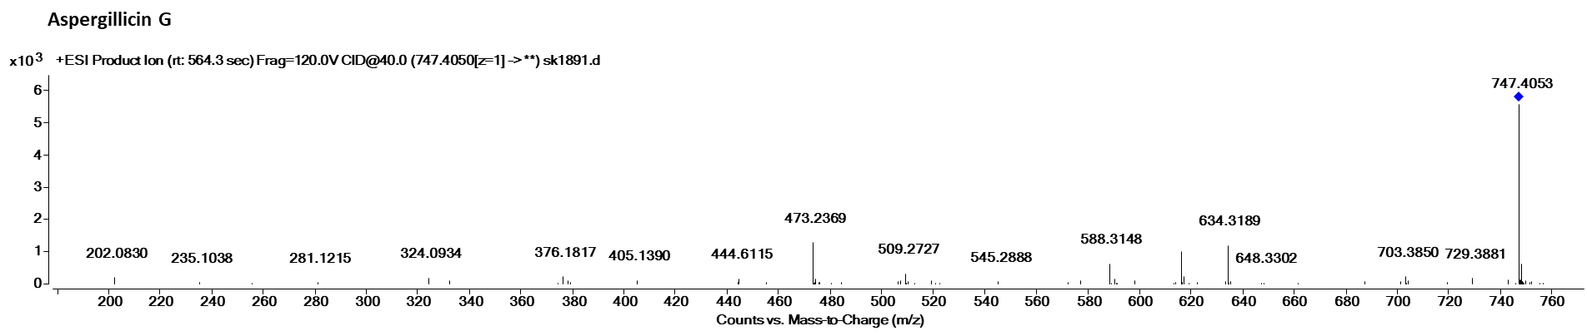
Figure S9. High resolution MS/MS spectra of aspergillicins at 40 eV.

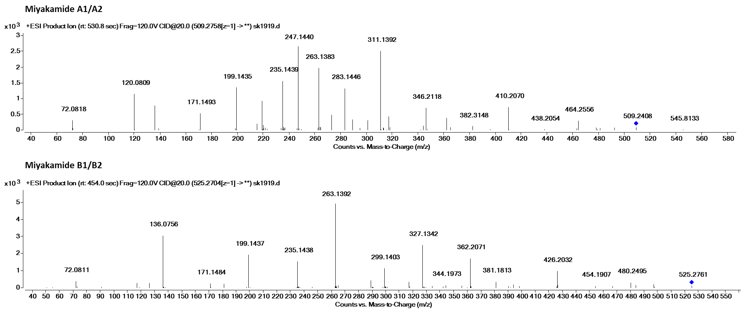
Figure S10. High resolution MS/MS spectra of miyakamides at 20 eV.

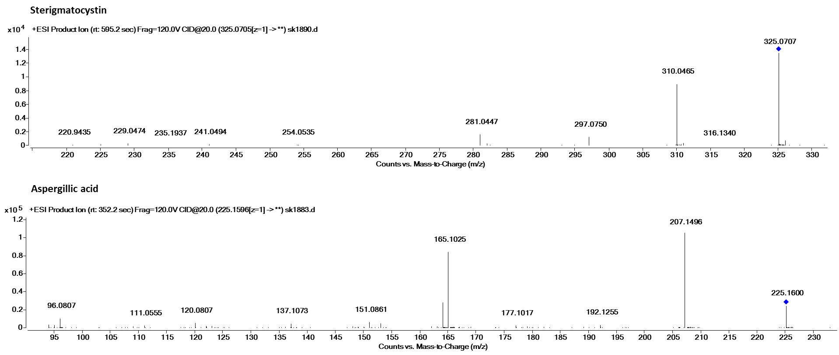
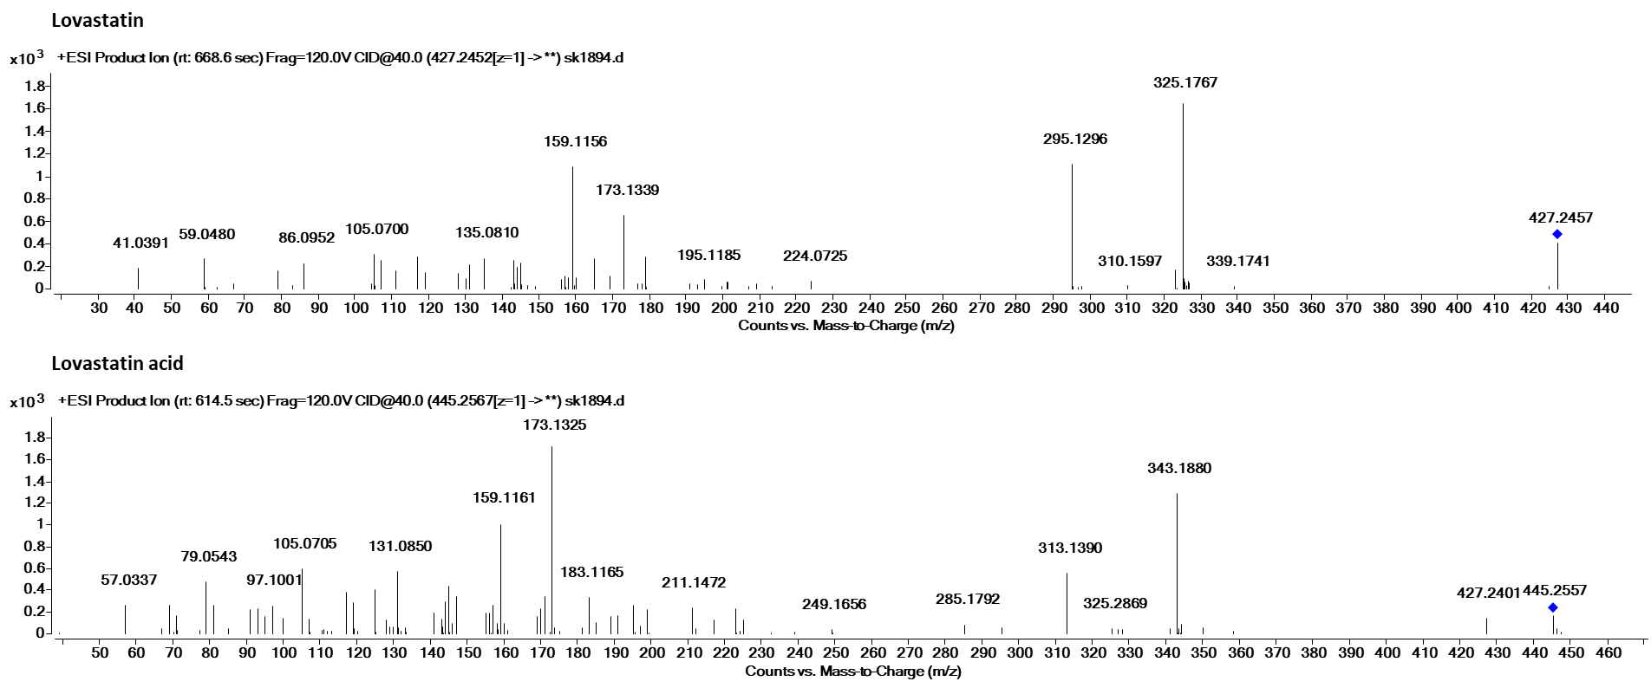
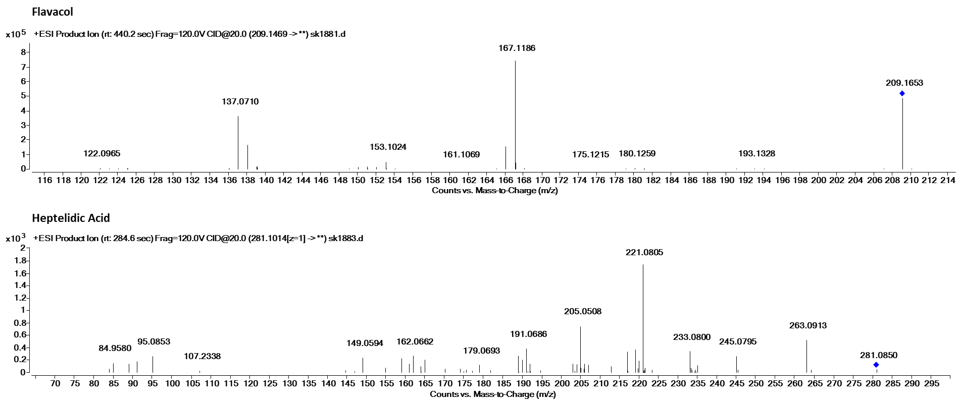
Figure S11. High resolution MS/MS spectra of some representative metabolites at 20 eV.

