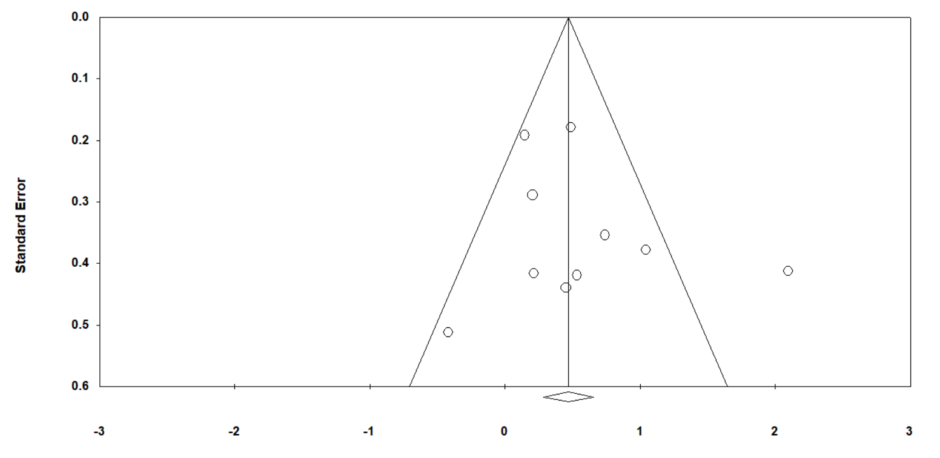

Figure 1S. The funnel plot of studies evaluating the prognostic value of CD133 overexpression in determining the PFS of patients with high-grade gliomas (Egger test P-value 1 tailed=0.22538, and P-value 2-tailed=0.45076)

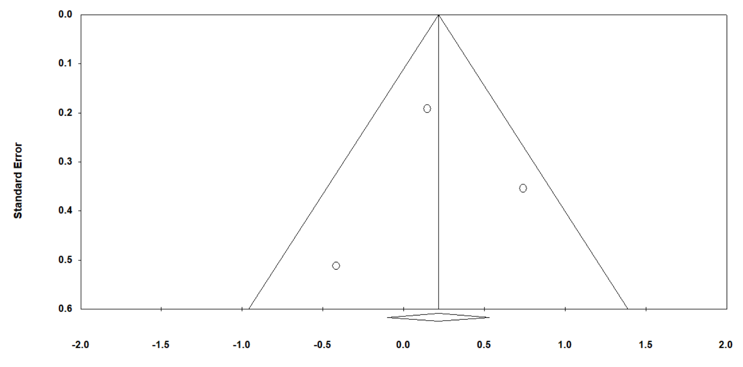

Figure 2S. The funnel plot of studies evaluating the prognostic value of CD133 overexpression with 2% cut-off in determining the PFS of patients with high-grade gliomas (Egger test P-value 1 tailed=0.47849, and P-value 2-tailed=0.95697)

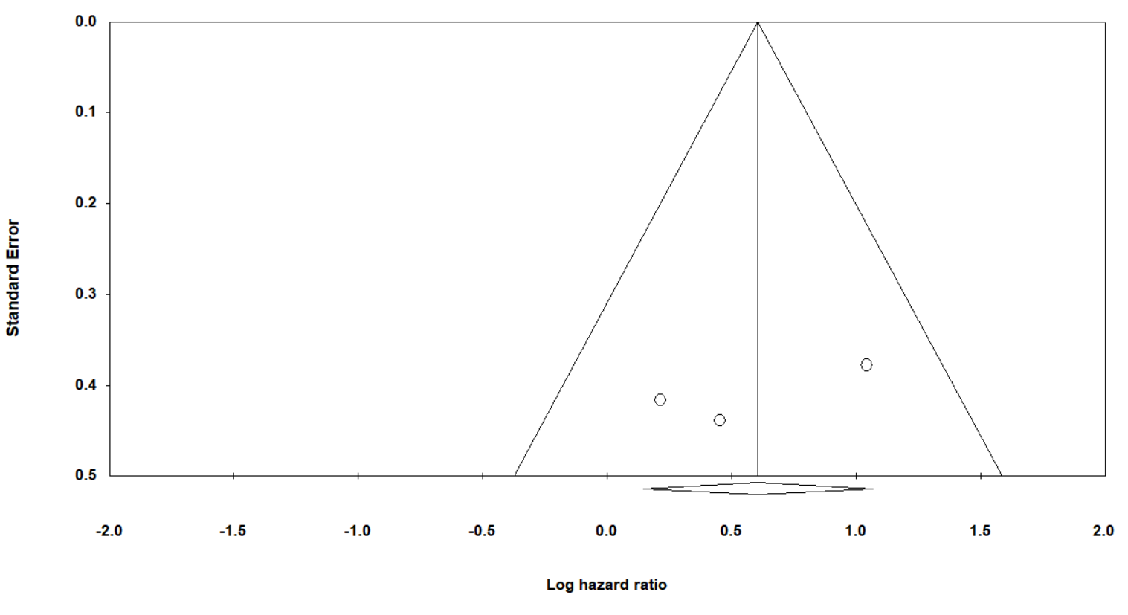

Figure 3S. The funnel plot of studies evaluating the prognostic value of CD133 overexpression with 10% cut-off in determining the PFS of patients with high-grade gliomas (Egger test P-value 1 tailed=0.19738, and P-value 2-tailed=0.39476)

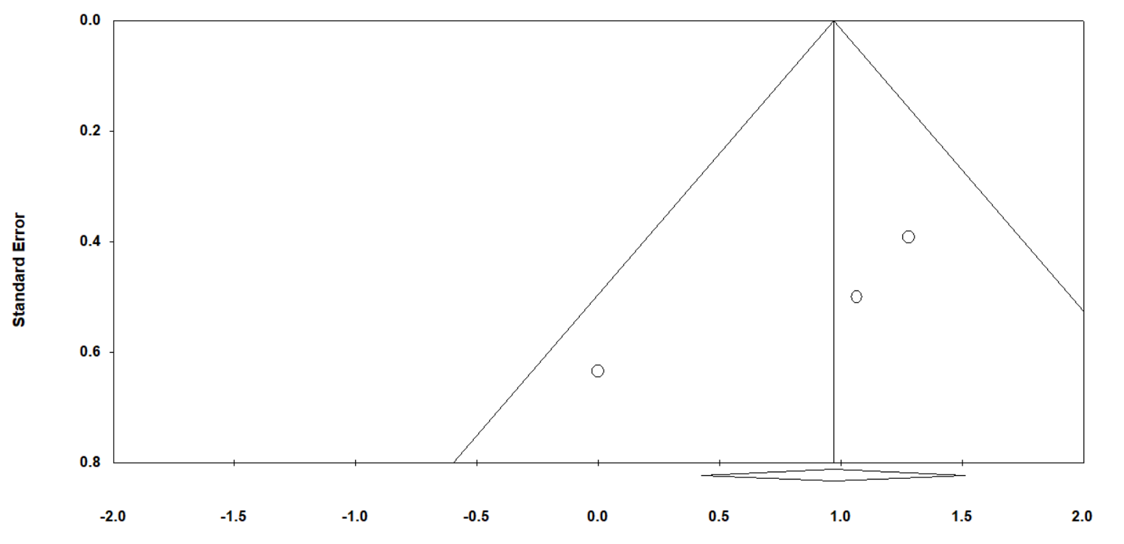

Figure 4S. The funnel plot of studies evaluating the prognostic value of CD133 in determining the TTD of patients with high-grade gliomas (Egger test P-value 1 tailed=0.10841, and P-value 2-tailed=0.21681)

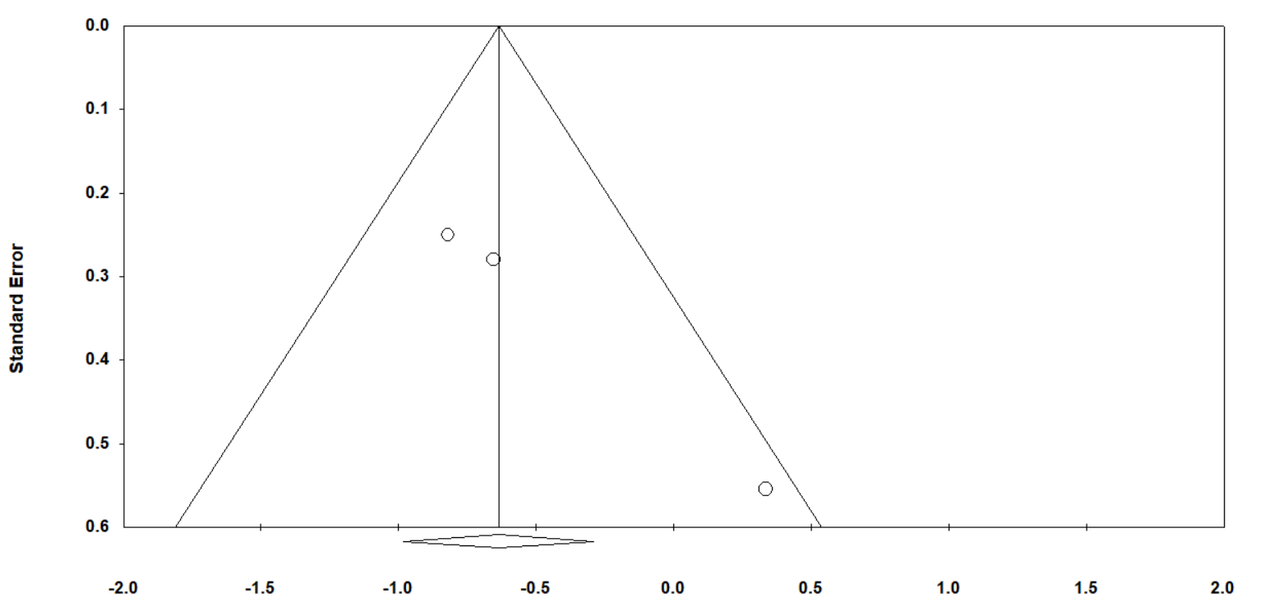

Figure 5S. The funnel plot of studies evaluating the prognostic value of CD133 in determining the TTL of patients with high-grade gliomas (Egger test P-value 1 tailed=0.02430, and P-value 2-tailed=0.04860)