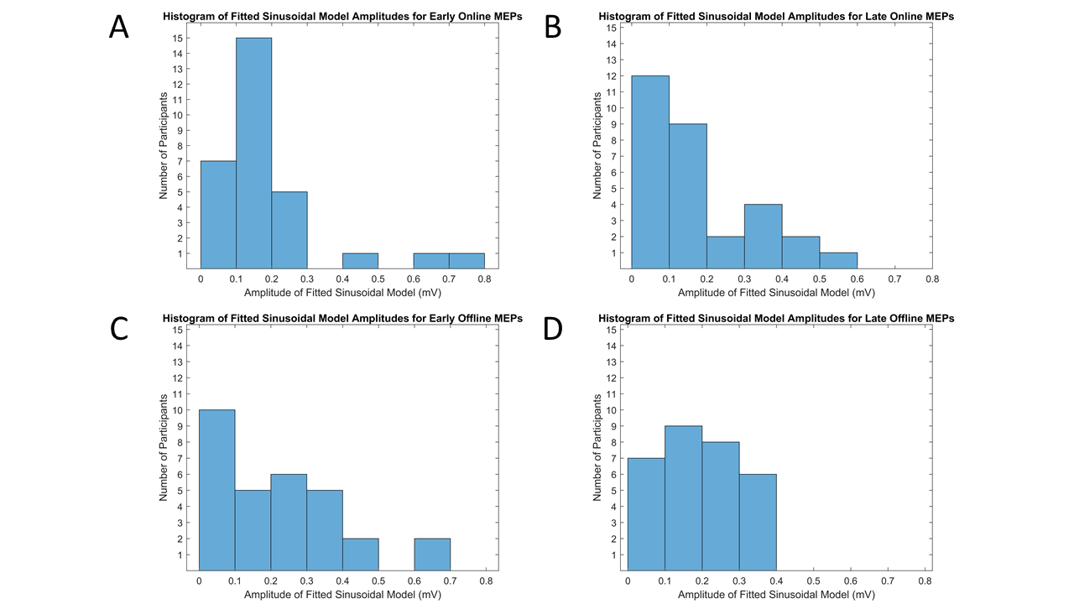

**Supplementary Figure 2. Histograms of Fitted Sinusoidal Model Amplitudes for Each Position.** Bars represent the number of participants with fitted sinusoidal model amplitudes within the range specified on the x-axis for (A) early online, (B) late online, (C) early offline, and (D) late offline MEPs.