Supplementary Material

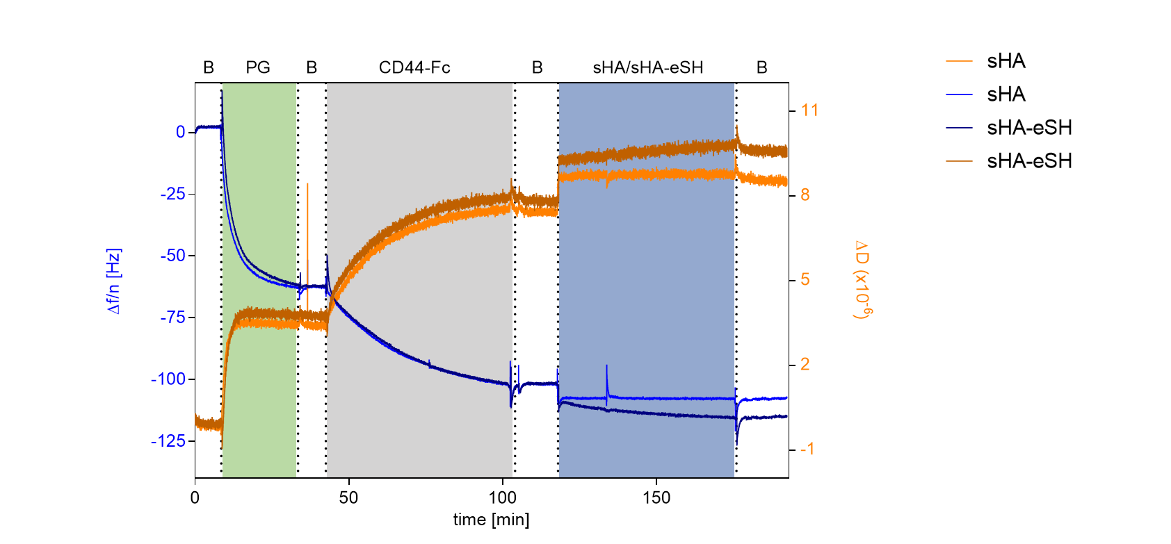

**Supplementary Figure 1.** QCM-D measurements confirm CD44 interactions with hyaluronan. The binding experiment shows the formation of a stable adlayer of protein G (PG) on a gold surface, followed by immobilization of Fc-tagged CD44 and its binding to sHA and sHA-eSH. Data from the 7th overtone are shown, frequency changes depicted in blue and dissipation changes in orange. As physiological conditions are used for this experiment, the change in frequency observed upon sHA-eSH binding is twice as high as for sHA, probably due to disulfide bond formation. This indicates that sHA-eSH binds to CD44 with the same effectivity.

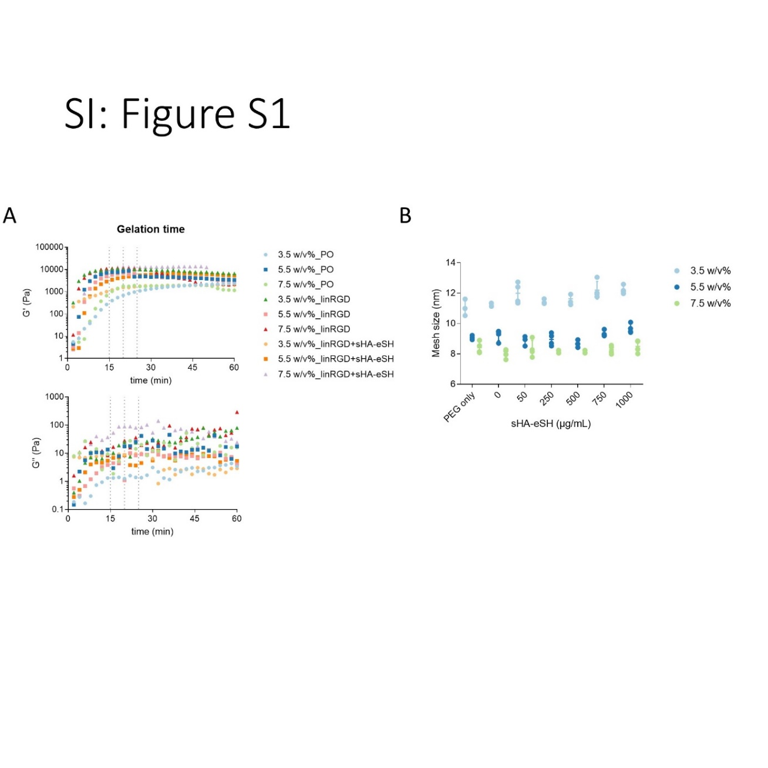

**Supplementary Figure 2.** (**A**) Gelation times obtained by time sweep experiments. Changes in the storage modulus G′ (Pa) and loss modulus G′′ (Pa) during hydrogel formation were monitored under a constant shear rate at 37 °C. (**B**) Mesh sizes, determined from swelling ratios in PBS. PEG hydrogels with three different polymer concentrations and degrees of functionalization (0.5x10-3 M linRGD and varying concentrations of end-thiolated sHA) were prepared by thiol-Michael addition reaction. Hydrogels were crosslinked with the PEG-dithiol linker. PO = PEG only, non-functionalized.

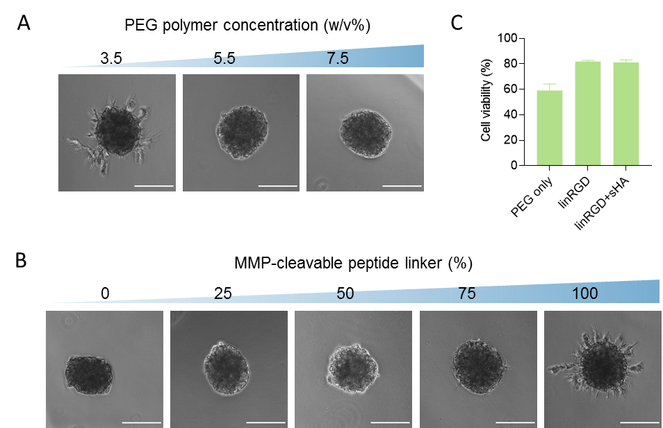

**Supplementary Figure 3.** PEG polymer concentration and enzymatic degradability constrains endothelial sprouting. Representative phase-contrast images of endothelial cell sprouts originating from PEG hydrogel embedded HUVEC spheroids. (**A**) Degradable hydrogels were prepared with three different polymer concentrations (3.5 w/v%, 5.5 w/v% and 7.5 w/v%) by Michael-type addition with a MMP-cleavable di-cysteine peptide. (**B**) 3.5 w/v% hydrogels were prepared by Michael-type addition reaction and crosslinked with a mixture of a non-degradable PEG-dithiol and a MMP-cleavable di-cysteine peptide in varying molar ratios. Percent refers to the ratio of MMP-cleavable peptide. Embedded HUVEC spheroids were stimulated with 50 ng/mL VEGF for 48 h. Scale bar 50 µm. (**C**) life/dead assay of evenly distributed HUVECs reveals 80% cell viability at day 2 of cultivation in degradable 3.5 w/v% hydrogels functionalized different bioactive cues.

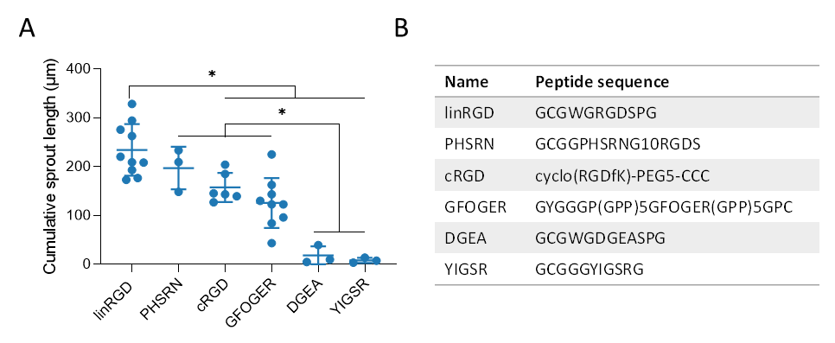

**Supplementary Figure 4.** Evaluation of six different peptide binding motifs on sprouting of endothelial cells. (**A**) Cumulative sprout length originating from HUVEC spheroids, embedded in 3.5 w/v% PEG hydrogel functionalized with 1x10-3 M peptide binding motif. HUVECs were stimulated with 50x10-9 g mL-1 VEGF for 48 h. Statistical significance was calculated using one-way ANOVA followed by Tukey’s test (* p < 0.05). (**B**) Peptide sequences of tested binding motifs.

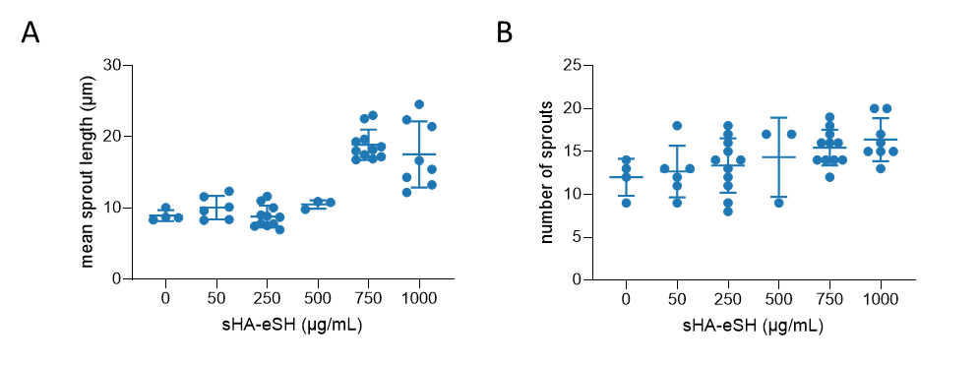

**Supplementary Figure 5.** Analysis of the (**A**) mean sprout length and (**B**) number of sprouts per HUVEC spheroid embedded in 3.5 w/v% PEG hydrogel functionalized with 0.5 mM linRGD and varying concentrations of sHA-eSH. Spheroids were stimulated with 50 ng/mL VEGF for 48 h.

**Supplementary Table 1.** Crosslinker concentrations (in mM) for hydrogel formation (exact concentration depends on the degree of functionalization with linRGD and sHA-eSH, as VS and SH groups are in a 1:1 molar ratio)

|  |  |  |  |  |
| --- | --- | --- | --- | --- |
| Crosslinker | Functionalization | 3.5 w/v% | 5.5 w/v% | 7.5 w/v% |
| Non-degradable | PEG only | 11.7 | 18.3 | 25.0 |
| 500 µM linRGD | 11.3 | 17.9 | 24.6 |
| 500 µM linRGD + 76.9 µM sHA-eSH | 11.2 | 17.9 | 24.5 |
| Semi-degradable* | PEG only | 11.0 | 17.3 | 23.6 |
| 500 µM linRGD | 10.6 | 16.9 | 23.2 |
| 500 µM linRGD + 76.9 µM sHA-eSH | 10.5 | 16.8 | 23.1 |
| Degradable | PEG only | 10.4 | 16.3 | 22.3 |
| 500 µM linRGD | 10.0 | 16.0 | 21.9 |
| 500 µM linRGD + 76.9 µM sHA-eSH | 10.0 | 15.9 | 21.9 |

* 1:1 molar ratio of non-degradable PEG-SH crosslinker and MMP-cleavable peptide crosslinker

**Example: Hydrogel calculations.**

Example calculation for 100 µL non-degradable 3.5 w/v% hydrogel, functionalized with 500 µM linRGD and 1 mg/mL (76.9 µM) sHA-eSH:

🡺 1. PEG-VS and PEG-SH make up 3.5 w/v% = 35 mg/mL (3.5 mg in 100 µL)

🡺 2. VS and SH functional groups at equal stoichiometric ratio (1:1)

|  |  |  |  |
| --- | --- | --- | --- |
|  | Number of functional groups per molecule | MW (g/mol) | Mass ratio for 1:1 molar ratio of SH:VS functional groups |
| PEG-SH | 2 | 1,000 | 8 x 1,000 Da = 8,000 Da – 1 part |
| PEG-VS | 8 | 20,000 | 2 x 20,000 Da = 40,000 Da – 5 parts |

1) How many SH groups are introduced by the functionalization with 500 µM linRGD and 76.9 µM sHA-eSH?

linRGD: 100 µL x 500 µM = 50 nmol

sHA-eSH: 100 µL x 76.9 µM = 7.69 nmol

* In total 57.69 nmol SH groups

2) How much 8-arm PEG-VS is consumed by the functionalization with linRGD and sHA-eSH?

SH groups = VS groups = 57.69 nmol

(57.69 nmol x 20,000 Da)/8 = 0.144 mg

* The mass of PEG-VS, which is needed for the conjugation of linRGD and sHA-eSH is 0.144 mg (massPEG-VS for functionalization)

3) Which mass of PEG-VS and PEG-SH are additionally needed for a 3.5 w/v% hydrogel?

Total PEG in 100 µL: 3.5 mg

3.5 mg = massPEG-VS for functionalization + massPEG-VS + massPEG-SH

* massPEG-VS + massPEG-SH  = 3.5 mg – 0.144 mg = 3.356 mg

4) How is the mass ratio for formation of hydrogels with an equal VS:SH molar ratio?

The mass ratio is 1:5 PEG-SH: PEG-VS for having equal molar ratios of SH:VS groups.

massPEG-SH: 3.356/6 x 1 = 0.559 mg (1118.40 nmol)

massPEG-VS: 3.356/6 x 5 = 2.796 mg (1176.09 nmol)

🡺 massPEG-SH + massPEG-VS + massPEG-VS for functionalization = 0.559 mg + 2.796 mg + 0.144 mg = 3.5 mg

🡺 molar ratios SH (linRGD, sHA-eSH + PEG-SH): VS (PEG-VS) 🡺 (57.69 nmol +1118.40 nmol):1176.09 nmol or (0.049+0.9519):1 or 1:1