Supplementary Figures

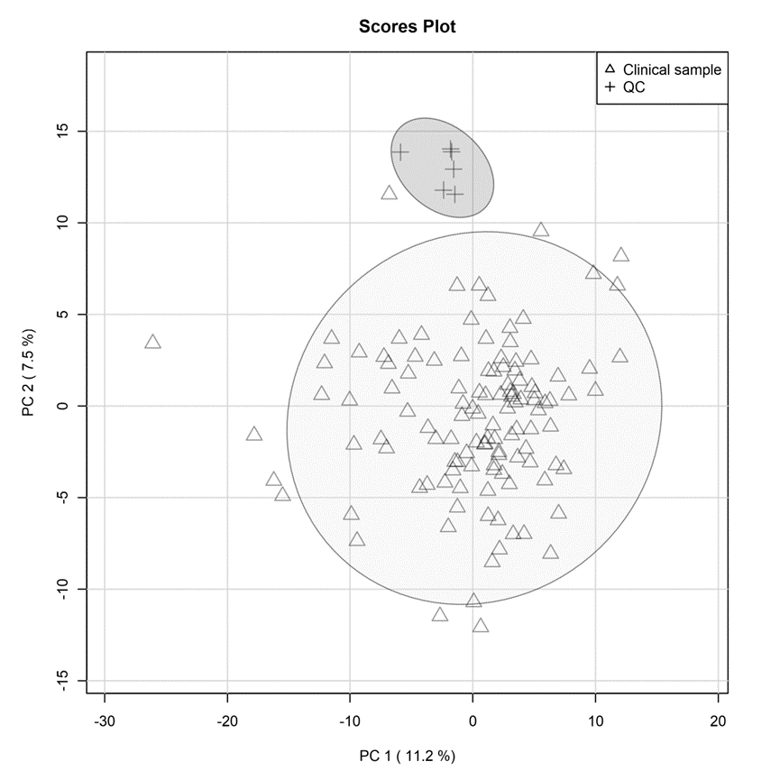

**Supplementary Figure 1.** PCA score plot showing clinical samples and quality control (QC).

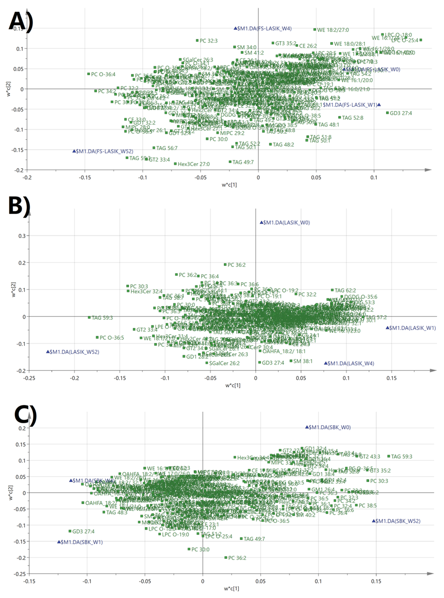

**Supplementary Figure 2.** PLS-DA loading plots. A) FS-LASIK; B) LASIK; C) SBK. Green square: X variables, i.e. lipid; Blue triangle: Y variables, i.e. time points.