Supplementary Material

Supplementary Figures
Supplementary Figure 1. Calibration curve of the logistics regression model in primary cohort. The resultant curve and ideal curve had good consistency, which was confirmed by Hosmer-Lemeshow test.
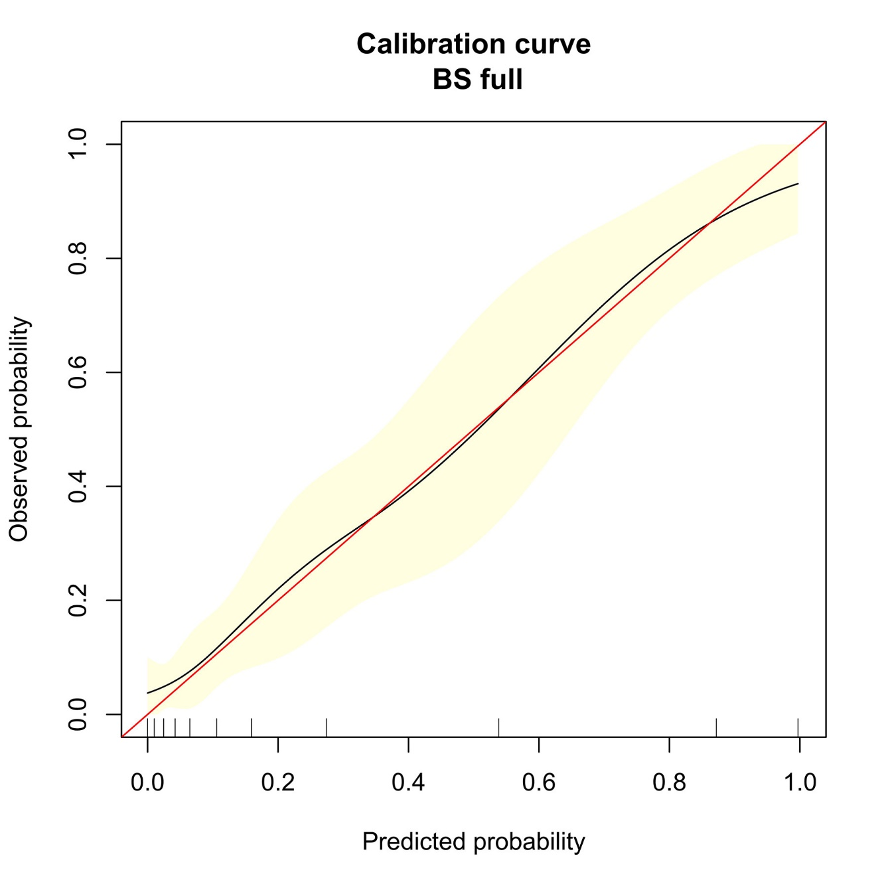

Supplementary Figure 2. Confusion matrix of the scoring system in the primary cohort (A) and external validation cohort (B), which was to show the diagnostic ability of the scoring system.
Figure 2A 2B
Supplementary Tables
Supplementary Table 1.
Table 1: The sensitivity and specificity for all scores of primary cohort and validation cohort.
 | Primary cohort |  | Validation cohort
 | Specificity | Sensitivity | Specificity | Sensitivity
≥1 | 0.00 (0.0 - 2.0) | 100.00 (95.3 - 100.0) | 0.00 (0.0 - 5.5） | 100.00 (81.5 -100.0）
＞1 | 13.98 (9.3 - 19.8) | 98.68 (92.9 - 100.0) | 7.69 (2.5 - 17.0) | 100.00 (81.5 -100.0）
＞2 | 43.55 (36.3 - 51.0) | 97.37 (90.8 - 99.7) | 32.31 (21.2 - 45.1) | 100.00 (81.5 -100.0）
＞3 | 72.04 (65.0 - 78.4) | 82.89 (72.5 - 90.6) | 53.85 (41.0 - 66.3) | 88.89 (65.3 - 98.6）
＞4 | 87.63 (82.0 - 92.0) | 71.05 (59.5 - 80.9) | 72.31 (59.8 - 82.7) | 77.78 (52.4 - 93.6）
＞5 | 95.16 (91.0 - 97.8) | 56.58 (44.7 - 67.9) | 90.77 (81.0 - 96.5) | 50.00 (26.0 - 74.0）
＞6 | 98.39 (95.4 - 99.7) | 44.74 (33.3 - 56.6) | 98.46 (91.7 - 100.0) | 27.78 (9.7 - 53.5）
＞7 | 100.00 (98.0 - 100.0) | 26.32 (16.9 - 37.7) | 98.46 (91.7 - 100.0) | 5.56 (0.1 - 27.3）
＞8 | 100.00 (98.0 - 100.0) | 11.84 (5.6 - 21.3) | 100.00 (94.5 - 100.0) | 0.00 (0.0 - 18.5）
＞9 | 100.00 (98.0 - 100.0) | 5.26 (1.5 - 12.9) | - | -
＞10 | 100.00 (98.0 - 100.0) | 1.32 (0.03 - 7.1) | - | -
＞11 | 100.00 (98.0 - 100.0) | 0.00 (0.0 - 4.7) | - | -

