Supplementary Material

This supplementary file includes 12 figures:

Figure S1. Coseismic Coulomb stress changes of slip distribution are constrained by CENC with the receiving fault of the mainshock. Coulomb stress changes at depths of 4, 8, 12, and 16 km, respectively.

Figure S2. Coseismic Coulomb stress changes of slip distribution are constrained by GCMT with the receiving fault of the mainshock. Coulomb stress changes at depths of 4, 8, 12, and 16 km, respectively.

Figure S3. Coseismic Coulomb stress changes of slip distribution are constrained by USGS with the receiving fault of the mainshock. Coulomb stress changes at depths of 4, 8, 12, and 16 km, respectively.

Figure S4. Coseismic Coulomb stress changes of slip distribution are constrained by CENC with the receiving fault of the MS 5.4 earthquake focal mechanism

Figure S5. Coseismic Coulomb stress changes of slip distribution are constrained by GCMT with the receiving fault of the *M*S 5.4 earthquake focal mechanism

Figure S6. Coseismic Coulomb stress changes of slip distribution are constrained by USGS with the receiving fault of the *M*S 5.4 earthquake focal mechanism

Figure S7. InSAR co-seismic deformation Observations, predictions and residuals constrained by IPGP.

Figure S8. InSAR co-seismic deformation Observations, predictions and residuals constrained by CENC.

Figure S9. InSAR co-seismic deformation Observations, predictions and residuals constrained by GCMT.

Figure S10. InSAR co-seismic deformation Observations, predictions and residuals constrained by USGS.

Figure S11. Aftershocks sequence relocation of the *M*S 6.6 Jinghe earthquake.

Figure S12. The error distribution and the RMS of aftershocks relocation.

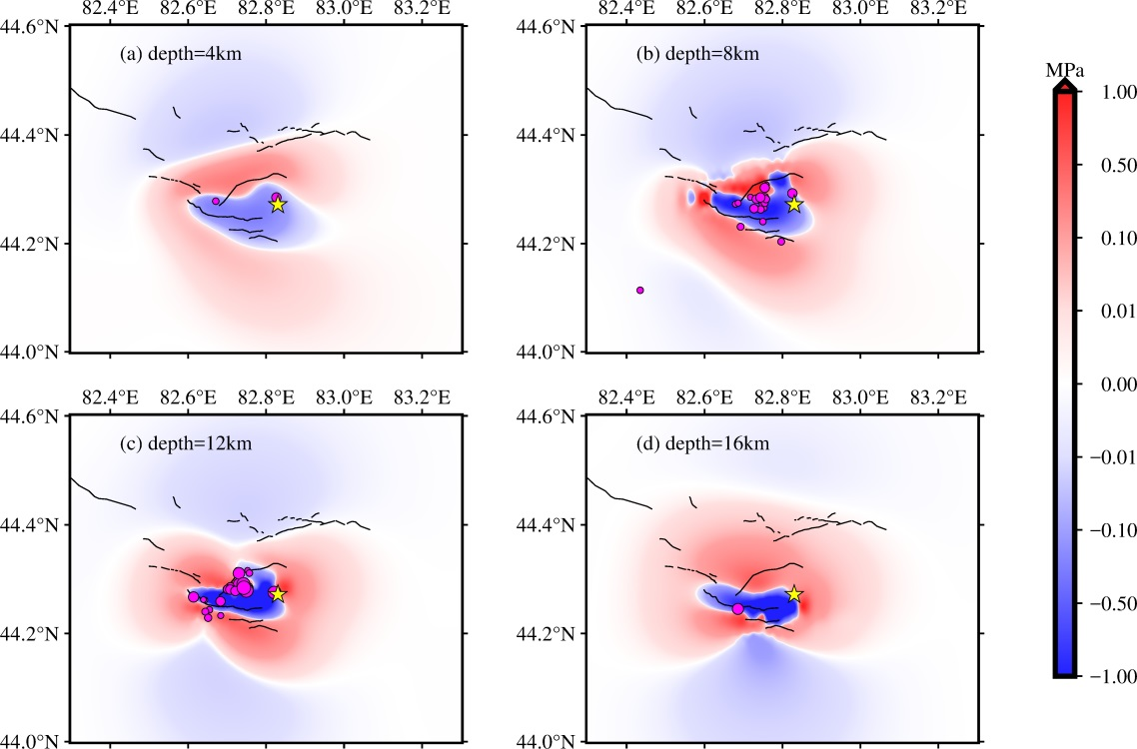

**Figure S1.** Coseismic Coulomb stress changes of slip distribution are constrained by **CENC** with the receiving fault of the mainshock. (i.e., strike = 76°, dip = 44°, rake = 80°, and friction = 0.8). Coulomb stress changes at depths of 4, 8, 12, and 16 km, respectively. The black lines denote the active faults. The aftershocks (M ≥ 2.0), which are at different depths of 2–18 km with an interval of 4 km, are denoted by black circles filled with rose. The epicenter of the mainshock is denoted by a yellow star.

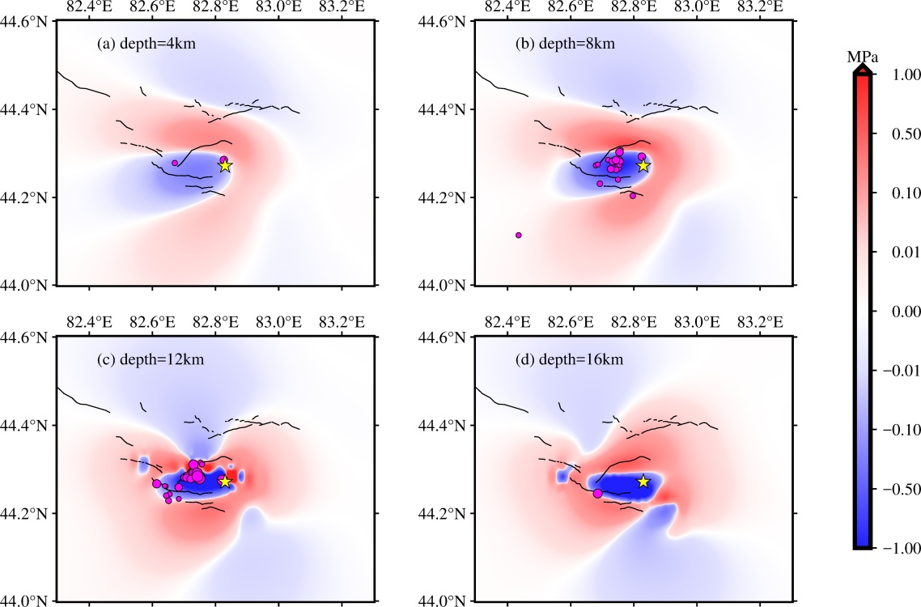

**Figure S2.** Coseismic Coulomb stress changes of slip distribution are constrained by **GCMT** with the receiving fault of the mainshock. (i.e., strike = 101°, dip = 44°, rake = 118°, and friction = 0.8). Coulomb stress changes at depths of 4, 8, 12, and 16 km, respectively. The black lines denote the active faults. The aftershocks (M ≥ 2.0), which are at different depths of 2–18 km with an interval of 4 km, are denoted by black circles filled with rose. The epicenter of the mainshock is denoted by a yellow star.

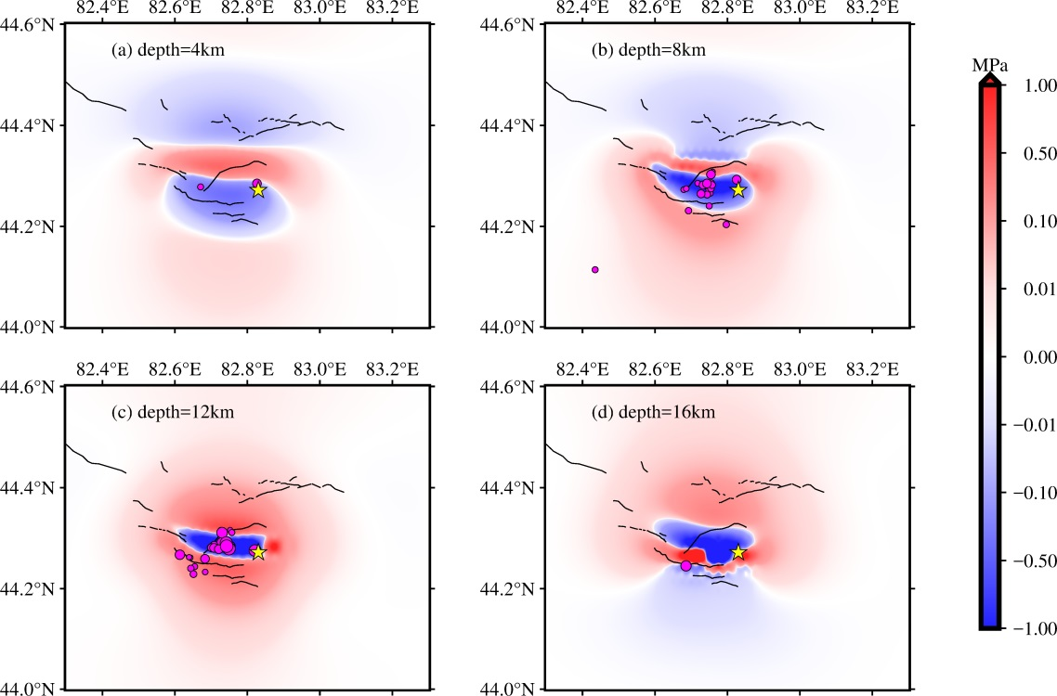

**Figure S3.** Coseismic Coulomb stress changes of slip distribution are constrained by **USGS** with the receiving fault of the mainshock. (i.e., strike = 92°, dip = 60°, rake = 92°, and friction = 0.8). Coulomb stress changes at depths of 4, 8, 12, and 16 km, respectively. The black lines denote the active faults. The aftershocks (M ≥ 2.0), which are at different depths of 2–18 km with an interval of 4 km, are denoted by black circles filled with rose. The epicenter of the mainshock is denoted by a yellow star.

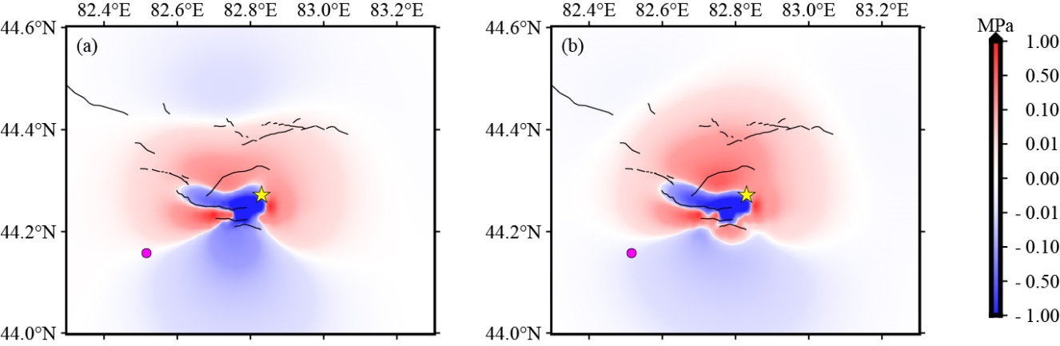

**Figure S4.** Coseismic Coulomb stress changes of slip distribution are constrained by **CENC** with the receiving fault of the *M*S 5.4 earthquake focal mechanism (strike = 106.3°, dip = 53.1°, rake = 100.0°). *M*S5.4 earthquake on October 16, 2018, is denoted by black circles filled with rose. The epicenter of the mainshock is denoted by a yellow star. Friction is (a) 0.4 or (b) 0.8.

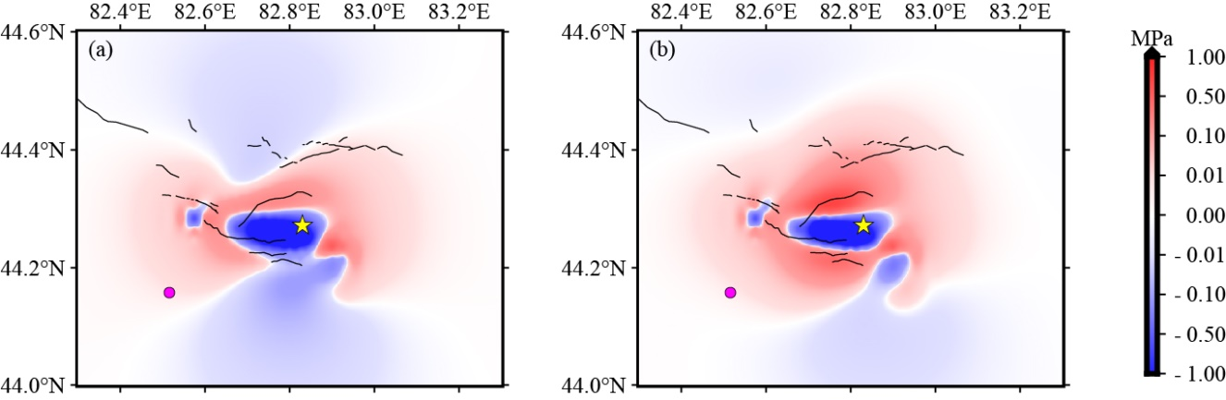

**Figure S5.** Coseismic Coulomb stress changes of slip distribution are constrained by **GCMT** with the receiving fault of the *M*S 5.4 earthquake focal mechanism (strike = 106.3°, dip = 53.1°, rake = 100.0°). *M*S5.4 earthquake on October 16, 2018, is denoted by black circles filled with rose. The epicenter of the mainshock is denoted by a yellow star. Friction is (a) 0.4 or (b) 0.8.

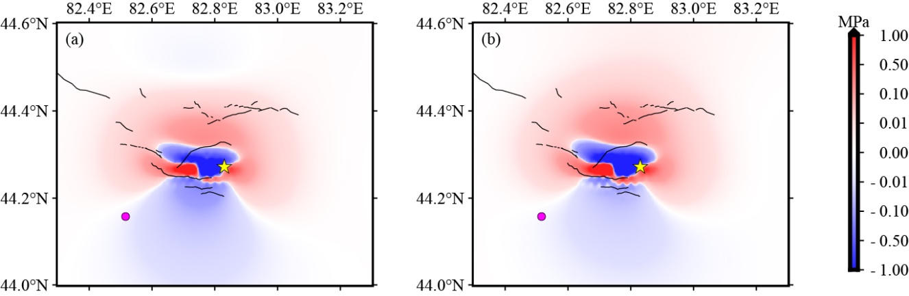

**Figure S6.** Coseismic Coulomb stress changes of slip distribution are constrained by **USGS** with the receiving fault of the *M*S 5.4 earthquake focal mechanism (strike = 106.3°, dip = 53.1°, rake = 100.0°). *M*S5.4 earthquake on October 16, 2018, is denoted by black circles filled with rose. The epicenter of the mainshock is denoted by a yellow star. Friction is (a) 0.4 or (b) 0.8.

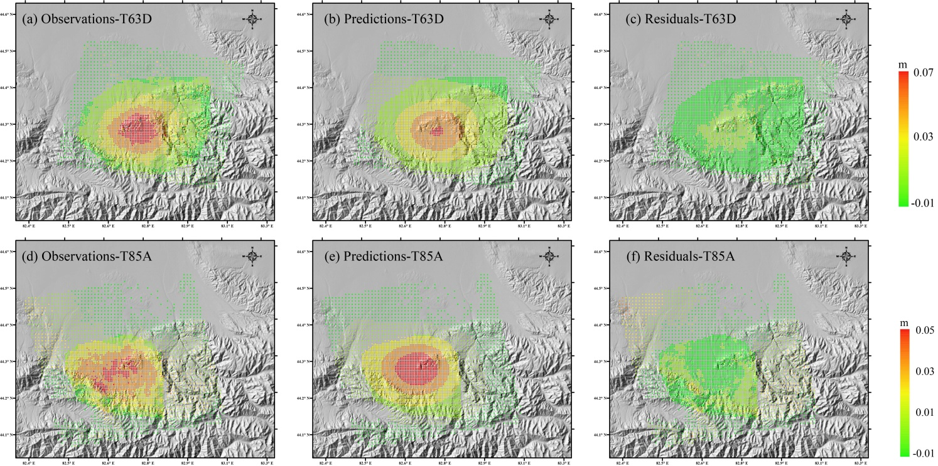

**Figure S7.** InSAR co-seismic deformations Observation points, predictions by jointly inverted slip model, and the residuals between them. The slip distribution is constrained by **IPGP**. (a,d) are the LOS deformation field at downsampled points from Sentinel-1 descending track T63D and ascending track T85A respectively; (b,e) are the corresponding model predictions; (c,f) are the respective residuals from fitting.

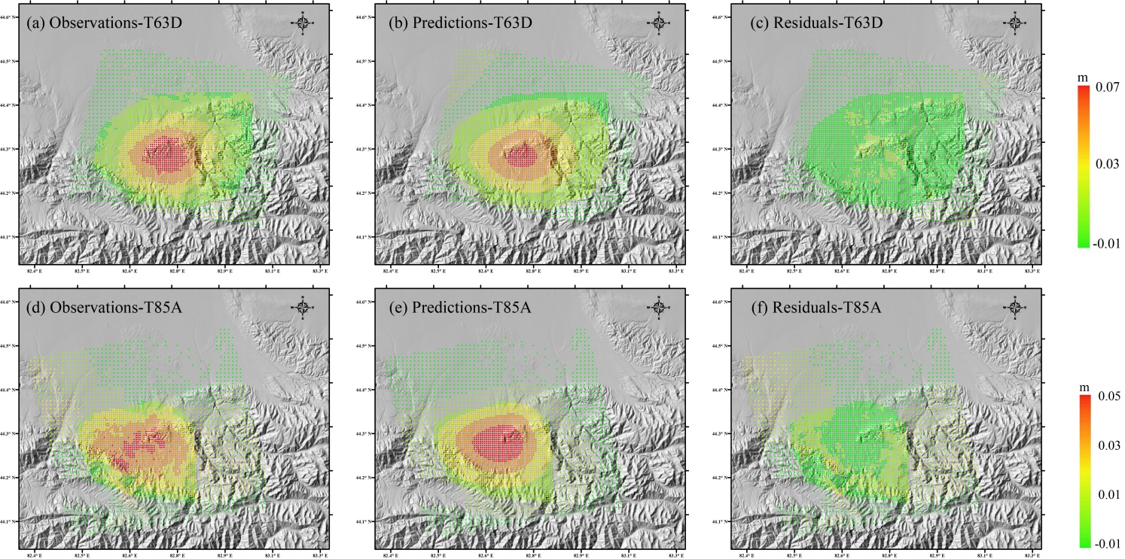

**Figure S8.** InSAR co-seismic deformations Observation points, predictions by jointly inverted slip model, and the residuals between them. The slip distribution is constrained by **CENC**. (a,d) are the LOS deformation field at downsampled points from Sentinel-1 descending track T63D and ascending track T85A respectively; (b,e) are the corresponding model predictions; (c,f) are the respective residuals from fitting.

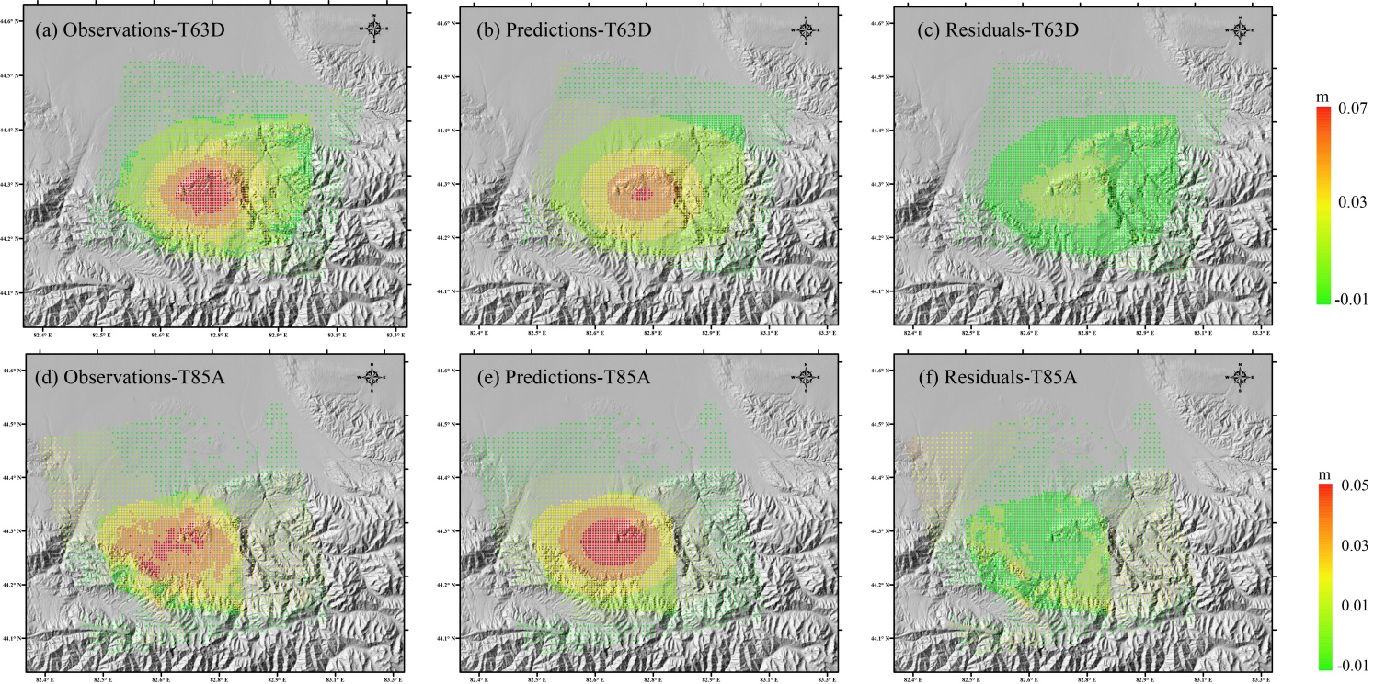

**Figure S9.** InSAR co-seismic deformations Observation points, predictions by jointly inverted slip model, and the residuals between them. The slip distribution is constrained by **GCMT**. (a,d) are the LOS deformation field at downsampled points from Sentinel-1 descending track T63D and ascending track T85A respectively; (b,e) are the corresponding model predictions; (c,f) are the respective residuals from fitting.

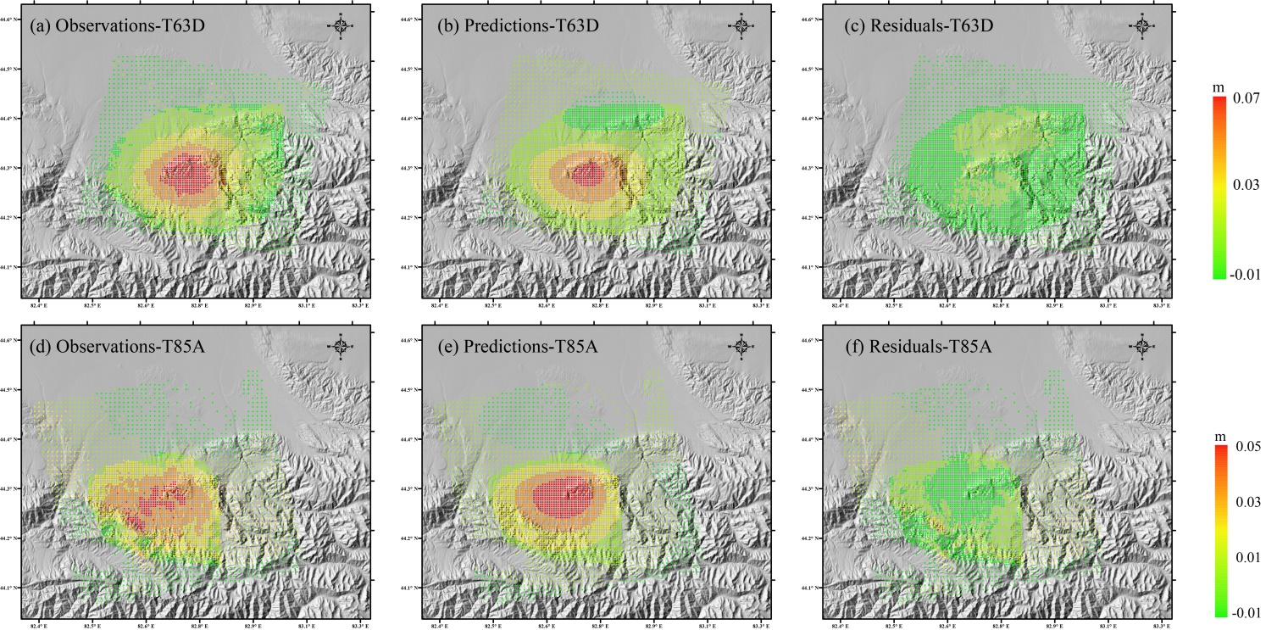

**Figure S10.** InSAR co-seismic deformations Observation points, predictions by jointly inverted slip model, and the residuals between them. The slip distribution is constrained by **USGS**. (a,d) are the LOS deformation field at downsampled points from Sentinel-1 descending track T63D and ascending track T85A respectively; (b,e) are the corresponding model predictions; (c,f) are the respective residuals from fitting.

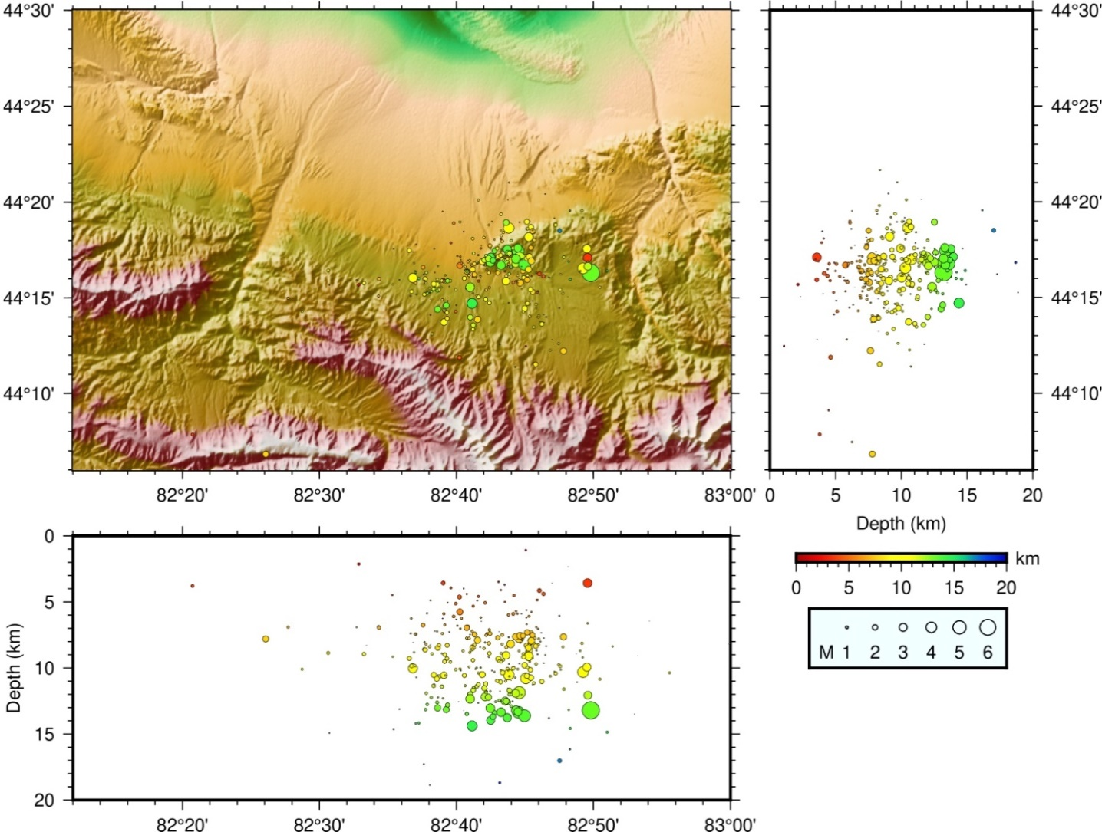

**Figure S11.** Aftershocks sequence relocation of the *M*S 6.6 Jinghe earthquake. The right picture and the below picture show the North-South vertical section and the East-West vertical section, respectively. The color indicates the depth, and the size of the circle indicates the magnitude.

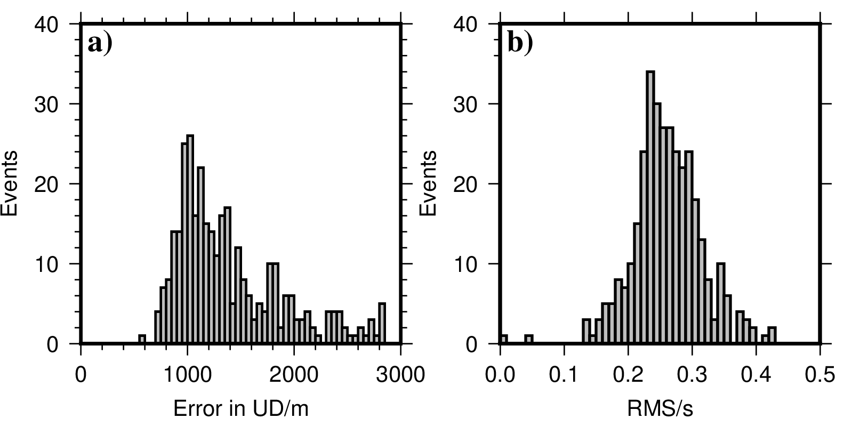

**Figure S12.** (a) The error distribution of aftershocks relocation in the vertical direction. (b) The RMS of aftershocks relocation.