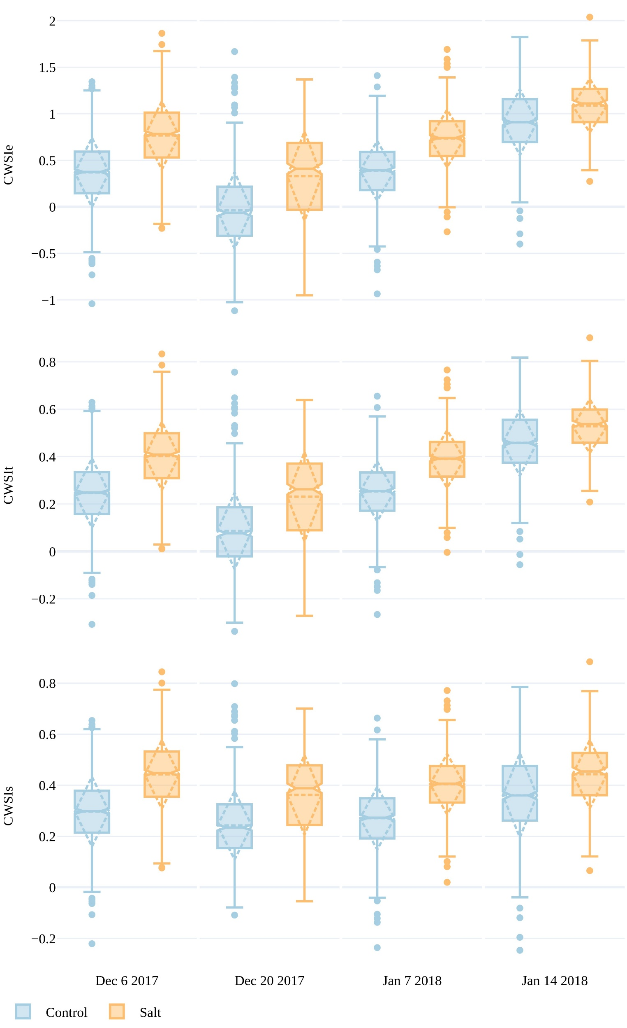

Supplementary Figure : Crop water stress index values for three methods: empirically (CWSIe), theoretically (CWSIt) and simplified statistical (CWSIs) over both salt and control plots for four UAV campaigns. The boxes span the interquartile range (IQR), with notches indicating the median and the dashed diamond the standard deviation and mean. The whiskers bound 1.5\*IQR.