Supplementary Table 1: Bioactive compounds selected from the literature
Bioactive compound | PubChem CID | Beneficial activity | Doi
Hidroquinone | 785 | Antibacterial activity | 10.1089 / mdr.2018.0149
4-hydroxybenzoic acid | 135 | Antibacterial and antifungal activity | 10.5539 / jas.v1n2p15
Amentoflavone | 5281600 | Antibacterial activity | 10.1016/j.foodchem.2018.07.159
Apigenin | 5280443 | Antibacterial and antibiofilm, inhibition of AI-1 and AI-2 | 10.1111/j.1365-2672.2010.04677.x
Arbutin | 440936 | Antibacterial and antitumor activity | 10.1016/j.phytol.2015.05.015
Baicalein | 5281605 | Antibacterial and antibiofilm activity, bactericidal | 10.1371/journal.pone.0153468
Bilobetin | 5315459 | Antifungal activity | 10.1515 / znc-2003-1-212
Bisdemethoxycurcumin | 5315472 | Anticancer activity | 10.1021/om500317b
BR-xanthone | 13964005 | Antifungal activity | 10.1021/np970165u
Caffeic acid | 689043 | Antimicrobial activity and inhibition of violacein | 10.1080/08927014.2013.852542
Capsaicin | 1548943 | Antivirulence and antibacterial activity, | 10.3389 / fmicb.2015.01281
Chlorogenic acid | 1794427 | Inhibition of violacein production | 10.1016/j.foodcont.2011.09.006
Cianidanol | 9064 | Antibacterial activity | 10.2101/Ajid.12v1S.8
Curcumin | 969516 | Antibacterial activity, anticancer and anti-inflammatory | 10.1016 / j.jgar.2017.03.006
Cyanidin | 128861 | Antibiofilm activity, inhibition of violacein and EPS production | 10.1007 / s13197-015-2031-9
Cyanidin-3-glucoside | 441667 | Anti-inflammatory activity | 10.1007/s10068-014-0279-x
Daidzein | 5281708 | Inhibition of violacein production | 10.1016/j.foodcont.2011.09.006
Delphinidin-3-glucoside | 102515359 | Antioxidant and antibacterial activity | 10.3390/molecules20045698
Delphinidin | 128853 | Anti-inflammatory and antibiofilm activity | 10.1016/B978-0-12-805417-8.00023-8
Demethoxycurcumin | 5469424 | Anti-inflammatory and anti infectious activity | 10.1002/jcp.28626
Dihydrocapsaicin | 107982 | Antibacterial activity | 10.1007 / s11418-011-0579-x
Ellagic acid | 5281855 | Inhibition of violacein and AHL production | 10.1016/j.foodcont.2011.09.006
Epicatechin | 72276 | Antimicrobial activity and inhibition of violacein | 10.1080/08927014.2013.852542
Epigallocatechin | 72277 | Antiabetic activity | 10.1093/jn/136.10.2512
Epigallocatechin (3- gallate) | 65064 | Inhibition of violacein production and antibiofilm | 10.1038/srep16158
Eriodictyol | 440735 | Inhibition of pyocyanine, elastase and violacein | 10.1099/mic.0.049338-0
Ferulic acid | 445858 | Inhibition of violacein and antibacterial activity | 10.1080/08927014.2013.852542
Gallic acid | 370 | Antibacterial activity | 10.1016/j.supflu.2018.07.025
Genistein | 5280961 | Bacteriostatic activity and inhibition of toxin production | 10.1007 / s12272-010-0520-y
Gentisic acid | 3469 | Radioprotective property | 10.3109/10715762.2011.633518
Gentisin | 5281636 | Antibacterial and antioxidant activity | 10.1016/j.micpath.2017.10.049
Ginkgetin | 5271805 | Anti-inflammatory, antiviral and antifungal. | 10.3109 / 10715762.2015.1032958
Globuxanthone | 60148490 | Antibacterial activity | 10.1016/j.phytol.2017.05.014
Glycitein | 5317750 | Antibacterial, antitumor and anticancer activity | PMID: 26339345; PMCID: PMC4555673
Hesperidin | 10621 | Inhibition of HSL and violacein production | 10.1021/jf301365a
Isorhamnetin | 5281654 | Antiviral, antimicrobial and anti-inflammatory activity | 10.1158 / 0008-5472.CAN-13-0525
Kaempferol | 5280863 | Antimicrobial activity, inhibition of AI-1 and AI-2 | 10.1111/j.1365-2672.2010.04677.x
Lapachol | 3884 | Antiviral, antibacterial and antifungal, anti-inflammatory | 10.1016/j.bmcl.2013.12.049
Luteoforol | 114505 | Antibacterial and antifungal activity | 10.1007/s10658-005-2192-x
Luteolin | 5280445 | Antibacterial activity, inhibition of HSL production and motility | 10.1007/s11104-015-2659-2
Malvidin | 159287 | Antibiofilm activity, inhibition of violacein and EPS production | 10.1016/j.micpath.2015.01.010
Malvidin-3-glucoside | 443652 | Anti-inflammatory activity | 10.1016/j.foodchem.2009.12.097
Mangiferin | 5281647 | Antidiabetic | 10.1078/0944-7113-00009
Mangostin | 5281650 | Antibacterial and antifungal activity | 10.1016/j.phymed.2003.09.012
Matairesinol | 119205 | Anti-inflammatory activity | 10.1007/s11064-017-2301-1
Methyl 4-hydroxycinnamate | 5319562 | Antibacterial activity | 10.1111/1750-3841.13302
Morelloflavone | 5464454 | Anti-inflammatory, antibacterial and hypocholesterolemic action | 10.1002/ptr.3286
Myricetin | 5281672 | Inhibition of pyocyanine and antibiofilm activity | 10.1016/j.micpath.2017.07.018
Naringenin | 932 | Inhibition of pyocyanine, elastase, production of HSL | 10.1099/mic.0.049338-0
P-coumaric acid | 637775 | Antibacterial and anti-QS activity | 10.1089/jmf.2012.0197
Pelargonidin | 440832 | Antibiofilm activity | 10.1080/14786419.2016.1222386
Peonidin | 441773 | Prebiotic and antibacterial activity | 10.1038/s41598-018-23397-0
Peonidin-3-glucoside | 443654 | Anticancer activity | 10.1080/01635580903441261
Petunidin | 441774 | Antibiofilm activity, inhibition of EPS production | 10.1039 / C5RA20677D
Phloretin | 4788 | Antibacterial activity | 10.1016/j.foodchem.2014.03.118
Piceatannol | 667639 | Anti-inflammatory and anticancer, therapeutic potential | 10.1089/jmf.2017.3916
Procyanidin | 107876 | Anti hypertensive | 10.1016/j.foodres.2013.01.023
Procyanidin B1 | 11250133 | Anti-inflammatory activity | 10.1007/s11010-015-2457-4
Pyrocatechol | 289 | Chemopreventive | 10.1016 / j.fct.2019.02.010
Quercetin | 5280343 | Antimicrobial activity, inhibition of AI-1 and AI-2 | 10.1111/j.1365-2672.2010.04677.x
Quercetin-3,4-diglucoside | 11215769 | Antibacterial activity | 10.3389/fmicb.2019.00867
Quercetin-3-glucoside | 44259229 | Antibacterial activity | 10.4314 / tjpr.v12i5.23
Quercetin-3-β-D-glucoside | 5280804 | Anticancer activity | 10.1021/jf8039796
Quercitrin | 5280459 | Anti-inflammatory activity | 10.1038/sj.bjp.0705941
Resorcinol | 5054 | Antibacterial and anticancer activity | 10.1016/j.jorganchem.2014.12.042
Resveratrol | 445154 | Inhibition of the production of violacein and HSL | 10.1016/j.foodcont.2011.09.006
Rutin | 5280805 | Inhibition of pyocyanine and antibiofilm activity | 10.1016/j.micpath.2017.07.018Obtenha direitos e conteúdo
Salicylic acid | 338 | Antimicrobial activity, inhibition of AHL, proteases and motility | 10.1128 / AAC.01283-08
Sciadopitysin | 5281696 | Anti-inflammatory activity | 10.1002/jat.3620
Secoisolariciresinol | 65373 | Anticancer and antidiabetic activity | 10.1016/j.biopha.2016.07.041
Sinapic acid | 637775 | Antibacterial activity | 10.1016/j.foodchem.2007.07.003
Syringic acid | 10742 | Antibacterial and antifungal activity | 10.5539 / jas.v1n2p15
Taxifolin | 439533 | Inhibition of pyocyanin, elastase and expression of QS genes | 10.1099/mic.0.049338-0
Theaflavin | 135403798 | Antibacterial activity | 10.1016/j.ijantimicag.2011.07.006
Theograndin | 11156985 | Antioxidant activity | https://doi.org/10.1021/np034002j
Vanillic acid | 8468 | Inhibition of violacein production | 10.1016/j.foodcont.2011.09.006
Vanillin | 1183 | Antimutagenic, , anti-colitis and analgesic effect | 10.1016/j.bbagen.2010.11.004
Viniferin | 5315232 | Anti-inflammatory and anticancer activity | 10.3390/molecules22050733
Volkensiflavone | 23844069 | Antibacterial activity | 10.1016/j.fitote.2003.12.023

Supplementary Table 2: Molecular docking of compounds with better binding affinity with CviR protein structures (Part 1: 3QP1, 3QP2, 3QP4).
Molecule | Type | Pubchem CID | 3QP1 |  |  |  |  | 3QP2 |  |  |  |  | 3QP4
Molecule | Type | Pubchem CID | Binding residue | Hydrogen bond score | Steric interaction score | GScore | Rank | Binding residue | Hydrogen bond score | Steric interaction score | GScore | Rank | Binding residue | Hydrogen bond score | Steric interaction score | GScore | Rank
N-(3-oxododecanoyl)-L-homoserine lactone | AHL | 3246941 | Y80, W84, Y88, D97, S155 | -10,00 | -77,53 | -83,91 | 1 | Y80, W84, Y88, D97, S155 | -10,00 | -77,26 | -82,53 | 3 | Y80, W84, Y88, D97, S155 | -9,87 | -79,46 | -85,61 | 1
N-(3-hydroxydodecanoyl)-DL-homoserine lactone | AHL | 11507677 | Y80, W84, Y88, D97, S155 | -10,00 | -78,69 | -82,29 | 2 | Y80, W84, D97, S155 | -9,49 | -78,24 | -83,73 | 1 | Y80, W84, D97, S155 | -10 | -79,94 | -84,55 | 3
N-dodecanoyl-DL-homoserine lactone | AHL | 11565426 | Y80, W84, D97, S155 | -8,00 | -78,52 | -81,99 | 3 | Y80, W84, D97, S155 | -8,00 | -79,34 | -82,61 | 2 | Y80, W84, D97, S155 | -8 | -81,3 | -85,43 | 2
Demethoxycurcumin | Polyphenol | 5469424 | M135 | -1,00 | -82,22 | -80,73 | 4 | M135 | -1,3 | -82,05 | -80,76 | 4 | M135 | -0,52 | -82,36 | -80,79 | 7
Bisdemethoxycurcumin | Polyphenol | 5315472 | M135 | -1,59 | -79,65 | -79,25 | 5 | M135 | -1,73 | -78,99 | -78,92 | 5 | M135 | -0,68 | -81,26 | -80,49 | 8
N-(3-hydroxydecanoyl)-DL-homoserine lactone | AHL | 71353010 | Y80, W84, D97, S155 | -10,00 | -72,18 | -79,00 | 6 | Y80, W84, Y88, D97, S155 | -10,00 | -73,92 | -78,08 | 7 | Y80, W84, Y88, D97, S155 | -8,8 | -76,31 | -81,61 | 4
N-(3-oxodecanoyl)-L-homoserine lactone | AHL | 10221060 | Y80, W84, Y88, D97, S155 | -9,86 | -71,88 | -77,80 | 7 | Y80, W84, D97, S155 | -8,00 | -73,49 | -78,50 | 6 | Y80, W84, D97, S155 | -8 | -75,77 | -80,87 | 6
N-decanoyl-DL-homoserine lactone | AHL | 11644562 | Y80, W84, D97, S155 | -8,00 | -74,05 | -77,43 | 8 | Y80, W84, D97, S155 | -8,00 | -73,11 | -77,77 | 8 | Y80, W84, D97, S155 | -8 | -75,71 | -81,4 | 5
N-(3-oxooctanoyl)-L-homoserine lactone | AHL | 127293 | Y80, W84, Y88, D97, S155 | -10,00 | -67,36 | -74,29 | 9 | Y80, W84, Y88, D97, S155 | -10,00 | -66,65 | -73,09 | 11 | Y80, W84, Y88, D97, S155 | -10 | -67,2 | -73,81 | 12
4-bromo-5-(bromomethylene)-3-dodecyl-2(5H)-furanone | Antagonist | 10180544 | W84 | -4,00 | -73,35 | -73,68 | 10 | S155 | -2 | -74,01 | -73,76 | 10 | S155 | -2 | -76,83 | -77,4 | 10
N-octanoyl-DL-homoserine lactone | AHL | 3474204 | Y80, W84, D97, S155 | -8,00 | -66,75 | -73,26 | 11 | Y80, W84, S155 | -8,00 | -66,11 | -72,47 | 12 | Y80, S155 | -8 | -66,43 | -73,19 | 13
Dihydrocapsaicin | Biflavonoid | 107982 | Y88 | -4,00 | -72,21 | -71,64 | 12 | W84, Y88 | -6,00 | -70,39 | -72,38 | 13 | Y80, W84, S155 | -5,74 | -70,41 | -72,62 | 15
Matairesinol | Lignan | 119205 | W84, Y88, D97 | -5,11 | -69,79 | -70,49 | 13 | W84,Y88, D97 | -5,35 | -74,63 | -76,76 | 9 | W84, Y88, D97 | -4,48 | -76,65 | -77,9 | 9
Capsaicin | Polyphenol | 1548943 | W84, Y88 | -4,00 | -71,98 | -70,39 | 14 | Y88, N92 | -1,71 | -73,06 | -70,65 | 15 | W84, Y88 | -4 | -72,4 | -71,74 | 16
Curcumin | Polyphenol | 969516 | N92 | -4,00 | -66,89 | -66,93 | 17 | W84 | -2,18 | -74,33 | -71,54 | 14 | N92 | -0,83 | -76,01 | -73,12 | 14
N-(3-hydroxyhexanoyl)-DL-homoserine lactone | AHL | 70185030 | Y80, W84, Y88, D97, S155 | -9,84 | -58,56 | -66,60 | 18 | Y80, W84, Y88, D97, S155 | -10,00 | -57,65 | -65,71 | 24 | Y80, W84, Y88, S155 | -9,63 | -58,67 | -66,49 | 28
N-(3-oxohexanoyl)-L-homoserine lactone | AHL | 688505 | Y80, W84, Y88, D97, S155 | -10,00 | -59,19 | -66,57 | 19 | Y80, W84, Y88, D97, S155 | -9,43 | -57,93 | -64,58 | 31 | Y80, W84, Y88, D97, S155 | -9,73 | -59,1 | -66,22 | 31
N-(3-hydroxyoctanoyl)-DL-homoserine lactone | AHL | 11586792 | W84, Y88, D97 | -9,80 | -59,10 | -65,65 | 21 | Y80, Y88, S155 | -7,72 | -60,94 | -66,46 | 22 | Y80, Y88, S155 | -8 | -60,52 | -66,47 | 29
Secoisolariciresinol | Lignan | 65373 | W84, D97 | -3,16 | -66,44 | -64,93 | 23 | W84 | -2 | -73,98 | -70,05 | 16 | Y88, D97 | -4 | -73,91 | -69,96 | 18
N-hexanoyl-DL-homoserine lactone | AHL | 3462373 | Y80, W84, D97, S155 | -8,00 | -58,09 | -64,90 | 24 | Y80, W84, D97, S155 | -8,00 | -57,33 | -63,91 | 33 | Y80, W84, D97, S155 | -8 | -57,94 | -64,77 | 32
Phloretin | Polyphenol | 4788 | Y88, M135 | -3,81 | -67,71 | -64,84 | 25 | M135 | -2 | -69,74 | -65,66 | 25 | Y88, M135 | -4 | -68,96 | -66,4 | 30
Mangostin | Xantone | 5281650 | Y80, S155 | -3,84 | -57,02 | -57,70 | 37 | Y80, S155 | -4 | -66,88 | -67,34 | 18 | Y80, S155 | -3,94 | -67,28 | -67,79 | 23
Naringenin | Flavonoid | 42607905 | L85 | -2,00 | -45,48 | -43,34 | 61 | Y80, Y88, D97, S155 | -8,61 | -53,93 | -60,85 | 39 | L85, M135 | -1,27 | -67,77 | -67,84 | 22
Selected phenolic compounds are in bold.
Supplementary Table 3: Molecular docking of compounds with better binding affinity with CviR protein structures (Part 2: 3QP5, 3QP6, 3QP8).
Molecule | Type | Pubchem CID | 3QP5 |  |  |  |  | 3QP6 |  |  |  |  | 3QP8
Molecule | Type | Pubchem CID | Binding residue | Hydrogen bond score | Steric interaction score | GScore | Rank | Binding residue | Hydrogen bond score | Steric interaction score | GScore | Rank | Binding residue | Hydrogen bond score | Steric interaction score | GScore | Rank
N-(3-oxododecanoyl)-L-homoserine lactone | AHL | 3246941 | W84, D97, S155 | -5,99 | -73,9 | -75,2 | 7 | Y80,W84, Y88, D97, S155 | -10 | -83,75 | -89,6 | 1 | Y80, W84, D97, S155 | -8 | -81,38 | -85,6 | 3
N-(3-hydroxydodecanoyl)-DL-homoserine lactone | AHL | 11507677 | W84, Y88, D97, S155 | -10 | -70,01 | -75,4 | 6 | Y80, W84, Y88, D97, S155 | -10 | -83,25 | -88,97 | 2 | Y80, W84, S155 | -10 | -79,99 | -86,2 | 2
N-dodecanoyl-DL-homoserine lactone | AHL | 11565426 | W84, D97, S155 | -6 | -71,8 | -72,03 | 11 | Y80, W84, D97, S155 | -8 | -82,31 | -87,18 | 3 | Y80, W84, S155 | -7,53 | -81,67 | -86,87 | 1
Demethoxycurcumin | Polyphenol | 5469424 | L85, M135 | -3,41 | -69,13 | -71,17 | 15 | S89, M135 | -4 | -87,95 | -85,33 | 4 | S89, M135 | -7,62 | -77,15 | -81,58 | 5
Bisdemethoxycurcumin | Polyphenol | 5315472 | L85, M135 | -3,53 | -68,36 | -71,33 | 14 | Y88, M135 | -3,27 | -83,58 | -83,36 | 7 | Y80, M135, S155 | -6 | -78,12 | -81,99 | 4
N-(3-hydroxydecanoyl)-DL-homoserine lactone | AHL | 71353010 | W84, Y88, D97, S155 | -8,63 | -63,32 | -68,93 | 21 | Y80, W84, Y88, D97, S155 | -10 | -77,17 | -85,11 | 5 | Y80, W84, Y88, D97, S155 | -9,85 | -74,01 | -81,54 | 6
N-(3-oxodecanoyl)-L-homoserine lactone | AHL | 10221060 | W84, D97, S155 | -5,96 | -67,54 | -70,1 | 18 | Y80, W84, Y88, D97, S155 | -10 | -77,23 | -83,99 | 6 | Y80, W84, Y88, D97, S155 | -9,96 | -74,07 | -80,88 | 8
N-decanoyl-DL-homoserine lactone | AHL | 11644562 | W84, D97, S155 | -6 | -66,79 | -69,89 | 19 | Y80, W84, D97, S155 | -8 | -77 | -82,21 | 8 | Y80, W84, S155 | -8 | -75,61 | -81,28 | 7
N-(3-oxooctanoyl)-L-homoserine lactone | AHL | 127293 | W84, Y88, D97, S155 | -8 | -60,09 | -65,42 | 25 | Y80, W84, Y88, D97, S155 | -10 | -68,58 | -75,47 | 11 | Y80, W84, Y88, D97, S155 | -9,96 | -66,93 | -74,21 | 12
4-bromo-5-(bromomethylene)-3-dodecyl-2(5H)-furanone | Antagonist | 10180544 | - | 0 | -80,21 | -75,52 | 5 | S155 | -2 | -77,57 | -76,86 | 9 | S155 | -2 | -74,37 | -72,78 | 17
N-octanoyl-DL-homoserine lactone | AHL | 3474204 | W84, D97, S155 | -6 | -59,8 | -63,52 | 27 | Y80, W84, S155 | -8 | -68,38 | -75,11 | 13 | Y80, W84, S155 | -7,77 | -68,25 | -73,55 | 15
Dihydrocapsaicin | Polyphenol | 107982 | Y88 | 0 | -74,53 | -70,5 | 17 | S89 | -1,95 | -76,76 | -75,42 | 12 | S89 | -0,75 | -72,46 | -69,51 | 16
Matairesinol | Lignan | 119205 | N92, M89 | -3,08 | -77,44 | -77,27 | 3 | W84, Y88, D97 | -5,02 | -70,45 | -72,2 | 15 | W84, Y88, D97 | -5,56 | -71,52 | -73,76 | 14
Capsaicin | Polyphenol | 1548943 | W84 | -2 | -73,36 | -70,62 | 16 | S89 | -1,89 | -77,38 | -76,67 | 10 | S89 | -1,68 | -76,08 | -73,8 | 13
Curcumin | Polyphenol | 969516 | N92 | -4 | -72,51 | -73,05 | 8 | N92 | -2 | -78,26 | -73,37 | 14 | W84 | -3,54 | -77,12 | -75,82 | 11
N-(3-hydroxyhexanoyl)-DL-homoserine lactone | AHL | 70185030 | W84, S155 | -6 | -54,28 | -58,11 | 43 | Y80, W84, Y88, D97, S155 | -9,95 | -60,56 | -69,15 | 18 | Y80, W84, Y88, S155 | -9,96 | -60,42 | -69,01 | 23
N-(3-oxohexanoyl)-L-homoserine lactone | AHL | 688505 | W84, Y88, D97, S155 | -7,98 | -53,55 | -58,97 | 40 | Y80, W84, Y88, D97, S155 | -10 | -60,08 | -67,4 | 20 | Y80, W84, Y88, D97, S155 | -10 | -59,6 | -66,67 | 25
N-(3-hydroxyoctanoyl)-DL-homoserine lactone | AHL | 11586792 | Y80, Y88, D97 | -5,32 | -57,67 | -60,9 | 34 | Y88, Y80, S155 | -7,73 | -63,05 | -68,87 | 19 | Y80, Y88, S155 | -7,18 | -64,22 | -69,18 | 22
Secoisolariciresinol | Lignan | 65373 | Y80, W84, S155 | -7,08 | -61,61 | -65,55 | 24 | S89 | -3,78 | -76,39 | -70,2 | 16 | D97 | -2 | -70,84 | -69,9 | 21
N-hexanoyl-DL-homoserine lactone | AHL | 3462373 | W84, S155 | -5,87 | -53,6 | -57,53 | 44 | W84, Y80, D97, S155 | -8 | -60,47 | -66,92 | 21 | Y80, W84, S155 | -7,87 | -60,43 | -66,69 | 24
Phloretin | Flavonoid | 4788 | W84, Y88, D98, M135 | -8 | -62,54 | -63,1 | 28 | Y80, W84, M135, S155 | -7,59 | -70,51 | -70,19 | 17 | M135 | -1,36 | -70,07 | -65,29 | 27
Mangostin | Xantone | 5281650 | W84,Y88 | -2,44 | -82,17 | -79,29 | 1 | Y80, S155 | -5,51 | -63,46 | -64,39 | 23 | Y80, S155 | -4 | -65,14 | -65,72 | 26
Naringenin | Flavonoid | 42607905 | Y80, Y88, D97, S155 | -12,19 | -61,51 | -71,69 | 12 | L85, S89, M135, S155 | -9,77 | -51,62 | -59,65 | 34 | M135 | -0,68 | -67 | -64,89 | 28
Selected phenolic compounds are in bold.

SUPPLEMENTARY FIGURES

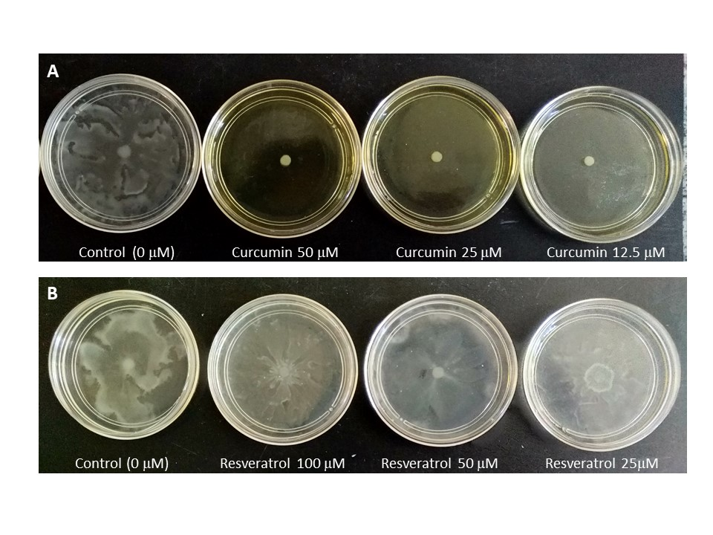
Figure 1S: Swarming motility of Serratia marcescens MG1 in semi-solid M8 agar 0.5% (w/v) with curcumin (A) and resveratrol (B).

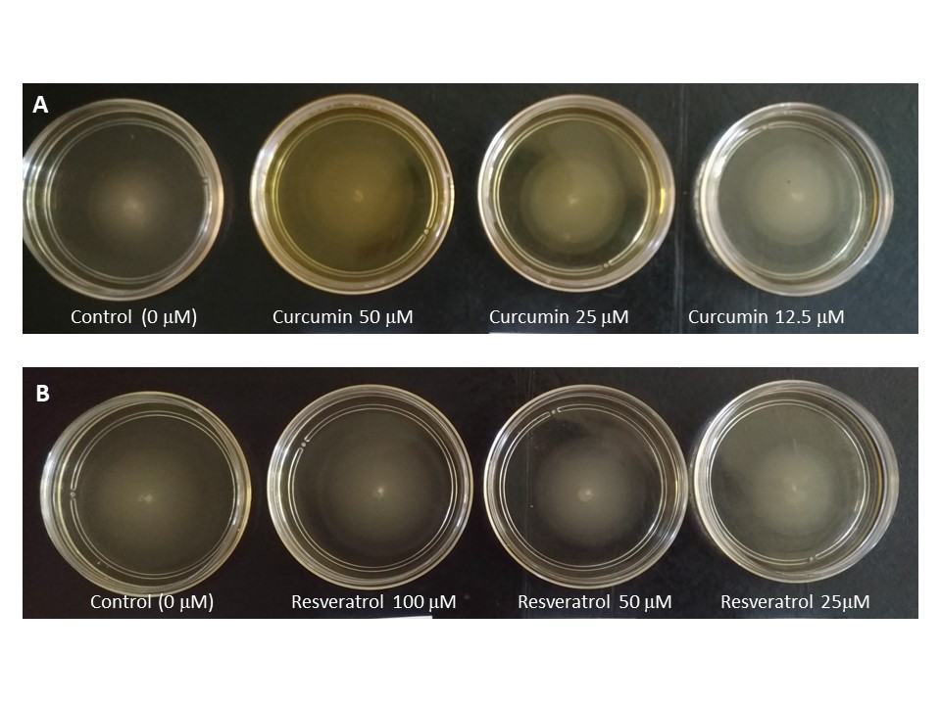
Figure 2S: Swimming motility of Serratia marcescens MG1 in semi-solid M8 agar 0.3% (w/v) with curcumin (A) and resveratrol (B).

Figure 3S: Growth curves for A. hydrophila IOC / FDA 110-36 during 24h incubation at 37 °C in different concentrations of curcumin (0, 3, 6 and 12 μM) and kanamycin antibiotic indicated by the letters: (A) 4 μg/ml; (B) 8 μg ml; (C) 16 μg/ml; (D) 32 μg/ml; (E) 64 μg/ ml; (F) 128 μg/ml; (G) 256 μg/ml; (H) 512 μg/ml. Control = bacterial growth in LB with DMSO at 1% which was used to dilute the compounds.
Figure 4S: Growth curves for S. Montevideo during 24h incubation at 37 °C in different concentrations of curcumin (0, 1.5, 3 and 6 μM) and kanamycin antibiotic indicated by the letters: (A) 4 μg/ml; (B) 8 μg ml; (C) 16 μg/ml; (D) 32 μg/ml; (E) 64 μg/ ml; (F) 128 μg/ml; (G) 256 μg/ml; (H) 512 μg/ml. Control = bacterial growth in LB with DMSO at 1% which was used to dilute the compounds.

Figure 5S: Growth curves for S. marcescens during 24h incubation at 30 °C in different concentrations of curcumin (50, 25 and 12 μM) and kanamycin antibiotic indicated by the letters: (A) 4 μg/ml; (B) 8 μg ml; (C) 16 μg/ml; (D) 32 μg/ml; (E) 64 μg/ ml; (F) 128 μg/ml; (G) 256 μg/ml; (H) 512 μg/ml. Control = bacterial growth in LB with DMSO at 1% which was used to dilute the compounds.

Figure 6S: Growth curves for A. hydrophila during 24h incubation at 37 °C in different concentrations of resveratrol (100, 50 and 25 μM) and kanamycin antibiotic indicated by the letters: (A) 4 μg/ml; (B) 8 μg ml; (C) 16 μg/ml; (D) 32 μg/ml; (E) 64 μg/ ml; (F) 128 μg/ml; (G) 256 μg/ml; (H) 512 μg/ml. Control = bacterial growth in LB with DMSO at 1% which was used to dilute the compounds.
Figure 7S: Growth curves for S. Montevideo during 24h incubation at 37 °C in different concentrations of resveratrol (100, 50 and 25 μM) and kanamycin antibiotic indicated by the letters: (A) 4 μg/ml; (B) 8 μg ml; (C) 16 μg/ml; (D) 32 μg/ml; (E) 64 μg/ ml; (F) 128 μg/ml; (G) 256 μg/ml; (H) 512 μg/ml. Control = bacterial growth in LB with DMSO at 1% which was used to dilute the compounds.
Figure 8S: Growth curves for S. marcescens during 24h incubation at 30 °C in different concentrations of resveratrol (100, 50 and 25 μM) and kanamycin antibiotic indicated by the letters: (A) 4 μg/ml; (B) 8 μg ml; (C) 16 μg/ml; (D) 32 μg/ml; (E) 64 μg/ ml; (F) 128 μg/ml; (G) 256 μg/ml; (H) 512 μg/ml. Control = bacterial growth in LB with DMSO at 1% which was used to dilute the compounds.

