Supplementary Material

## Supplementary Figures

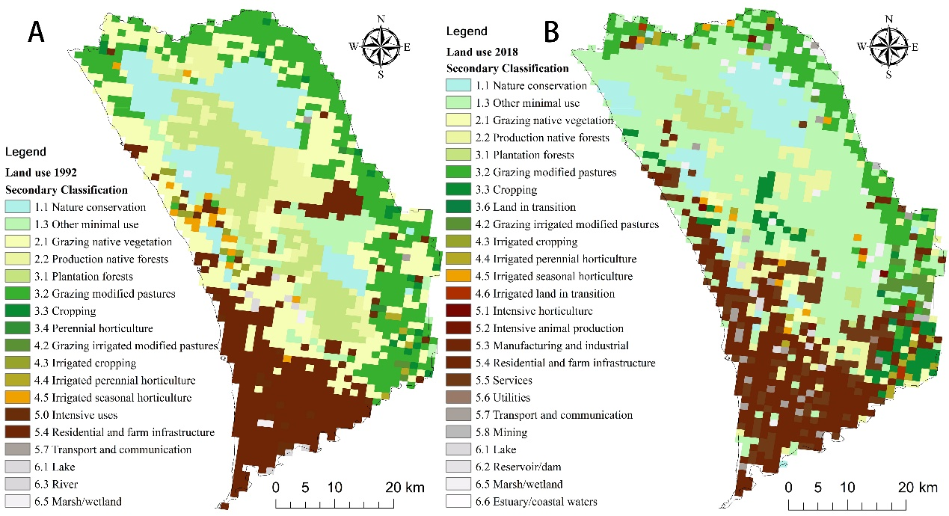

**Supplementary Figure 1.** Land use map of the Gnangara region in 1992 (A) and 2018 (B).

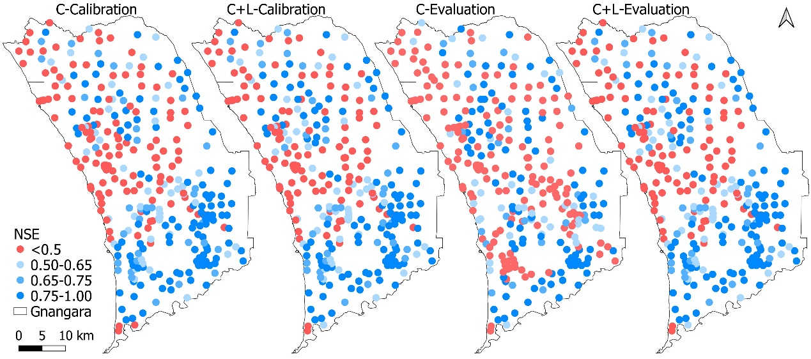

**Supplementary Figure 2.** Distribution of the model performance results of the climate-only (C) analysis, and climate and land cover (C+L) analysis during the calibration and evaluation period.

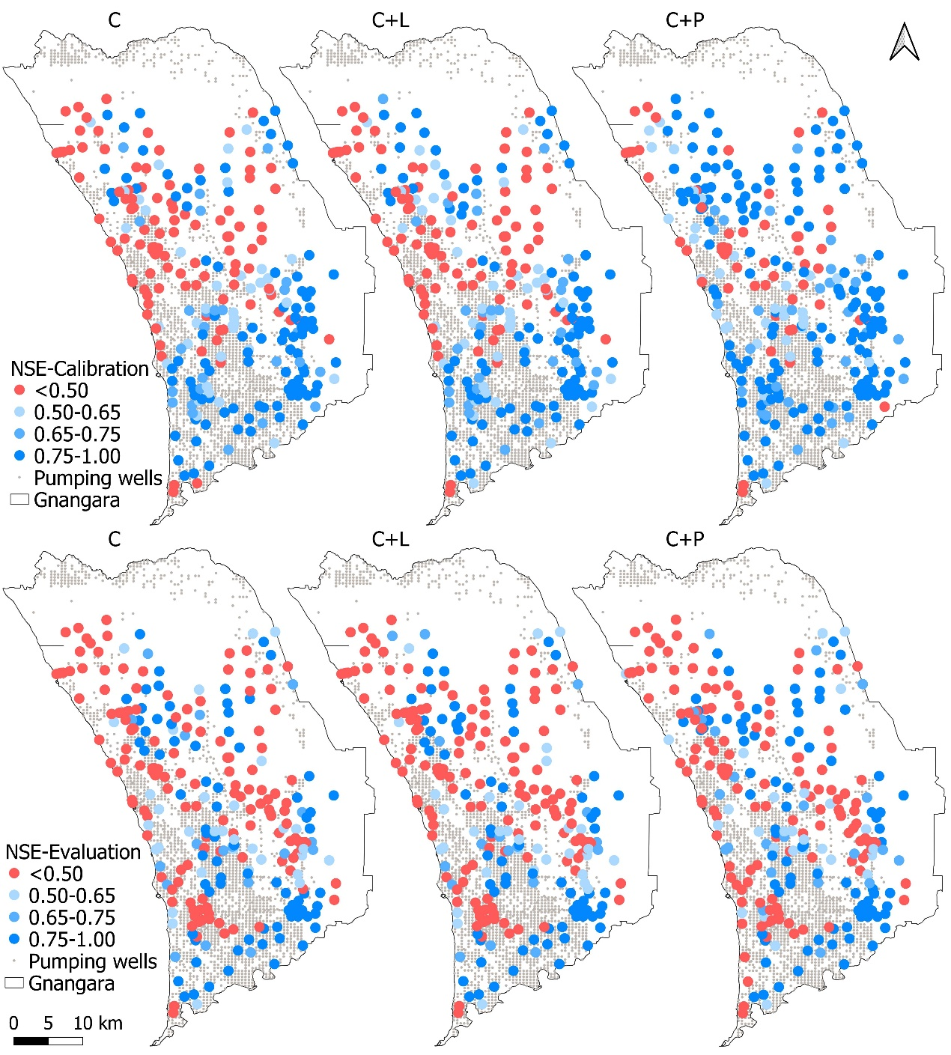

**Supplementary Figure 3.** NSE spatial distribution of the climate-only (C), climate and land cover (C+L), and climate and pumping (C+P) analyses.