Supplement

Supplementary Figure S1
Supplementary Figure 1. Proportion of different types of small RNAs

Supplementary Figure S2
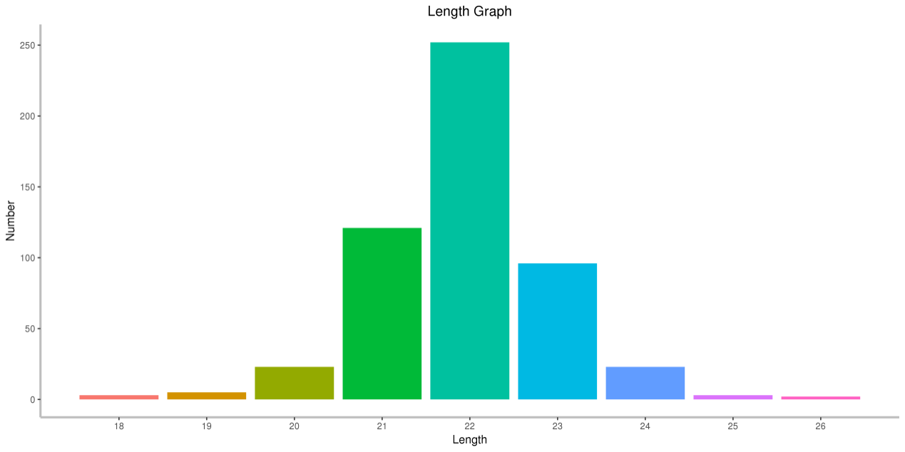
Supplementary Figure 2. The length distribution of miRNAs in all samples

Supplementary Figure S3
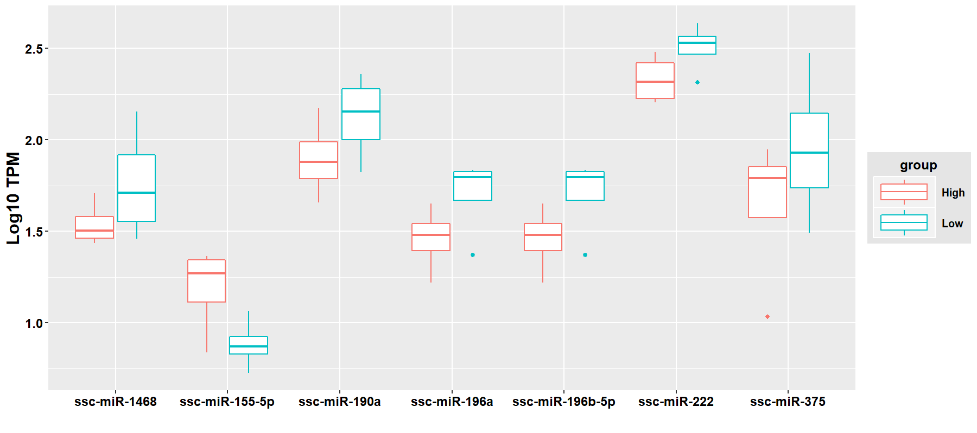
Supplementary Figure 3. Expression levels of differentially expressed miRNAs in High and Low groups based on RNA-seq data

Supplementary Figure S4
Supplementary Figure 4. Proportion of different types of lncRNAs

Supplementary Figure S5
Supplementary Figure 5. MiR-222 had no effect on the luciferase activity of wild-type LHX8 and NASP
a The predicted target-binding sites between miR-222 and NASP and between miR-222 and LHX8. b A luciferase activity assay showed that miR-222 does not target the NASP 3'UTR and LHX8 3'UTR.

