**Supporting Information**

**Metal-Free Heptazine Based Porous Polymeric Network as Highly Efficient Catalyst for CO2 Capture and Conversion**

Neha Sharma, Bharat Ugale, Sunil Kumar and Kamalakannan Kailasam*

Advanced Functional Nanomaterials, Energy and Environment Unit, Institute of Nano Science and Technology (INST), Knowledge city, Sector-81, Manauli, SAS Nagar, 140306 Mohali , Punjab, India.

Email: [kamal@inst.ac.in](mailto:kamal@inst.ac.in)

**Contents:**

1. **Material and monomer synthesis**
2. **Figure S1.** 13C NMR of Heptazine chloride.
3. **Figure** **S2**. PXRD plot of HMP-TAPA.
4. **Figure S3.** Nitrogen isotherm at 273 K (symbols) and Langmuir-Freundlich equation fit (line) for HMP-TAPA.
5. **Figure S4**. Carbon dioxide isotherm at 273 K (symbols) and Langmuir-Freundlich equation fits (line) for HMP-TAPA.
6. **Figure S5.** TPD Data of HMP-TAPA.
7. **Figure S6.** 1H NMR (CDCl3, 400 MHz) spectra for the cycloaddition reaction of propylene oxide with CO2 catalyzed by HMP-TAPA (Table 2, entry no. 1).
8. **Figure S7.** 1H NMR (CDCl3, 400 MHz) spectra for the cycloaddition reaction of epichlorohydrin with CO2 using HMP-TAPA as catalyst (Table 2, entry no. 3).
9. **Figure S8.** 1H NMR (CDCl3, 400 MHz) spectra for the cycloaddition reaction of butylene oxide with CO2 catalyzed by HMP-TAPA (Table 2, entry no. 4).
10. **Figure S9.** 1H NMR (CDCl3, 400 MHz) spectra for the cycloaddition reaction of 1,2-epoxyhexane with CO2 catalyzed by HMP-TAPA (Table 2, entry no. 5).
11. **Figure S10.** 1H NMR (CDCl3, 400 MHz) spectra for the cycloaddition reaction of 1,2-epoxydecane with CO2 catalyzed by HMP-TAPA (Table 2, entry no. 6).
12. **Figure S11.** 1H NMR (CDCl3, 400 MHz) spectra for the cycloaddition reaction of butyl glycidyl ether with CO2 catalyzed by HMP-TAPA (Table 2, entry no. 7).
13. **Figure S12.** 1H NMR (CDCl3, 400 MHz) spectra for the cycloaddition reaction of allyl glycidyl ether with CO2 catalyzed by HMP-TAPA (Table 2, entry no. 8).
14. **Figure S13.** 1H NMR (CDCl3, 400 MHz) spectra for the cycloaddition reaction of styrene oxide with CO2 catalyzed by HMP-TAPA (Table 2, entry no. 9).
15. **Figure S14.** 1H NMR (CDCl3, 400 MHz) spectra for the cycloaddition reaction of phenyl glycidyl ether with CO2 catalyzed by HMP-TAPA (Table 2, entry no. 10).
16. **Figure S15.** FT-IR spectra for HMP-TAPA and the recovered sample after five catalytic cycles.
17. **Table S1**. Comparison of the reaction conditions used for cycloaddition of CO2 by various triazine based framework by taking epichlorohydrin as model substrate.

**Material and monomer synthesis**

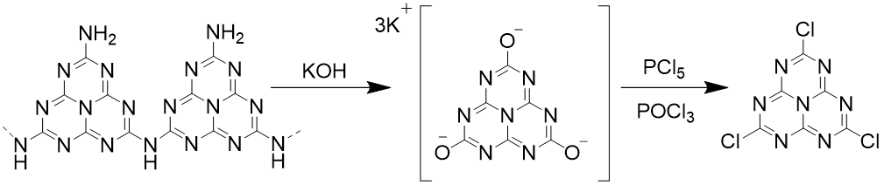

**Yield = ~ 40%**



**Figure S1.** 13C NMR of Heptazine chloride.



**Figure** **S2**. PXRD plot of **HMP-TAPA**.

**Analysis of gas adsorption isotherms**

**IAST Selectivity:**

Gas selectivity of mixture at different temperatures were calculated based on Ideal Adsorbed Solution Theory (IAST) proposed by Mayer and Praunitz. In order to calculate the sorption selectivity of CO2 and N2 mixture using HMP-TAPA the values used were fitted from the single component of CO2 and N2 adsorption based on Langmuir –Freundlich model and parameter used are given as follows

Y=B*x^(1/t)/[1+B*x^(1/t)]*Q

The predicted adsorption selectivity is defined

S=

Where,

xi and yi are the mole fraction of component in the adsorbed and bulk phase. The IAST calculation was carried out for binary reaction mixture containing 15% CO2 (y1) and 85% N2  (y2).



**Figure S3.** Nitrogen isotherm at 273 K (symbol) and Langmuir-Freundlich equation fit (line) for **HMP-TAPA**.



**Figure S4.** Carbon dioxide isotherm at 273 K (symbol) and Langmuir-Freundlich equation fit (line) for **HMP-TAPA**.



**Figure S5.** TPD Data of **HMP-TAPA**.



**Figure S6.** 1H NMR (CDCl3, 400 MHz) spectra for the cycloaddition reaction of propylene oxide with CO2 catalyzed by **HMP-TAPA** (Table 2, entry no. 1).



**Figure S7.** 1H NMR (CDCl3, 400 MHz) spectra for the cycloaddition reaction of epichlorohydrin with CO2 using **HMP-TAPA** as catalyst (Table S4, entry no. 3).



**Figure S8.** 1H NMR (CDCl3, 400 MHz) spectra for the cycloaddition reaction of butylene oxide with CO2 catalyzed by **HMP-TAPA** (Table 2, entry no. 4).



**Figure S9.** 1H NMR (CDCl3, 400 MHz) spectra for the cycloaddition reaction of 1,2-epoxyhexane with CO2 catalyzed by **HMP-TAPA** (Table 2, entry no. 5).



**Figure S10.** 1H NMR (CDCl3, 400 MHz) spectra for the cycloaddition reaction of 1,2-epoxydecane with CO2 catalyzed by **HMP-TAPA** (Table 2, entry no. 6).



**Figure S11.** 1H NMR (CDCl3, 400 MHz) spectra for the cycloaddition reaction of butyl glycidyl ether with CO2 catalyzed by **HMP-TAPA** (Table 2, entry no. 7).



**Figure S12.** 1H NMR (CDCl3, 400 MHz) spectra for the cycloaddition reaction of allyl glycidyl ether with CO2 catalyzed by **HMP-TAPA** (Table 2, entry no. 8).



**Figure S13.** 1H NMR (CDCl3, 400 MHz) spectra for the cycloaddition reaction of styrene oxide with CO2 catalyzed by **HMP-TAPA** (Table 2, entry no. 9).



**Figure S14.** 1H NMR (CDCl3, 400 MHz) spectra for the cycloaddition reaction of phenyl glycidyl ether with CO2 catalyzed by **HMP-TAPA** (Table 2, entry no. 10).

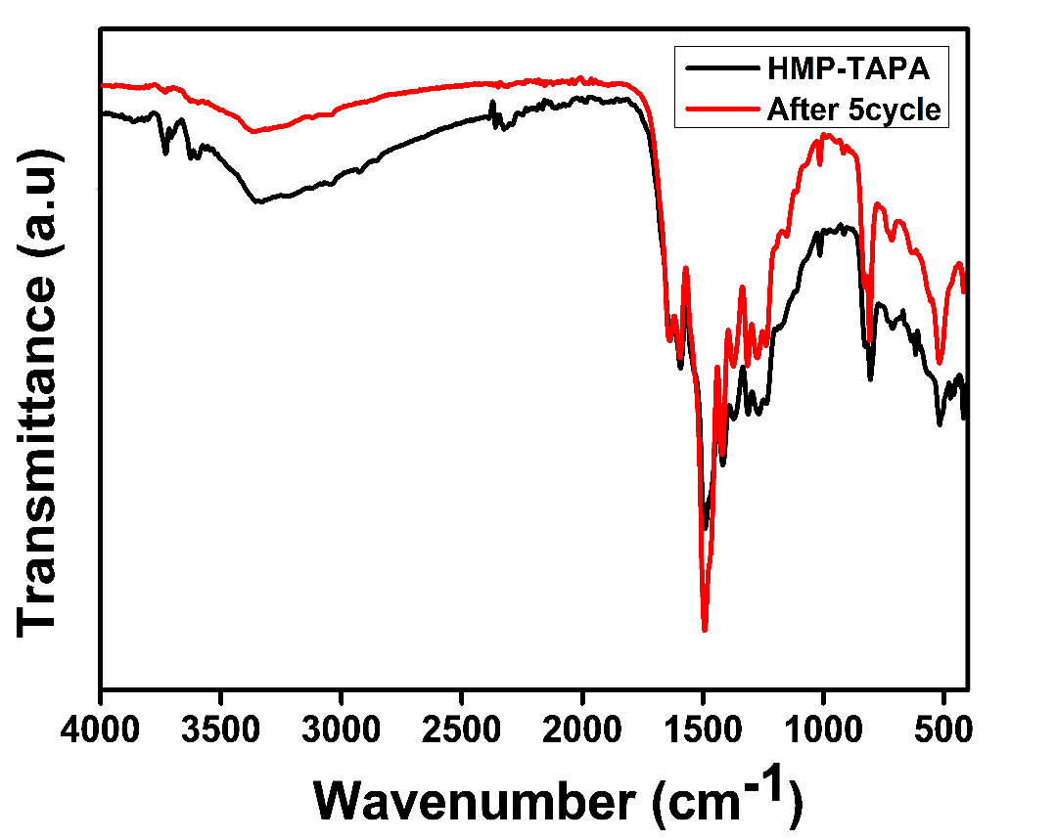

**Figure S15.** FT-IR spectra for **HMP-TAPA** and the recovered sample after five catalytic cycles.

**Table S1**. Comparison of the reaction conditions used for cycloaddition of CO2 by various triazine based framework taking epichlorohydrin as model substrate.

|  |  |  |  |  |  |  |  |
| --- | --- | --- | --- | --- | --- | --- | --- |
| **Sr. No.** | **Catalyst/Triazine Frameworks** | **Catalyst Loading [mg]** | **Pressure [MPa]** | **Time**  **[h]** | **Temp.**  **[o C]** | **Con.**  **(%)** | **Ref.** |
| 1. | CTF-1 | 55 | 0.69 | 4 | 130 | 77 | **1** |
| 2. | CTF-P-HAS | 55.5 | 0.69 | 4 | 130 | 95 | **1** |
| 3. | CTF-0 | 55.5 | 0.69 | 4 | 130 | 93 | **2** |
| 4. | 2,5-DCP-CTF | 55.5 | 0.69 | 4 | 130 | 95 | **3** |
| 5. | CTF-CSU-19 | 10 | 0.1 | 48 | 25 | 96 | **4** |
| 6. | cCTF-500 | 37 | 1.0 | 12 | 90 | 95 | **5** |
| 7. | CCTFs-350 | 15 | 0.1 | 24 | 120 | 95 | **6** |
| 8. | Co-PCCTFs | 15 | 0.1 | 24 | 120 | 94 | **7** |
| 9. | NHC-CTFs | 23 | 0.5 | 6 | 100 | 97 | **8** |
| 10. | CYA-ANIS+ TBAI | 100 | 0.1 | 12 | 105 | 80 | **9** |
| 11. | HMP-TAPA | 10 | 0.6 | 6 | 80 | >99 | **Present Work** |

**References:**

1. J. Roeser, K. Kailasam and A. Thomas, *ChemSusChem*, 2012, **5**, 1793-1799.

2. P. Katekomol, J. Roeser, M. Bojdys, J. Weber and A. Thomas, *Chem. Mater.*, 2013, **25**, 1542-1548.

3. Y.-M. Li, L. Yang, L. Sun, L. Ma, W.-Q. Deng and Z. Li,  *J. Mater. Chem. A*, 2019, **7**, 26071-26076.

4. W. Yu, S. Gu, Y. Fu, S. Xiong, C. Pan, Y. Liu and G. Yu, *J. Catal.*, 2018, **362**, 1-9.

5. O. Buyukcakir, S. H. Je, S. N. Talapaneni, D. Kim and A. Coskun, *ACS Appl. Mater. Interfaces*, 2017, **9**, 7209-7216.

6. T.-T. Liu, R. Xu, J.-D. Yi, J. Liang, X.-S. Wang, P.-C. Shi, Y.-B. Huang and R. Cao, *ChemCatChem*, 2018, **10**, 2036-2040.

7. Q.-J. Wu, M.-J. Mao, J.-X. Chen, Y.-B. Huang and R. Cao, *Catal. Sci. Technol.*, 2020, **10**, 8026-8033.

8. C. Yue, W. Wang and F. Li, *ChemSusChem*, 2020, **13**, 5996-6004.

9. T. Biswas, A. Halder, K. S. Paliwal, A. Mitra, G. Tudu, R. Banerjee and V. Mahalingam, *Chem. Asian J.*, 2020, **15**, 1683-1687.