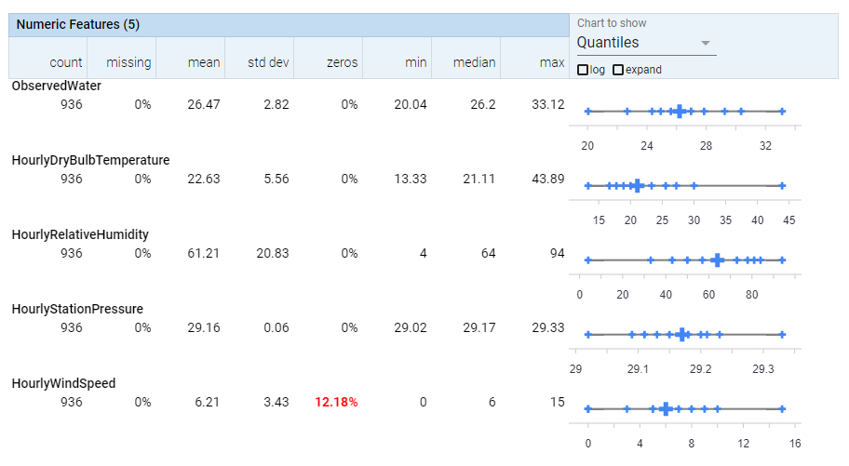

Figure S1. Variation of the dependent and independent parameters as well as their statistical characteristics extracted from Facets visualization tool.

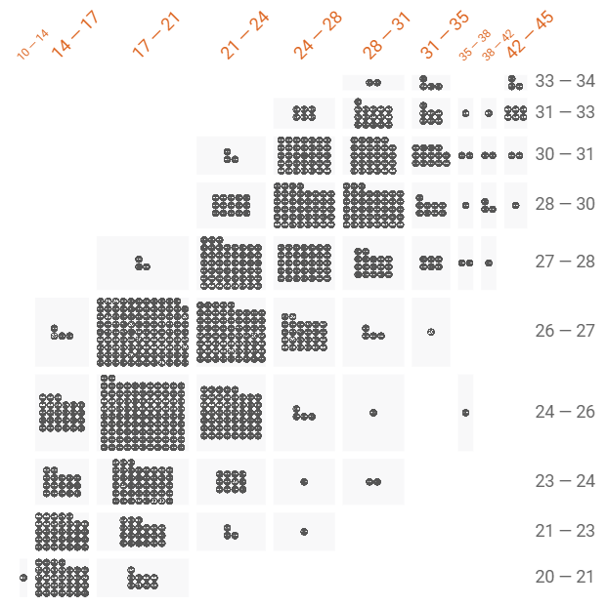

Figure S2. Binning technique for visualizing the distribution of the air temperature against water temperature using the Facets tools. We selected 10 bins for each feature.



Figure S3. Pairwise visualization of the selected independent features as well as the dependent variable (water temperature) of training dataset using the Seaborn package in Python 3.