**Supplementary Material**

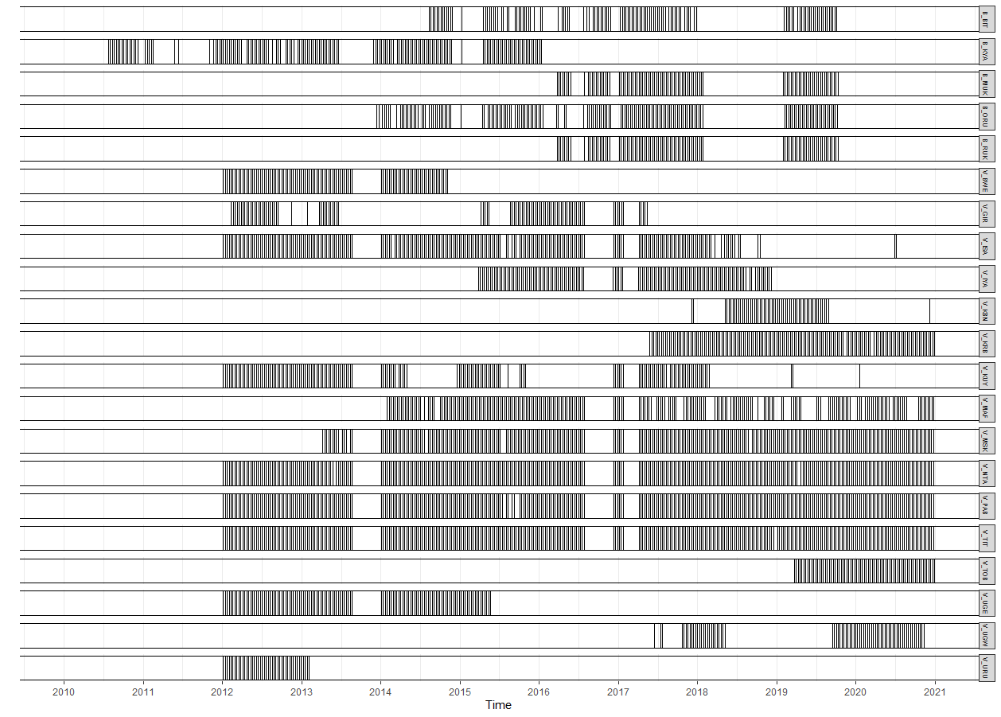

Figure S1. Data availability for the 21 study groups in the two mountain gorilla populations between 2010 and 2020. Bwindi and Virunga groups are demarcated with a “B” and “V”, respectively. Each vertical line corresponds to a 9-day data point, consisting of between 1 and 9 group observation days. The study incorporated 25, 813 group observation days and 77, 674 group observation hours.

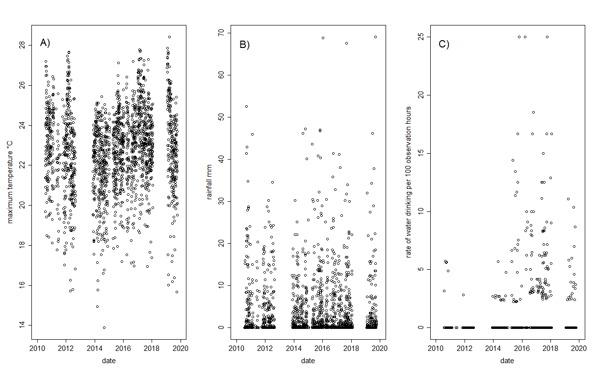

Figure S2. Maximum temperature (A), rainfall (B) and the rate of water drinking per 100 observation hours (C) plotted over time in the Bwindi population. In figures A and B, each circle represents a day (*N* = 2034) whilst in figure C it represents a data point in the model (9 day periods; *N* = 586).

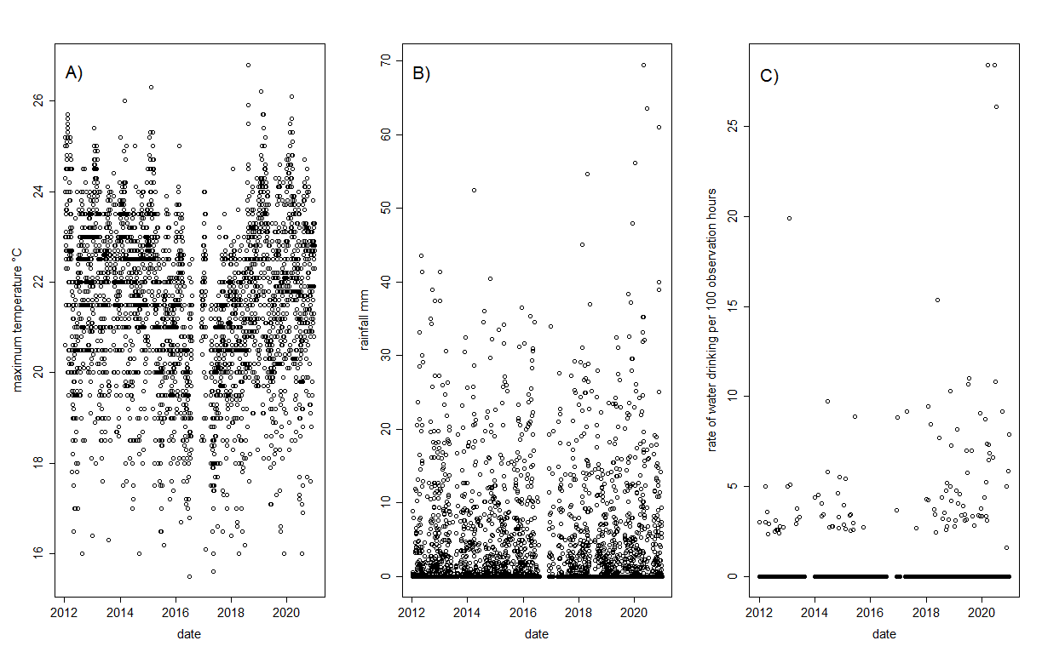

Figure S3. Maximum temperature (A), rainfall (B) and the rate of water drinking per 100 observation hours (C) plotted over time in the Virunga population. In figures A and B, each circle represents a day (*N* = 3065) whilst in figure C it represents a data point in the model (9 day periods; *N* = 2690). In figures A and B data was prioritized from the Busogo weather station (the closest weather station to the gorillas).

Water content of foods

The methods to obtain the water content of gorilla foods are detailed in Ganas et al. (2008) and Grueter et al. (2016). Briefly, samples were collected from the same plant eaten by the gorillas or from several adjacent plants of the same species and processed in a similar way to the feeding behaviour of the gorillas, with only the ingested sections of each food item being analysed. All samples were weighed immediately after collection to determine their total wet mass and then dried until there was no further loss in weight.

Table S1. The water content and dietary importance of key gorilla foods in the two mountain gorilla populations. Key foods were defined as those contributing to at least 1% of the total energy consumed for groups in each population.

|  |  |  |  |
| --- | --- | --- | --- |
| Species/Population | Part | Water content % | Dietary importance % |
| **Bwindi** |  |  |  |
| *Carduus sp* | Leaf | 89.4 | 2.1 |
| *Basella alba* | Leaf | 89.2 | 3.1 |
| *Momordica foetida* | Leaf | 82.6 | 10.8 |
| *Urera hypselodendron* | Leaf | 80.9 | 8.7 |
| *Chrysophyllum sp* | Fruit | 79.4 | 14.1 |
| *Urera hypselodendron* | Bark | 79.0 | 15.1 |
| *Ipomoea involucrate* | Leaf | 78.5 | 12.9 |
| *Maesa lanceolata* | Fruit | 76.5 | 3.0 |
| *Triumfetta sp* | Leaf | 75.8 | 15.1 |
| *Mimulopsis solmsii* | Leaf | 74.0 | 6.1 |
| *Ipomoea involucrate* | Bark | 71.8 | 1.4 |
| *Myrianthus holstii* | Leaf | 59.3 | 3.8 |
| *Rubus sp* | Leaf | 58.0 | 3.8 |
|  |  |  |  |
| **Virunga** |  |  |  |
| *Carduus nyassanus* | Stem | 95.4 | 29.6 |
| *Peucedanum linderi* | Stem | 89.9 | 3.1 |
| *Lobelia stuhlmannii* | Pith | 89.4 | 2.9 |
| *Carduus nyassanus* | Leaf | 88.6 | 9.1 |
| *Lobelia wollastonii* | Pith | 89.2 | 2.9 |
| *Yushania alpina* | Shoots | 89.1 | 4.3 |
| *Galium sp.* | Leaf | 87.9 | 29.6 |
| *Carduus nyassanus* | Root | 85.7 | 2.1 |
| *Rubus runssorensis* | Fruit | 79.9 | 3.4 |
| *Eucalyptus sp.* | Bark | 75.4 | 1.8 |
| *Laportea alatipes* | Leaf | 74.9 | 2.5 |
| *Droguetia iners* | Leaf | 68.4 | 3.4 |
| *Yushania alpina* | Leaf | 57.2 | 1.9 |
| *Rubus runssorensis* | Leaf | 51.9 | 3.4 |

The water content of gorilla foods was taken from Grueter et al. (2016) and Ganas et al. (2008; unpublished data). Dietary importance was measured as the proportion of energy each food item contributed to the total amount of energy ingested for each population (Bwindi *N* groups = 1; Virunga *N* groups = 3; averaged across groups from the same population; and adjusted to total 100%) and taken from Wright et al. (2015; and unpublished data). Each food item was weighted by its dietary importance.

**References**

Ganas, J., Ortmann, S., and Robbins, M. M. (2008). Food preferences of wild mountain gorillas. *American Journal of Primatology* 70, 927–938.

Grueter, C. C., Robbins, A. M., Abavandimwe, D., Vecellio, V., Ndagijimana, F., Ortmann, S., et al. (2016). Causes, mechanisms, and consequences of contest competition among female mountain gorillas in Rwanda. *Behav Ecol* 27, 766–776. doi:10.1093/beheco/arv212.

Wright, E., Grueter, C. C., Seiler, N., Abavandimwe, D., Stoinski, T. S., Ortmann, S., et al. (2015). Energetic responses to variation in food availability in the two mountain gorilla populations (*Gorilla beringei beringei*). *Am. J. Phys. Anthropol.* 158, 487–500. doi:10.1002/ajpa.22808.