Supplementary material

Primers for qRT-PCR:

fgf8 | dir -5’ -CTGCGTCTTCTCGGAAATTGTC, rev - 5’-TTTGGCAACCTCTTCATGAAGT
msx1b | dir -5’ -TCTCCTATGGGACTTTACACA, rev - 5’- AATCACTCAAGTCTTCTTTC
fgf20 | dir -5’ -ATCACAGCCGATTCGGTATCC, rev - 5’-CTCAAACTGTTCCCGAAAAATGC
ef-alfa | dir -5’ - AAGAACGTGTCAGTCAAGGACAT, rev - 5’ - CGTAACCCTGAGAGATCTGACCA
odc | dir -5’ - CTCCACCTTCAATGGCTTCCAG, rev - 5’ - AGTGGGATGGCACGTTTCCAG
cyclin d1 | dir-5’- AGCAGCAACACAACGCTTC, rev - 5’ - GATCCGTTTGATGTCAGATG
cdk4 | dir -5’ - CGTATTTCCGCCTCCGAT, rev - 5’ - ATGCCGTTTCATTTCACTT
cdca9 | dir -5’ - CTGACTTTGACTTATGGAATC, rev - 5’ - ATTAGTACACAAAGCCATTA
ag1 | dir 5′-TGCTGCCAAGTCTGAGCCTGC, rev- 5′ - TCCTGAGCCAGTTTCTGTGCCA
agr2 | dir 5′-TGGCCAGTATGTTCCCAAGGTTGT, rev 5′ - CATCACTTTAGCATACACCTCCGC

Primers for the odc, ef-1alpha, fgf20a, ag1, agr2, fgf8, msx1b were the same as in (Ivanova et al. 2018; Ivanova et al. 2013).
PCR efficiency (PE) for cyclin d1, cdk4, cdca9 was calculated as described previously and were respectively the following: 1,903, 1,875, 1,732.
Primers for cDNA synthesizing:

cyclin d1 forward | 5’ - CGCAGGATCCCACAGACAACATGGAGCTT
cyclin d1 reverse | 5’ - TGTGATCGAATTCATGTCAGATGTTGACGT

Morpholino oligonucleotides (MO)
control vivo-MO | 5’ GCAAGATTCCTCATTCAAAAGTCTC
agr2 vivo-MO | 5’ CAGTGCTTTACTCCAGAGGCAGGAG
ag1 vivo-MO | 5’ TCTGTGGATGTCTTGCTCTTCCAGG
ag1 MO | 5’ TCTGTGGATGTCTTGCTCTTCCAGG
agr2 MO | 5’ CAGTGCTTTACTCCAGAGGCAGGAG
control MO | 5’ TTAACTGTTTAATGTTGAATGAGAAC
ag1 photo-MO | 5’ GGAAGAGCAPGACATCCACAG
agr2 photo-MO | 5’ GCCTCTGPAGTAAAGCACTG

Morpholino Oligonucleotides (MO) sequences and efficiency/specificity tests
See scheme of MO sites on ag1 and agr2 mRNAs on Figure S1A.
The evaluation the effectiveness and specificity of ag1 and agr2 MO is published in our previous article (Tereshina et al. 2014). Here, we tested the efficiency and specificity of vivo- and photo-MO. For this, we injected Xenopus two-cell embryos with the following solutions: ag1-TagRFP mRNA or agr2-TagRFP (which were obtained earlier (Tereshina et al. 2014)) (100pg/blastomere ) alone or in a mixture with agr-specific or control vivo-MO/(photo-MO+MO). Embryos injected with photo-MO were illuminated for 30 minutes by 365 nm light immediately after injection and incubated at daylight or as control were injected under 560mn and kept in dark. At the blastula-early gastrula stage, the injected embryos were collected and analyzed for the presence of Ag1-tagRFP and Agr2-tagRFP proteins by Western blotting with anti-tRFP antibody (Evrogen, cat.#AB233) as described previously. Tubulin was detected by monoclonal anti-tubulin antibody, obtained from the Institute of Protein RAS, and was used as a loading control. Strong suppression of ag1-tagRFP and agr2-tagRFP mRNAs translation was observed in embryos microinjected with these mRNAs and the respective ag1 vivo-MO and agr2 vivo-MO (Figure S1B and C). In contrast, co-injection of control vivo-MO did not show any Ag1-tagRFP or Agr2-tagRFP translation inhibition. Similar results were observed for cross-injection of ag1-tagRFP RNA with agr2 vivo-MO or agr2-tagRFP RNA + ag1 vivo-MO. These results confirm the efficiency and specificity of ag1 vivo-MO and agr2 vivo-MO. The testing of photo-MO efficiency showed that co-injection of ag1-tagRFP RNA with ag1(photo-MO+MO) does not disturb translation until illumination with 365nm light, which leads to ag1 photo-MO disruption and ag1 MO release and action preventing mRNA translation (Figure S1D).
Recombinant proteins
For the production of the Xenopus laevis recombinant Ag1 and Agr2 proteins, we used the E.coli expression system. The Agr2.L expressing construct was generated previously on the base of pQE80, in which the cassette encoding 6His, the site for TEV proteinase and agr2 cDNA reading frame, was inserted (Ivanova et al. 2018). The ag1.s cDNA coding frame was sub-cloned into this pQE80-6His-TEV-ag1 construct instead of agr2. The overnight cultures of DH5 E. coli strain transformed with these plasmids were prepared. To induce protein production, IPTG (isopropyl-β-D-1-thiogalactopyranoside) was added to the medium at a final concentration of 1 mM and incubated for 4 h. After incubation, the mixture was centrifuged for 10 min at 1400 g, the supernatant was discarded, and 15 ml of the lysis buffer (50 mM NaH2PO4, 300 mM NaCl, 1 μM PMSF, 1 mg/mL lysozyme, pH 8.0) was added to 0.7-1g of the pellet. The recombinant protein purification was carried out on ice according to the recommendations for the use of the TALON® Metal Affinity Resins from the User Manual (Clontech Laboratories, Inc. A Takara Bio Company). The resulting fraction was dialyzed against 2 L 1× PBS for 12 h. To remove 6His-tag, we added 10 units of recombinant 6 His TEV proteinase (GeneScript) (typical ratio 1 V TEV: 100 V solution) to the dialyzed protein and incubated overnight at 4ºC. After incubation, the removal of proteinase and uncleaved protein was performed by incubation with 50 μL of TALON resin. As a result, from 1g of the E. coli pellet, we usually obtained 0.25-0.3 mg of purified Ag1 protein and 0.5-0.6 mg of Agr2 protein. The purity of the obtained proteins was checked using SDS-PAGE analysis and the efficiency of His-tag removal by immunoblotting with monoclonal anti-6HIS AP-conjugated antibodies. Analysis of the stability of the Agr2 and Ag1 proteins was carried out by SDS PAAG and SuperBlue Coomassie staining. Samples were prepared with protein precipitation from 1 ml of the incubation medium as described in (Martynova et al., 2021) (Figure S3).
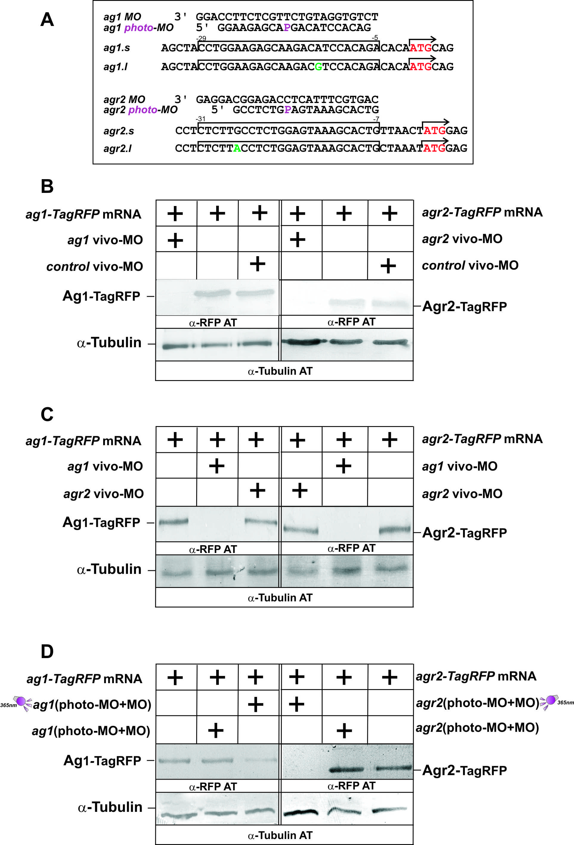

Figure S1. Vivo- and photo-morpholino oligonucleotides (MO) efficiency tests. (A) The MO (conventional and vivo-MO) and complementary photo-MO sequences and scheme of their sites on ag1 and agr2 mRNAs. (B)Results of Western blotting with rabbit anti-tRFP (Evrogen) and anti-rabbit alkaline phosphatase antibody (Sigma-Aldrich) and monoclonal anti-tubulin antibody (Sigma-Aldrich) demonstrate specific and effective inhibition of Ag1-tagRFP/Agr2-tagRFP synthesis by ag1/agr2 vivo-MO, but not by control vivo-MO. (C) Results of Western blotting demonstrate specific and effective inhibition of Ag1-tagRFP synthesis by ag1 vivo-MO, but not by agr2 vivo-MO and vice versa. (D) Results of Western blotting demonstrate specific and effective inhibition of Ag1-tagRFP or Agr2-tagRFP synthesis by ag1 (photo-MO+MO)or agr2 (photoMO+MO) only after illumination at 365 nm (violet lamp).

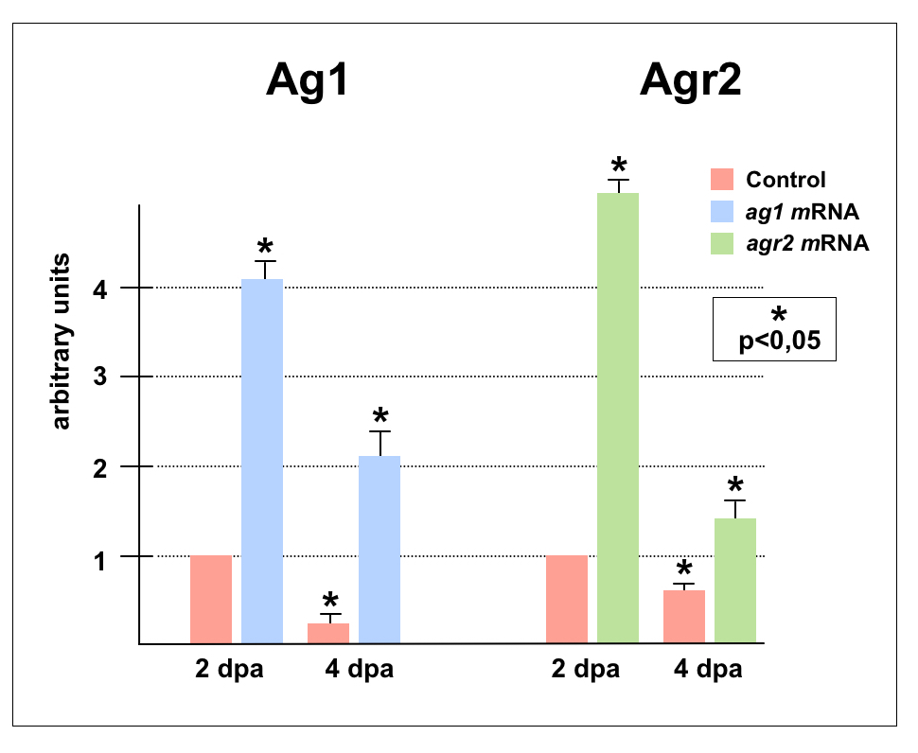
Figure S2. Tail tips of tadpoles developed from embryos injected with ag1 and agr2 mRNAs contain high level of these mRNAs in the refractory period.
The qRT-PCR analysis of ag1 and agr2 expression in the tips of tails amputated in the refractory period demonstrates much higher level of ag1 and agr2 mRNAs in the tips of tadpoles developed from embryos injected with these synthetic mRNA comparing to the tips of control tadpoles. Statistical significance was determined by t-test for independent samples, p<0.05 (asterisk). Error bars indicate SD.

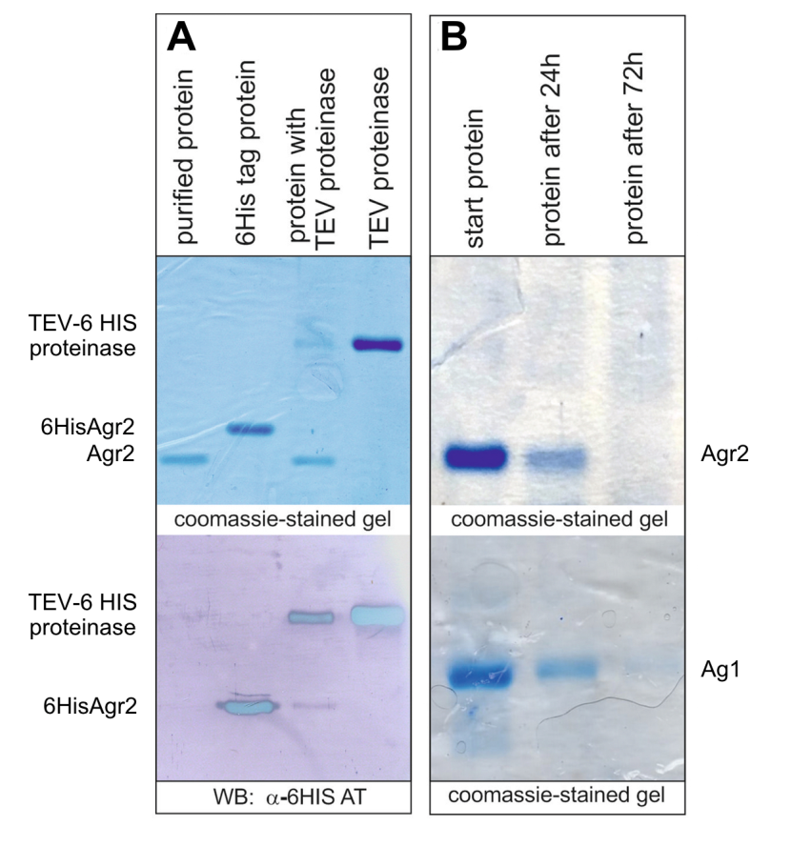
Figure S3. Analysis of recombinant proteins. (A) The main stages of protein purification are shown in the example Agr2. (B) Recombinant Ag1 precipitated from 1ml of 0.1XMMR after incubation with tadpoles for 0, 24 and 72 hours, respectively (Martynova et al., 2021).
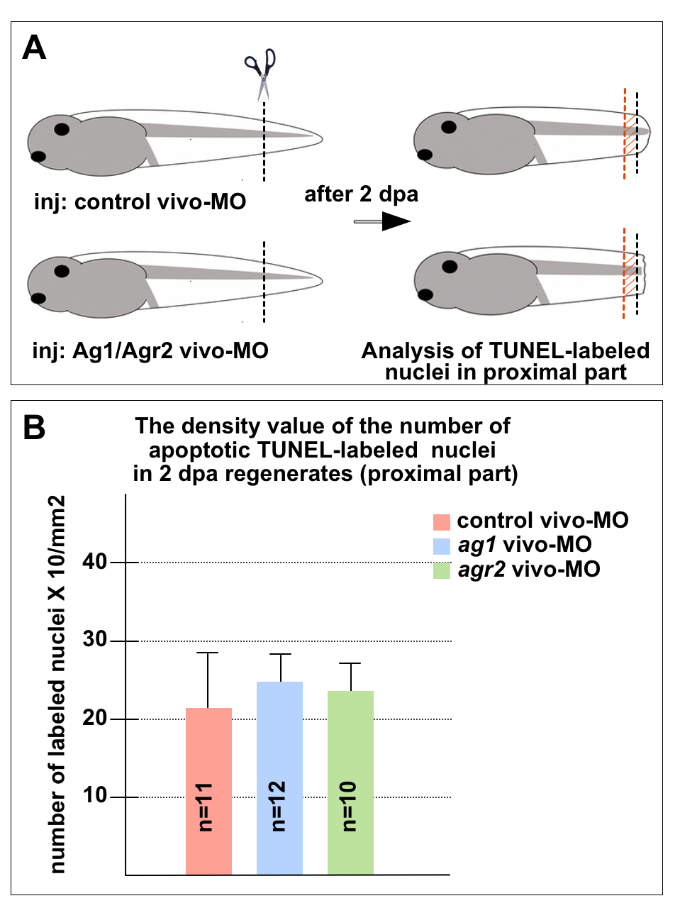
Figure S4. The apoptotic cell density in the area proximal to amputation level does not change in response to ag1 and agr2 downregulation. (A) scheme of the experiment: tadpoles tail stumps at st.40-41 were injected by control vivo-MO, ag1-vivo MO or agr2-vivo-MO. After 2 days, the tadpoles' tails were stained for the presence of apoptotic cells using the TUNNEL analysis, and then in the area located proximal to the level of amputation (between the black and red lines, the distance between which was approximately equal to half the tail width), the density of apoptotic cells was determined per 1 mm². (B) No statistically significant difference in the apoptotic cell density was revealed between control tails and those injected with ag1-vivo MO or agr2-vivo-MO. Error bars indicate SD.

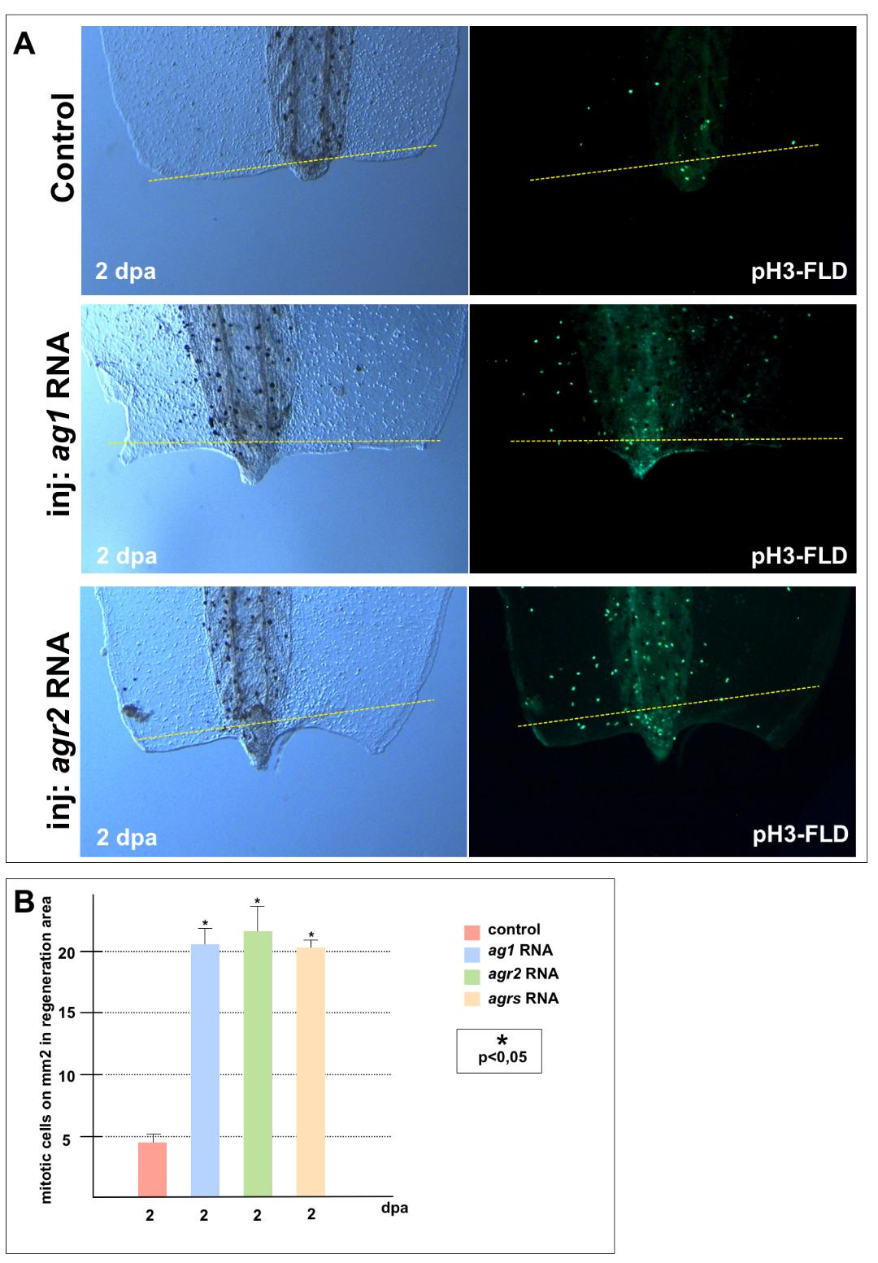
Figure S5. Overexpression of ag1/agr2 is sufficient to reactivate cell prolifertion and regeneration in the refractory period when they are naturally blocked. (A) The transmitted light and fluorescent images of tail tips of tadpoles injected with solution of RDA amputated in the refractory period after immunostaining with anti-pH3-fluorescein demonstrate very low mitotic activity in the tail tip area at 2dpa. In contrast, tadpoles injected with the solution of ag1 RNA or agr2 RNA after amputation in the refractory period demonstrate much higher proliferative activity in distal area of the tail. (B) Quantification of number of mitotic cells per 1 mm² of tail regenerating area. Data of five independent experiments (10 tadpoles of each injection type were used in 1 experiment) were used for statistical analysis; statistical significance was determined using t-test for independent samples, p<0.05 (asterisk). Error bars indicate SD.

References

Ivanova, A. S., Martynova N. Y., Komarov P. A., Orlov E. E., Ermakova G. V., Zaraisky A. G., and Tereshina M. B. (2018). Obtaining of Agr2 Specific Antibodies and Determination of the Agr2 Protein Distribution Pattern during Early Embryonic Development and Tadpole Regeneration in Xenopus Laevis. Russian Journal of Developmental Biology 49 (6): 393–97. doi: 10.1134/s1062360418060036.
Ivanova A. S., Korotkova D. D., Ermakova G.V., Martynova N. Y., Zaraisky A. G., and Tereshina M. B. (2018). Ras-Dva Small GTPases Lost during Evolution of Amniotes Regulate Regeneration in Anamniotes. Scientific Reports 8(1): 13035. doi: 10.1038/s41598-018-30811-0.
Ivanova A. S., Tereshina M. B., Ermakova G. V., Belousov V. V., and Zaraisky A. G. (2013). Agr Genes, Missing in Amniotes, Are Involved in the Body Appendages Regeneration in Frog Tadpoles. Scientific Reports 3: 1279. doi: 10.1038/srep01279.
Martynova N. Y., Parshina E. A., and Zaraisky A. G. (2021). Protocol for Separation of the Nuclear and the Cytoplasmic Fractions of Xenopus Laevis Embryonic Cells for Studying Protein Shuttling. STAR Protocols 2 (2): 100449. doi: 10.1016/j.xpro.2021.100449.
Tereshina M. B., Ermakova G. V., Ivanova A. S., and Zaraisky A. G. (2014). Ras-Dva1 Small GTPase Regulates Telencephalon Development in Xenopus Laevis Embryos by Controlling Fgf8 and Agr Signaling at the Anterior Border of the Neural Plate. Biology Open, 3(3): 192-203. doi: 10.1242/bio.20147401.

