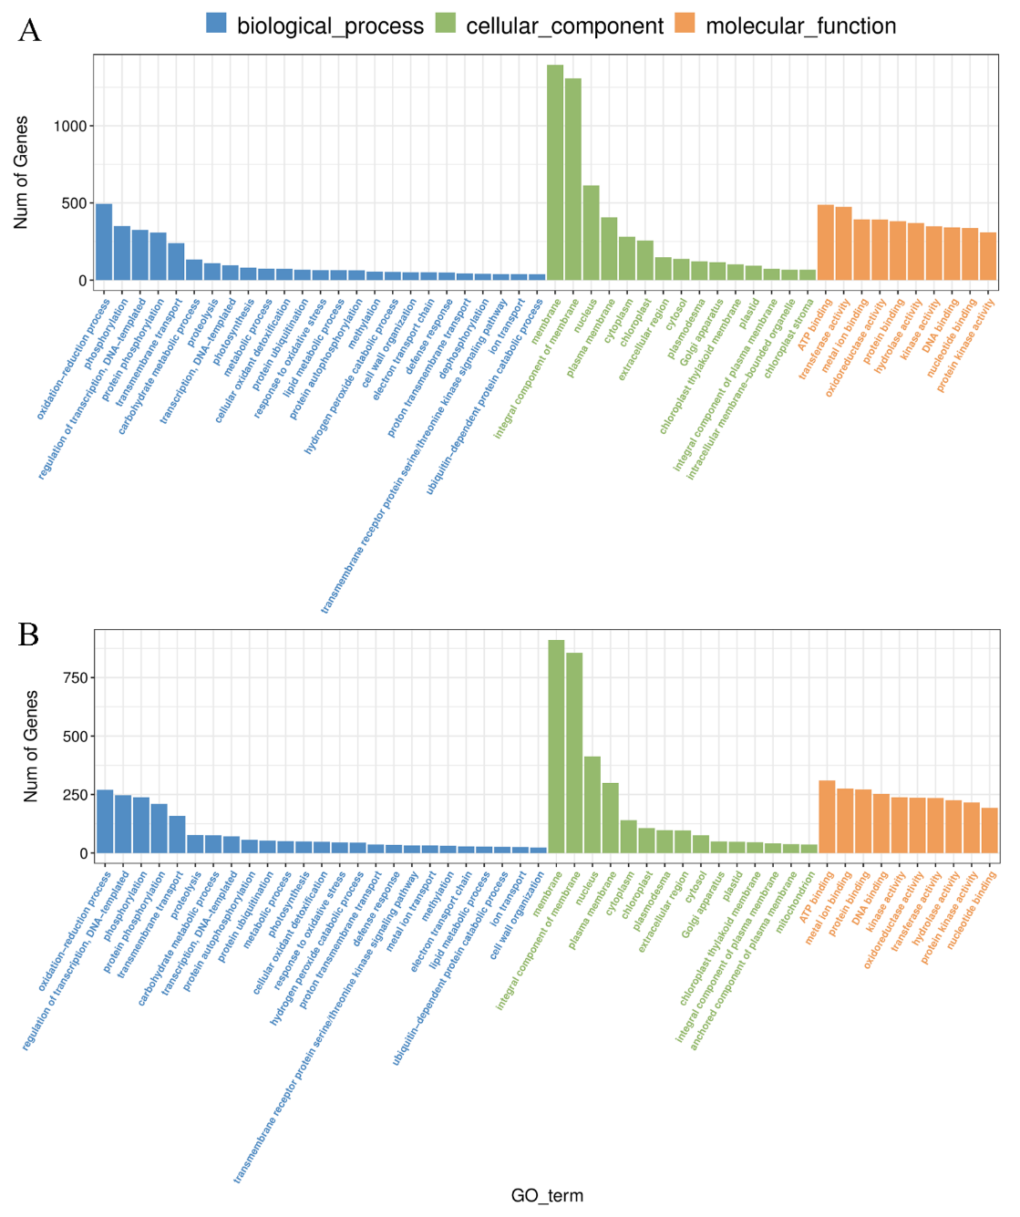

**Figure S1.** GO annotations of DEGs in Qi319 and Zi330 identified under deep sowing treatments. A: QDS *vs.* QCK, B: ZDS *vs*. ZCK.

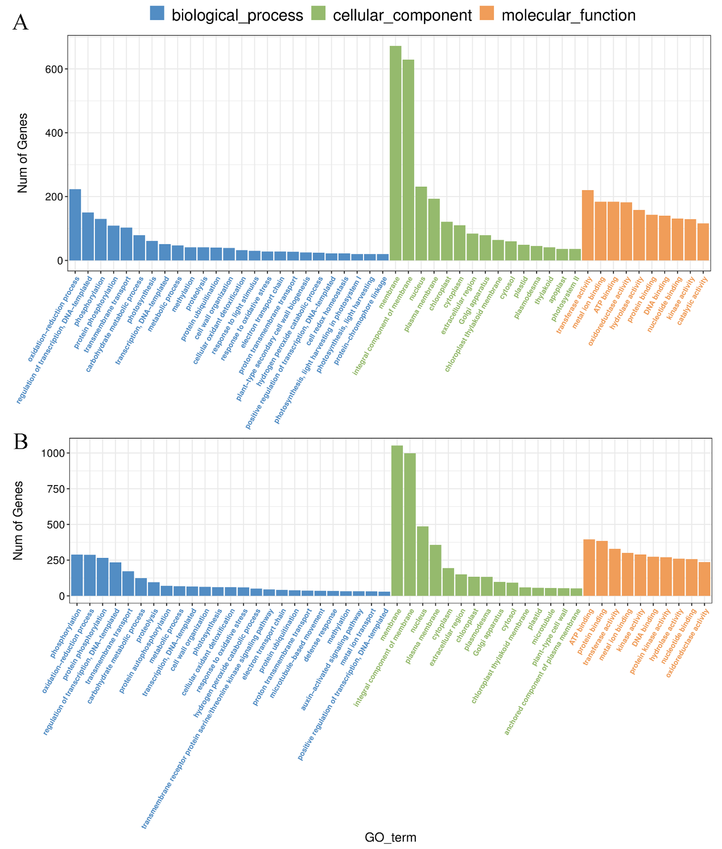

**Figure S2.** GO annotations of DEGs in Qi319 and Zi330 identified after adding exogenous GA under normal sowing depth and deep sowing stress. A: QDSGA *vs.* QCKGA, B: ZDSGA *vs.* ZCKGA.

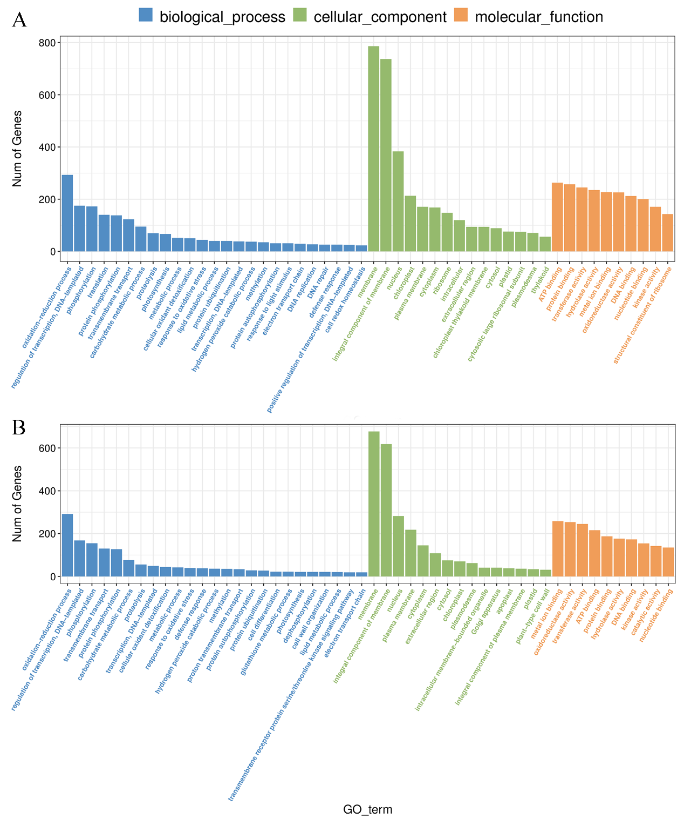

**Figure S3.** GO annotations of DEGs in Qi319 and Zi330 identified after adding exogenous BR under normal sowing depth and deep sowing stress. A: QDSBR *vs.* QCKBR, B: ZDSBR *vs.* ZCKBR.

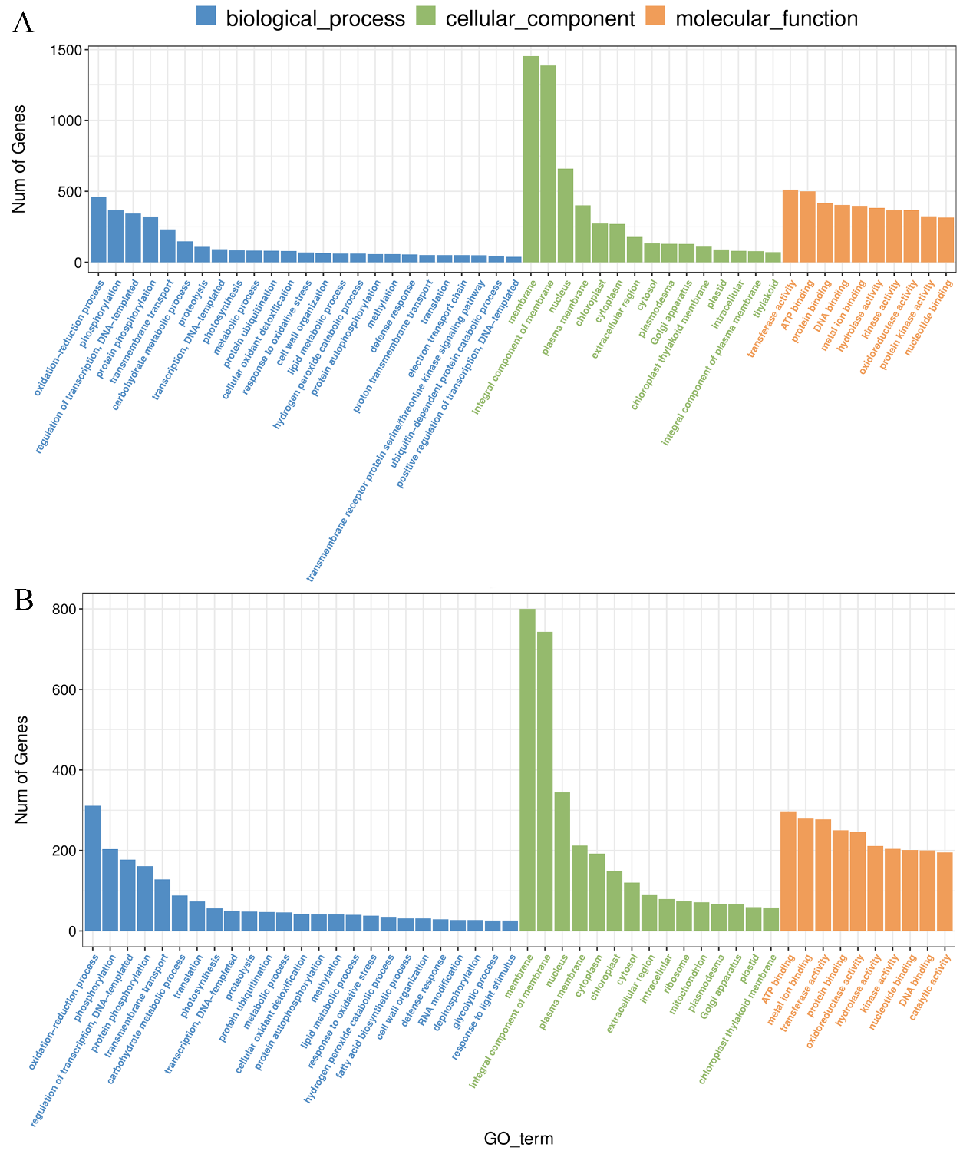

**Figure S4.** GO annotations of DEGs in Qi319 and Zi330 identified after adding exogenous SL under normal sowing depth and deep sowing stress. A: QDSSL *vs.* QCKSL, B: ZDSSL *vs.* ZCKSL.