**C**

**C**

**B**

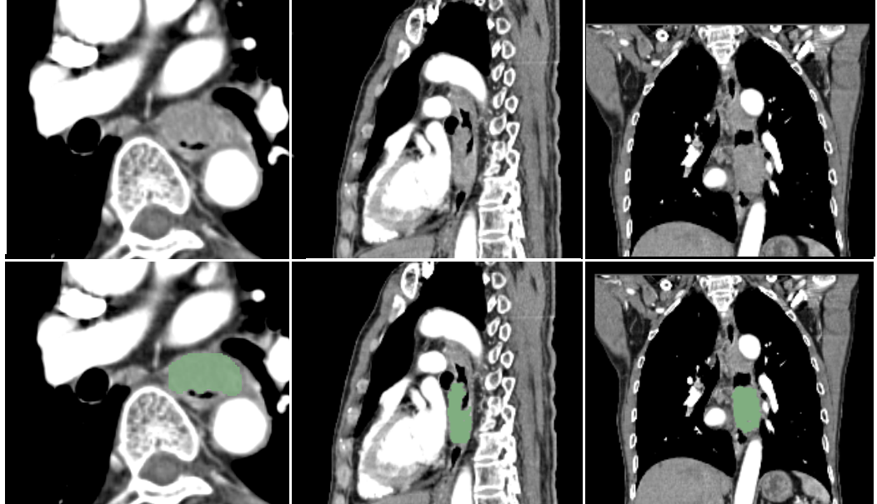

**F**

**E**

**D**

**d**

**A**

**B**

Supplementary figure 1:The demonstration of our working on the tumor segmentation with 3D slicer. (A), (B), (C) shows original computed tomography (CT) images in axial, sagittal, coronal planes;(D), (E), (F) screenshots of segmentation results in axial, sagittal, coronal planes