Figure S1
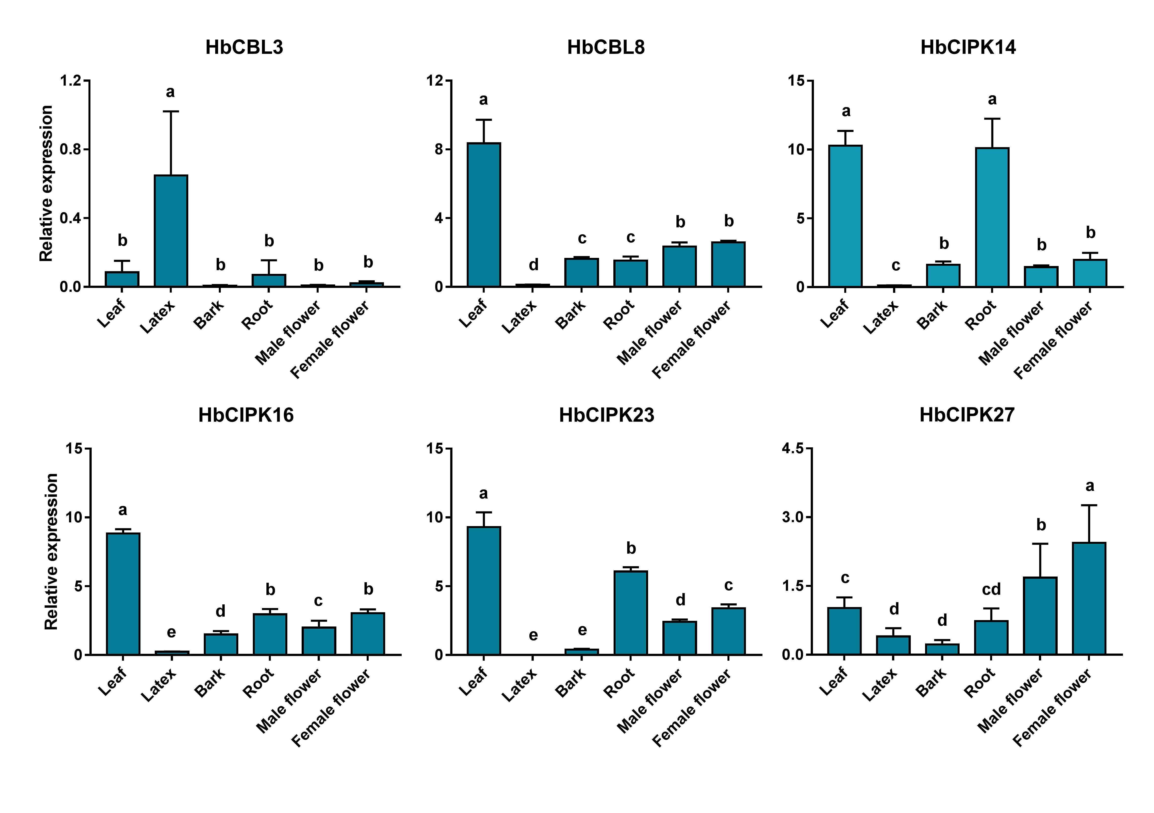
Figure S1. Expression analyses of HbCIPK and HbCBL genes in different tissues based on qPCR. Relative expressionvalues of HbCIPK14, 16, 23, 27 and HbCBL3, 8 in seven tissues (leaf, bark, latex, root, seed, female flower, and male flower) were given as means ± standard deviations of three biological replicates. Different letters indicate significant difference with P < 0.05.

Figure S2

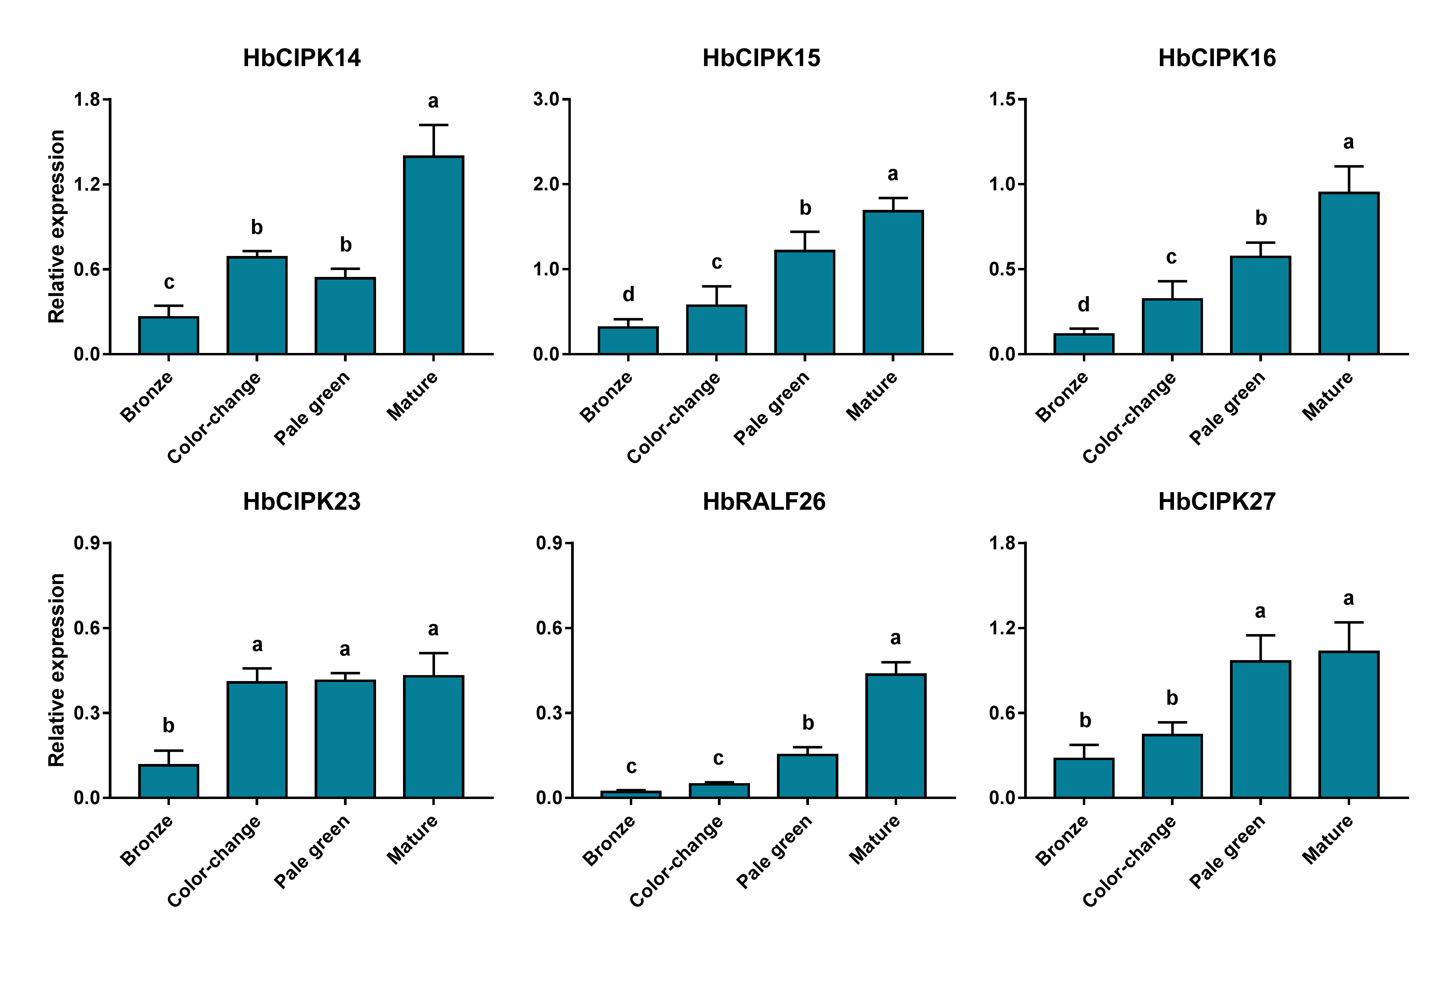
Figure S2. Expression analyses of six HbCIPK genes at different leaf developmental stages based on qPCR. Relative expression values of HbCIPK14, 15, 16, 23, 26, and 27 at four developmental stages of leaf (bronze, color change, pale-green and mature) were given as means ± standard deviations of three biological replicates. Different letters indicate significant difference with P < 0.05.

Figure S3
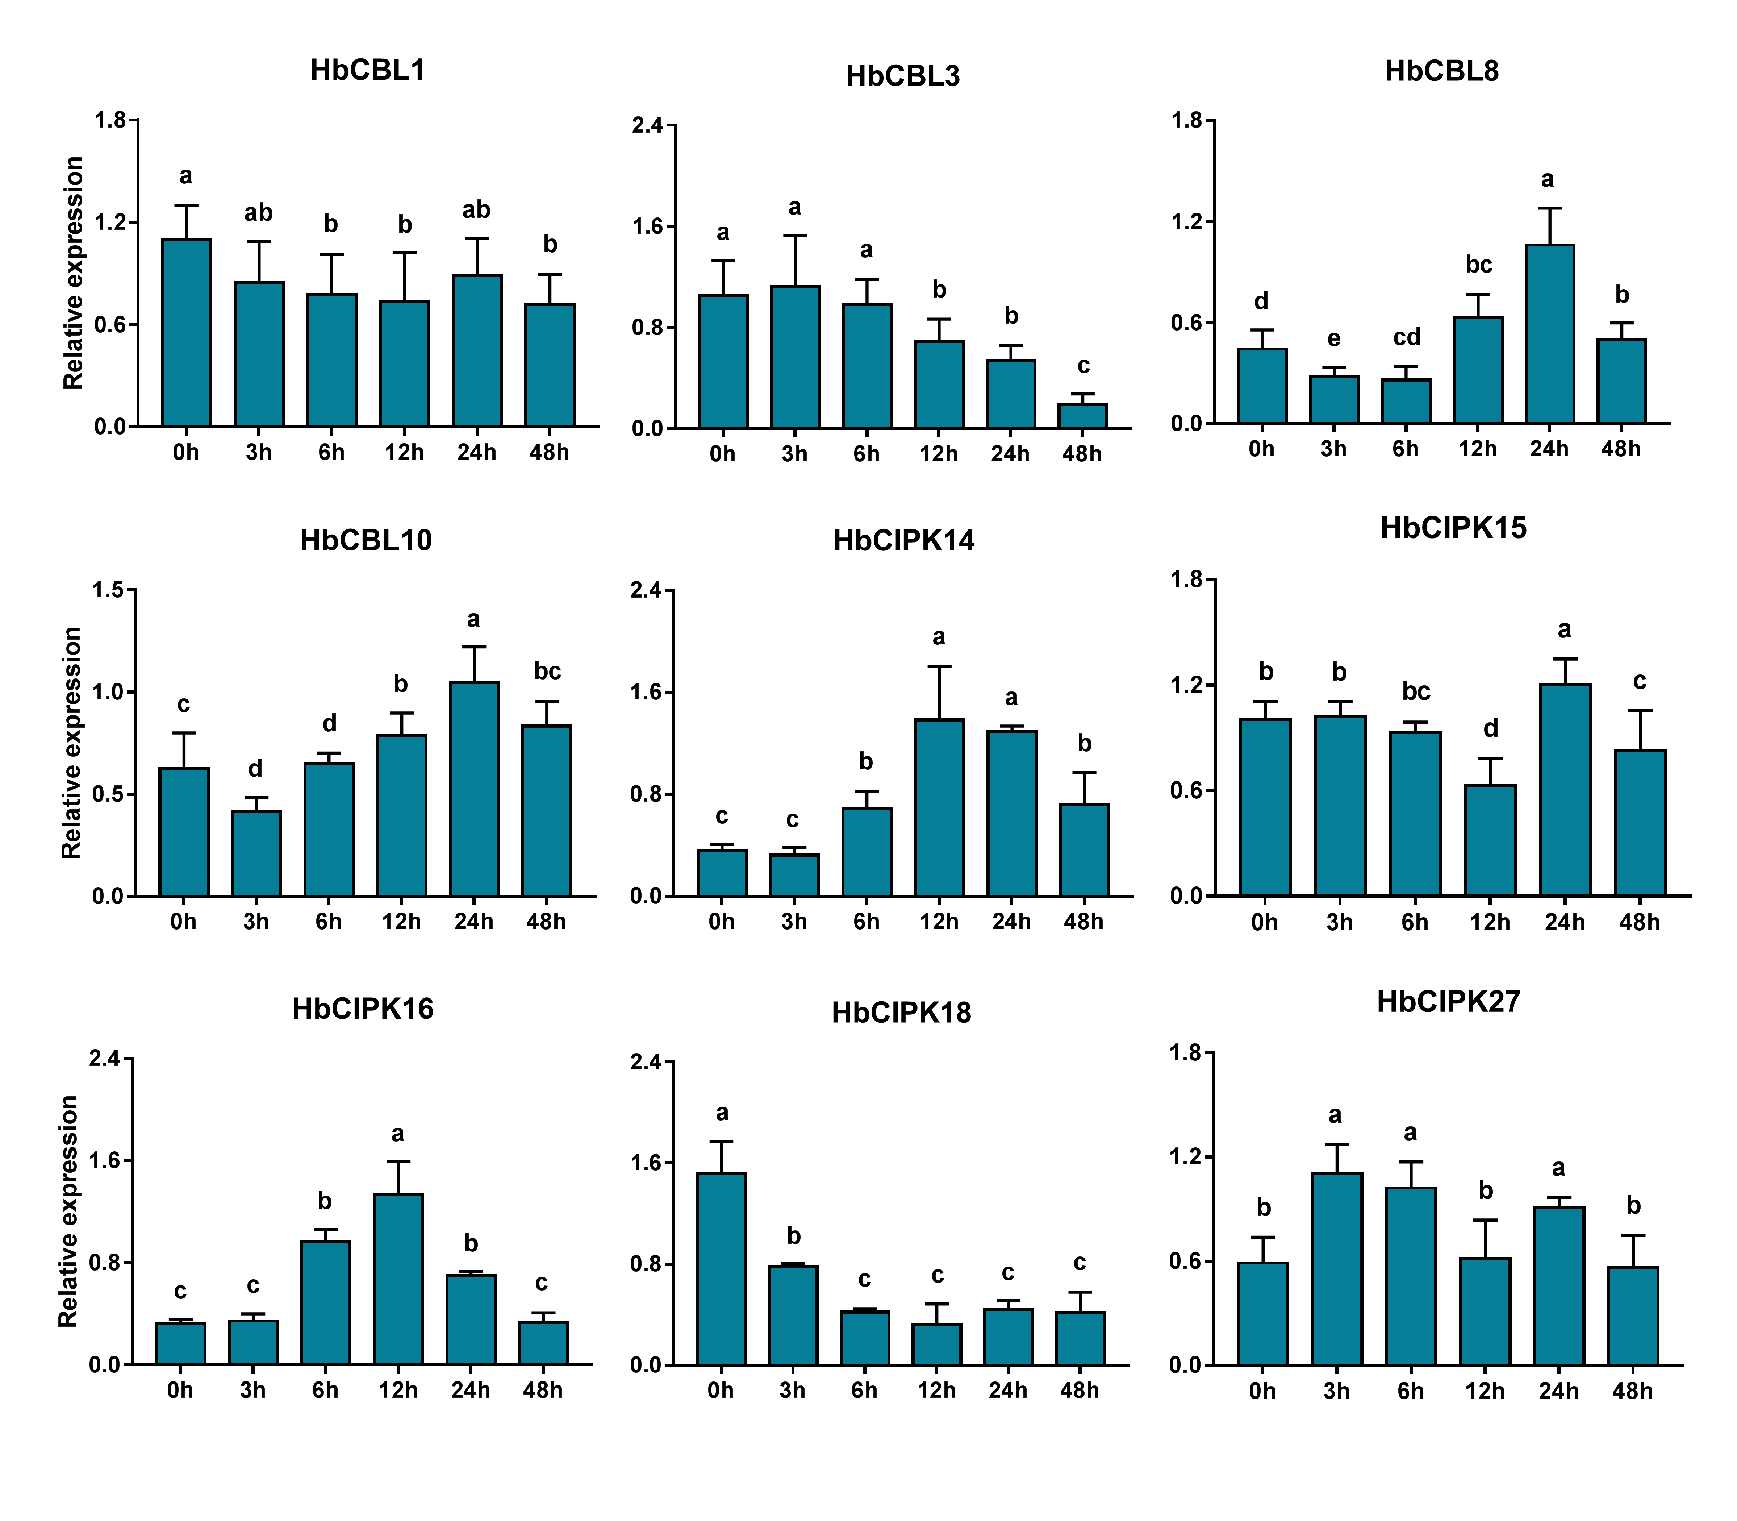
Figure S3. Expression analyses of HbCIPK and HbCBL genes in latex following ethephon treatment based on qPCR. Relative expression values of HbCBL1, 3, 8, 10 and HbCIPK14, 15, 16, 18 and 27 transcripts in latex following ethephon treatment (0 h, 3 h, 6 h, 12 h, 24 h, and 48 h) were given as means ± standard deviations of three biological replicates. Different letters indicate significant difference with P < 0.05.

Figure S4
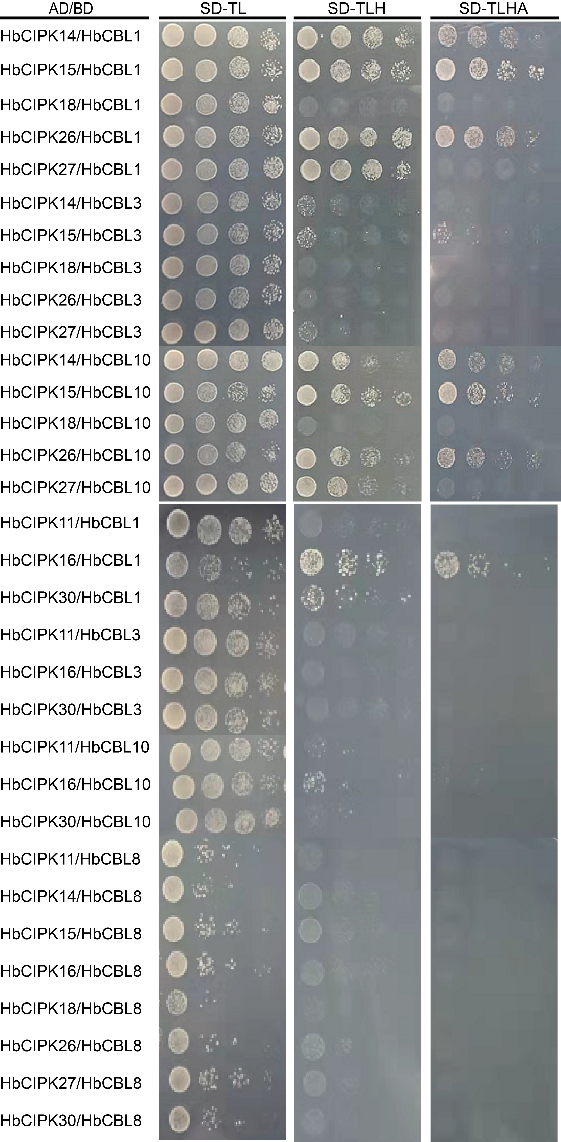
Figure S4. Identifying interactions between HbCIPK and HbCBL proteins. Interactions between HbCIPK (HbCIPK11/14/15/16/18/26/27/30) and HbCBL (HbCBL1/3/8/10) proteins were assayed using a yeast two-hybrid method. Yeast cells harboring different AD- and BD-fusion protein combinations were plated on SD-TL (lacking Trp and Leu), SD-TLH (lacking Trp, Leu and His), and SD-TLHA (lacking Trp, Leu, His and Ade) media, as described in the section “Materials and Methods”, and cultured at 28℃ for 3-5 days.
Figure S5
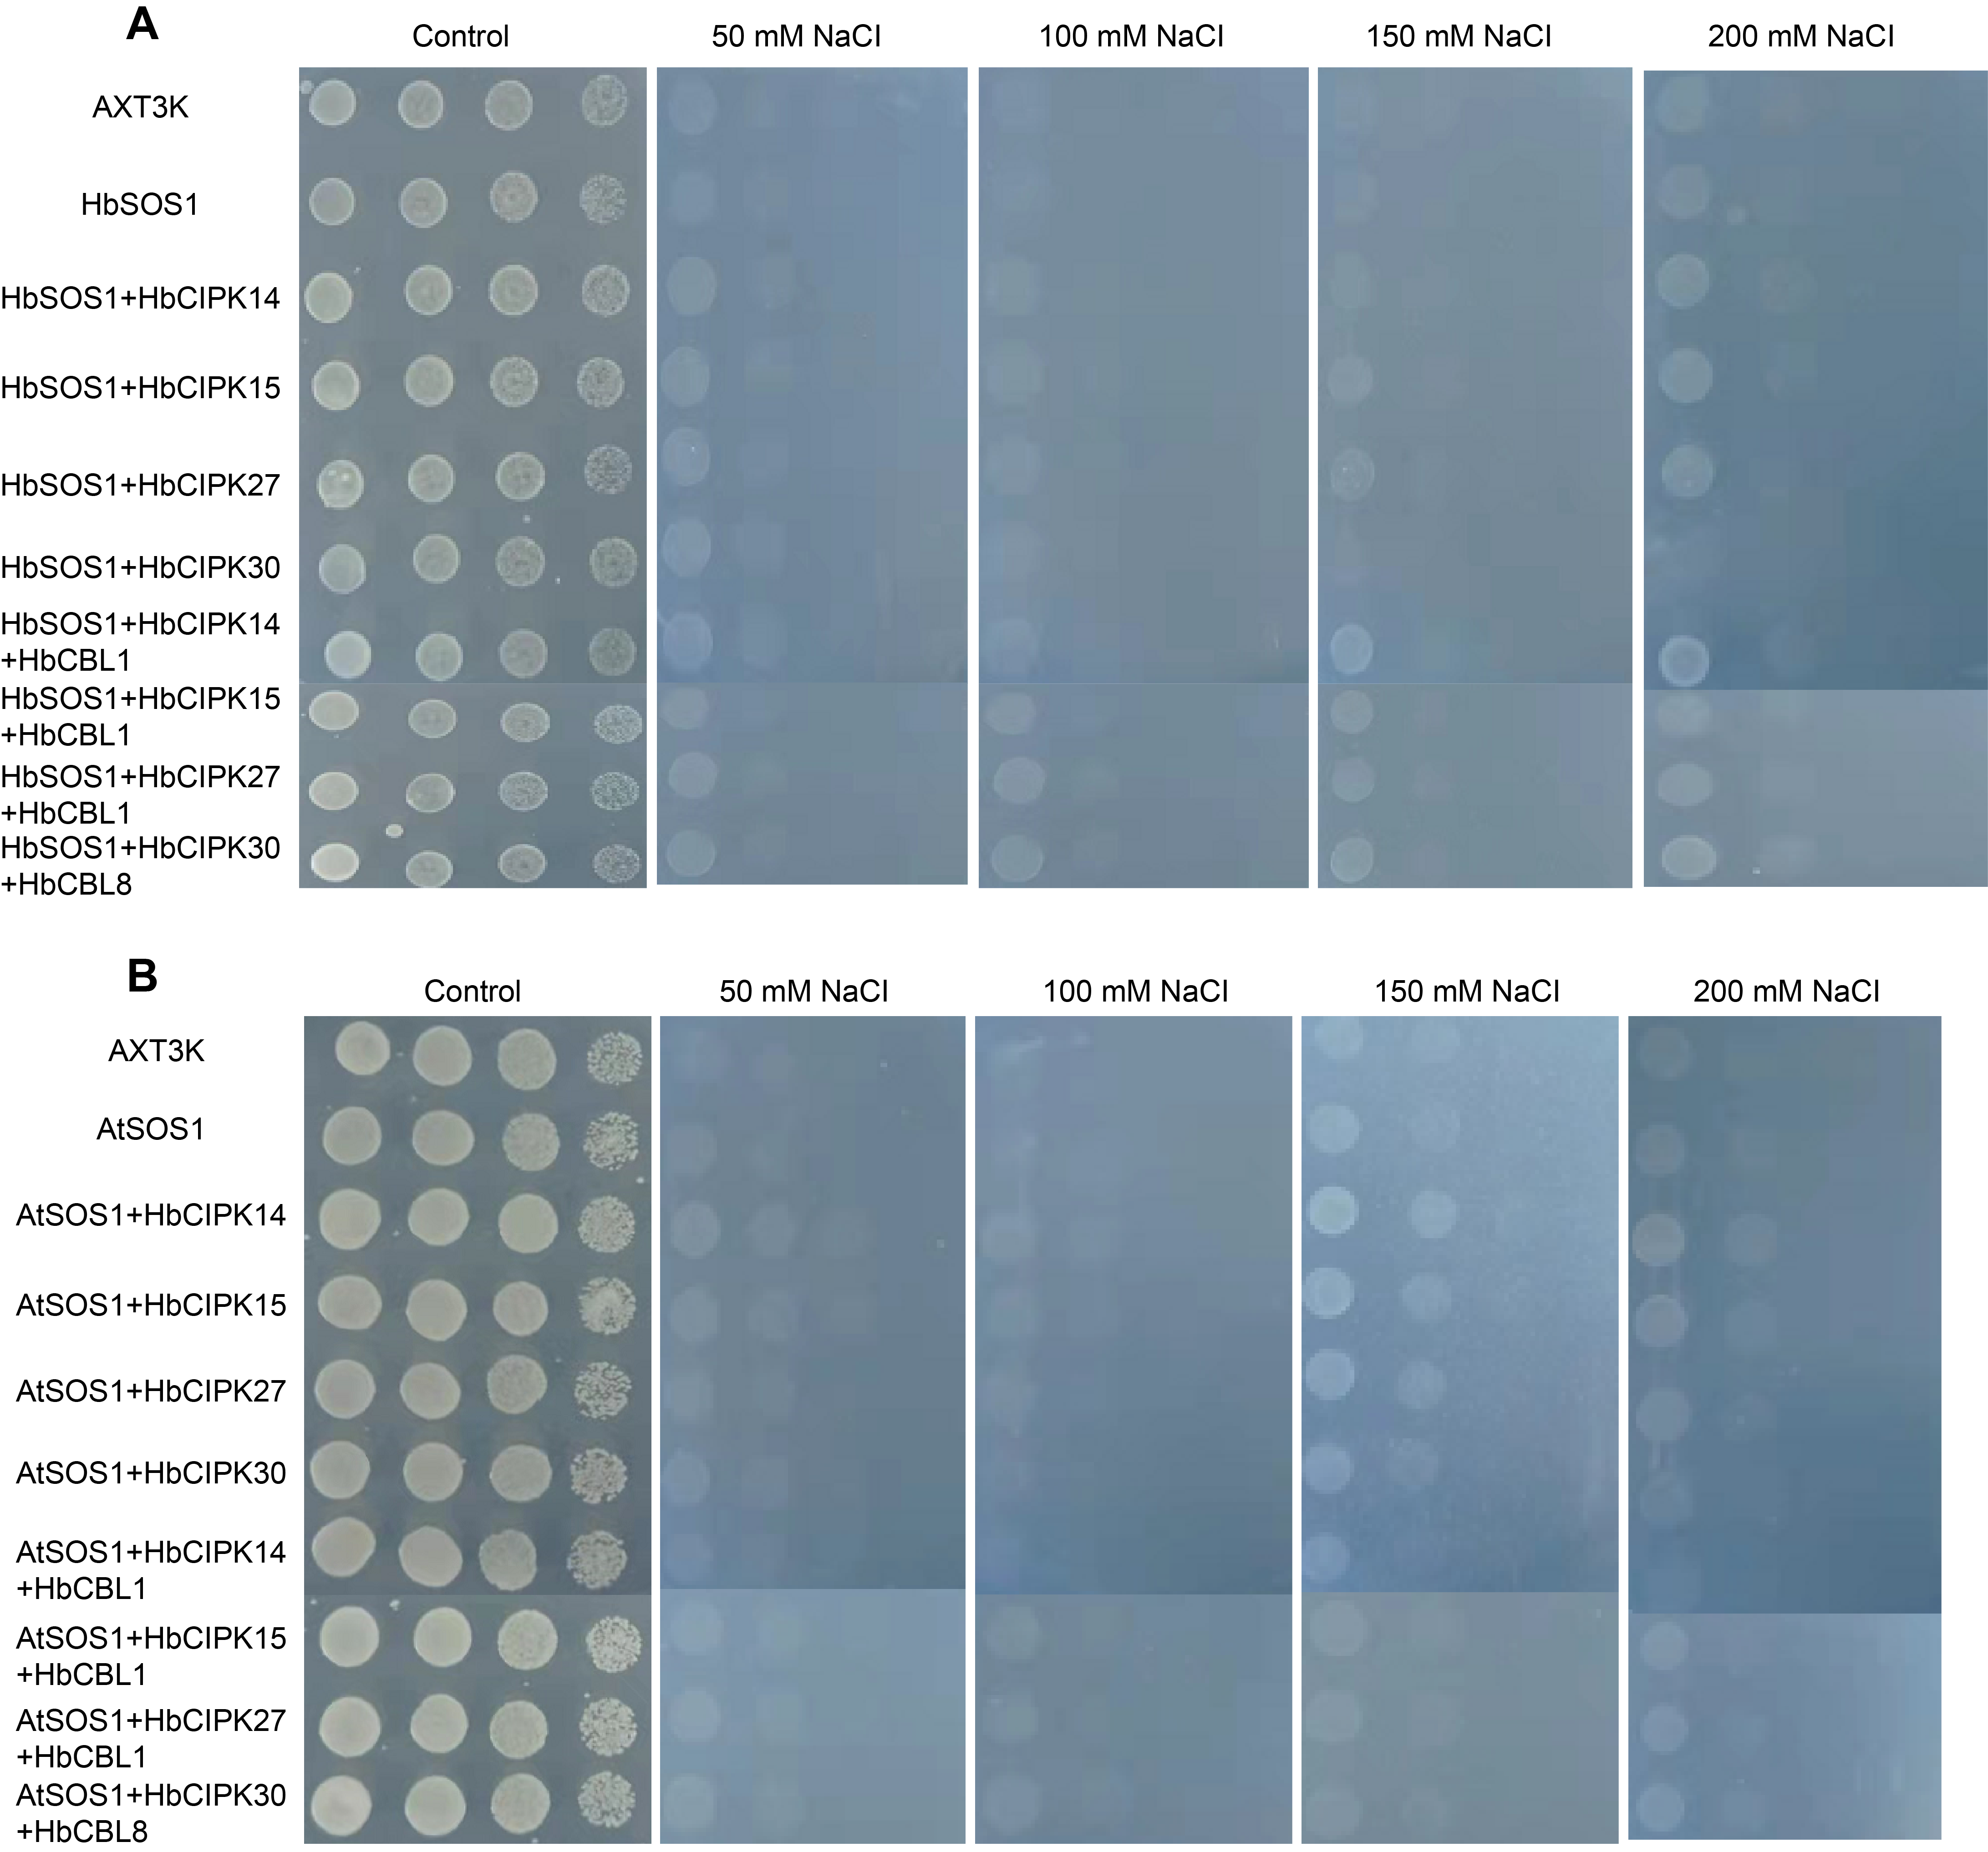
Figure S5. Yeast complementation test for salinity stress tolerance. (A), transformed and untransformed yeast cells were cultured to saturation, and serially diluted 10-fold and spotted on AP plates without or with NaCl as detailed in Materials and Methods. After 5 days, the growth of yeast cells on plates was recorded. AXT3K, untransformed yeast mutant strain lacking salt tolerance capacity; HbSOS1, AXT3K strain transformed with the Hevea Na⁺/H⁺ antiporter gene HbSOS1; HbSOS1+HbCIPK, AXT3K strain transformed with HbSOS1 and HbCIPK (HbCIPK14/15/27/30) genes; HbSOS1+HbCIPK+HbCBL, AXT3K strain transformed with HbSOS1, HbCIPK (HbCIPK14/15/27/30) and HbCBL (HbCBL1/HbCBL8) genes. (B), Same as (A) except for the replacement of HbSOS1 with its Arabidopsis ortholog AtSOS1.

