Supplementary Material

Supplementary Table 1. List of natural compounds exclusively found in Sesame (Sesamum indicum L.).
S.No | Compound Name | PubChem ID | Molecular Formula | Molecular  Weight (g/mol) | Chemical Structure
 |  |  |  |  | 2D | 3D
1. | Latifonin | CID_156633 | C₁₁H₁₆O₇ | 260.24 | 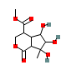 | 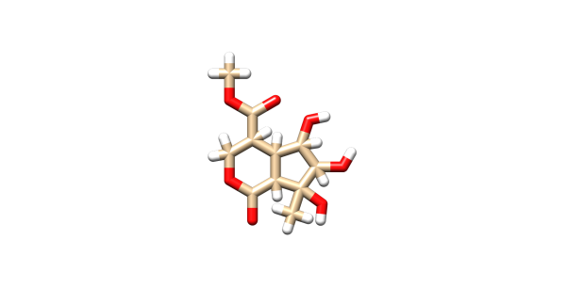
2. | Momor-Cerebroside I | CID_91895300 | C₄₈H₉₃NO₁₀ | 844.3 | 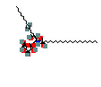 | 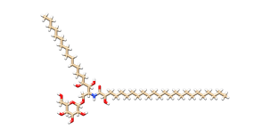
3. | Soyacerebroside II | CID_6450042 | C₄₀H₇₅NO₉ | 714 | 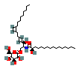 | 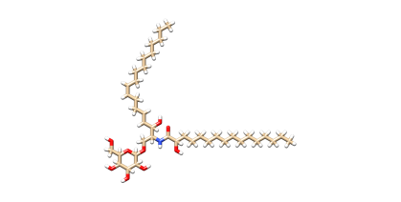
4. | Aurantiamide acetate | CID_9832120 | C₂₇H₂₈N₂O₄ | 444.5 | 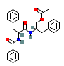 | 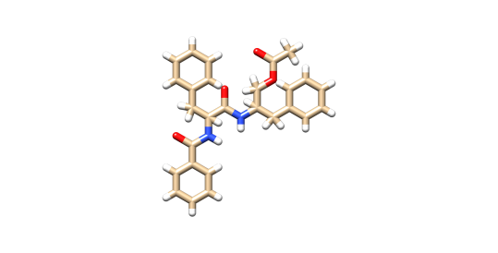
5. | Beta-sitosterol | CID_ 222284 | C₂₉H₅₀O | 414.7 | 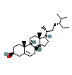 | 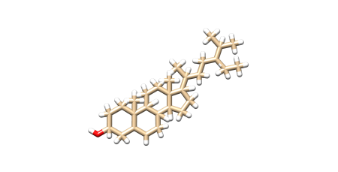
6. | Daucosterol | CID_5742590 | C₃₅H₆₀O₆ | 576.8 | 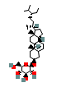 | 
7. | D-Galactitol | CID_ 11850 | C₆H₁₄O₆ | 182.17 | 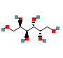 | 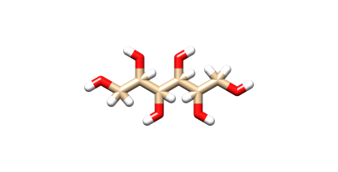
8. | Sesamolin | CID_131801617 | C₂₀H₁₈O₇ | 370.4 | 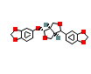 | 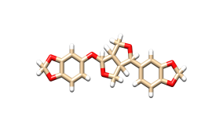
9. | Dronabinol | CID_ 16078 | C₂₁H₃₀O₂ | 314.5 | 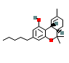 | 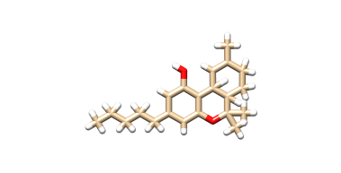
10. | 1,2-Dilinoleoyl-3-Palmitoyl-Rac-Glycerol | CID_9544106 | C₅₅H₉₈O₆ | 855.4 | 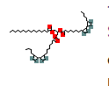 | 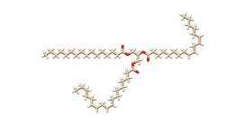
11. | 1,2-Dilinoleoyl-3-Oleoyl-Rac-Glycerol | CID_ 9544291 | C₅₇H₁₀₀O₆ | 881.4 | 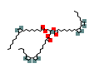 | 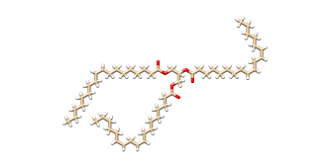
12. | Linoleic Acid | CID_ 5280450 | C₁₈H₃₂O₂ | 280.4 | 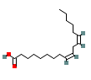 | 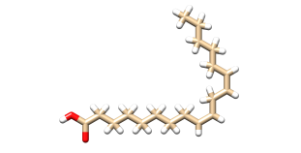
13. | Linolenic Acid | CID_5280934 | C₁₈H₃₀O₂ | 278.4 | 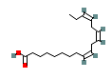 | 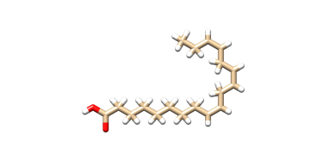
14. | Oleic Acid | CID_ 445639 | C₁₈H₃₄O₂ | 282.5 | 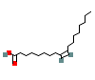 | 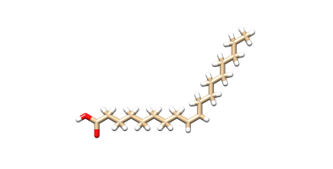
15. | Palmitic Acid | CID_ 985 | C₁₆H₃₂O₂ | 256.42 | 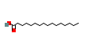 | 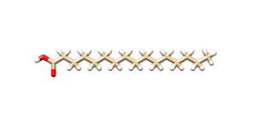
16. | Pinoresinol | CID_ 73399 | C₂₀H₂₂O₆ | 358.4 | 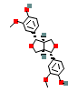 | 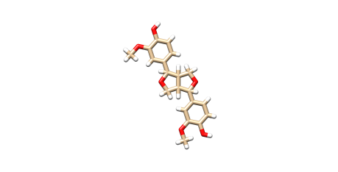
17. | Sesamin | CID_ 72307 | C₂₀H₁₈O₆ | 354.4 | 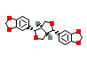 | 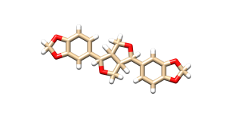
18. | Sesaminol | CID_ 94672 | C₂₀H₁₈O₇ | 370.4 | 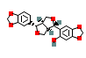 | 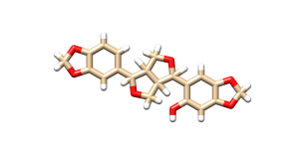
19. | Sesamol | CID_ 68289 | C₇H₆O₃ | 138.12 | 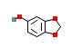 | 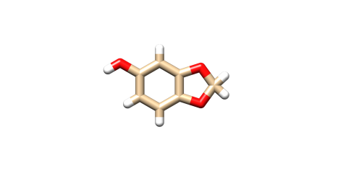
20. | Sesamolinol | CID_ 443019 | C₂₀H₂₀O₇ | 372.4 | 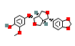 | 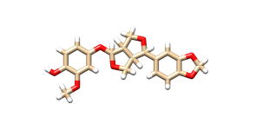
21. | Stearic Acid | CID_ 5281 | C₁₈H₃₆O₂ | 284.5 | 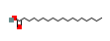 | 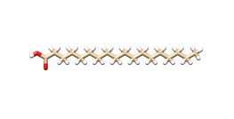
22. | Tocopherol | CID_ 14985 | C₂₉H₅₀O₂ | 430.7 | 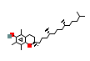 | 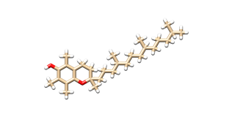
23. | Vitamin A Retinol | CID_ 445354 | C₂₀H₃₀O | 286.5 | 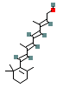 | 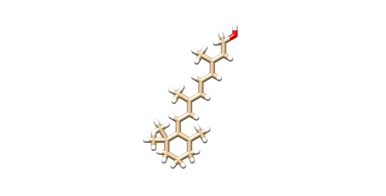
24. | Vitamin K Phylloquinone | CID_ 5284607 | C₃₁H₄₆O₂ | 450.7 | 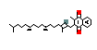 | 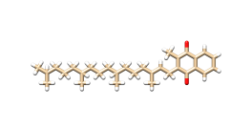
25. | Arachidic acid | CID_ 10467 | C₂₀H₄₀O₂ | 312.5 | 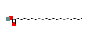 | 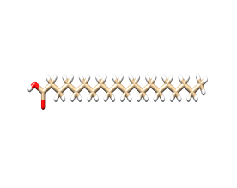
26. | Myristic acid | CID_ 11005 | C₁₄H₂₈O₂ | 228.37 | 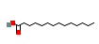 | 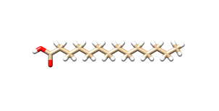
27. | Behenic acid | CID_ 8215 | C₂₂H₄₄O₂ | 340.6 | 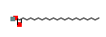 | 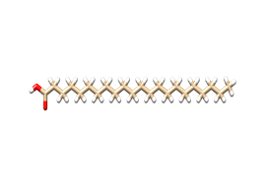
28. | Octanoic acid | CID_ 379 | C₈H₁₆O₂ | 144.21 | 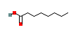 | 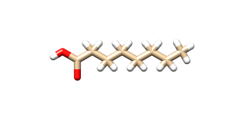
29. | Decanoic acid | CID_ 2969 | C₁₀H₂₀O₂ | 172.26 | 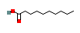 | 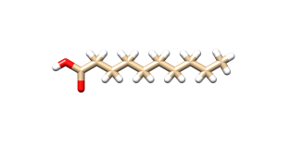
30. | Lauric acid | CID_ 3893 | C₁₂H₂₄O₂ | 200.32 | 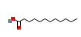 | 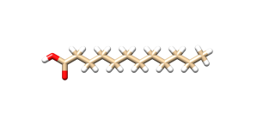
31. | Eicosenoic acid | CID_ 5282768 | C₂₀H₃₈O₂ | 310.5 | 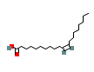 | 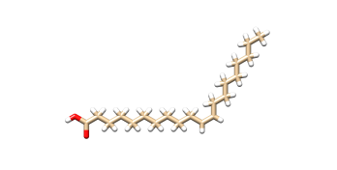
32. | Lariciresinol | CID_ 332427 | C₂₀H₂₄O₆ | 360.4 | 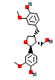 | 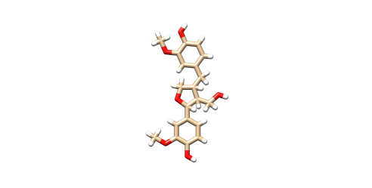
33. | Campesterol | CID_ 173183 | C₂₈H₄₈O | 400.7 | 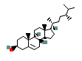 | 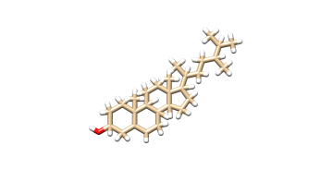
34. | Δ5‐Avenasterol | CID_5281326 | C₂₉H₄₈O | 412.7 | 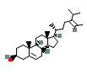 | 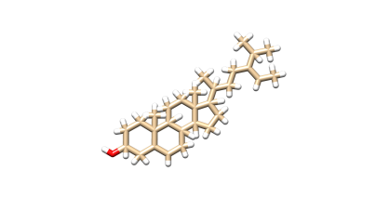
35. | Δ7‐Stigmasterol | CID_131751494 | C₂₉H₄₆O | 410.7 | 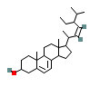 | 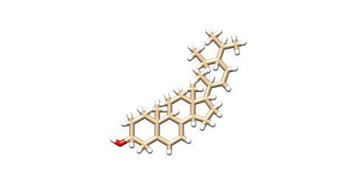
36. | Δ7‐Avenasterol | CID_12795736 | C₂₉H₄₈O | 412.7 | 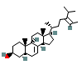 | 