Supplementary information

Advances in studies on microbiota involved in nitrogen removal processes and their applications in wastewater treatment
Wenning Mai^{1,2#}, Jiamin Chen^{1,3#}, Hai Liu⁴, Jiawei Liang², Jinfeng Tang⁵, Yongjun Wei^{3,6*}

¹School of Ecology and Environment, Zhengzhou University, Zhengzhou, China

²College of Public Health, Zhengzhou University, Zhengzhou, China

³Laboratory of Synthetic Biology, Zhengzhou University, Zhengzhou, China
⁴Henan Public Security Bureau, Zhengzhou, China
⁵Key Laboratory for Water Quality and Conservation of Pearl River Delta, Ministry of Education, School of Environmental Science and Engineering, Linköping University – Guangzhou University Research Center on Urban Sustainable Development, Guangzhou University, Guangzhou China
⁶Key Laboratory of Advanced Drug Preparation Technologies, Ministry of Education, School of Pharmaceutical Sciences, Zhengzhou University, Zhengzhou, China

#These two authors contributed equally to this work.

*Corresponding author
Yongjun Wei
E-mail: yongjunwei@zzu.edu.cn
TEL: +86 (0)371 67781908
The biological nitrogen pollutant removal process mainly composed with the reactions of partial nitrification, nitrification, denitrification, and anammox. The chemical reactions are listed as below:
Partial nitrification process:
NH₃ + O₂+ 2H⁺ +2e⁻→NH₂OH + H₂O (1)
NH₂OH + H₂O→HNO₂ ⁺ 4H⁺ + 4e⁻ (2)
Partial nitrification: NH₄⁺ + 1.5O₂ →NO₂⁻ + 2H⁺ + H₂O (3)
Nitrification process:
Partial nitrification: NH₄⁺ + 1.5O₂ →NO₂⁻ + 2H⁺ + H₂O (1)
Nitrite oxidation reaction: NO₂⁻ + 0.5O₂ → NO₃⁻ (2)
Nitrification: NH₄⁺ + 2O₂→NO₃⁻ + H₂O+ 2H⁺ (3)
Denitrification process:
6NO₃⁻ + 2CH₃OH → 6NO₂⁻ + 2CO₂ + 4H₂O (1)
6NO₂⁻ + 3CH₃OH→ 3N₂ + 3CO₂ + 3H₂O + 6OH⁻ (2)
Denitrification process：8NO₃⁻ + 5CH₃COOH → 4N₂ + 10CO₂ + 6H₂O + 8OH⁻ (3)
Anammox process:
NO₂⁻ + 2H⁺ + e⁻ = NO + H₂O (1)
NO + NH₄⁺ + 2H⁺ + 3e⁻ = N₂H₄ + H₂O (2)
N₂H₄ = N₂ + 4H⁺ + 4e⁻ (3)
Anammox: NH₄⁺ + NO₂⁻ = N₂ + 2H₂O (4)
Supplementary Tables and Figures

Supplementary Tables
Table S1 Biological reactions in nitrogen recycling.
Table S2 Summary of anammox and traditional biological nitrogen removal processes.

Supplementary Figures
Fig S1 Biological nitrogen pollutant removal process and functional genes. AMO, ammonium monooxygenase of ammonia oxidizing bacteria; HAO, hydroxylamine oxidase of ammonia oxidizing bacteria; NXR, nitrite oxidoreductase of nitrite oxidizing bacteria; NAR, nitrate reductase of denitrification; NIR, nitrite reductase of denitrification; NOR, nitric oxide reductase of denitrification; NOS, nitrous oxide reductase of denitrification; HZS, hydrazine synthase of anammox; HZO, hydrazine oxidase of anammox. The amoA and hao genes are the key functional genes involved in partial nitrification. The nxrB gene is the main factor of nitrate nitrogen change. The narG gene is the key functional gene involved in partial denitrification. The nirS/nirK, norB, and nosZ genes are the key functional genes involved in denitrification. The hzsB and hzo genes are the key functional genes involved in anammox.
Fig S2 The traditional biological denitrification process of activated sludge.
Table S1 Biological reactions of nitrogen recycling in nature.
Process | Reaction | Bacteria involved
Ammonification | Organic nitrogen → NH₄⁺-N | Amino acid degrading bacteria
Partial nitrification | NH₄⁺-N → NO₂⁻-N | Ammonia oxidizing bacteria
Nitrification | NO₂⁻-N → NO₃⁻-N | Nitrite oxidizing bacteria
Denitrification | NO₃⁻-N → NO₂⁻-N and N₂ | Denitrification bacteria
Anammox | NO₂⁻-N + NH₄⁺-N → N₂ | Anammox

Table S2 Summary of anammox and traditional biological nitrogen removal processes.
Process | Microorganisms | Nitrogen load rate (kg N/m³/d) | Oxygen requirements | Organic carbon | TN removal rate (%)
BNR | Autotrophic+  Heterotrophic | 2-8 | High | Yes | 100
SND | Autotrophic+  Heterotrophic | 1-3.5 | Low | Yes | 100
Anammox | Autotrophic | 5.1 | None | No | 84
PN/A | Autotrophic | 1.2-8.9 | Low | No | 89
DN-PN/A | Autotrophic+  Heterotrophic | Unknown | None | Yes | 100

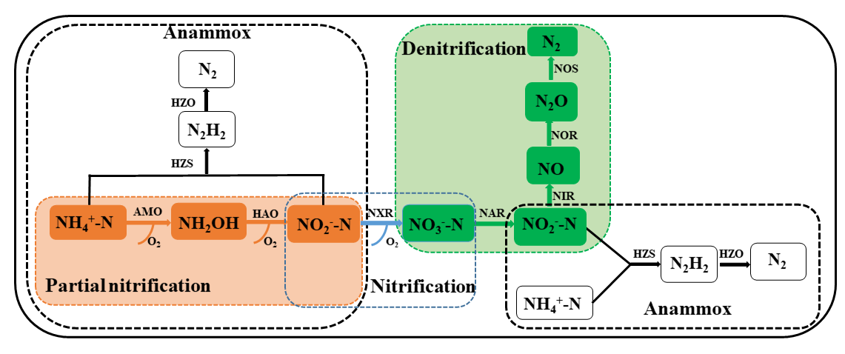
Fig S1 Biological nitrogen pollutant removal process and functional genes. AMO, ammonium monooxygenase of ammonia oxidizing bacteria; HAO, hydroxylamine oxidase of ammonia oxidizing bacteria; NXR, nitrite oxidoreductase of nitrite oxidizing bacteria; NAR, nitrate reductase of denitrification; NIR, nitrite reductase of denitrification; NOR, nitric oxide reductase of denitrification; NOS, nitrous oxide reductase of denitrification; HZS, hydrazine synthase of anammox; HZO, hydrazine oxidase of anammox. The amoA and hao genes are the key functional genes involved in partial nitrification. The nxrB gene is the main factor of nitrate nitrogen change. The narG gene is the key functional gene involved in partial denitrification. The nirS/nirK, norB, and nosZ genes are the key functional genes involved in denitrification. The hzsB and hzo genes are the key functional genes involved in anammox.
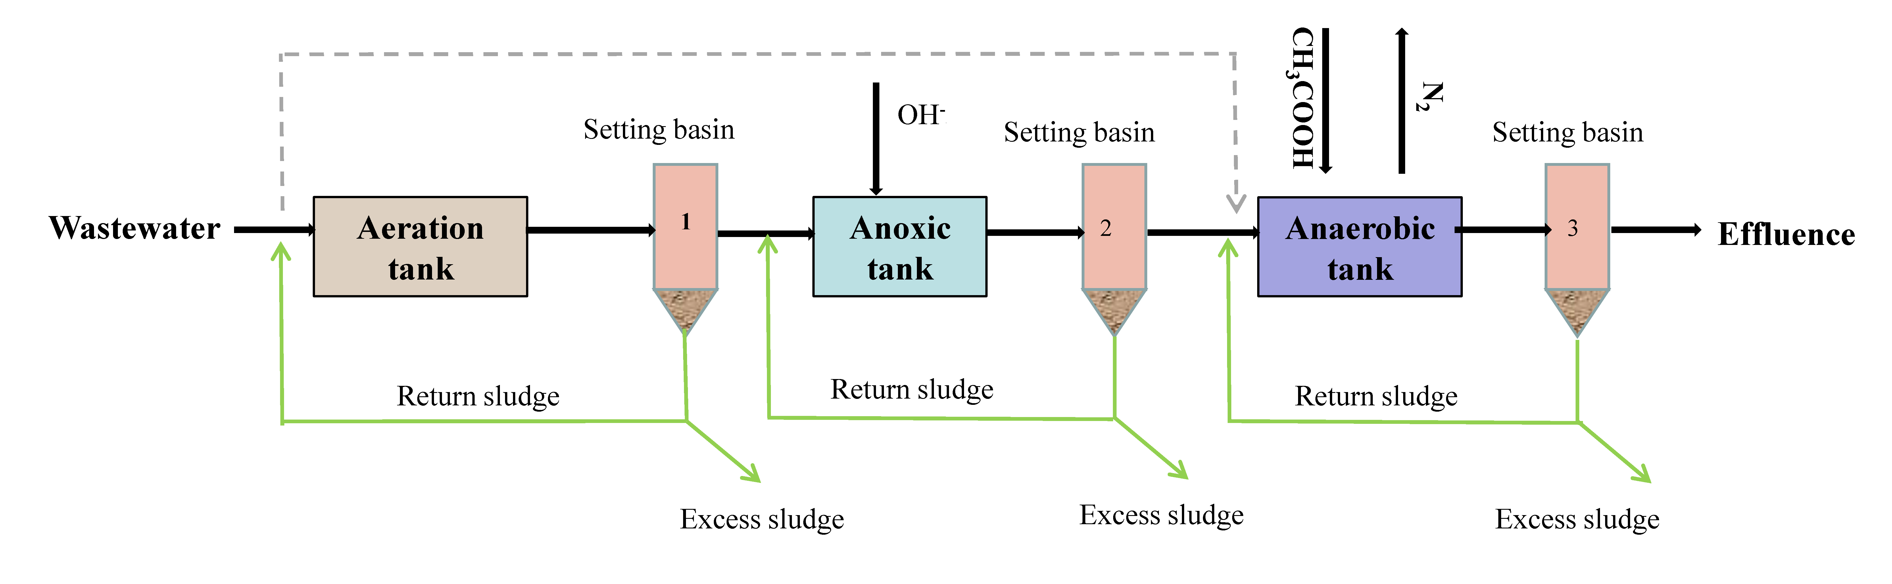
Fig S2 The traditional biological denitrification process of activated sludge.

