Supplementary Material

Supplementary Figures and Tables
A
B

Figure S1. Cumulated monthly precipitation during the maize growing season of 2018-19 represented as the dark blue bars and historical precipitation of the area represented as the dashed black line (A) and monthly mean daily air temperature during the maize growing season of 2018-19 represented as the dark red bars and historical mean air temperature of the area represented as the dashed black line (B).

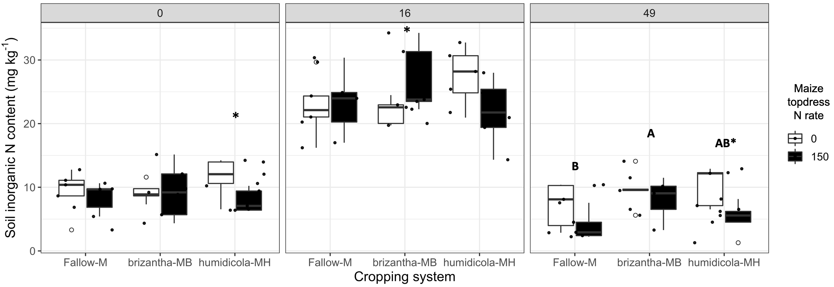
Figure S2. Soil inorganic N content as affected by the cropping system (Fallow-M: maize monocrop; brizantha – MB: maize intercropped with B. brizantha; and humidicola-MH: maize intercropped with B. humidicola) and maize topdress N rate (0 and 150 kg ha⁻¹) in three different time-points of soil sampling: 0, 16 and 49 days after cover crop termination. Different capital letters represent the statistical difference of the soil cover and asterisk represent the statistical difference of historical topdress N rate within soil cover (Tukey test, p<0.05). The full circles represent the actual measurement for each treatment while the empty circle represents the outliers, the horizontal mark on the boxplot represent the median and the bars represent the maximum and minimum values.

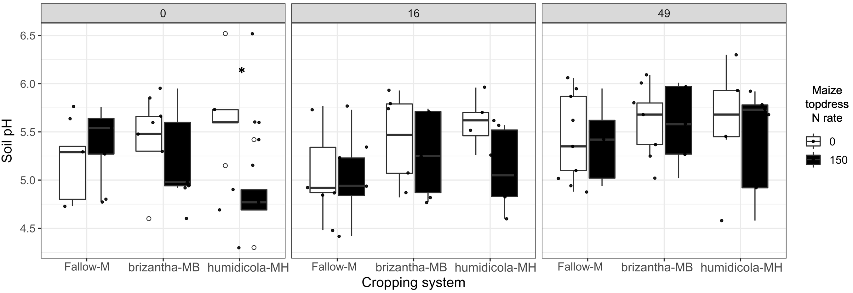
Figure S3. Soil pH as affected by the cropping system (Fallow-M: maize monocrop; brizantha – MB: maize intercropped with B. brizantha; and humidicola-MH: maize intercropped with B. humidicola) and maize topdress N rate (0 and 150 kg ha⁻¹) in three different time-points of soil sampling: 0, 16 and 49 days after cover crop termination. Asterisks represent the statistical difference of historical topdress N rate within soil cover (Tukey test, p<0.05). The full circles represent the actual measurement for each treatment while the empty circle represents the outliers, the horizontal mark on the boxplot represent the median and the bars represent the maximum and minimum values.

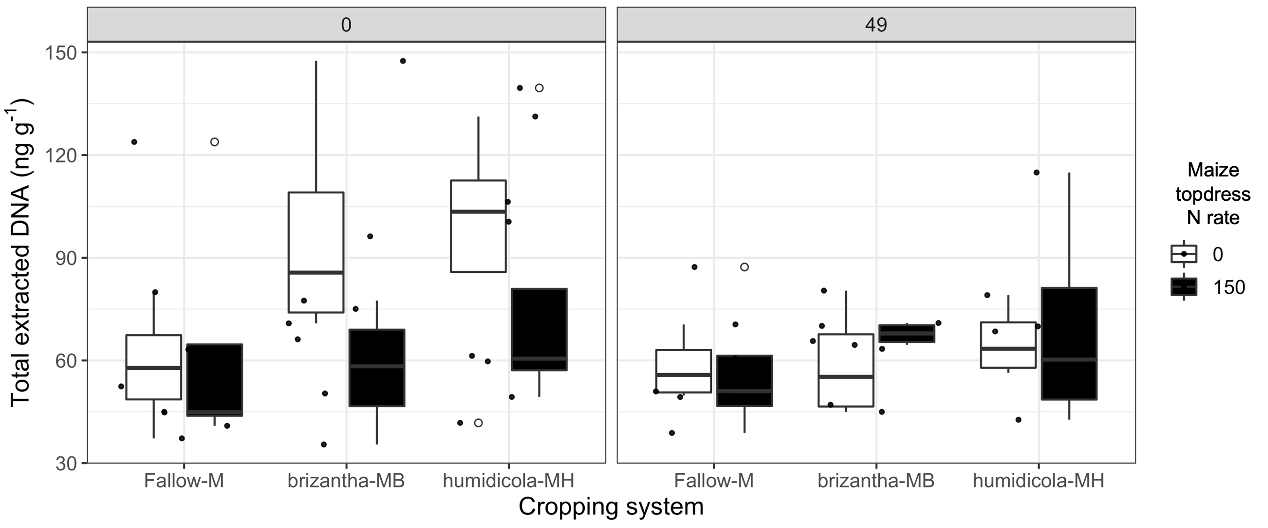
Figure S4. Total DNA extracted from soil as affected by the cropping system (Fallow-M: maize monocrop; brizantha – MB: maize intercropped with B. brizantha; and humidicola-MH: maize intercropped with B. humidicola) and maize topdress N rate (0 and 150 kg ha⁻¹) in two different time-points of soil sampling: 0 and 49 days after cover crop termination. The full circles represent the actual measurement for each treatment while the empty circle represents the outliers, the horizontal mark on the boxplot represent the median and the bars represent the maximum and minimum values.

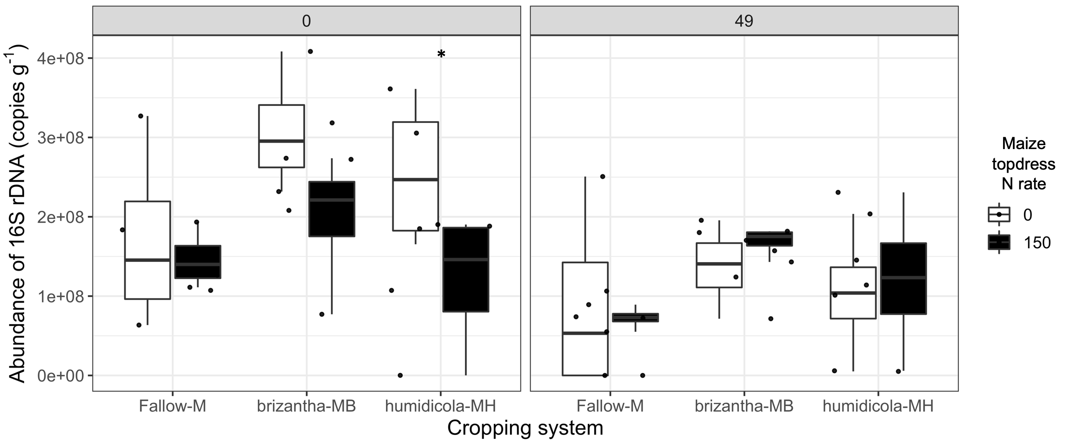
Figure S5. Abundance of 16S rDNA gene as affected by the cropping system (Fallow-M: maize monocrop; brizantha – MB: maize intercropped with B. brizantha; and humidicola-MH: maize intercropped with B. humidicola) and maize topdress N rate (0 and 150 kg ha⁻¹) in two different time-points of soil sampling: 0 and 49 days after cover crop termination. Asterisks represent the statistical difference of historical topdress N rate within soil cover (Tukey test, p<0.05). The full circles represent the actual measurement for each treatment while the empty circle represents the outliers, the horizontal mark on the boxplot represent the median and the bars represent the maximum and minimum values.

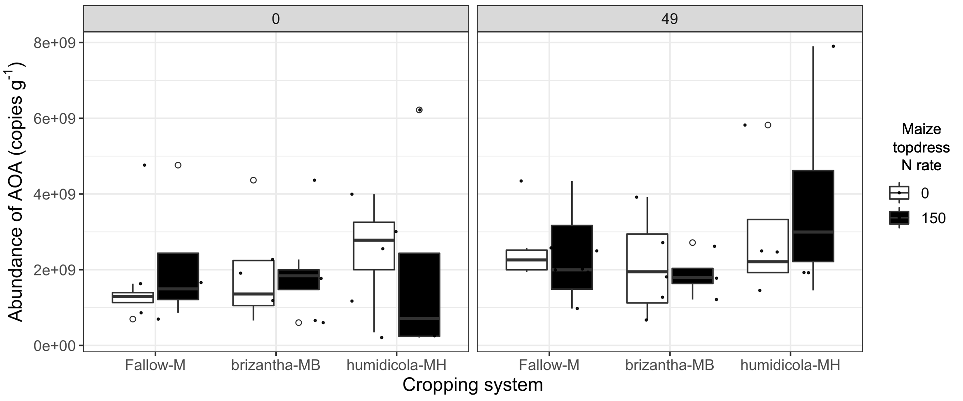
Figure S6. Abundance of AOA gene as affected by the cropping system (Fallow-M: maize monocrop; brizantha – MB: maize intercropped with B. brizantha; and humidicola-MH: maize intercropped with B. humidicola) and maize topdress N rate (0 and 150 kg ha⁻¹) in two different time-points of soil sampling: 0 and 49 days after cover crop termination. The full circles represent the actual measurement for each treatment while the empty circle represents the outliers, the horizontal mark on the boxplot represent the median and the bars represent the maximum and minimum values.

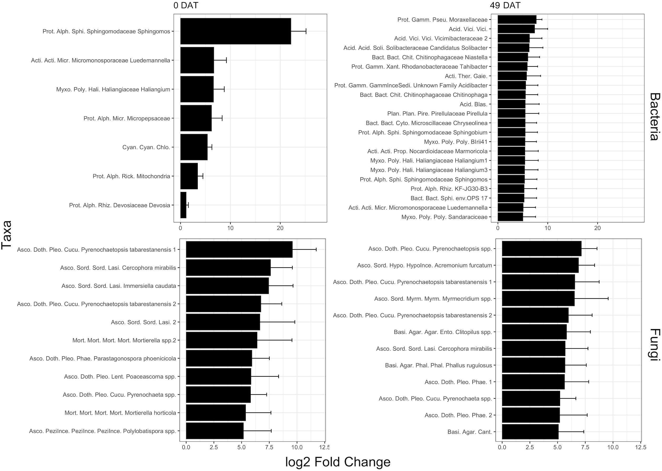
Figure S7. Taxa associated with monocropping when soil was sampled 0 or 49 DAT with log2 Fold Change greater the 5 or all significant taxa if less than 10 taxa had less than 5 log2 Fold Change. See taxa abbreviation listed below.
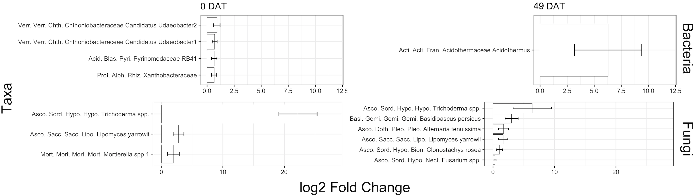
Figure S8. Taxa associated with intercropping when soil was sampled 0 or 49 DAT with log2 Fold Change greater the 5 or all significant taxa if less than 10 taxa had less than 5 log2 Fold Change. See taxa abbreviation listed below.

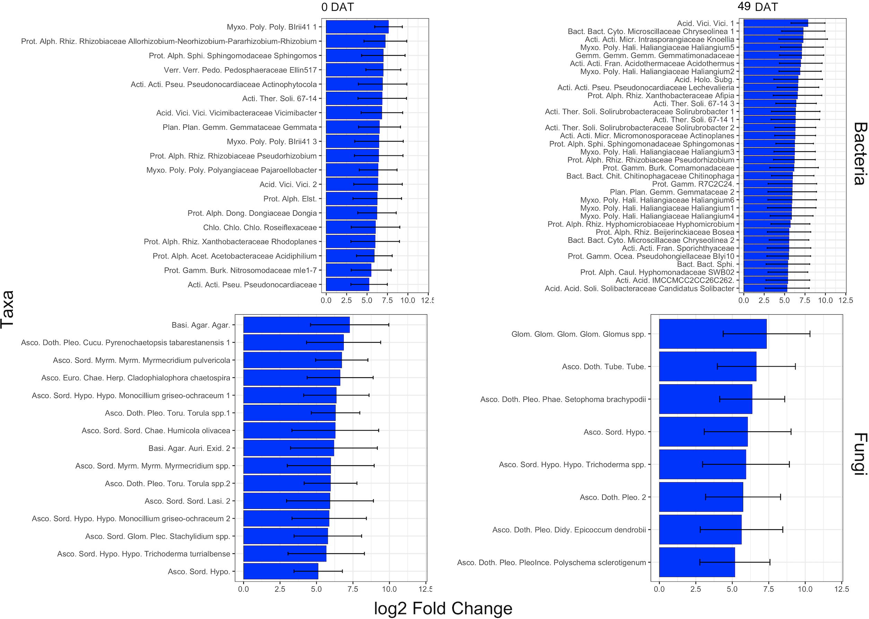
Figure S9. Taxa associated with B. brizantha within intercropping system when soil was sampled 0 or 49 DAT with log2 Fold Change greater the 5. See taxa abbreviation listed below.
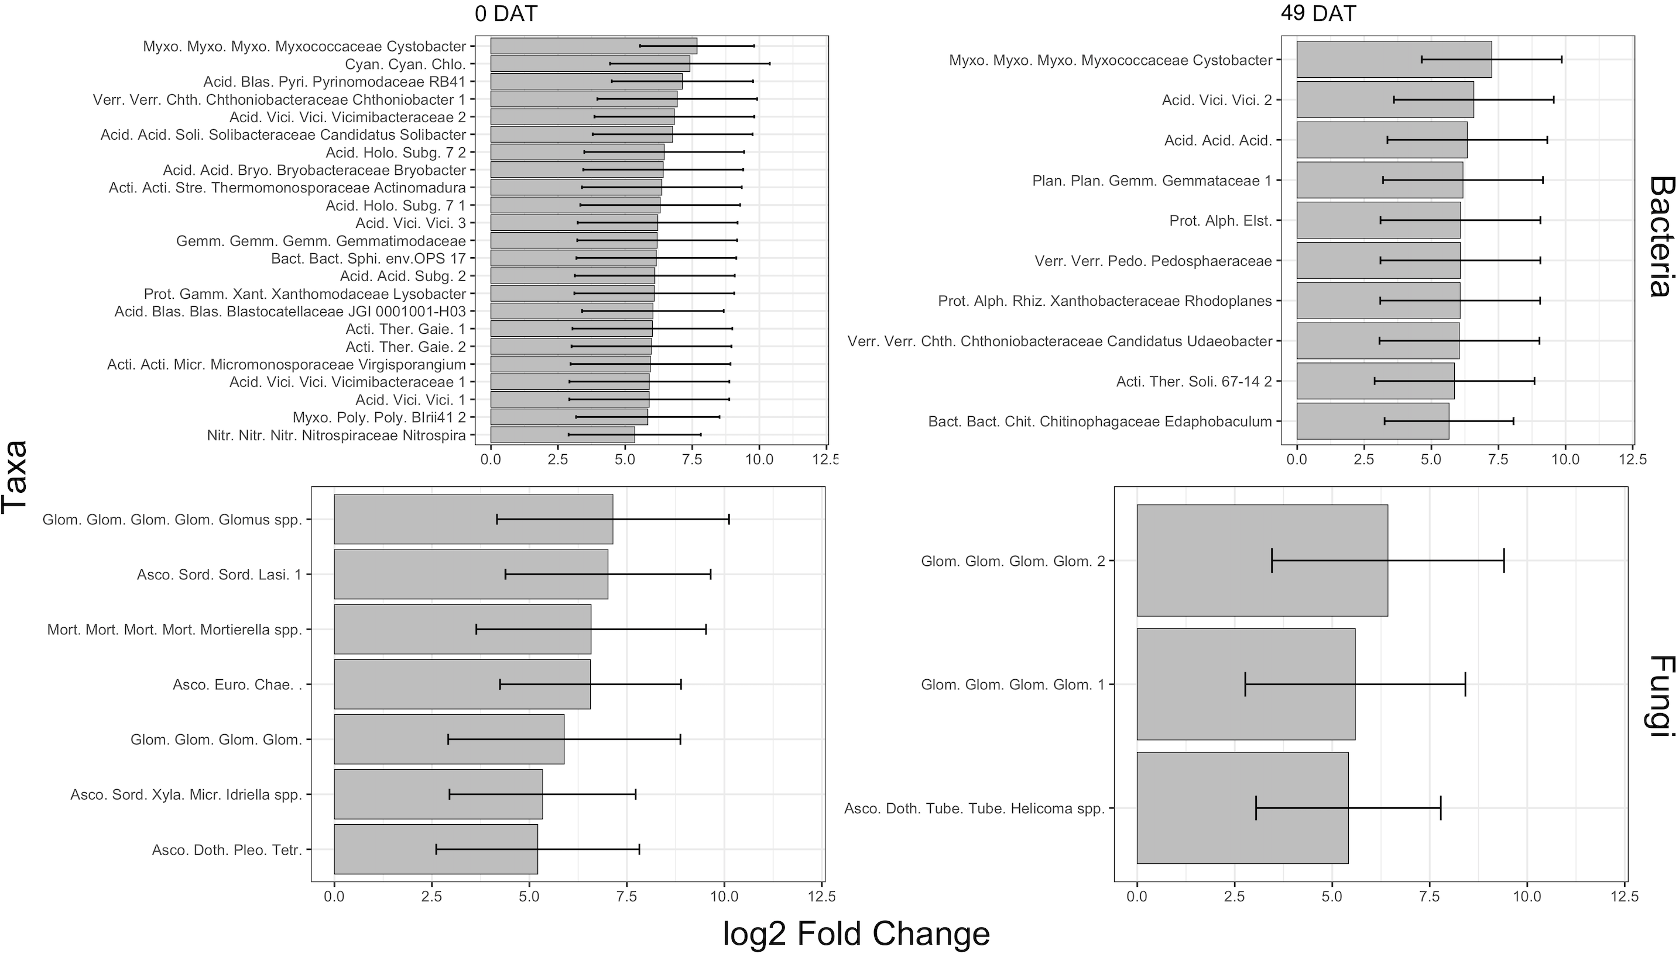
Figure S10. Taxa associated with B. humidicola within intercropping system when soil was sampled 0 or 49 DAT with log2 Fold Change greater the 5. See taxa abbreviation listed below.

Taxa abbreviation list
Bacteria taxonomy abbreviation for phylum are Acid.: Acidobacteriota; Acti.: Actinobacteriota; Bact.: Bacteroidota; Chlo.: Chloroflexi; Cyan.: Cyanobacteria; Gemm.: Gemmatimonadota; Myxo.: Myxococcota; Nitr.: Nitrospirota; Plan.: Planctomycetota; Prot.: Proteobacteria; Verr.: Verrucomicrobiota. Class abbreviation are Acid.: Acidobacteriae; Acti.: Actinobacteria; Alph.: Alphaproteobacteria; Bact.: Bacteroidia; Blas.: Blastocatellia; Chlo.: Chloroflexia; Cyan.: Cyanobacteriia; Gamm.: Gammaproteobacteria; Gemm.: Gemmatimonadetes; Holo.: Holophagae; Myxo.: Myxococcia; Nitr.: Nitrospiria; Plan.: Planctomycetes; Poly.: Polyangia; Ther.: Thermoleophilia; Verr.: Verrucomicrobiae; Vici.: Vicinamibacteria. Order abbreviation are Chit.: Chitinophagales; Cyto.: Cytophagales; Fran.: Frankiales; Gaie.: Gaiellales; Gamm.: Gammaproteobacteria Incertae Sedis; Hali.: Haliangiales; Micr.: Micromonosporales; Micr.: Microtrichales; Pire.: Pirellulales; Poly.: Polyangiales; Prop.: Propionibacteriales; Pseu.: Pseudomonadales; Rhiz.: Rhizobiales; Soli.: Solibacterales; Sphi.: Sphingobacteriales; Ster.: Steroidobacterales; Vici.: Vicinamibacterales; Xant.: Xanthomonadales.

Fungi taxanomy abbreviation for Phylum are Asco.: Ascomycota; Basi.: Basidiomycota; Glom.: Glomeromycota; Mort.: Mortierellomycota; Olpi.: Olpidiomycota. Classes: Agar.: Agaricomycetes; Doth.: Dothideomycetes; Euro.: Eurotiomycetes; Gemi.: Geminibasidiomycetes; Glom.: Glomeromycetes; Leca.: Lecanoromycetes; Mort.: Mortierellomycetes; Olpi.: Olpidiomycetes; PeziInce.: Pezizomycotina_cls_Incertae_sedis; Sacc.: Saccharomycetes; Sord.: Sordariomycetes; Sord.: Sordariomycetes. Order: Agar.: Agaricales; Annu.: Annulatascales; Auri.: Auriculariales; Cant.: Cantharellales; Capn.: Capnodiales; Chae.: Chaetothyriales; Gemi.: Geminibasidiales; Glom.: Glomerellales; Hypo.: Hypocreales; Mort.: Mortierellales; Myrm.: Myrmecridiales; Olpi.: Olpidiales; Pelt.: Peltigerales; PeziInce.: Pezizomycotina_ord_Incertae_sedis; Phal.: Phallales; Pleo.: Pleosporales; Sacc.: Saccharomycetales; Sord.: Sordariales. Family: Annu.: Annulatascaceae; Bion.: Bionectriaceae; Bion.: Bionectriaceae; Chae.: Chaetomiaceae; Chae.: Chaetomiaceae; Clad.: Cladosporiaceae; Clav.: Clavicipitaceae; Cucu.: Cucurbitariaceae; Didy.: Didymellaceae; Ento.: Entolomataceae; Exid.: Exidiaceae; Gemi.: Geminibasidiaceae; Glom.: Glomeraceae; Herp.: Herpotrichiellaceae; Hypo.: Hypocreaceae; HypoInce.: Hypocreales_fam_Incertae_sedis; Lasi.: Lasiosphaeriaceae; Lent.: Lentitheciaceae; Lipo.: Lipomycetaceae; Micr.: Microdochiaceae; Micr.: Microdochiaceae; Mort.: Mortierellaceae; Myrm.: Myrmecridiaceae; Nect.: Nectriaceae; Olpi.: Olpidiaceae; Pann.: Pannariaceae; PeziInce.: Pezizomycotina_fam_Incertae_sedis; Phae.: Phaeosphaeriaceae; Phal.: Phallaceae; Plec.: Plectosphaerellaceae; Pleo.: Pleosporaceae; PleoInce.: Pleosporales_fam_Incertae_sedis; Tetr.: Tetraplosphaeriaceae; Toru.: Torulaceae; Tube.: Tubeufiaceae

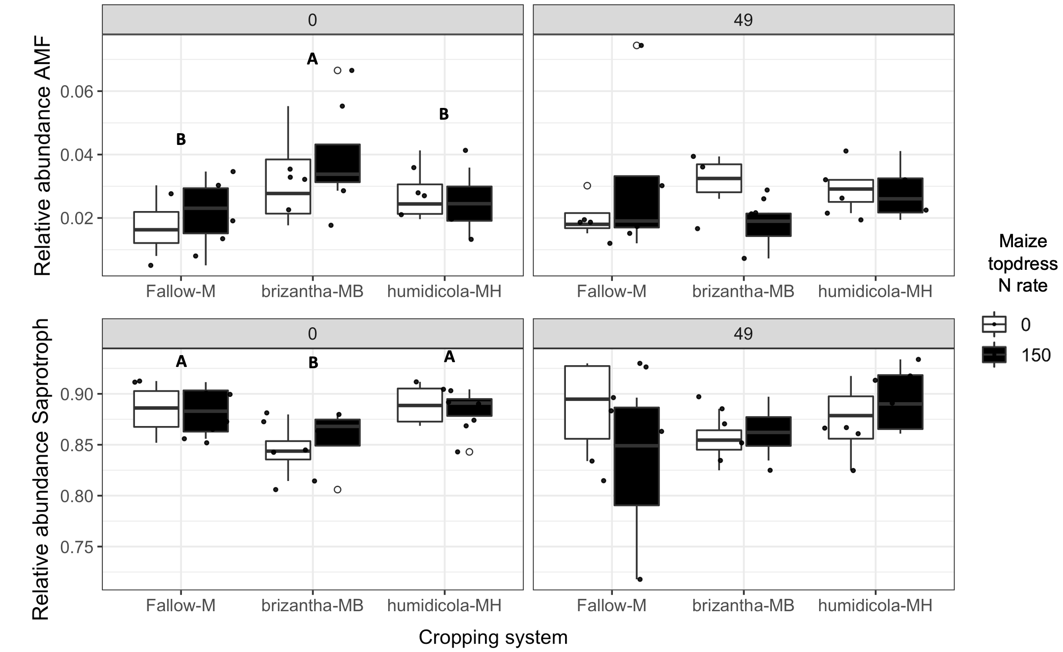
Figure S11. Relative abundance of saprotrophs and AMF as affected by the cropping system (Fallow-M: maize monocrop; brizantha – MB: maize intercropped with B. brizantha; and humidicola-MH: maize intercropped with B. humidicola) and maize topdress N rate (0 and 150 kg ha⁻¹) in two different time-points of soil sampling: 0 and 49 days after cover crop termination. The capital letter on the boxplot represents the statistical difference between the interaction of cropping system with N rate (Tukey test; p<0.05). The full circles represent the actual measurement for each treatment while the empty circle represents the outliers, the horizontal mark on the boxplot represent the median and the bars represent the maximum and minimum values.
Table S1. Distribution of gas sampling dates over the maize harvest season referenced to important agronomical events: days after cover crop termination (DAT), days after maize sowing (DAS) and days after fertilization (DAF).

