Supplementary Material

The Landscape of Actionable Genomic Alterations by Next-Generation Sequencing in Tumor Tissue versus Circulating tumor DNA in **Chinese Patients with** Non-Small Cell Lung Cancer

**Jun Cai1,**†**, Huihui Jiang2,**†**, Shuqing Li3, Xiaoxia** **Yan2,** **Meng Wang1****, Na Li1****, Cuimin Zhu****4, Hui Dong****4, Dongjuan Wang4, Yue Xu2, Hui Xie2, Shouxin Wu2,*,** **Jingwei Lou2,*,** **Jiangman Zhao2,*, Qingshan Li4,\***

1Department of Oncology，First Affiliated Hospital of Yangtze University, Jingzhou, Hubei Province, China

2Zhangjiang Center for Translational Medicine, Shanghai BiotecanPharmaceuticals Co., Ltd., 180 Zhangheng Road, Shanghai, China

3Department of general surgery, Yucheng Hospital of Traditional Chinese Medicine, 601Kaituo Road, Yucheng City, Dezhou City, Shandong Province, China

4Department of oncology, Affiliated Hospital of Chengde Medical University, Nan Ying Zi street, Chengde, Hebei province, China.

**\*Correspondence:**Qingshan Li

libing200865@126.com

Jiangman Zhao

zhaojiangman86@163.com

Jingwei Lou

jingweilou@biotecan.com

Shouxin Wu

swu@biotecan.com

†These authors have contributed equally to this work

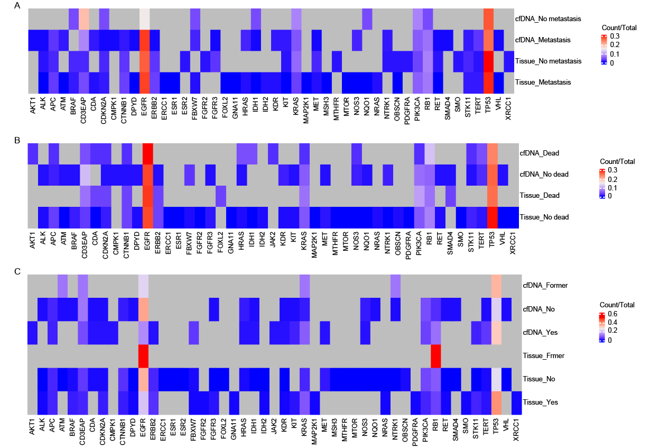 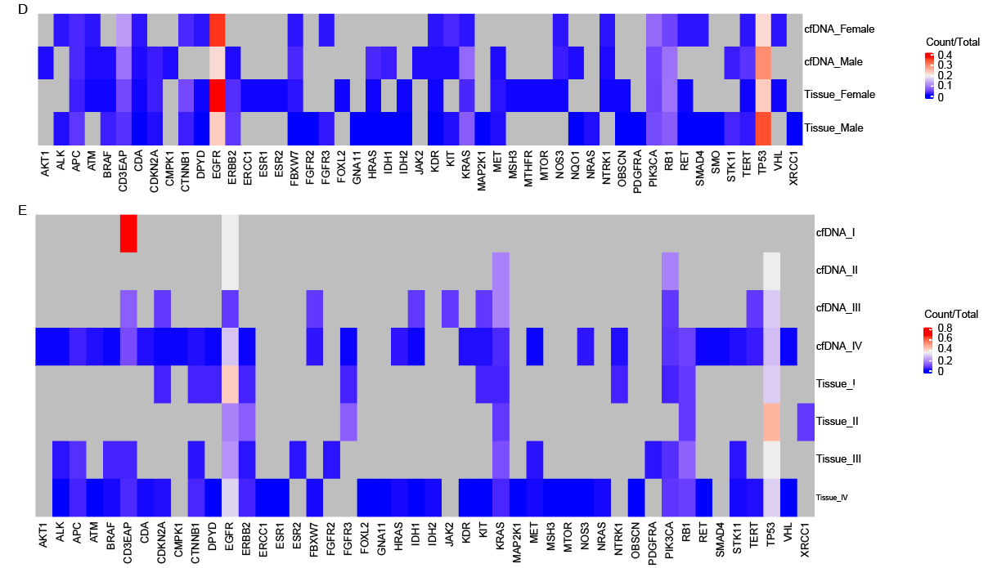

Supplementary **figure 1.** Concordance of genomic subtyping derived from tissue DNA or cfDNA in NSCLC patients with organ metastasis **(A)**, survival **(B)**, smoking **(C)**, gender **(D)**, and disease stage **(E)**.

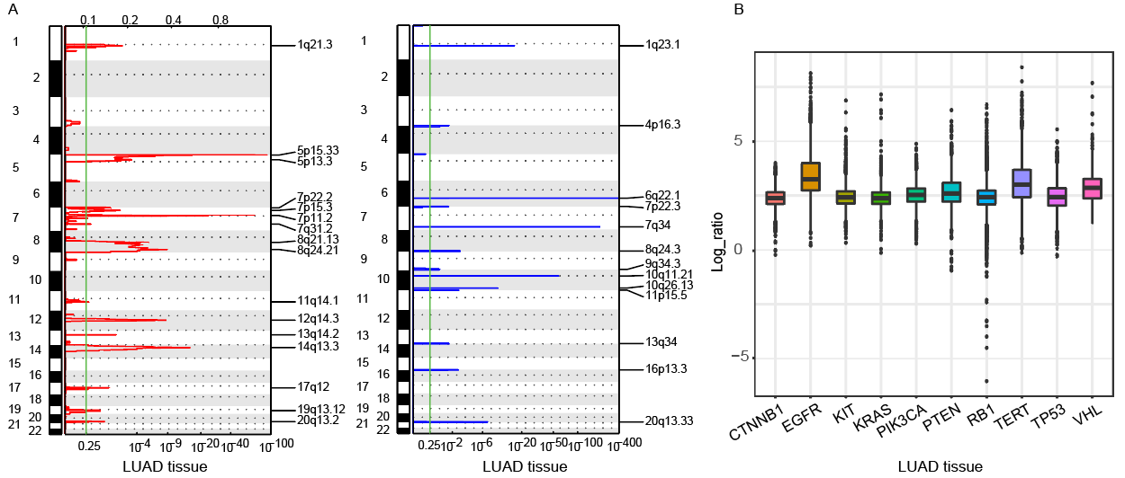 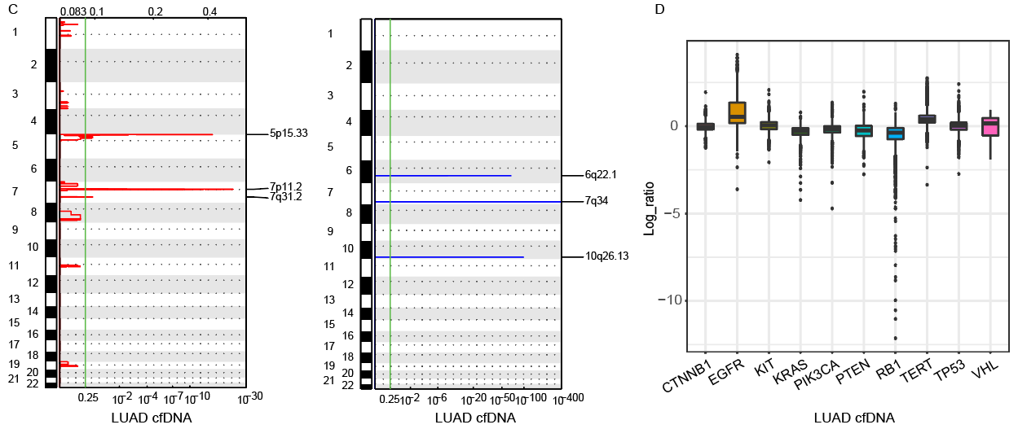

Supplementary **figure 2.** Somatic copy number alterations (SCNAs) of lung adenocarcinoma derived fromNGS of tumor tissue samples (A, B) and cfDNA (C, D). (A) The significant peaks of copynumber gain (left)and significant peaks of copynumber loss(right)in lung adenocarcinoma tissue samples are plotted by chromosomal location (vertical axis) by CNVkit. (B) The 10 genes were examined by the hybridization capture-based NGS panel of 95 genes in lung adenocarcinoma tissue samples. (C) The significant peaks of copynumber gain (left)and significant peaks of copynumber loss(right)in lung adenocarcinoma plasma samples are plotted by chromosomal location (vertical axis) by CNVkit. (D) The 10 genes were examined by the hybridization capture-based NGS panel of 95 genes in lung adenocarcinoma plasma samples.

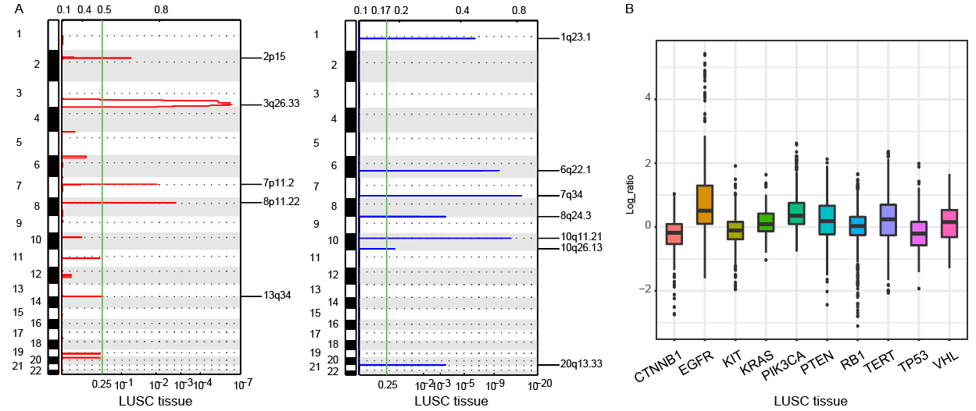 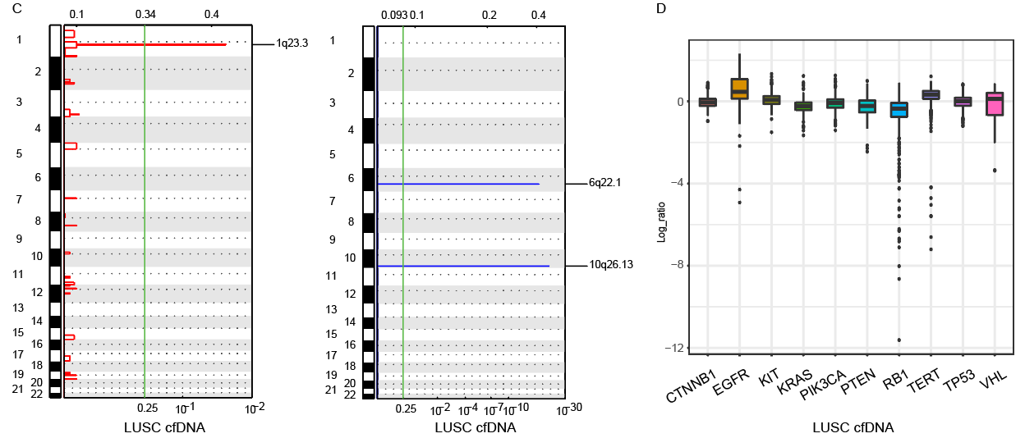

Supplementary **figure 3.** Somatic copy number alterations (SCNAs) of lung squamous carcinoma derived fromNGS of tumor tissue samples (A, B) and cfDNA (C, D). (A) The significant peaks of copynumber gain (left)and significant peaks of copynumber loss(right)in lung squamous carcinoma tissue samples are plotted by chromosomal location (vertical axis) by CNVkit. (B) The 10 genes were examined by the hybridization capture-based NGS panel of 95 genes in lung squamous carcinoma tissue samples. (C) The significant peaks of copynumber gain (left)and significant peaks of copynumber loss(right)in squamous carcinoma plasma samples are plotted by chromosomal location (vertical axis) by CNVkit. (D) The 10 genes were examined by the hybridization capture-based NGS panel of 95 genes in lung squamous carcinoma plasma samples.

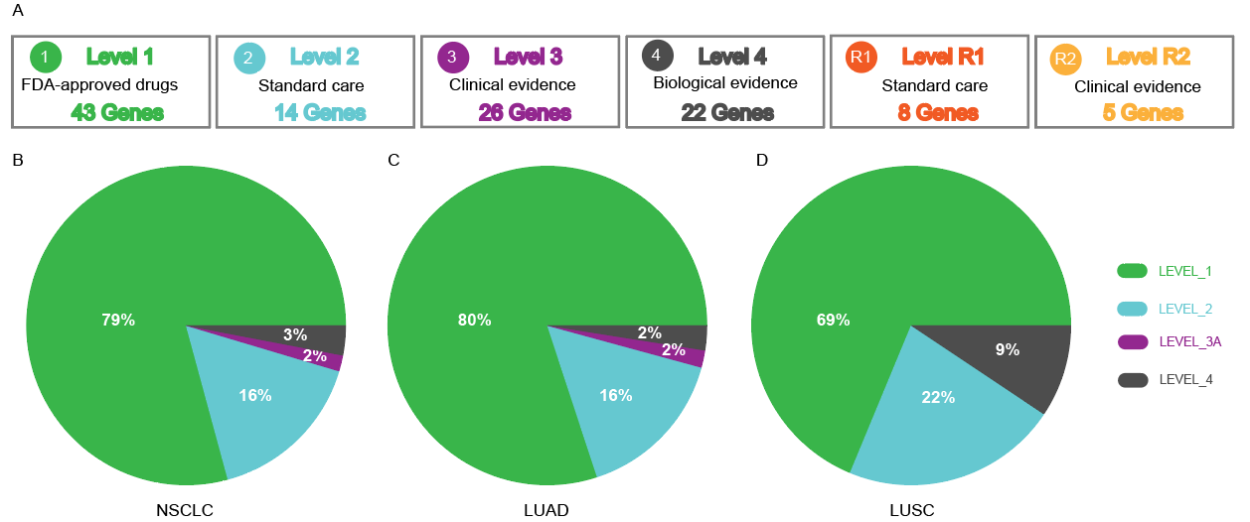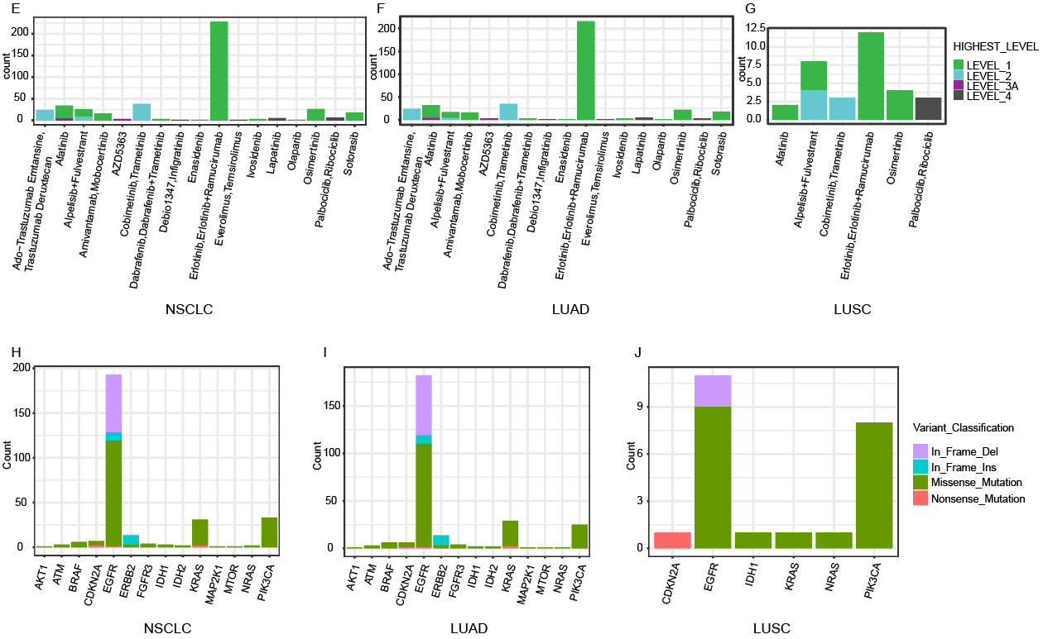

Supplementary **figure 4.** Clinical action ability of somatic mutations revealed by the hybridization capture-based NGS panel of 95 genes. Somatic mutations were defined based on their clinical evidence in terms ofOncoKB (A). Samples were matched to the highest level of actionable alterations in NSCLC (n=395) (B)**,** LUAD (n=340) (C), and LUSC (n=54) (D). Distribution ofactionable alterations in NSCLC (n=395) (E)**,** LUAD (n=340) (F), and LUSC (n=54) (G). Distribution ofalteration types in NSCLC (H)**,** LUAD (I), and LUSC (J).