Supplementary Material

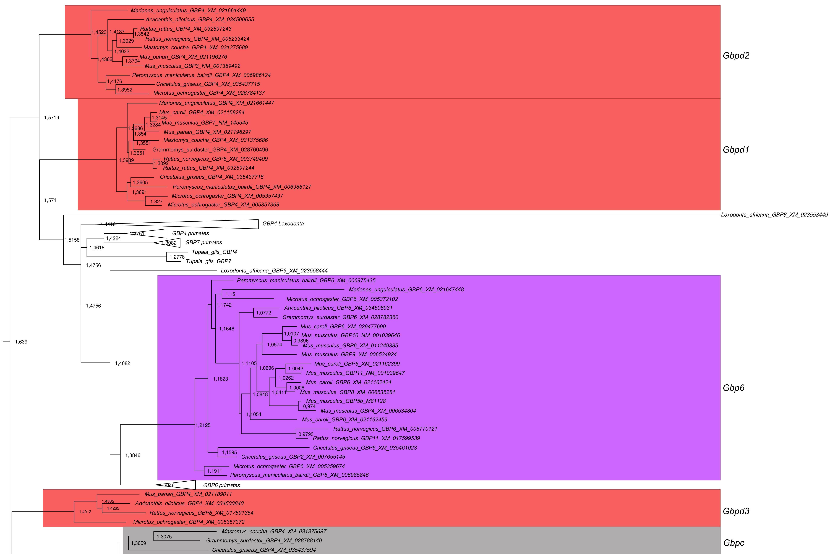

# Supplementary Figure 3.1. Bayesian inference of *Gbp* phylogeny in Muridae and Cricetidae. The tree is drawn to scale with branch length measuring the number of amino acid substitutions per site and using the midpoint root criterion. The model used for BEAST analysis was JTT+G+I+F (gamma model + proportion of invariant sites + empirical frequencies). This part contains *Gbpd* (red)*, c* (grey)and *Gbp6* (purple), additionally sequences of *GBP4*, *6* and *7* of primates are also present.

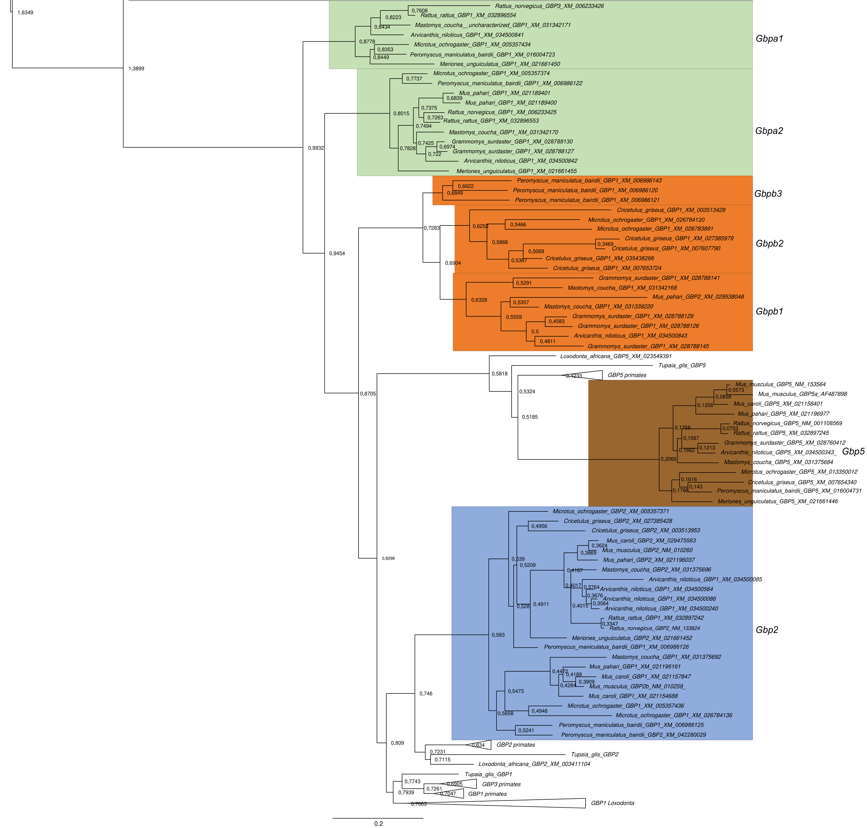

**Supplementary Figure 3.2. Bayesian inference of *Gbp* phylogeny in Muridae and Cricetidae.** The tree is drawn to scale with branch length measuring the number of amino acid substitutions per site and using the midpoint root criterion. This part contains *Gbpa* (green), *Gbpb* (orange), *Gbp2* (blue) and *Gbp5* (brown). Primates *GBP2* and *5* are also depicted.