**Supplemental Material**

Remote Chemical Sensing by SERS with Self-Assembly Plasmonic Nanoparticle Arrays on a Fiber

Xin Zhang1, Kunyi Zhang1, Hasso von Bredow3, Christopher Metting3, George Atanasoff3, Robert M. Briber1, Oded Rabin1,2*

1Department of Materials Science and Engineering, University of Maryland, College Park, MD, USA

2Institute of Research in Electronics and Applied Physics, University of Maryland, College Park, MD, USA

3Accustrata, Inc., Rockville, MD, USA

**\* Correspondence:**Prof. Oded Rabin  
oded@umd.edu

**Calculation of the SERS enhancement factor for acquisition via a fiber optic**

**Calculation of Full Acceptance Angle**

 the numerical aperture of the fiber (source: Edmund Optics)

$n_{dry}=1.55$ estimated index of refraction of the block-copolymer (source: materials.alfachemic.com)

$n_{liquid}=1.45$ index of refraction of pentanediol (source: Sigma Aldrich, sigma.com)

$n_{liquid}=1.442 @ 633nm$ index of refraction of pentanediol (source: refractiveindex.info)



 

Assumption #1: The nanoparticle array does not affect the index of refraction.

The Full Acceptance Angle in solution is 17.5 degrees. The Full Acceptance Angle in polymer is 16.3 degrees.

**Model Definitions:**

**A Cartesian coordinate system is aligned with the fiber such that the x-axis is parallel to the fiber axis near the tip of the fiber (Figure S1) and normal to the fiber tip surface. The origin is placed at the tip of the illumination cone.**

 – Radius of the core of the fiber.

 – The distance from the fiber tip surface to the tip of the illumination cone.

 – The axial (horizontal in Fig. S1) distance from the tip of illumination cone.

 – The radial (vertical in Fig. S1) distance from the tip of illumination cone.

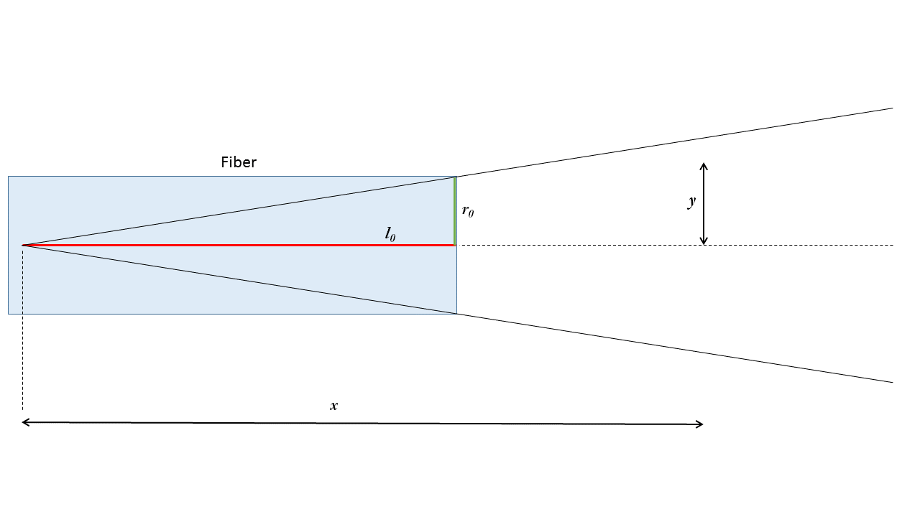

Figure S1: Model of illumination in front of fiber tip. The tip surface is at a distance  from the origin (tip of cone). The radius of the fiber is .

**Model for the distribution of the excitation light intensity in the liquid in front of the fiber tip**

Assumption #2: The intensity of the excitation beam is uniform at the surface of the fiber tip. Each point at the fiber tip acts as a light point source. Photons emerge from the point sources at all angles between  in equal probability.

– Light intensity at the tip of the fiber

A molecule at position  may interact with photons emerging from a point source at location (${x_{src}= l}_{0},y_{src}$) if point  is inside the cone with central angle projecting from the point source into the liquid in front of the fiber tip. This divides space into 4 zones are shown in Figure S2:

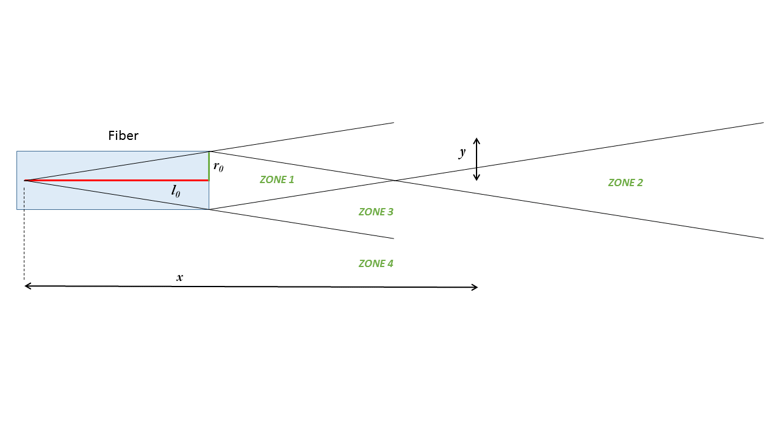

Figure S2: The 4 zones of illumination in front of the fiber tip. Raman-active molecules in the liquid experience different photon fluxes depending on their location.

Zone 2 – Every position  receives photons from all the point sources.

Zone 1 – Each position  receives photons from a subgroup of point sources. The number of point sources illuminating a position  is independent of .

Zone 3 – Each position  receives photons from a subgroup of point sources. The number of point sources illuminating a position  decreases as increases.

Zone 4 – No photons.

The flux of photons reaching position  is calculated by numerical integration:

$A\left(x,y\right)=\int_{0}^{2π}{d∅\int_{0}^{r_{0}}{rdrδ_{angle}\frac{1}{{\left|d_{12}\right|}^{2}}}}A_{0}$, where $d_{12}$ is the vector from the source point at ($l_{0},r,∅$) to the point at ($x,y$), and $δ_{angle}=0 or 1$ for the angle between $\overline{d_{12}} and \hat{x}$ greater or lower than $θ_{max}^{liquid}$, respectively.

**Modeling the probability of collecting a scattered photon from the liquid in front of the fiber tip**

The probability of a photon scattered at location hitting the tip of the fiber at an angle lower than $θ_{max}^{liquid}$ with respect to the fiber axis, is calculated as the ratio of the *relevant* cross-section area of the fiber to the surface of a sphere with radius $(x-l_{0})$. The *relevant* cross-section area of the fiber is the intersection of the cross-section area of the fiber (i.e. circle with radius *r0*) and a cone emerging from point  with central angle $2θ_{max}^{liquid}$ (i.e. circle with radius $(x-l_{0})\tan{θ}$). The intersection is round or lens-shaped depending on the offset between the centers of the circles, given by .



where, the function ${Area}_{lens}^{}\left(d,r,R\right)$ is the intersection area of two circles with radii  and , whose centers are separated by distance .



[Source: Wolfram, https://mathworld.wolfram.com/Circle-CircleIntersection.html]

The maximum value of , for points located near the surface of the tip of the fiber, is only 0.00627, due to the small acceptance angle of the fiber.

**Calculation of the effective Raman signal from a liquid**

Assumption #3: All photons have equal probability to undergo Raman scattering.

Assumption #4: Scattered photons are emitted in random directions.

 represents the contribution of each position in the liquid to the Raman signal under the above assumptions. The total signal  is obtained by integrating over the whole volume of the liquid in zones 1-3. Using cylindrical symmetry,



where  is the concentration of the Raman-active molecule in .

**Numerical Estimation**: For  , using a grid of dimensions  in front of the fiber tip, 

**Calculation of probability of collecting a Raman photon from the nanoparticle array**

All the SERS-active molecules are on the nanoparticles at the tip, i.e. at location $(x\sim l_{0})$.

The probability of capturing a scattered photon is 0.00627 (see above).

The excitation light intensity at the location of the nanoparticles is where is the thickness of the polymer film (25nm).



where  is the effective concentration of the SERS-active molecule in .

**Numerical Estimation**: For ,



**Summary**

Under the same acquisition conditions, the signals of SERS and Raman are related by the model as:



**Numerical Estimation**:











With only 50%-70% of the tip surface functionalized with nanoparticles, 



**Calculation of the SERS Enhancement Factor**



where  is the experimental measured counts, and  is the acquisition time.