Table S1 List of haplotypes used in the molecular phylogenetic analysis with GenBank accession numbers for each gene.

|  |  |  |
| --- | --- | --- |
| Taxon | Haplotypes | Accession numbers |
| **nr28 rRNA** | | |
| *A. lischkeana* | Hap1 | MZ493692 |
| *A. pectinata* | Hap2 | MZ493694 |
|  | KU987186 | KU987186* |
| *Atrina sp.* | Hap3 | MZ493693 |
| *A. japonica* |  | HM015782* |
| *A. chinensis* |  | HM015780* |
| *A. exusta* |  | KU987174* |
| *A. hystrix* |  | KJ366078* |
| *A. vexillum* |  | KU987197* |
| *A. inflata* |  | KU987181* |
| *A. rigida* |  | KJ366076* |
| *P. bicolor* |  | JN182981* |
| **mtCOI** | | |
| *A. lischkeana* | Hap1 | MZ490947 |
|  | Hap2 | MZ490948 |
|  | Hap3 | MZ490949 |
|  | Hap4 | MZ490950 |
|  | Hap5 | MZ490951 |
|  | Hap6 | MZ490952 |
|  | Hap7 | MZ490953 |
|  | Hap8 | MZ490954 |
|  | Hap9 | MZ490955 |
|  | Hap10 | MZ490956 |
|  | Hap11 | MZ490957 |
|  | Hap12 | MZ490958 |
|  | Hap13 | MZ490959 |
|  | Hap14 | MZ490960 |
|  | Hap15 | MZ490961 |
|  | Hap16 | MZ490962 |
|  | Hap17 | MZ490963 |
|  | Hap18 | MZ490964 |
|  | Hap19 | MZ490965 |
|  | Hap20 | MZ490966 |
|  | Hap21 | MZ490967 |
|  | Hap22 | MZ490968 |
|  | Hap23 | MZ490969 |
|  | LC191940 | LC191940* |
|  | LC191942 | LC191942* |
|  | LC191943 | LC191943* |
|  | LC191944 | LC191944* |
|  | LC191945 | LC191945* |
|  | LC191946 | LC191946* |
|  | LC191947 | LC191947* |
|  | LC191948 | LC191948* |
|  | LC191949 | LC191949* |
|  | LC191950 | LC1919508* |
|  | AB059423 | AB059423* |
|  | MF378640 | MF378640* |
|  | MF378642 | MF378642* |
|  | MH536081 | MH536081* |
|  | MH536082 | MH536082* |
| *A. pectinata* | Hap24 | MZ490971 |
|  | Hap25 | MZ490970 |
|  | Hap26 | MZ490972 |
|  | Hap27 | MZ490973 |
|  | Hap28 | MZ490974 |
|  | Hap29 | MZ490975 |
|  | Hap30 | MZ490976 |
|  | Hap31 | MZ490977 |
|  | Hap32 | MZ490978 |
|  | Hap33 | MZ490979 |
|  | Hap34 | MZ490980 |
|  | Hap35 | MZ490981 |
|  | Hap36 | MZ490982 |
|  | Hap37 | MZ490983 |
|  | Hap38 | MZ490984 |
|  | Hap39 | MZ490985 |
|  | Hap40 | MZ490986 |
|  | Hap41 | MZ490987 |
|  | Hap42 | MZ490988 |
|  | Hap43 | MZ490989 |
|  | KU987231 | KU987231* |
|  | KU987232 | KU987232* |
|  | KU987234 | KU987234* |
|  | KU987235 | KU987235* |
|  | KU987236 | KU987236* |
|  | KU987237 | KU987237* |
|  | KU987238 | KU987238* |
|  | KU987239 | KU987239* |
| *Atrina sp.* | Hap44 | MZ490990 |
|  | Hap45 | MZ490991 |
|  | Hap46 | MZ490992 |
|  | Hap47 | MZ490993 |
|  | Hap48 | MZ490994 |
|  | Hap49 | MZ490995 |
|  | Hap50 | MZ490996 |
|  | Hap51 | MZ490997 |
|  | Hap52 | MZ490998 |
|  | Hap53 | MZ490999 |
|  | Hap54 | MZ491000 |
|  | Hap55 | MZ491001 |
|  | Hap56 | MZ491002 |
|  | Hap57 | MZ491003 |
|  | Hap58 | MZ491004 |
|  | Hap59 | MZ491005 |
|  | Hap60 | MZ491006 |
|  | Hap61 | MZ491007 |
|  | Hap62 | MZ491008 |
|  | Hap63 | MZ491009 |
|  | Hap64 | MZ491010 |
|  | Hap65 | MZ491011 |
|  | Hap66 | MZ491012 |
|  | Hap67 | MZ491013 |
|  | Hap68 | MZ491014 |
|  | Hap69 | MZ491015 |
|  | Hap70 | MZ491016 |
|  | Hap71 | MZ491017 |
|  | Hap72 | MZ491018 |
|  | Hap73 | MZ491019 |
|  | Hap74 | MZ491020 |
|  | Hap75 | MZ491021 |
|  | Hap76 | MZ491022 |
|  | Hap77 | MZ491023 |
|  | KJ366386 | KJ366386* |
| *A. japonica* | JN182705 | JN182705* |
|  | JN182708 | JN182708* |
|  | JN182710 | JN182710* |
|  | JN944103 | JN944103* |
|  | HM015786 | HM015786* |
|  | HM015790 | HM015790* |
| *A. chinensis* |  | JN182721* |
| *A. exusta* |  | KJ366476* |
| *A. hystrix* |  | KJ366369* |
| *A. vexillum* |  | KJ366323* |
| *A. inflata* |  | KJ366322* |
| *A. rigida* |  | KJ366468* |
| *P. bicolor* |  | JN182785* |
| **mt16S rRNA** | | |
| *A. lischkeana* | Hap1 | MZ486318 |
|  | Hap2 | MZ486319 |
|  | Hap3 | MZ486320 |
| *Atrina sp.* | Hap4 | MZ486321 |
| *A. pectinata* | Hap5 | MZ486315 |
|  | Hap6 | MZ486316 |
|  | Hap7 | MZ486317 |
|  | KU987084 | KU987084* |
|  | KU987088 | KU987088* |
|  | KU987089 | KU987089* |
| *A. japonica* |  | JN182765* |
| *A. chinensis* |  | JN182772* |
| *A. exusta* |  | KJ365710* |
| *A. hystrix* |  | KJ365562* |
| *A. vexillum* |  | KJ365711* |
| *A. inflata* |  | KJ365523* |
| *A. rigida* |  | KJ365702* |
| *P. bicolor* |  | JN182779* |

*Sequences were retrieved from GenBank.

**Figure S1 The analysis of ABGD.** Yellow box is the initial partition and the red box is recursive partition.

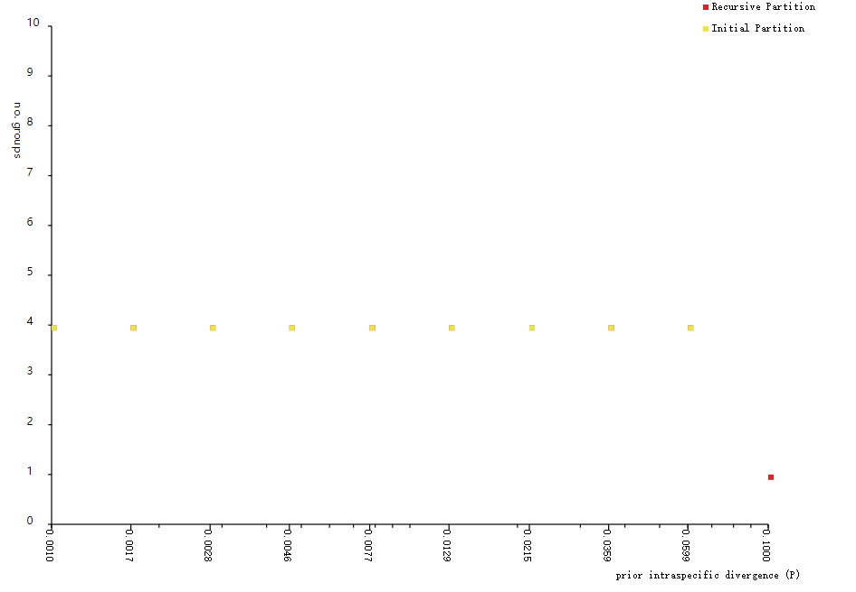

**Figure S2 The best optimal tree of bPTP identification.**

C:\Users\俊秀霖\Desktop\Figure S2.tif

**Figure S3 The relationship between time and species numbers based on GMYC analysis.** the number of species defined at the turning point of the rapidly rising branch length rate (Dotted line marker).

