Supplementary Material

Contents.
Text S1. Guidance provided to participants on collecting a sample.
Figure S1. A stacked phylum level bar chart displaying the percentage relative abundance profiles for the sequenced dust samples.
Figure S2. A stacked family level bar chart displaying the percentage abundance profiles for the sequenced dust samples.
Figure S3. Family level alpha diversity distribution box plots using Shannon and Simpson indices measuring sample richness and abundance grouped by location. Statistical significance tested using Wilcoxon rank-sum pairwise comparison.
Figure S4. A) the prevalence of the Greece unique core microbes in the UK samples, B) the prevalence of the UK unique core microbes in the Greece samples.
Table S1. Key characteristics of the homes in the pilot dataset, captured via the study questionnaire.
Table S2. Mean and standard deviation for Shannon and inverse Simpson diversity indices for samples from UK and Greece.

Text S1. Guidance provided to participants on collecting a sample
Collecting a sample is easy!
First, clearly label your sample bag with your address and the date the bag was filled and sealed. Note: this is sometimes easier to do BEFORE you fill your bag with dust.
Put the entire contents of your vacuum cleaner bag, or cylinder (or several cylinders worth if needed), into your re-sealable bag. Carefully release excess air and seal it up. You may prefer to fill your sample bag in a well-ventilated area and use a disposable mask if you are concerned about inhaling the dust.
We recommend that you place this bag into another bag, as this helps protect the label and protects against any leaks.
A useful video explaining the process in available here:
https://www.mapmyenvironment.com/sampling/

All that is left is for you to send us your vacuum dust sample! Please mail your sample to one of the locations detailed below. Once we receive your sample we will analyse it and email you back within 3-6 months with a bespoke report of the metals/trace elements within your dust sample.

THANK YOU from the Home Biome team
Home Biome is part of the Map My Environment initiative. Data from the Home Biome project can be viewed directly on our Global Map (https://iupui-earth-science.shinyapps.io/mme_global/)

[see https://www.mapmyenvironment.com/homebiome/home-biome-submission/]

Figure S1. A stacked phylum level bar chart displaying the percentage relative abundance profiles for the sequenced dust samples.

Figure S2. A stacked family level bar chart displaying the percentage abundance profiles for the sequenced dust samples.

Figure S3. Family level alpha diversity distribution box plots using Shannon and Simpson indices measuring sample richness and abundance grouped by location. Statistical significance tested using Wilcoxon rank-sum pairwise comparison.

Figure S4. A) the prevalence of the Greek unique core microbes in the UK samples, B) the prevalence of the UK unique core microbes in the Greece samples.
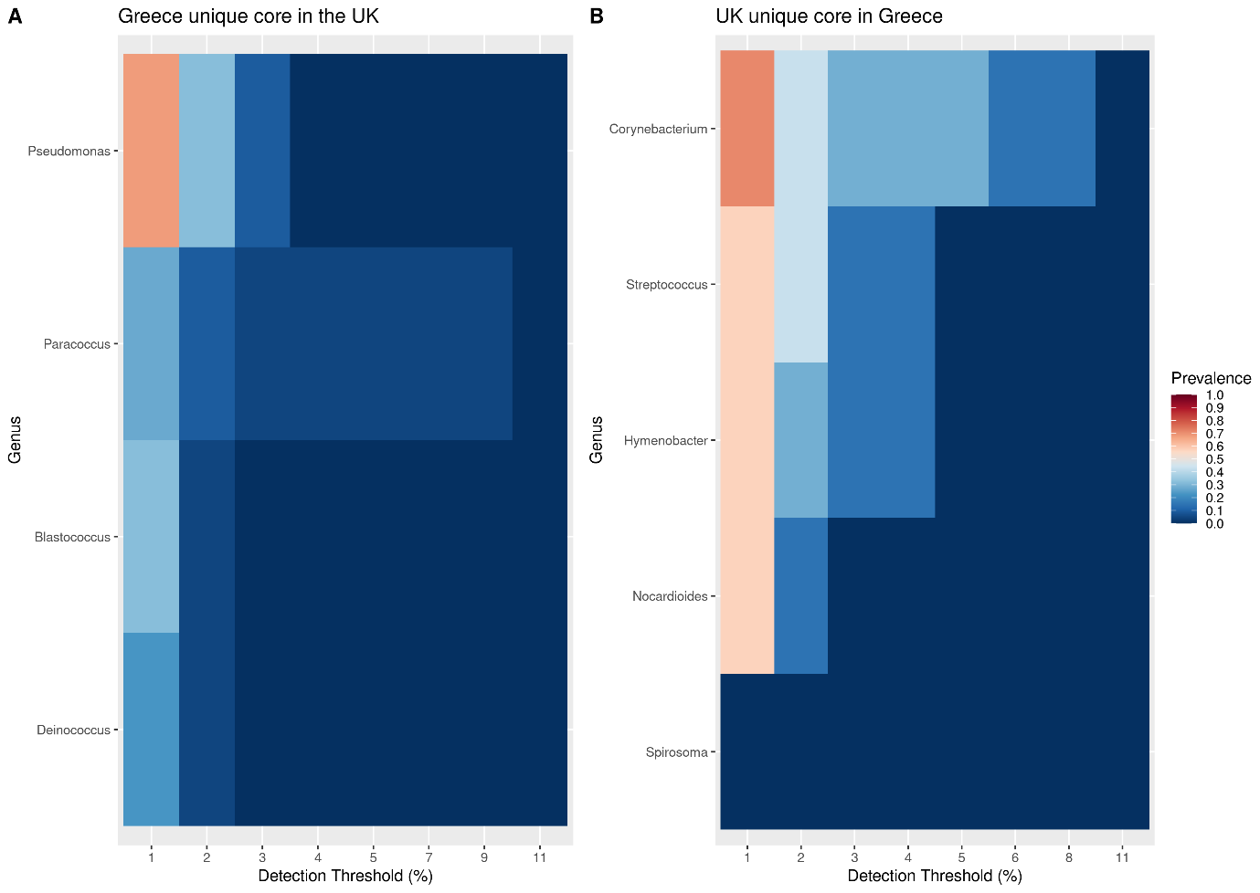

Table S1. Key characteristics of the homes in the pilot dataset, captured via the study questionnaire.
 | Season of sample  submission | Time period of vacuuming represented by the sample | Home Type | Home fabric | Occupant number | Male & Female occupants | Indoor smoker (y/n) | Pets (y/n) | Vacuum frequency (w/2m) | Outdoor vacuum use (c/g/w/p) | Home age | Primary heating | Dominant flooring | No garden
UK 13 | Summer | <4 weeks | SD | brick | 1 | 1F |  | y | 2m |  | 51-100 | Gas | Carpet
UK 50 | Summer | >1 month | D | brick | 2 | 1 F & 1 M |  |  | w | p | <40 y | Oil | Wood
UK 51 | Summer | >1 month | D | brick | 2 | 1 F & 1 M |  |  | w | p | <40 y | Oil | Wood
UK 54 | Summer | >1 month | D | stone/cement | 4 | 1 M & 3F |  | y | w | c,g,w,p | >100 | Oil | Wood
UK 70 | Autumn | <2 weeks | SD | brick | 6 | 2 M & 4 F |  |  | w | c | 51-100 | Gas | Carpet
UK 74 | Autumn | unknown | SD | brick & timber | 3 | 1 M & 2 F |  |  | 2m |  | 51-100 | Gas | Wood
UK 75 | Autumn | unknown | SD | brick | 4 | 2 M & 2 F |  | y | w |  | 51-100 | Gas | Carpet
UK 79 | Autumn | unknown | SD | brick | 4 | 3 M & 1 F |  | y | w |  | 51-100 | Gas | Carpet
UK 109 | Autumn | unknown | SD | brick & timber | 1 | 1 M |  |  | w | c | 51-100 | Gas | Carpet
UK 110 | Autumn | unknown | SD | brick | 3 | 1 M & 2 F |  | y | w |  | 51-100 | Gas | Carpet
GR 144 | Summer/  Autumn | >1 month | D | brick | 4 | 2 M & 2 F |  |  | w |  | <40 y | Gas | Wood
GR 146 | Summer/  Autumn | >1 month | SD | brick | 4 | 2M, 1F, 1 other |  |  | w |  | <40 y | Other | Tiled
GR 147 | Summer/  Autumn | >1 month | F | brick | 4 | 1 M & 3F |  |  | w |  | <40 y | Oil | Tiled | y
GR 149 | Summer/  Autumn | >1 month | F | brick | 3 | 2 M & 1 F | y |  | w |  | 50-40 y | Gas | Wood | y
GR 150 | Summer/  Autumn | <4 weeks | F | brick | 3 | 1 M & 2 F | y |  | w |  | <40 y | Wood | Tiled
GR 155 | Summer/  Autumn | <1 week | F | brick | 1 | 1 F |  |  | 2m |  | 50-40 y | Gas | Wood
GR 159 | Summer/  Autumn | < 1 week | SD | brick | 5 | 3 M & 2 F | y |  | w | c | <40 y | Electricity | Carpet
UK 165 | unknown | < 2 weeks | D | brick & timber | 4 | 2 M & 2 F |  | y | 2m | c | <40 y | Gas | Wood
UK 166 | unknown | >1 month | D | brick, stone/cement | 5 | 1 M & 4 F |  | y | w | c | 51-100 | Gas | Wood
UK 167 | unknown | >1 month | D | brick & stone/cement & timber | 2 | 1 F & 1 M |  |  | w | c | 51-100 | Gas | Other
UK 168 | unknown | <4 weeks | SD | brick | 4 | 2 M & 2 F |  |  | w | w | >100 | Gas | Carpet
UK 169 | unknown | <1 week | SD | brick & stone/cement & timber | 1 | 1 M |  |  | w | c | 51-100 | Gas | Carpet | y
UK 170 | unknown | <2 weeks | SD | brick | 2 | 1 F & 1 M |  | y | 2m |  | 51-100 | Gas | Wood
UK 176 | unknown | <2 weeks | D | brick | 1 | 1 F | y |  | 2m |  | <40 y | Oil | Carpet
UK 179 | unknown | >1 month | SD | brick | 3 | 2 M & 1 F | y | y | w |  | >100 | Gas | Wood
UK 181 | Winter | >1 month | D | stone/cement | 4 | 2 M & 2 F |  |  | w | c, g | <40 y | Oil | Carpet
UK 182 | Winter | <1 week | D | brick | 5 | 2 M & 2 F |  |  | w | g | <40 y | Gas | Carpet
Notes: UK = sample from UK; GR = sample from Greece; no meta-data (other than NE location) available for UK dust sample A1.
D= detached freestanding house, SD= semi-detached joined house, F=unit or flat;
w= weekly or more, 2m= twice a month;
c= car, g=garage, w=workshop, p=porch

Table S2. Mean and standard deviation for Shannon and inverse Simpson diversity indices for samples from UK and Greece.
 | Diversity Index
 | Shannon |  |  |  | Inverse Simpson
 | Mean | SD |  | Mean |  | SD
UK | 4.37 | 0.35 |  | 43.18 |  | 16.24
Greece | 3.58 | 0.53 |  | 17.56 |  | 11.37

