Supplementary Material
Figure S1 Validation of the transcriptome data. (A) The results from RNA-seq analysis were compared with those from qPCR. Bars represent the mean ± SD (n=3). (B) Comparison and log2 expression of 12 selected differentially regulated genes from infected kiwifruit as measured by RNA-Seq and qPCR. Positive and negative log₂ expression ratios represent up- and downregulation, respectively, compared with uninfected kiwifruit.

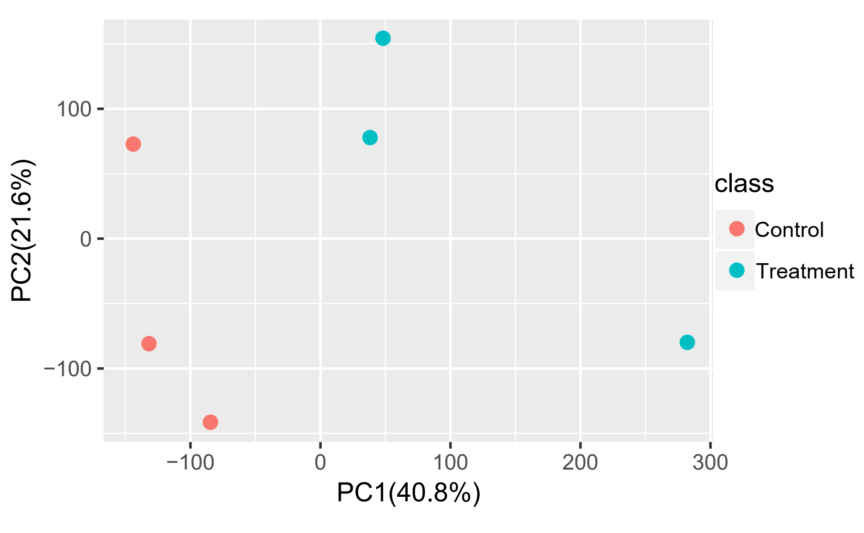
Figure S2 Principal component analysis (PCA) of metabolite and gene expression data. ‘Jinkui’ leaves were sampled from the control and infected plants after inoculation at 1 dpi.

Figure S3 Correlation analysis performed at the transcriptome and proteome levels. According to the expression trend of protein level and mRNA level, the correlation between mRNA with the same change trend and protein was analyzed.

Figure S4 GO (A) and KEGG (B) enrichment of differentially expressed genes (DEGs) of ‘Jinkui’ leaves at 1 dpi of Psa.

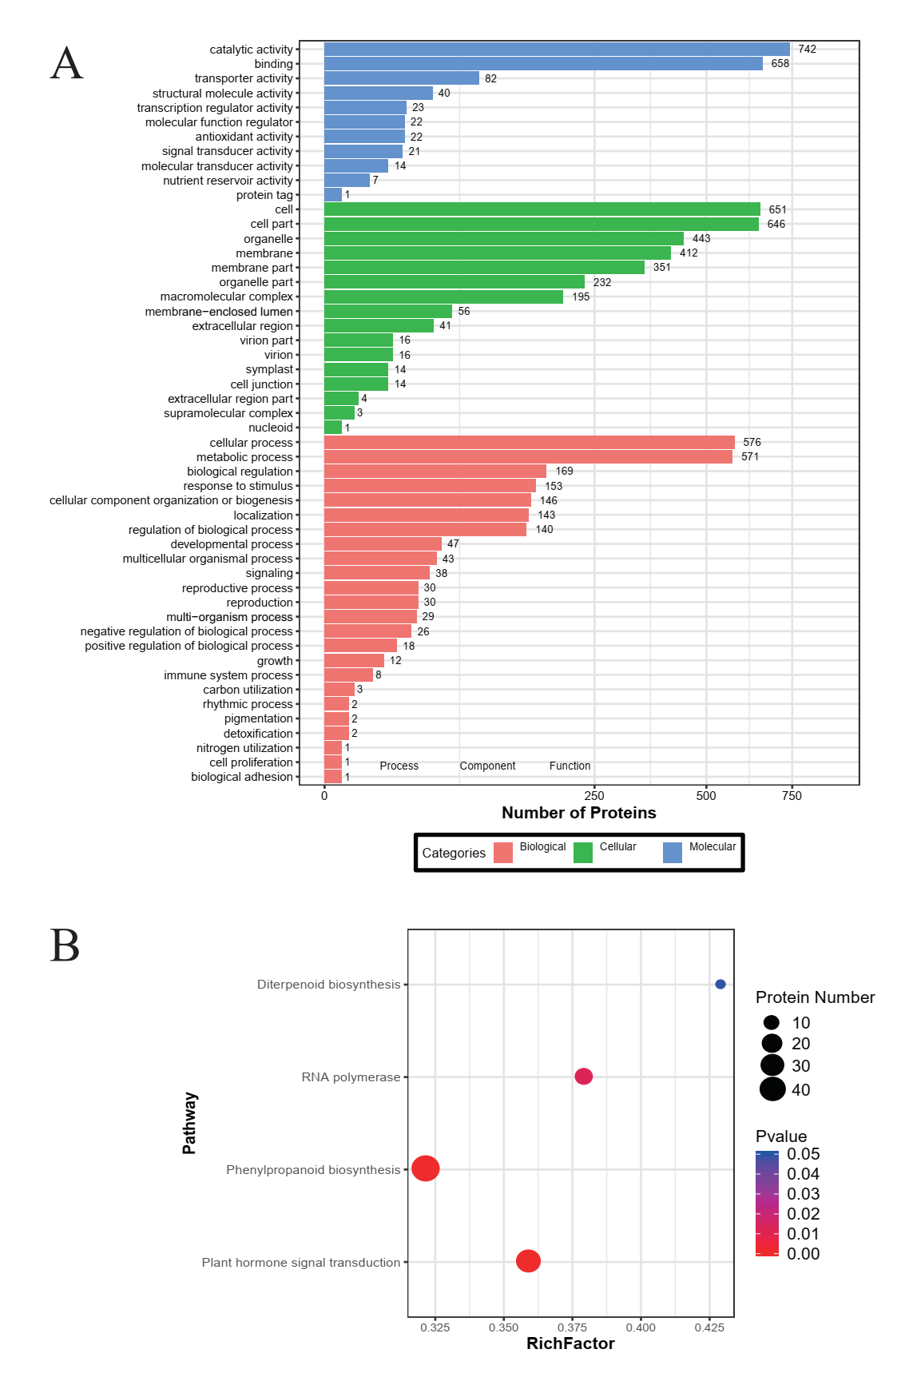
Figure S5 GO (A) and KEGG (B) enrichment of differentially expressed proteins (DAPs) in ‘Jinkui’ leaves at 1 dpi of Psa.

Figure S6 Phylogeny of R2R3-MYB TFs from subgroup 4 R2R3-MYB TFs from Arabidopsis, F. tataricum, and C. morifolium. The phylogenetic tree is based on the alignment of complete protein sequences.
Figure S7 Amino acid sequence alignment of a clade of subgroup 4 R2R3-MYB TFs. Sequences were aligned using Clustal W and MEGA version 7.
Table S1 Sequences of primers used in qRT-PCR analysis.
Table S2 Differentially expressed genes (DEGs, |log₂ fold change| > 1, P < 0.05) were identified in A. c. var. deliciosa cultivar ‘Jinkui’ after inoculation with Psa.
Table S3 Protein profile analysis produced 8,067 proteins from the kiwifruit leaf libraries.
Table S4 Pathways of differential accumulation of proteins and differential expression of related transcripts in A. c. var. deliciosa cultivar ‘Jinkui’ after Psa inoculation.

