Supplementary Material

Seismic imaging of lithospheric structure beneath Central-East Java region, Indonesia: Relation to recent earthquakes
Faiz Muttaqy,^{1*} Andri Dian Nugraha,² James Mori,³ Nanang T Puspito,² Pepen Supendi,⁴ Supriyanto Rohadi⁴
¹Graduate Program of Geophysical Engineering, Faculty of Mining and Petroleum Engineering, Institut Teknologi Bandung, Jalan Ganesha No. 10, Bandung 40132, Indonesia
²Global Geophysics Research Group, Faculty of Mining and Petroleum Engineering, Institut Teknologi Bandung, Jalan Ganesha No. 10, Bandung 40132, Indonesia
³Disaster Prevention Research Institute, Kyoto University, Gokasho, Uji, Kyoto, 611-0011, Japan
⁴Agency for Meteorology, Climatology and Geophysics (BMKG), Jakarta 10610, Indonesia
* Correspondence:
Faiz Muttaqy
faiz.muttaqy@yahoo.com
Andri Dian Nugraha
nugraha@gf.itb.ac.id

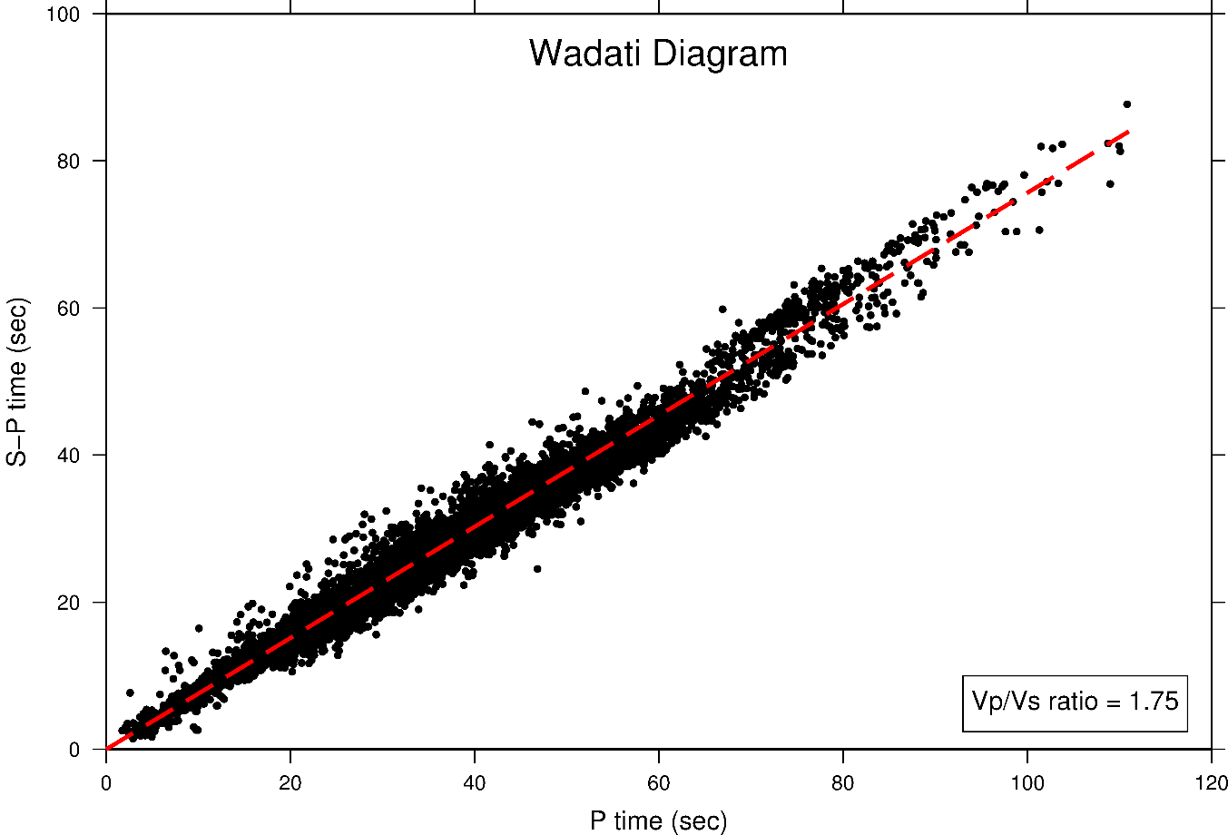
Figure S1. Wadati diagram showing a linear relationship between picked phases (Muttaqy et al., 2021 - in review). The Vp/Vs ratio of 1.75 was obtained based on the diagram. These data show deviations from a constant Vp/Vs ratio and/or reading data errors.
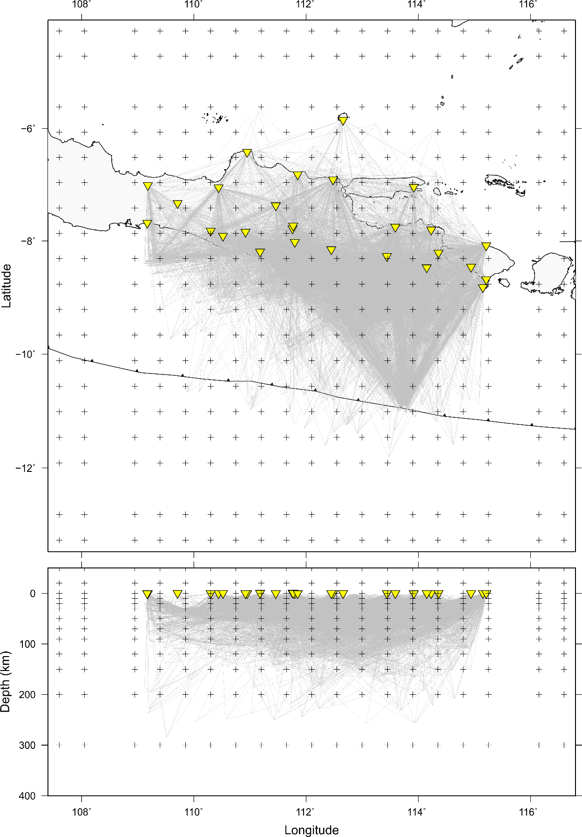
Figure S2. Grid node parameterization used for the seismic tomography inversion (plus signs) and ray path distribution (gray lines) that connect the hypocenters to the stations (yellow inverted triangles) through the 3-D seismic velocity model of our results.
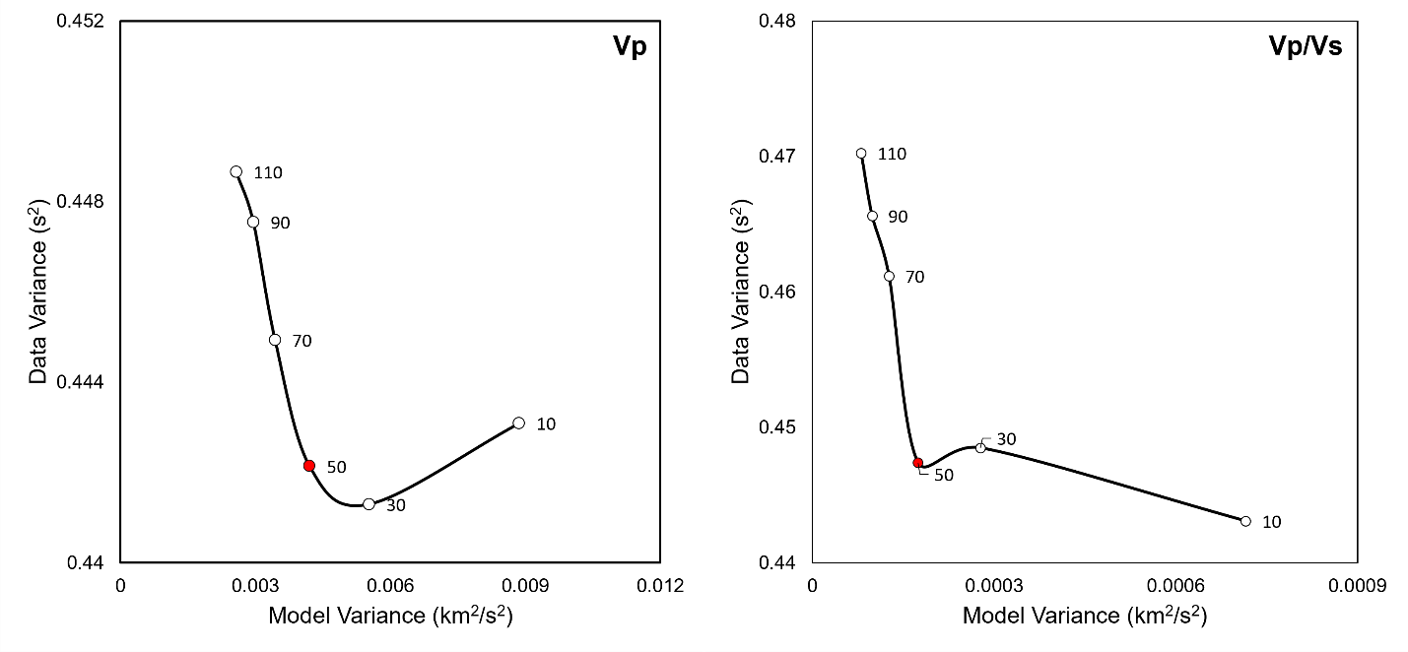
Figure S3. Trade-off curves showing model variance versus data variance for selecting optimal damping values in the inversions. Damping value of 50 (red dots) was selected for both Vp and Vp/Vs inversions.
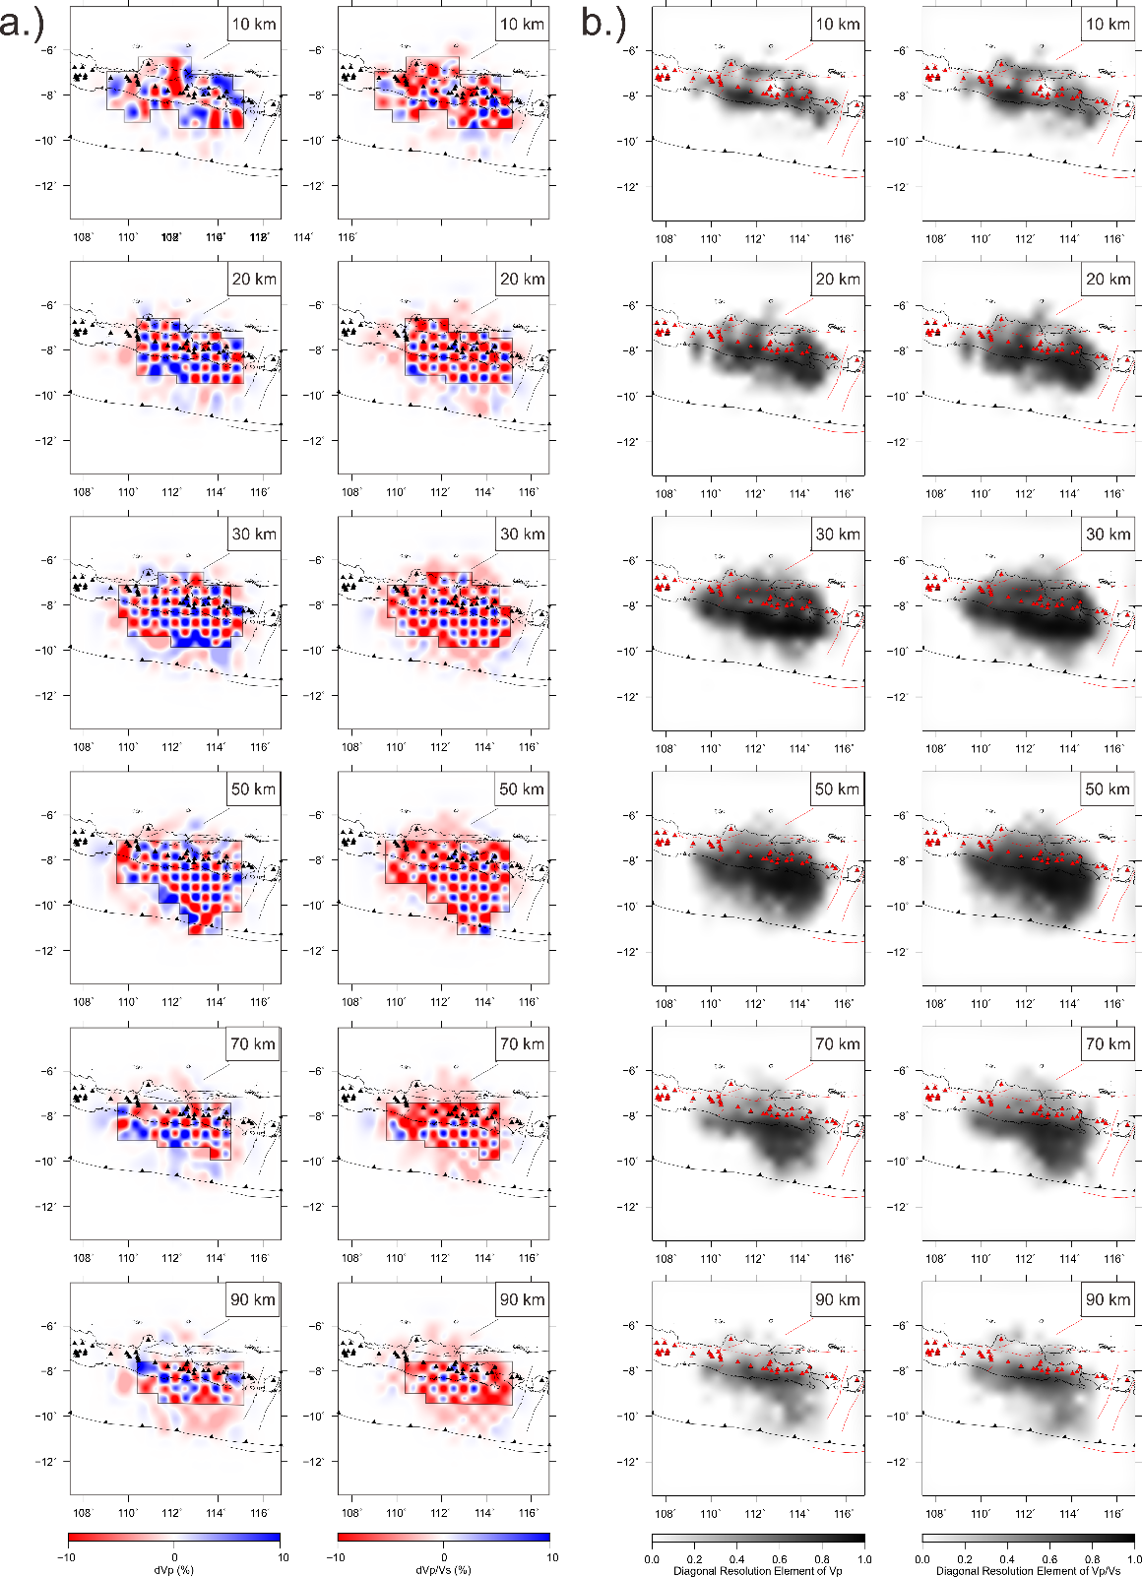
Figure S4. Horizontal sections of resolution test results for Vp and Vp/Vs ratio at depths of 10-90 km beneath the study area, using (a) checkerboard resolution test (CRT), (b) diagonal resolution element (DRE), (c) derivative weight sum (DWS) and (d) ray hit count (RHC). Blue and red colors represent positive and negative perturbations relative to the initial model, respectively. DWS and RHC are plotted on a logarithmic scale, while DRE value varies from 0 (unresolved) to 1 (resolved). Darker shades denote higher values of RHC, DWS and DRE for both Vp and Vp/Vs ratio. Dashed polygons are the area recovered by this study. Red lines and triangles indicate the fault and volcano distribution, respectively.

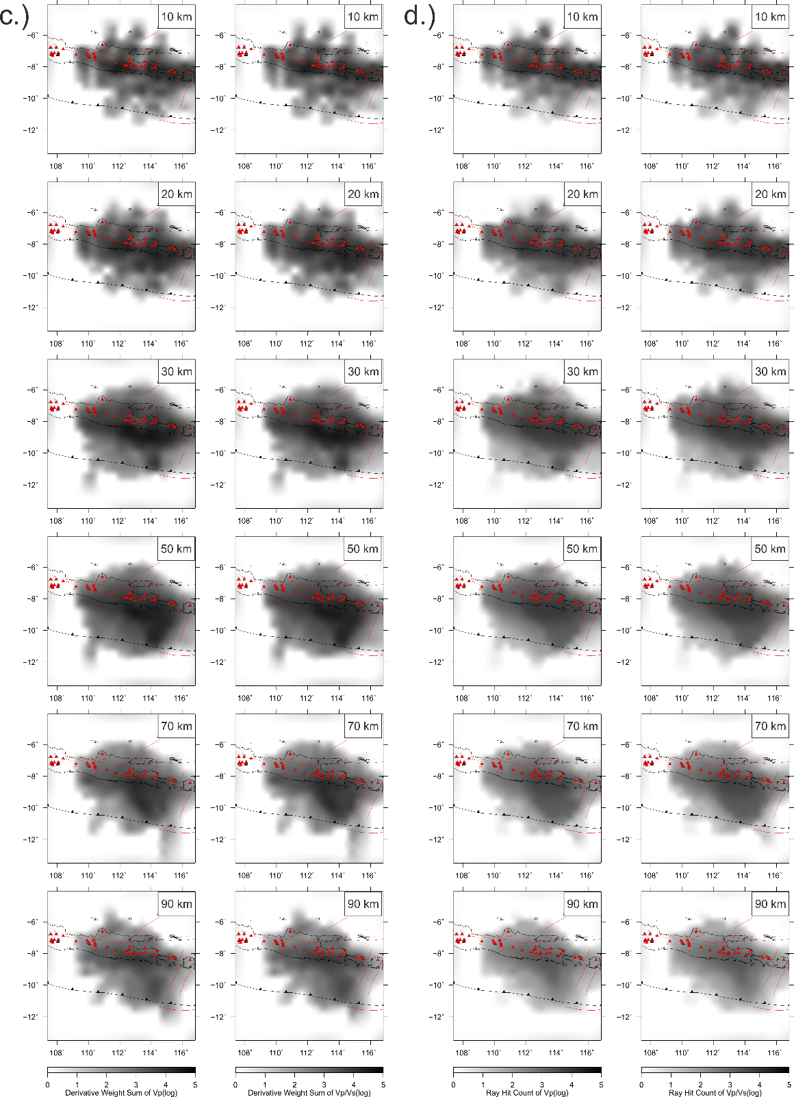
Figure S4. Continued
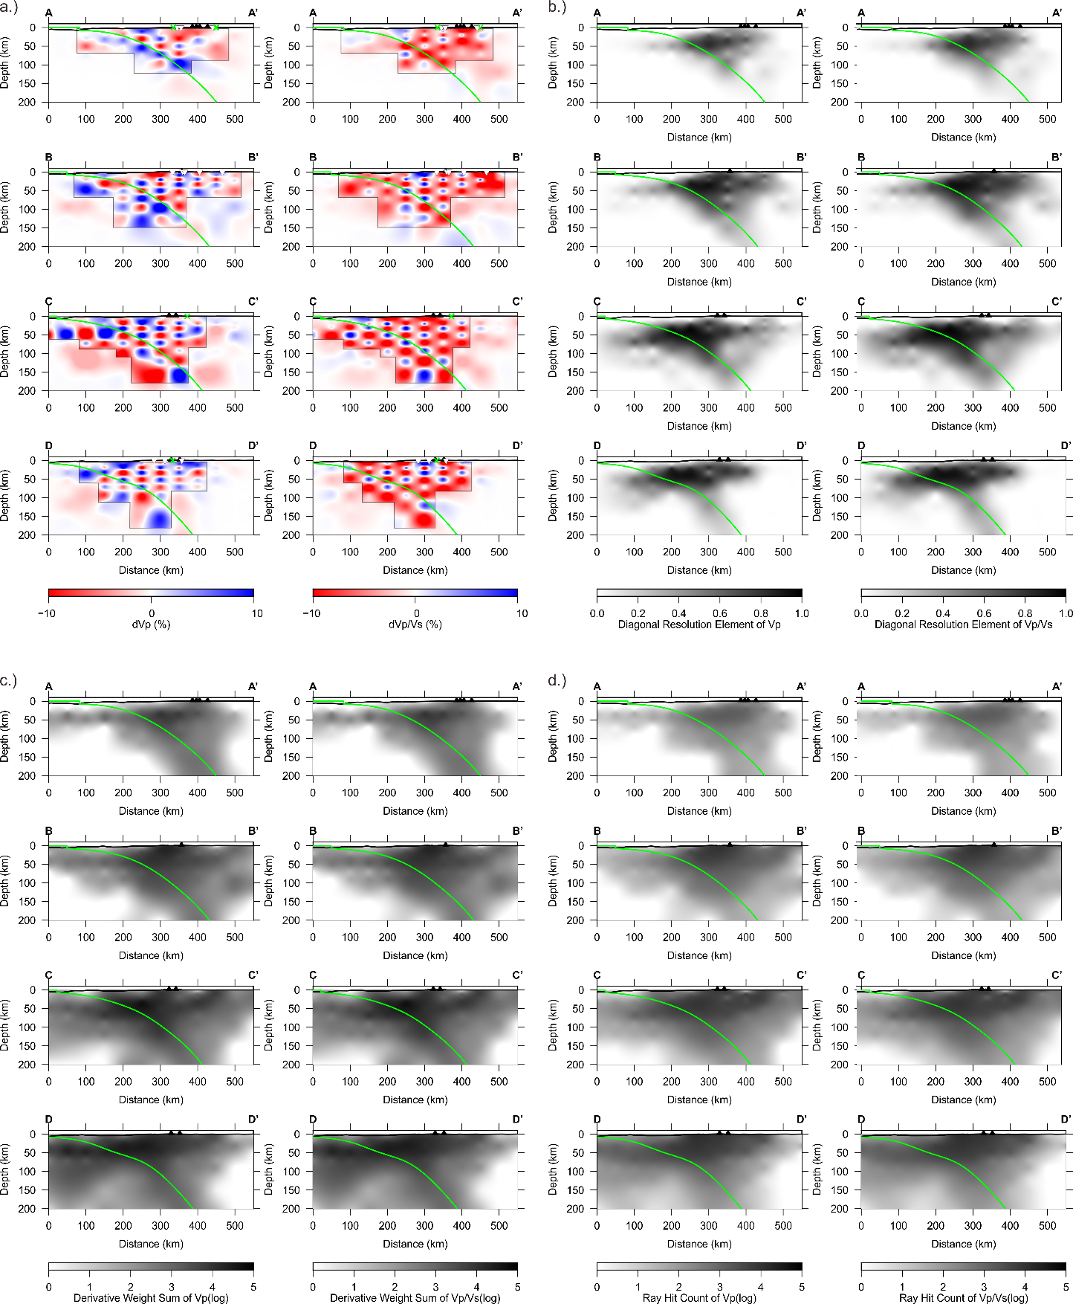
Figure S5. Vertical sections of resolution test results for Vp and Vp/Vs across Mt. Merapi-Merbabu (A-A’), Mt. Wilis-Pandan (B-B’), Mt. Bromo (C-C’), and Mt. Ijen-Baluran (D-D’), using (a) checkerboard resolution test (CRT), (b) diagonal resolution element (DRE), (c) derivative weight sum (DWS) and (d) ray hit count (RHC). Green line indicates the slab model 2.0 (Hayes et al., 2018). Black triangles show locations of volcanoes.

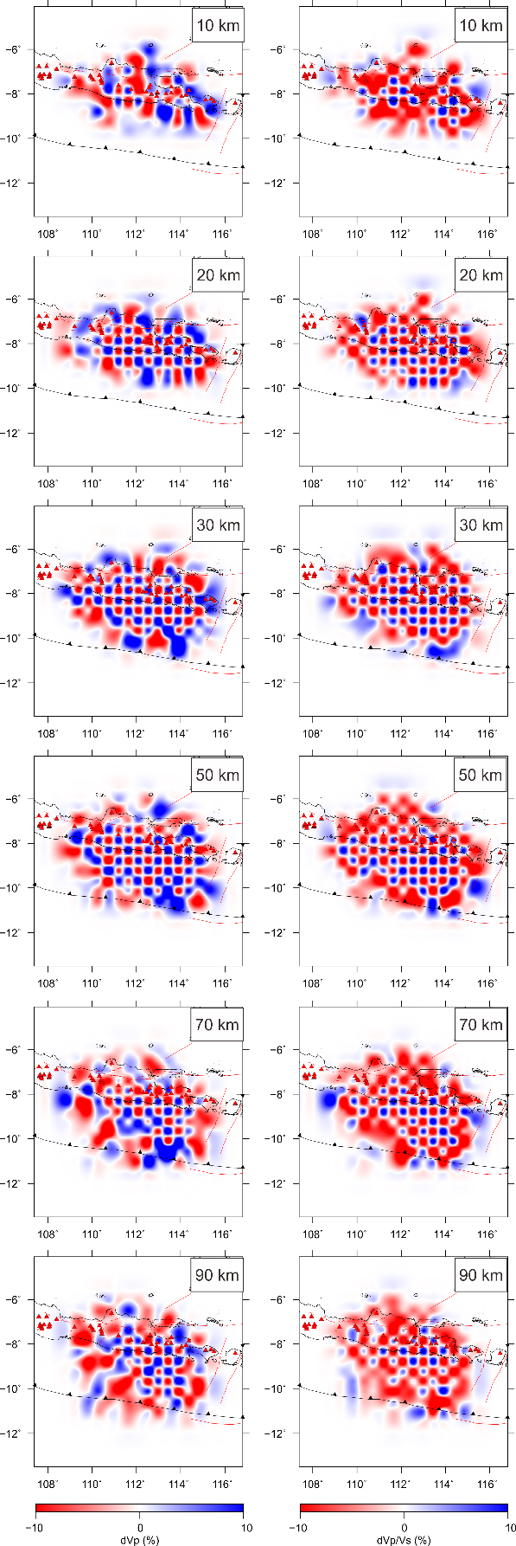
Figure S6. Same as Figure S4a, but with Gaussian noise of standard deviation 0.6149 s.

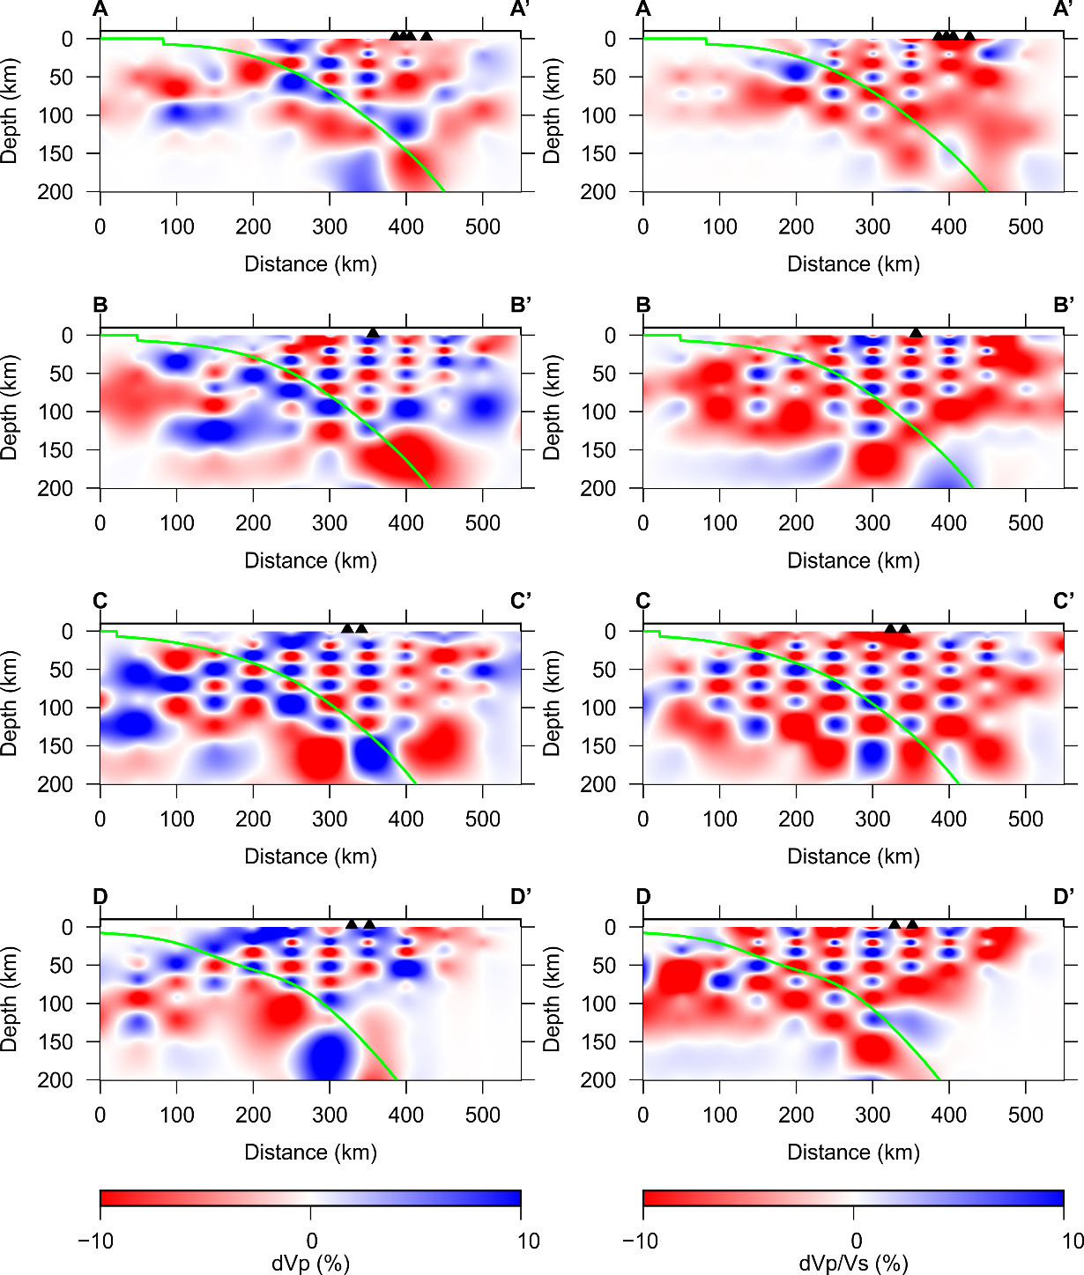
Figure S7. Same as Figure S5a, but with Gaussian noise of standard deviation 0.6149 s.
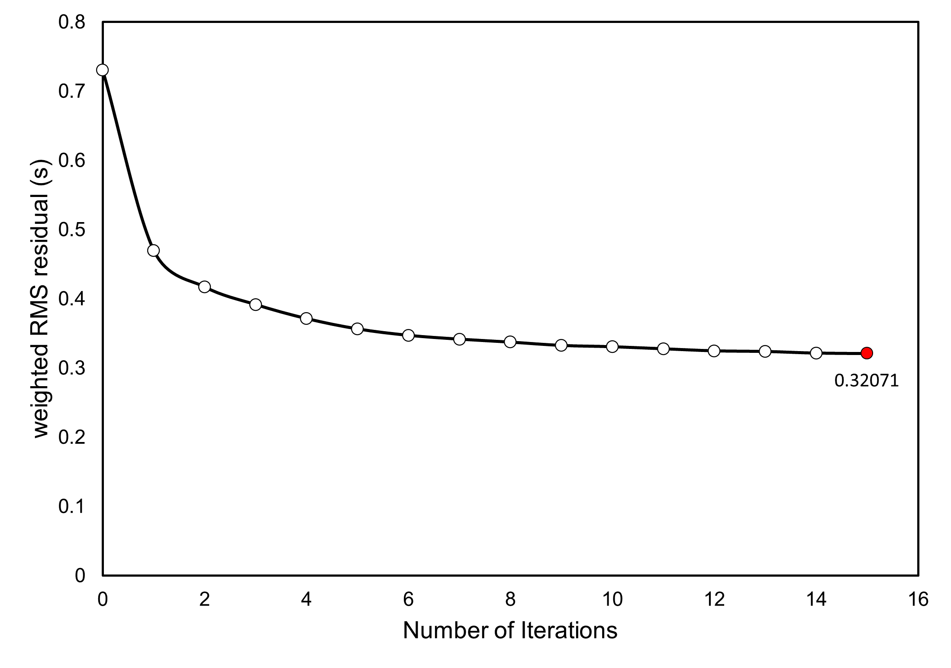
Figure S8. Graph showing the weighted RMS residual time of model for each iteration. The inversion reached the convergence at the 15th iteration with the value of 0.32071 s.
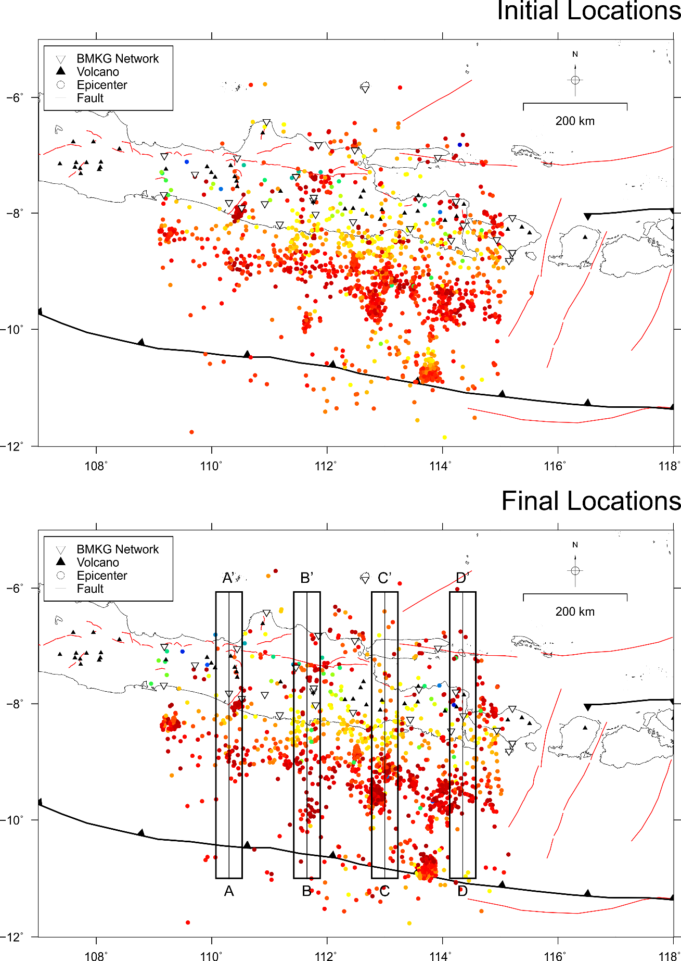
Figure S9. Map of seismicity distribution around Central and East Java region before (initial) and after (final) relocation using the determined 3-D seismic velocity model. The blocks A-D are the areas used to plot the vertical cross-sections shown in Figure S10.
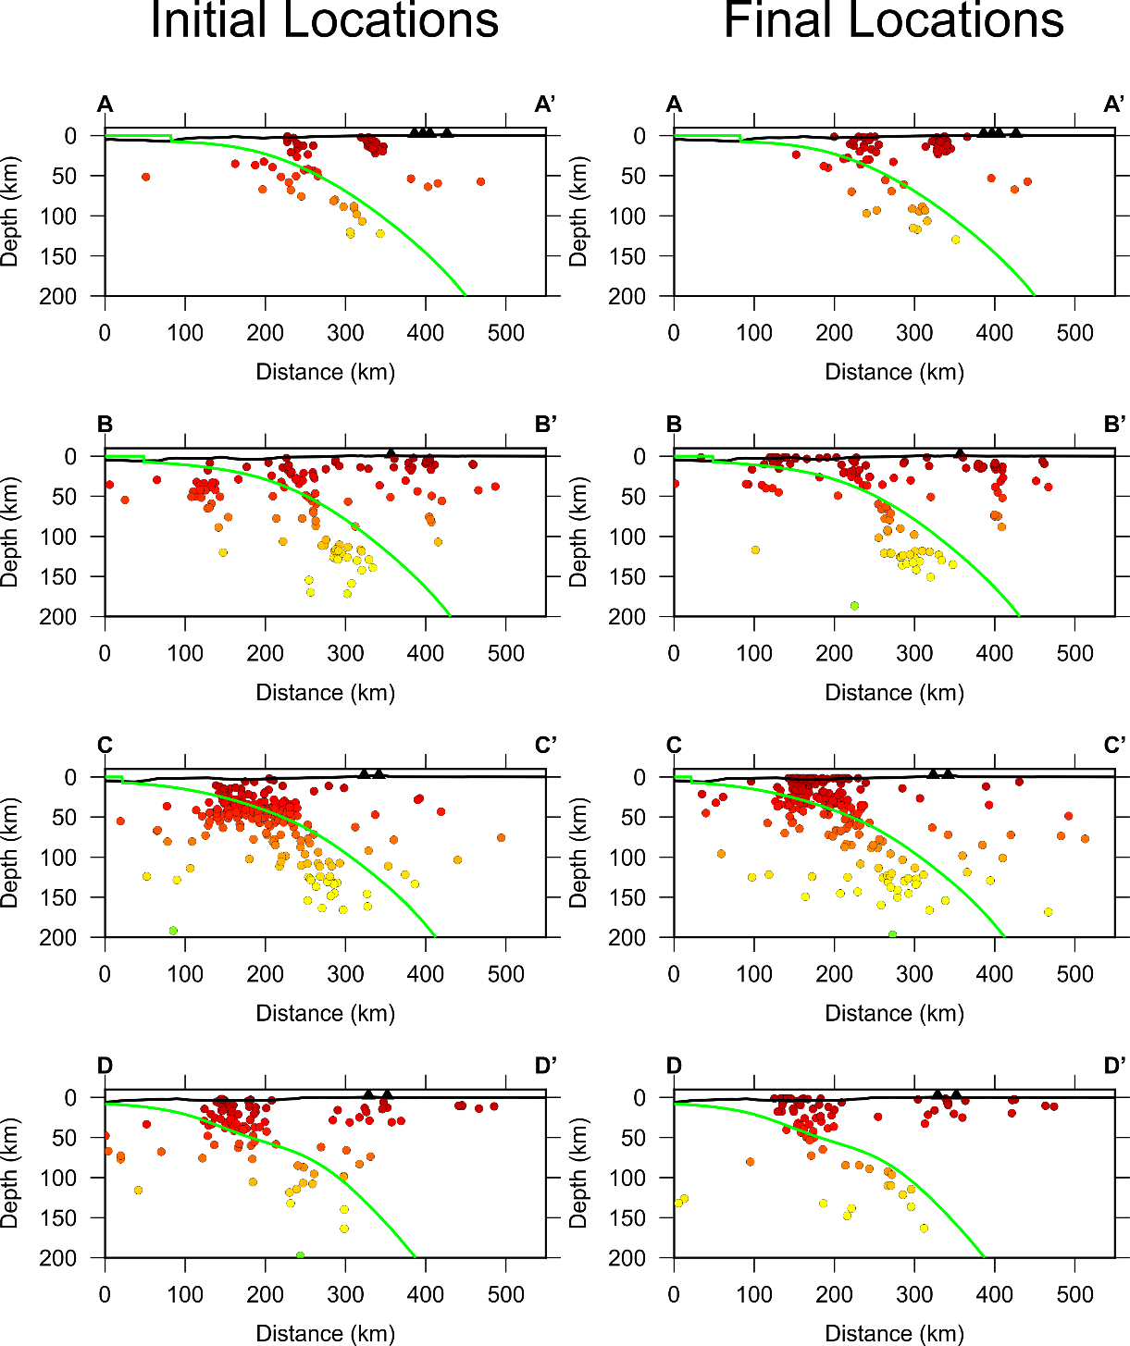
Figure S10. Vertical sections of initial and final seismicity around Central and East Java region for the locations shown in Figure S9. Green line indicates the slab model 2.0 (Hayes et al., 2018). Black triangles show locations of volcanoes.

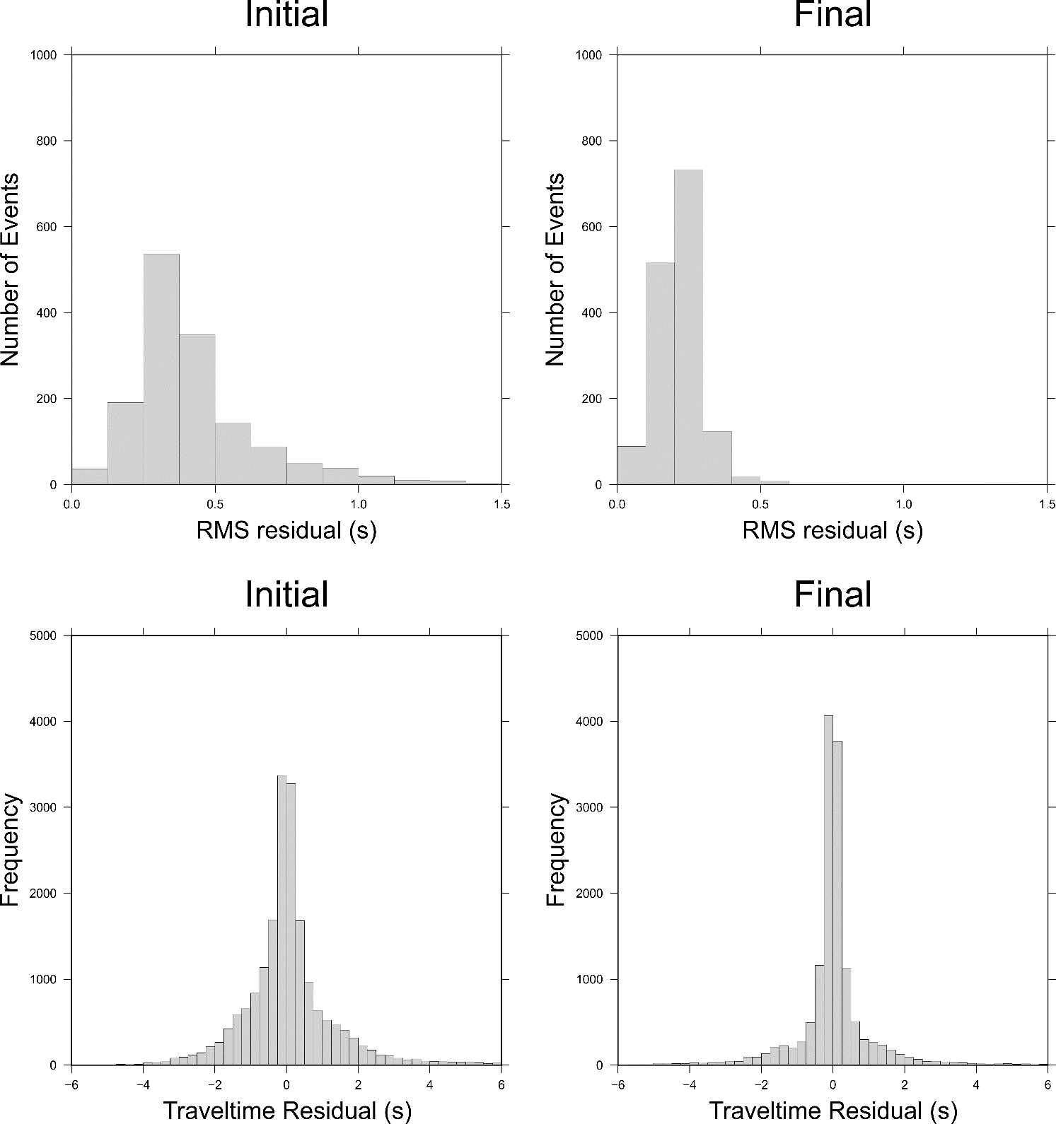
Figure S11. Histogram of RMS and travel time residuals associated with the initial and final model.

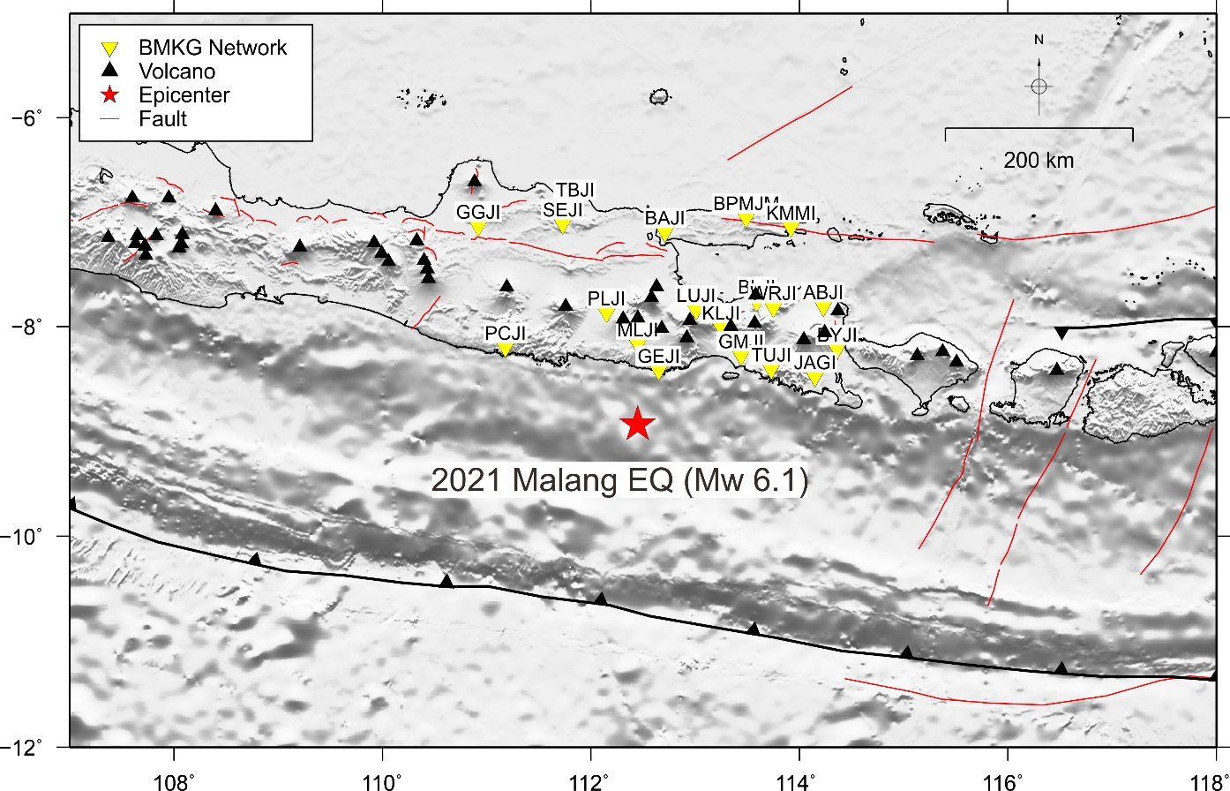
Figure S12. Map showing the epicenter of 2021 Malang earthquake (Mw 6.1) (red star) and the distribution of recording stations (yellow inverted triangles).

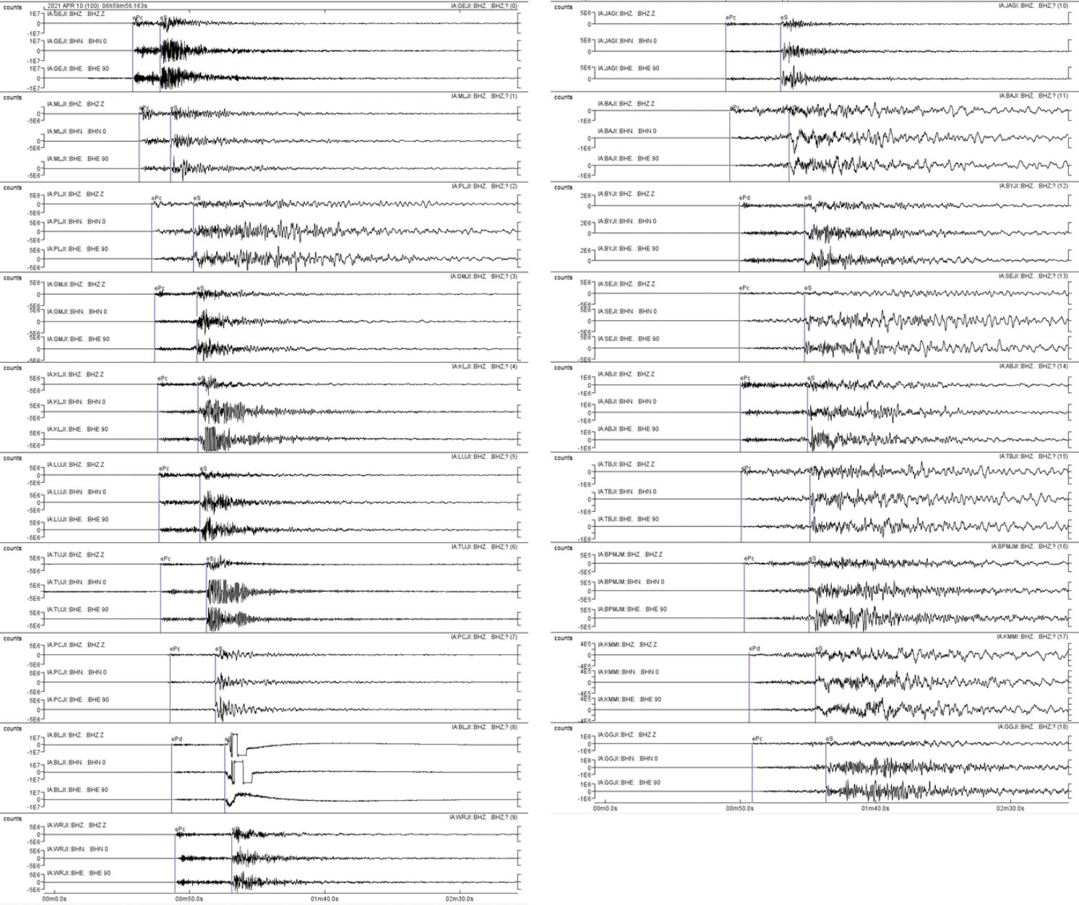
Figure S13. Three component seismograms of the 2021 Malang earthquake (Mw 6.1) recorded by 19 stations (shown in Figure S7). Purple lines are the arrival times of P and S-wave identified by manual picking process.

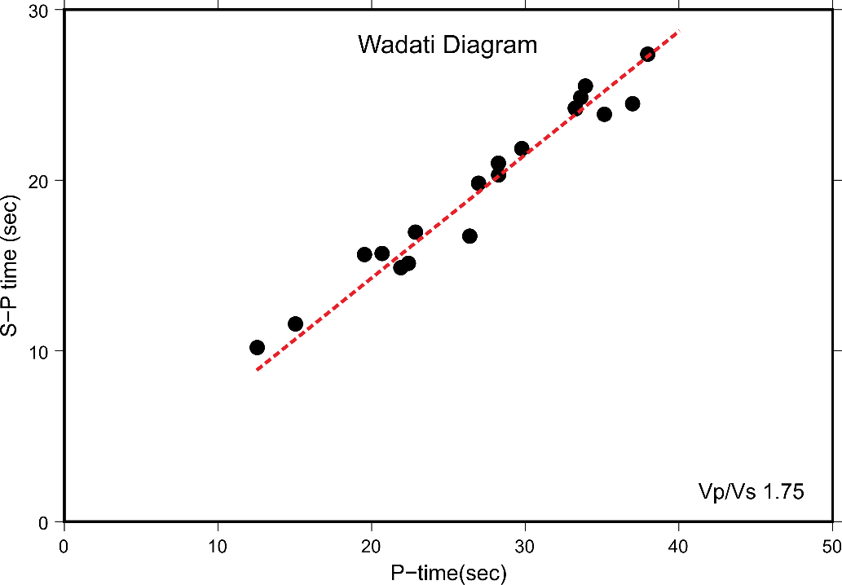
Figure S14. Wadati diagram showing a linear relationship between picked phases. Resulting the Vp/Vs ratio of 1.75. Red dashed lines indicate deviations from a constant Vp/Vs ratio and/or reading data errors.

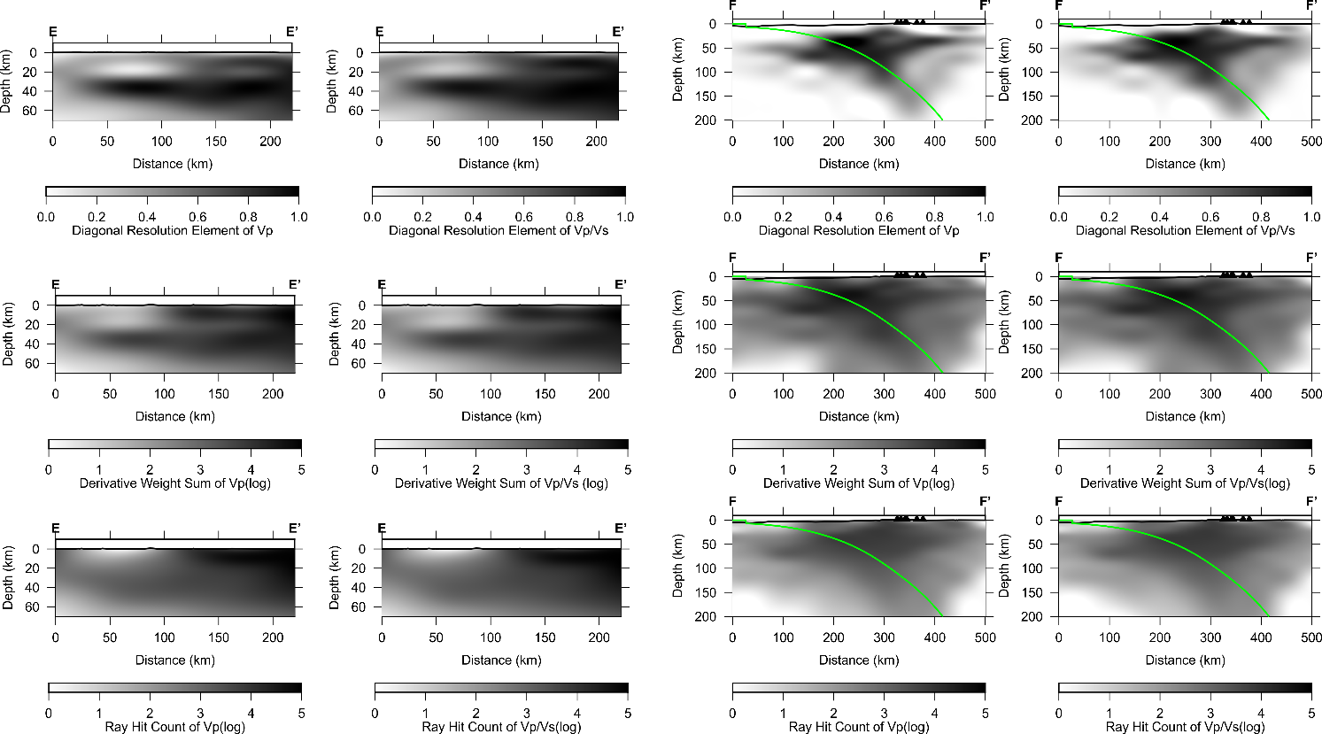
Figure S15. Vertical sections of resolution test results for Vp and Vp/Vs across the 2006 Yogyakarta earthquake (Mw 6.3) (E-E’), the 1994 Banyuwangi earthquake (Mw 7.8) and the 2021 Malang earthquake (Mw 6.1) (F-F’), using diagonal resolution element (DRE), derivative weight sum (DWS) and ray hit count (RHC). Green line indicates the slab model 2.0 (Hayes et al., 2018). Black triangles show locations of volcanoes.
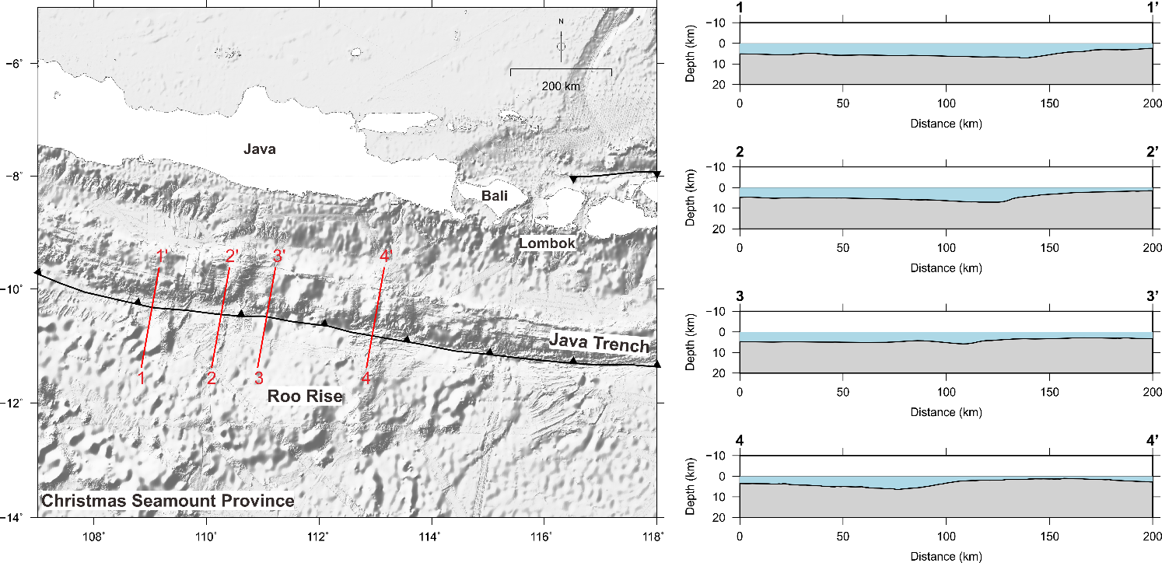
Figure S16. Bathymetric map of the Central and East Java from the General Bathymetric Chart of the Oceans (GEBCO) (https://download.gebco.net/) and vertical profiles across the subducting seamounts (red lines).

References
Hayes, G. P., Moore, G. L., Portner, D. E., Hearne, M., Flamme, H., Furtney, M., et al. (2018). Slab2, a comprehensive subduction zone geometry model. Science 362, 58–61. doi:10.1126/science.aat4723.
Muttaqy, F., Nugraha, A. D., Puspito, N. T., Sahara, D. P., Zulfakriza, Z., Rohadi, S., et al. (2021). Double-difference earthquake relocation using waveform cross-correlation in Central and East Java, Indonesia (Preprint). EarthArXiv. doi:https://doi.org/10.31223/X5MS4F.

