Supplementary Material

1. Comparison among regression models
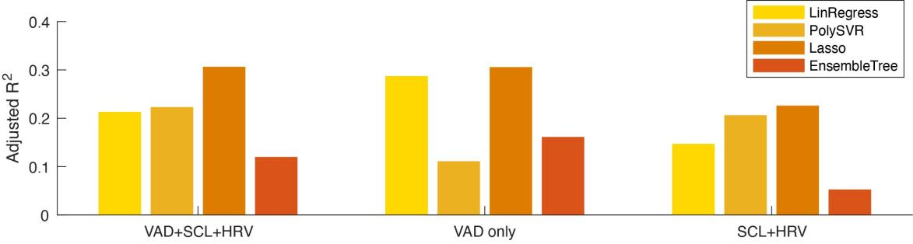
Supplementary Figure 1. Prediction performance of four regression models with all features (left), VAD only (middle), or physiological features only (right) in terms of Adjusted R².

Table 1. Prediction performance of regression models
Model | Feature | Evaluation Metric
Model | Feature | MAE | RMSE | R² | Adjusted R²
Linear Regression | VAD+SCL+HRV | 0.5966 | 0.7182 | 0.2123 | 0.2015
Linear Regression | VAD | 0.5677 | 0.7022 | 0.2863 | 0.2765
Linear Regression | SCL+HRV | 0.6445 | 0.7458 | 0.1461 | 0.1344
Support Vector Regression | VAD+SCL+HRV | 0.6926 | 0.8426 | 0.2222 | 0.2115
Support Vector Regression | VAD | 0.6632 | 0.8378 | 0.1103 | 0.0981
Support Vector Regression | SCL+HRV | 0.6455 | 0.7617 | 0.2055 | 0.1946
LASSO Regression | VAD+SCL+HRV | 0.5576 | 0.6789 | 0.3056 | 0.2961
LASSO Regression | VAD | 0.5614 | 0.6892 | 0.3050 | 0.2955
LASSO Regression | SCL+HRV | 0.6056 | 0.7104 | 0.2254 | 0.2148
Ensemble  of Tree | VAD+SCL+HRV | 0.7318 | 0.9201 | 0.1191 | 0.1070
Ensemble  of Tree | VAD | 0.6908 | 0.8712 | 0.1606 | 0.1491
Ensemble  of Tree | SCL+HRV | 0.7676 | 0.9446 | 0.0517 | 0.0387

2. Example application of the prediction model
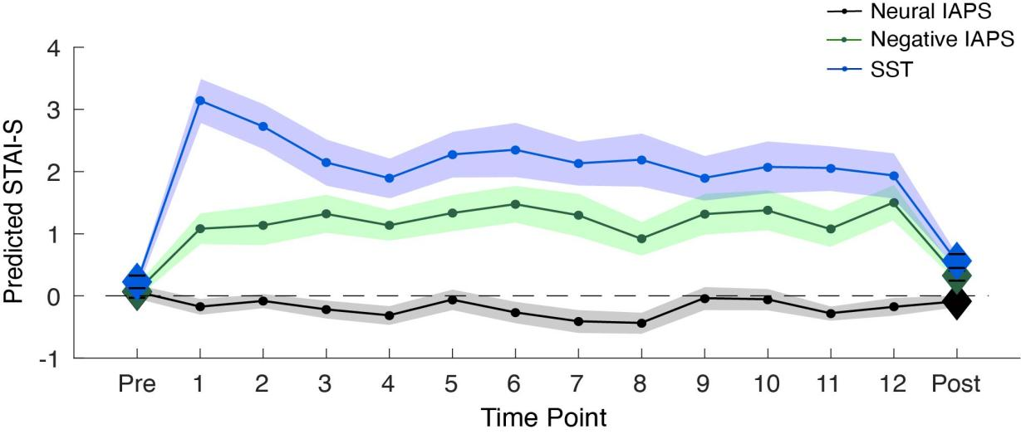
Supplementary Figure 2. Reconstruction of state anxiety levels during the tasks. Neutral IAPS, negative IAPS, and SST are respectively indicated by blue lines, green lines, and black lines. The dot markers correspond to each recording point; the diamond markers indicate the resting state before and after task blocks, the shadows represent the standard error mean.

