Supplementary Material

# The operating principle of SOM

The SOM is an unsupervised neural network model based on competitive learning and thus has been widely applied in weather and climate classification (Gao et al., 2019). As a feature of neural network, the SOM algorithm presents the input data to a layer of neurons or an equivalent layer of nodes. The SOM node describes the position on the two-dimensional mesh containing the dominant mode. In addition, nodes are associated with "reference vectors", which eventually become the dominant mode through the iterative process. Here, we use extreme precipitation to illustrate the process of the SOM clustering. To begin with, the precipitation of all grid points (1232 in total) in this study area on extreme precipitation days (2775 days in total) are converted into their corresponding percentiles in the entire wet day (above 1.0 mm d−1) time series. The percentile field of each extreme precipitation day is considered as a row vector ($p$). Then, all the vectors are input into the SOMs with a specified number of nodes.

The SOM selects a vector $p$ from all vectors and calculates the similarity (usually Euclidean distance) between $p$ and all reference vectors $m_{i}$. Then, the SOM selects the node with the smallest distance as the “winning’ node, also known as best matching unit. The SOM describes this determination of the winning node $c$ with:

$$c={argmin}_{i}\{\left\|p-m_{i}\right\|\}$$

where $i∈\{2,…,20\}$. At this point, the learning process activates the winning node and those nodes close to it. The activated nodes adjust reference vectors a specific amount toward the input vector $p$ by according to:

$$m_{i}\left(t+1\right)=m_{i}\left(t\right)+α\left(t\right)h_{ci}\left(t\right)\left[{p\left(t\right)-m}_{i}\left(t\right)\right]$$

where $h_{ci}\left(t\right)$ is the neighborhood kernel around the winning node $c$ and $α\left(t\right)$ is the learning rate at iteration $t$*.* Thelearning rateused in this study is $α\left(t\right)=0.5$*.*

The neighborhood kernel is used to smooth the reference vector in the neighborhood centered on the winning node. Therefore, the winning node usually makes the maximum adjustment to its reference vector, while all other adjacent nodes make small adjustments according to their distance from the winning node. In addition, the neighborhood kernel decreases with the increase of $t$, so the amplitude of reference vector adjustment decreases during training. Finally, we continue this process of presenting data vectors and modifying reference vectors for a specific number of iterations. In our study, the neighborhood kernel takes the Gaussian form:

$$h_{ci}\left(t\right)=e^{-d_{ci}^{2}/2σ_{t}^{2}}$$

where $σ_{t}$ is the neighborhood radius at time $t$, $d_{ci}=\left\|r_{c}-r_{i}\right\|$ is the distance between the winning nodes c and $i$ on the map grid. The neighborhood radius used is $σ_{t}=0.6$.

# Determining the optimal number of nodes

To determine the optimum number ($N$) of SOM nodes (i.e., best match units), we adopt the overall mean correlation coefficient ($R$) between each vector and its best match unit and the mean distance between each pair of best match units from Lee et al. (2017). The mean distance between each cluster pair is calculated in a slight adaptation of Wards’ distance (Ward, 1963; Lee et al., 2017):

$$D=\frac{1}{N_{p}}\sum_{n=1}^{N_{p}}{d_{n}(r,s)}$$

$$d(r,s)=\sqrt{\frac{2n_{r}n_{s}}{n_{r}+n_{s}}}{\left\|{\overline{x}}_{r}-{\overline{x}}_{s}\right\|}_{2}$$

where $d\left(r,s\right)$ is the Ward’s distance between clusters $r$ and $s$; $n_{r}$ and $n_{s}$ are the numbers of vectors of clusters $r$ and $s$, respectively. And ${\overline{x}}_{r}$ and ${\overline{x}}_{s}$ are the cluster centroids (i.e., best match units) of clusters $r$ and $s$, respectively. $N_{p}$ is the number of pairs in $N$ clusters. The more the number of nodes ($N$), the larger similarity among the vectors of all clusters (a larger value of $R$) and the smaller the inter-class distance (a smaller value of $D$). In practical, the number of nodes should be large enough to accurately capture the extreme precipitation patterns, but small enough to be significant differences between clusters. Therefore, we repeat the SOM with $N$ from 2 to 20 and calculate the mean correlation coefficients and distances.

As can be seen from Figure S1 , as the number of nodes ($N$) increases, the overall mean correlation coefficient ($R$) gradually increases, while the overall mean distance ($D$) gradually decreases. It is worth noting that as $N$ increases to a large value, the changes of $R$ and $D$ tend to be smooth, that is, the differences between each cluster could be negligible. It can be seen that when $N$ increases from 2 to 4, the increase range of $R$ is large. By contrast, the increase of $R$ is relatively small with $N$ above 4. A similar change is discernible in $D$. The combination of these two objective measures suggests that 4 is the optimum number of extreme precipitation clusters in the Indochina Peninsula–South China.

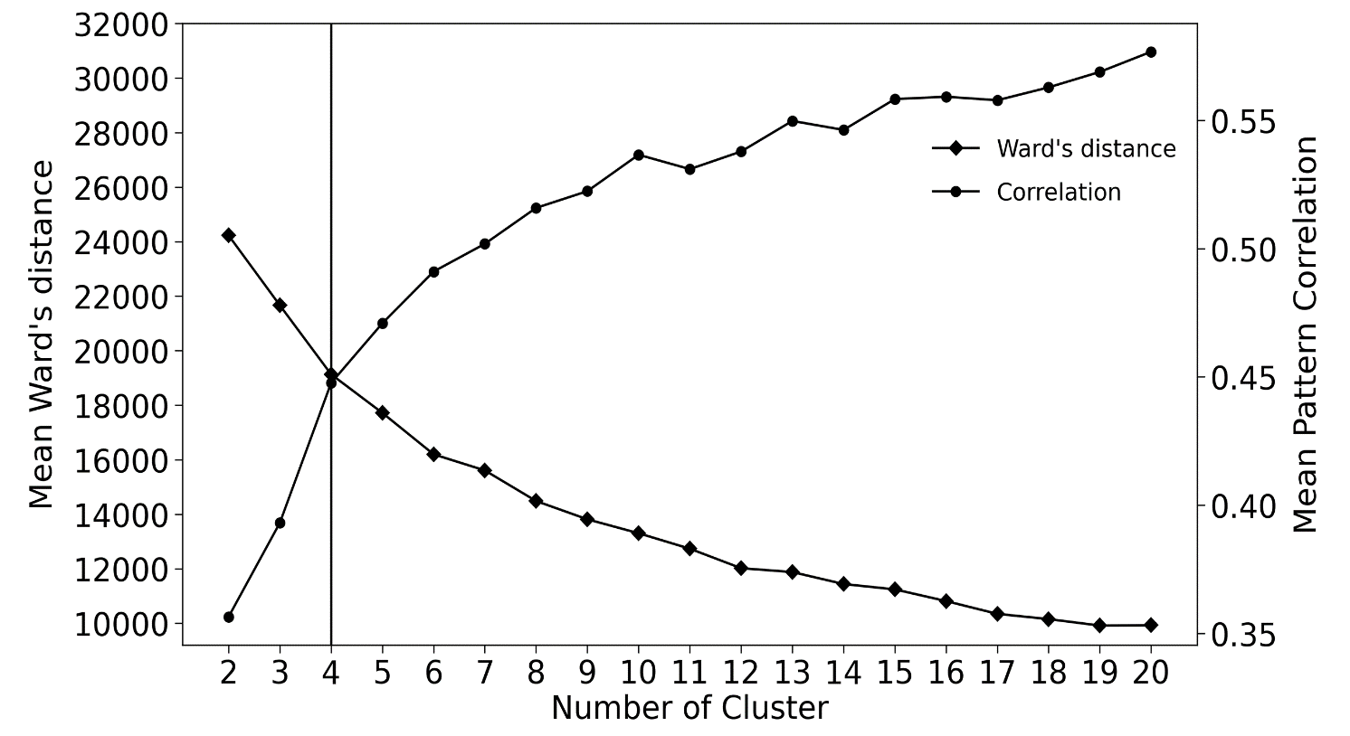

**Supplementary FIGURE S1**  Mean overall correlation spatial coefficient ($R$) between each vector of clusters and the corresponding cluster centroid, and the mean overall Ward’s distance ($D$) between each pair of cluster centroids. Right vertical, left vertical and horizontal axes indicate the correlation coefficient, left the Ward’s distance, and the number of clusters, respectively

# Typical clusters of extreme precipitation

According to the optimal classification number, we use SOM to divide the extreme precipitation in Indochina Peninsula–South China into four clusters. They are named as the South China cluster, the Indochina Peninsula cluster, the Burma–Yunnan cluster and the Southern South China–Northern Vietnam clusters according to their respective geographical distributions of extreme precipitation (Figure S2). The current study simply adopts the Indochina Peninsula cluster of extreme precipitation (Figure S2B). It contains 543 days of extreme precipitation days, accounting for 19.3% of the total days of extreme precipitation.

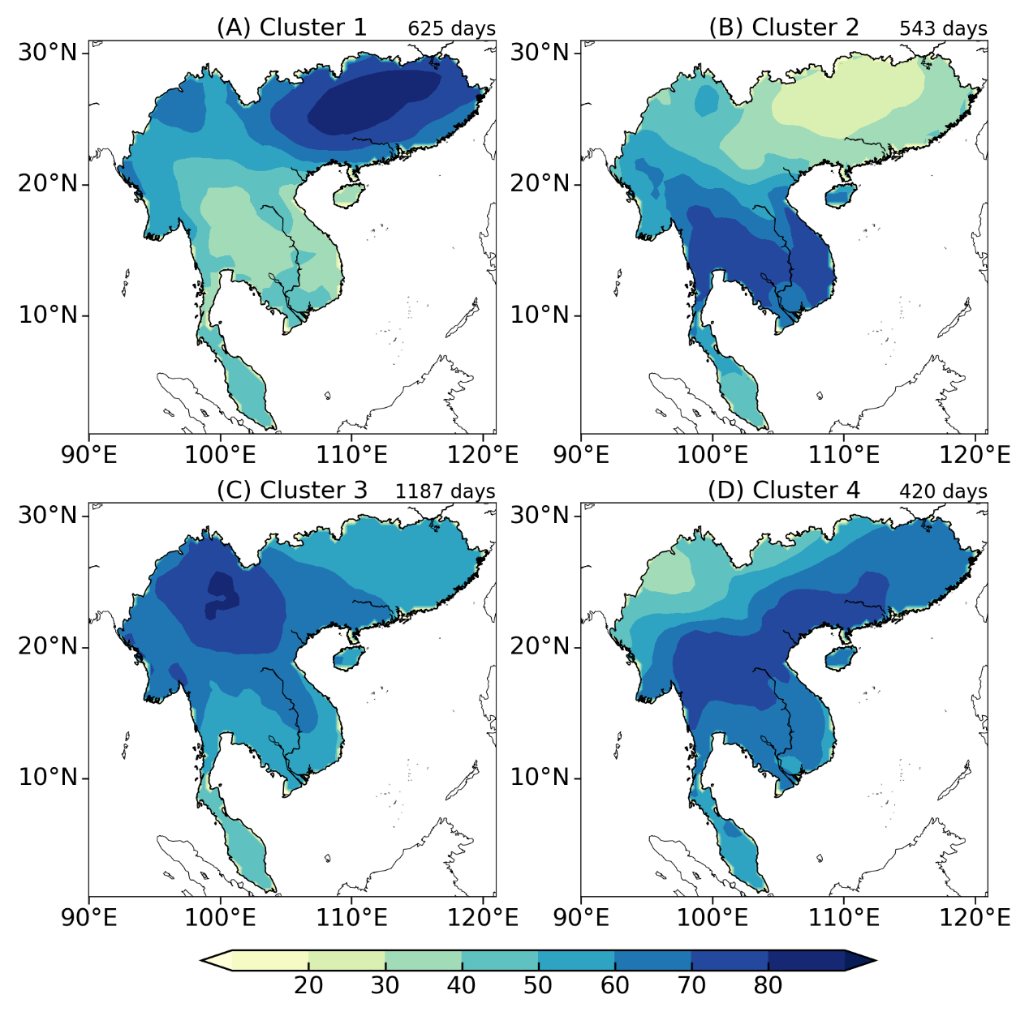

**Supplementary FIGURE S2** Composite precipitation percentile for the four clusters of extreme precipitation in the Indochina Peninsula–South China region (unit: percentile). (A−D) are clusters 1 to 4, and right subtitle indicates the days for each cluster of extreme precipitation

# Specific humidity profile associated with extreme precipitation

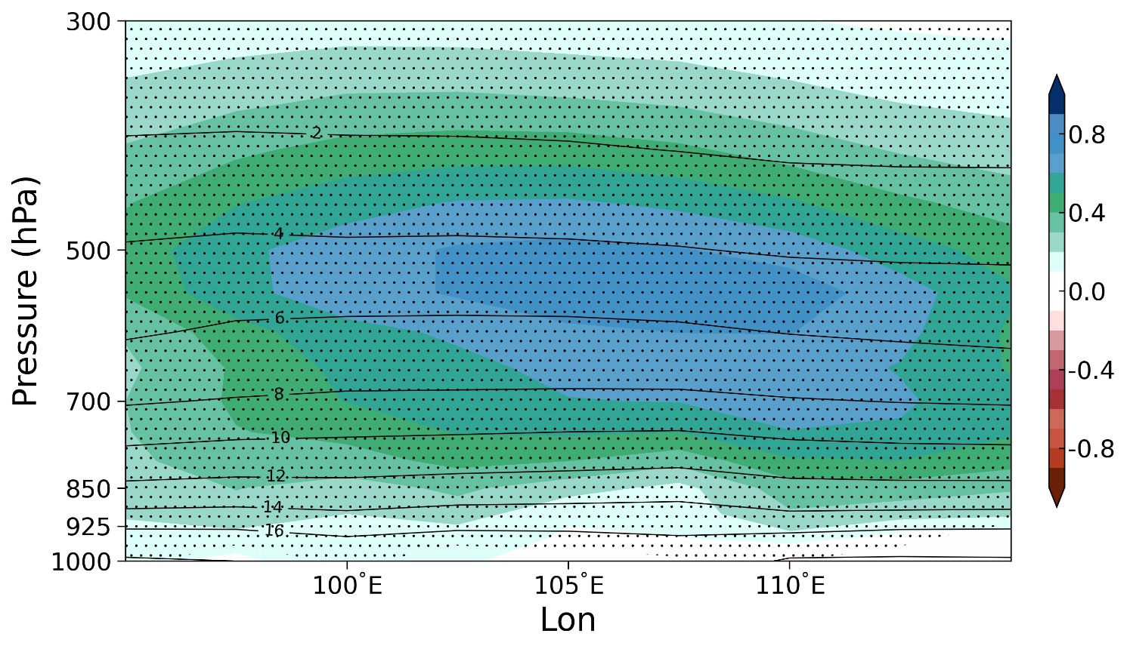

**Supplementary FIGURE S3**  Longitude–pressure cross section of composite specific humidity (contours; units: g kg-1) and corresponding anomalies (shading) relative to the climatological mean averaged within the latitude belt of 10−17°N associated with extreme precipitation.

**References**

Gao, N., Bueh, C., Xie, Z. W., and Gong, Y. F. (2019). A Novel Identification of the Polar/Eurasia Pattern and Its Weather Impact in May. *J. Meteorol. Res.* 33, 810–825. doi: 10.1007/s13351-019-9023-z

Lee, M. H., Lee, S., Song, H. J., and Ho, C. H. (2017). The Recent Increase in the Occurrence of a Boreal Summer Teleconnection and Its Relationship with Temperature Extremes. *J. Clim.* 30, 7493–7504. doi: 10.1175/JCLI-D-16-0094.1

Ward, J. H. (1963). Hierarchical Grouping to Optimize an Objective Function. *J. Am. Stat. Assoc.* 58, 236–244. doi: 10.1080/01621459.1963.10500845