Supplementary Material

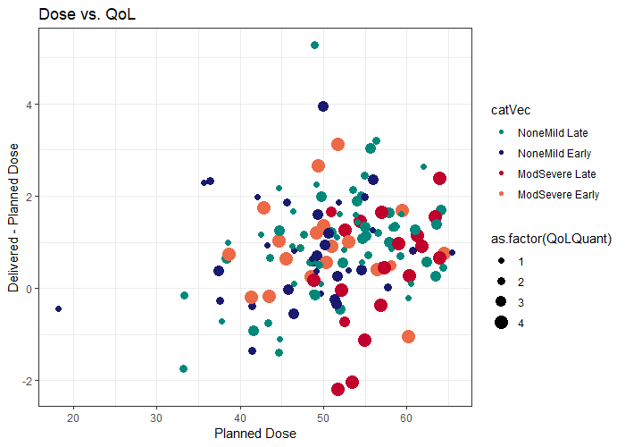

Planned Pharyngeal Constrictor Dmean (Gy)

Delivered – Planned Pharyngeal Constrictor Dmean (Gy)

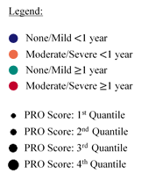

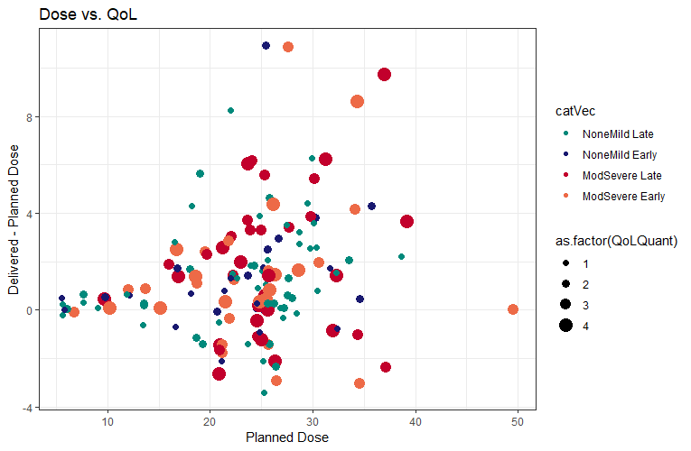

Planned Parotid Gland Dmean (Gy)

Delivered – Planned Parotid Gland Dmean (Gy)

Figure S.1: Differences in planned vs. delivered dose with associated PRO scores. Upper: Pharyngeal constrictor Dmean and MDADI Composite scores. Lower: Parotid gland Dmean and MDASI-HN Dry Mouth scores.