***Supplemental Information***

Table S1. Principle equations used for LePA model operating of all experimental sites

|  |  |  |  |  |  |  |
| --- | --- | --- | --- | --- | --- | --- |
| Equation number | Equations |  |  |  |  |  |
|  | Yangling | Qiyang | Jinxian | Chongqing | Zhengzhou | Gongzhuling |
| a Correlation between soil TP (x) and Olsen-P (y) |  |  |  |  |  |  |
| 1 | y1=93.1x-51.1, x<1.32 | y1=3.5x+2.8, x<0.51 | y1=20.7x-2.0, x≤0.51 | y1=5.3x-0.05, x<0.73 | y1=34.3x-13.3, x≤0.64 | y1=44.4x-9.1, x<0.74 |
| 2 | y2=257.6x-268.4, x>1.32 | y2=152.8x-73.3, x≥0.51 | y2=105.9x-45.2, x>0.51 | y2=57.0x-20.3, x≥0.73 | y2=237.1x-143.1, x>0.64 | y2=175.2x-106.1, x>0.74 |
| b Correlation between soil Olsen-P (x) and crop yield (y) |  |  |  |  |  |  |
| 3 Wheat (Early rice in Jinxian) | y=0.06x-0.5, x<16.1 | y=0.04x+0.19, x<12.7 | y=0.01x+0.57, x<29.2 | y=0.05x+0.76, x<11.1 | y=0.08x+0.30, x<7.6 |  |
| 4 Wheat (Early rice in Jinxian) | y=0.90, x≥16.1 | y=0.69, x≥12.7 | y=0.94, x≥29.2 | y=0.87, x≥11.1 | y=0.91, x≥7.6 |  |
| 5 Maize (Late rice in Jinxian; Rice in Chongqing) | y=0.05x+0.22, x<14.6 | y=0.02x+0.22, x<28.2 | y=0.01x+0.56, x<30.0 | y=0.02x+0.75, x<10.9 | y=0.04x+0.60, x<8.0 | y=0.03x+0.67, x<10.4 |
| 6 Maize (Late rice in Jinxian; Rice in Chongqing) | y=0.90, x≥14.6 | y=0.71, x≥28.2 | y=0.92, x≥30.0 | y=0.93, x≥10.9 | y=0.90, x≥8.0 | y=0.93, x≥10.4 |
| c Correlation between soil *TPA* (x)and *PA* (y)  7 Wheat  8 Maize | y=0.04x-51.19  y=0.02x-9.22 | y=0.02x-25.30  y=0.02x-17.93 | y=0.0035x+5.5331  y=0.0016x+8.0522 | y=0.0222x-27.851  y=0.0093x-0.2541 | y=0.0693x-81.696  y=0.0195x-8.4064 | *PA*/*TPA*=0.03 |

a The correlation between soil TP and Olsen-P at Yangling and Qiyang sites in detail was shown in the published literatures (Bai et al., 2013; Yu et al., 2021). Figure S1 showed the correlation between soil TP and Olsen-P of Jinxian, Chongqing, Zhengzhou and Gongzhuling in detail

b The correlation between soil Olsen-P and crop yield at Yangling and Qiyang sites in detail was shown in the published literatures (Bai et al., 2013; Yu et al., 2021). The correlation between soil Olsen-P and crop yield at Chongqing site was shown in Bai et al. (2013). Figure S2 showed the correlation at Jinxian, Zhengzhou and Gongzhuling sites in detail

c The correlation between soil *TPA* and *PA* at Yangling and Qiyang sites in detail was shown in Yu et al. (2021). Figure S3 showed the correlation between soil *TPA* and *PA* of Jinxian, Chongqing and Zhengzhou in detail

Table S2. Observed crop P uptakes (kg ha-1) in the Yangling, Qiyang, Jinxian, Chongqing, Zhengzhou and Gongzhuling for validation of LePA model.

|  |  |  |  |  |  |  |  |  |  |  |  |  |  |  |  |  |  |
| --- | --- | --- | --- | --- | --- | --- | --- | --- | --- | --- | --- | --- | --- | --- | --- | --- | --- |
|  | Yanglinga | Qiyangb | Jinxianc | | | Chongqingd | | | | Zhengzhoue | | | | Gongzhulingf | | | |
| Year | Wheat-Maize | Wheat-Maize | Rice-Rice | | | Wheat-Rice | | | | Wheat-Maize | | | | Maize | | | |
|  | NP NPK NPKS | NP NPK NPKS | NP | NPK | HNPK | NK | NP | NPK | NPKS | NK | NP | NPK | NPKS | NK | NP | NPK | NPKS |
| 1981 |  |  | 22 | 24 | 24 |  |  |  |  |  |  |  |  |  |  |  |  |
| 1982 |  |  | 23 | 25 | 27 |  |  |  |  |  |  |  |  |  |  |  |  |
| 1983 |  |  | 19 | 22 | 24 |  |  |  |  |  |  |  |  |  |  |  |  |
| 1984 |  |  | 20 | 21 | 23 |  |  |  |  |  |  |  |  |  |  |  |  |
| 1985 |  |  | 21 | 22 | 24 |  |  |  |  |  |  |  |  |  |  |  |  |
| 1986 |  |  | 23 | 27 | 31 |  |  |  |  |  |  |  |  |  |  |  |  |
| 1987 |  |  | 19 | 23 | 28 |  |  |  |  |  |  |  |  |  |  |  |  |
| 1988 |  |  | 18 | 22 | 26 |  |  |  |  |  |  |  |  |  |  |  |  |
| 1989 |  |  | 19 | 23 | 29 |  |  |  |  |  |  |  |  |  |  |  |  |
| 1990 |  |  | 20 | 22 | 28 |  |  |  |  |  |  |  |  | 31 | 32 | 33 | 23 |
| 1991 | 39 40 43 | 19 18 22 | 18 | 22 | 25 |  |  |  |  | 47 | 48 | 47 | 52 | 28 | 29 | 29 | 26 |
| 1992 | 37 38 40 | 22 24 25 | 19 | 21 | 24 | 27 | 28 | 29 | 32 | 42 | 54 | 52 | 54 | 27 | 29 | 28 | 27 |
| 1993 | 40 40 39 | 18 17 27 | 20 | 23 | 26 | 21 | 21 | 23 | 29 | 41 | 51 | 59 | 50 | 29 | 31 | 31 | 30 |
| 1994 | 38 37 41 | 21 21 24 | 17 | 19 | 24 | 29 | 32 | 32 | 36 | 26 | 39 | 35 | 41 | 33 | 35 | 35 | 33 |
| 1995 | 40 41 43 | 19 22 22 | 16 | 17 | 19 | 27 | 27 | 29 | 32 | 28 | 46 | 49 | 50 | 33 | 35 | 37 | 36 |
| 1996 | 39 38 38 | 20 26 28 | 22 | 23 | 27 | 25 | 29 | 29 | 32 | 25 | 45 | 45 | 48 | 30 | 31 | 32 | 32 |
| 1997 | 48 49 41 | 14 25 30 | 24 | 28 | 34 | 22 | 26 | 29 | 30 | 26 | 43 | 47 | 53 | 29 | 30 | 30 | 31 |
| 1998 | 57 52 56 | 5 25 23 | 16 | 17 | 21 | 18 | 21 | 25 | 28 | 16 | 42 | 39 | 44 | 33 | 30 | 33 | 33 |
| 1999 | 58 40 47 | 11 19 24 | 20 | 21 | 24 | 22 | 25 | 29 | 29 | 32 | 60 | 55 | 60 | 34 | 32 | 35 | 36 |
| 2000 | 41 43 46 | 3 14 11 | 16 | 24 | 26 | 21 | 25 | 28 | 30 | 24 | 53 | 47 | 53 | 19 | 22 | 22 | 24 |
| 2001 | 49 55 50 | 11 18 22 | 21 | 22 | 26 | 20 | 25 | 28 | 29 | 28 | 43 | 53 | 57 | 34 | 32 | 36 | 37 |
| 2002 | 68 67 69 | 7 18 19 | 19 | 21 | 27 | 18 | 23 | 28 | 29 | 21 | 42 | 47 | 46 | 30 | 33 | 33 | 36 |
| 2003 | 34 39 42 | 8 17 22 | 20 | 20 | 23 | 25 | 31 | 37 | 36 | 21 | 44 | 53 | 47 | 27 | 30 | 32 | 33 |
| 2004 | 45 50 50 | 5 13 13 | 22 | 24 | 27 | 24 | 29 | 33 | 33 | 29 | 61 | 62 | 58 | 28 | 28 | 30 | 32 |
| 2005 | 45 46 44 | 4 9 11 | 22 | 24 | 25 | 21 | 27 | 33 | 32 |  |  |  |  | 29 | 30 | 31 | 32 |
| 2006 | 48 48 48 | 3 5 10 | 16 | 18 | 20 | 18 | 22 | 27 | 26 |  |  |  |  | 30 | 32 | 34 | 34 |
| 2007 | 46 47 53 | 3 6 7 | 17 | 20 | 24 | 19 | 21 | 25 | 25 |  |  |  |  | 34 | 37 | 39 | 36 |
| 2008 | 48 48 53 |  | 23 | 24 | 25 | 25 | 32 | 36 | 37 |  |  |  |  | 30 | 34 | 35 | 36 |
| 2009 |  |  |  |  |  |  |  | 30 | 31 |  |  |  |  | 32 | 35 | 38 | 38 |
| 2010 |  |  |  |  |  |  |  | 32 | 34 |  |  |  |  | 28 | 35 | 37 | 39 |
| 2011 |  |  |  |  |  |  |  | 33 | 33 |  |  |  |  | 29 | 38 | 41 | 41 |
| 2012 |  |  |  |  |  |  |  | 31 | 30 |  |  |  |  | 28 | 39 | 41 | 39 |
| 2013 |  |  |  |  |  |  |  |  |  |  |  |  |  | 24 | 37 | 39 | 36 |
| 2014 |  |  |  |  |  |  |  |  |  |  |  |  |  | 26 | 35 | 38 | 35 |

Crop P uptakes = Crop grain yields × P concentration in grain + Crop straw yields × P concentration in straw. Crop straw yields are calculated by crop grain yields and crop harvest index. P concentrations respectively in grain and straw of wheat are 3.25 and 0.8 g kg-1, P concentrations respectively in grain and straw of maize are 2.18 and 1.52 g kg-1 and P concentrations respectively in paddy and straw of rice are 1.1 and 1.3 g kg-1 (Zhu et al., 2017).

a Data of crop grain yields at Yangling site sources from Xu et al. (2015).

b Data of crop grain yields at Qiyang site was collected from the published literatures (Cai et al., 2011; Zhao et al., 2012).

c Data of crop grain yields at Jinxian site sources from Xu et al. (2015).

d Data of crop grain yields at Chongqing site sources from Xu et al. (2015).

e Data of crop grain yields at Zhengzhou site sources from Zhao et al. (2012).

f Data of crop grain yields at Gongzhuling site was collected from the published literatures (Zhao et al., 2012; Xu et al., 2015).

Table S3. Observed soil TP (g kg-1)and Olsen-P (mg kg-1) in Yangling for validation of LePA model.

|  |  |  |  |  |  |  |
| --- | --- | --- | --- | --- | --- | --- |
| Year | TP | | | Olsen-P | | |
| NP | NPK | NPKS | NP | NPK | NPKS |
| 1991 | 0.58 | (0.62) | 0.59 | 7.89 | 7.65 | 12.94 |
| 1992 |  |  |  | 16.76 | 14.92 | 15.80 |
| 1993 | 0.73 | 0.72 |  | 14.83 | 15.61 | 17.70 |
| 1994 | (0.71) | 0.60 | (0.70) | 15.27 | 11.91 | 17.50 |
| 1995 | 0.79 | 0.85 |  | 14.83 | 21.07 | 26.65 |
| 1996 | 0.84 | 0.83 | 0.86 | 18.28 | 23.41 | 25.81 |
| 1997 | 0.84 | (0.77) |  | 15.61 | 14.73 | 21.46 |
| 1998 |  |  |  | 21.75 | 25.28 |  |
| 1999 | 0.86 | 0.83 |  | 21.41 | 25.26 |  |
| 2000 | 0.95 | 0.91 | 0.95 | 19.47 | 18.89 | 29.57 |
| 2001 | 0.88 | 0.82 |  | 24.68 | 24.73 | 28.76 |
| 2002 | 0.86 | (0.76) | 0.96 | 25.61 | 28.08 | 25.68 |
| 2003 | 0.92 | 0.86 | (0.83) |  |  |  |
| 2004 |  |  |  | 22.48 | 24.69 | 34.49 |
| 2005 | 1.17 | 1.14 | 1.24 | 25.61 | 25.61 | 33.51 |
| 2006 |  |  |  | 25.19 | 30.86 | 25.93 |
| 2007 | 1.03 | 0.99 | 1.02 | 28.10 | 27.49 | 31.37 |
| 2008 | 0.93 | 1.01 | 1.03 | 25.82 | 33.30 | 23.96 |

Data of soil TP and Olsen-P was collected from the published literatures (Yang et al., 2009; Yang et al., 2014; Xu et al., 2015; Yang et al., 2018; Khan et al., 2018; Wu et al., 2020). Unseasonable values of observed soil TP were obvious within these datasets according to the P budget between P inputs and removals, and these values were eliminated as outliers when less than 1/3 or more than 3 times the theoretical changes between two adjacent years were evident. Soil TP data in parentheses are the observed values used to validate the LePA model after removing outliers. Observed soil Olsen-P are used to validate the LePA model.

Table S4. Observed soil TP (g kg-1)and Olsen-P (mg kg-1) in Qiyang for validation of LePA model.

|  |  |  |  |  |  |  |
| --- | --- | --- | --- | --- | --- | --- |
| Year | TP | | | Olsen-P | | |
| NP | NPK | NPKS | NP | NPK | NPKS |
| 1991 | 0.51 | 0.51 | 0.52 | 9.57 | 9.68 | 8.06 |
| 1992 | (0.56) | (0.55) | 0.52 | 9.57 | 9.68 | 8.06 |
| 1993 | (0.61) | 0.63 | (0.58) | 14.36 | 20.97 | 18.31 |
| 1994 | 0.73 | 0.74 | 0.62 | 19.26 | 24.18 | 21.80 |
| 1995 | 0.69 | 0.65 | 0.75 | 14.36 | 12.90 | 29.03 |
| 1996 | 0.66 | 0.83 | 0.66 | 20.74 | 24.38 | 31.89 |
| 1997 | (0.73) | 0.96 | 0.78 | 22.34 | 31.86 | 35.48 |
| 1998 | 0.96 | 1.39 | 0.85 | 38.86 | 27.42 | 33.61 |
| 1999 | 0.74 | 0.74 | 0.69 | 27.15 | 22.58 | 22.58 |
| 2000 | 0.74 | 0.71 | 0.69 | 18.01 | 17.42 | 11.60 |
| 2001 | 0.74 | 0.86 | 0.75 |  |  |  |
| 2002 | (0.69) | 0.74 | 0.69 | 22.54 | 43.54 | 27.42 |
| 2003 | 0.53 | 0.65 | 0.64 | 41.17 | 35.48 | 35.48 |
| 2004 | (0.77) | 0.78 | 0.78 | 23.53 | 27.41 | 25.20 |
| 2005 | (0.74) | 0.79 | 0.79 | 44.98 | 45.16 | 48.36 |
| 2006 | (0.79) | 0.79 | 0.47 |  |  |  |
| 2007 | (0.81) | 0.84 | 0.97 | 37.80 | 37.81 | 39.79 |

Data of soil TP and Olsen-P was collected from the published literatures (Xu et al., 2015; Li et al., 2019). Unseasonable values of observed soil TP were obvious within these datasets according to the P budget between P inputs and removals, and these values were eliminated as outliers when less than 1/3 or more than 3 times the theoretical changes between two adjacent years were evident. Soil TP data in parentheses are the observed values used to validate the LePA model after removing outliers. Observed soil Olsen-P are used to validate the LePA model.

Table S5. Observed soil TP (g kg-1)and Olsen-P (mg kg-1) in Jinxian for validation of LePA model.

|  |  |  |  |  |  |  |
| --- | --- | --- | --- | --- | --- | --- |
| Year | TP | | | Olsen-P | | |
| NP | NPK | HNPK | NP | NPK | HNPK |
| 1981 | (0.50) | 0.48 | (0.52) | 4.73 | 5.45 | 10.06 |
| 1982 | 0.39 | 0.40 | 0.49 | 6.59 | 7.27 | 10.95 |
| 1983 | 0.50 | (0.51) | (0.54) | 6.61 | 7.27 | 10.92 |
| 1984 | 0.61 | 0.57 | (0.60) | 13.96 | 13.64 | 21.88 |
| 1985 | 0.77 | 0.69 | 0.73 | 11.24 | 10.00 | 20.94 |
| 1986 | 0.56 | 0.56 | 0.58 | 9.43 | 12.73 | 19.09 |
| 1987 | 0.57 | 0.57 | (0.64) | 15.86 | 15.45 | 24.56 |
| 1988 | 0.57 | 0.59 | (0.68) | 19.55 | 19.09 | 30.03 |
| 1989 | (0.56) | 0.58 | 0.78 | 15.00 | 15.45 | 26.34 |
| 1990 | (0.56) | (0.56) | 0.67 | 14.11 | 14.55 | 25.40 |
| 1991 |  |  |  |  |  |  |
| 1992 | 0.41 | (0.57) | 0.70 | 10.49 | 31.82 | 59.22 |
| 1993 |  |  |  |  |  |  |
| 1994 |  |  |  |  |  |  |
| 1995 | 0.56 | 0.63 | (0.80) | 19.72 | 22.73 | 42.67 |
| 1996 | 0.65 | 0.69 | 0.96 |  |  |  |
| 1997 |  |  |  |  |  |  |
| 1998 | 0.88 | 0.41 | 1.11 | 59.16 | 34.55 | 62.74 |
| 1999 |  |  |  |  |  |  |
| 2000 | 0.51 | 0.53 | (0.89) | 11.61 | 11.82 |  |
| 2001 |  |  |  |  |  |  |
| 2002 | 0.59 | 0.57 | 0.99 | 20.81 | 21.82 | 68.14 |
| 2003 |  |  |  |  |  |  |
| 2004 |  |  |  |  |  |  |
| 2005 |  |  |  |  |  |  |
| 2006 |  |  |  |  |  |  |
| 2007 | (0.69) | 0.84 | (1.03) | 26.42 | 31.82 | 75.34 |

Data of soil TP and Olsen-P source from Xu et al. (2015). Unseasonable values of observed soil TP were obvious within these datasets according to the P budget between P inputs and removals, and these values were eliminated as outliers when less than 1/3 or more than 3 times the theoretical changes between two adjacent years were evident. Soil TP data in parentheses are the observed values used to validate the LePA model after removing outliers. Observed soil Olsen-P are used to validate the LePA model.

Table S6. Observed soil TP (g kg-1)and Olsen-P (mg kg-1) in Chongqing for validation of LePA model.

|  |  |  |  |  |  |  |
| --- | --- | --- | --- | --- | --- | --- |
| Year | TP | | | Olsen-P | | |
|  | NP | NPK | NPKS | NP | NPK | NPKS |
| 1992 | 0.59 | 0.57 | 0.62 |  |  |  |
| 1993 |  |  |  |  |  |  |
| 1994 | 0.93 |  | 1.07 | 6.54 | 6.53 | 5.61 |
| 1995 |  |  |  |  |  |  |
| 1996 | 0.91 | 0.83 | 1.08 |  |  |  |
| 1997 |  |  |  | 16.50 | 16.55 | 18.56 |
| 1998 |  |  |  |  |  |  |
| 1999 | 0.68 |  |  |  |  |  |
| 2000 | (0.79) | 0.70 | 0.65 | 25.90 | 30.3 | 32.49 |
| 2001 | 0.61 | 0.73 | (0.77) |  |  |  |
| 2002 |  |  |  |  |  |  |
| 2003 |  |  |  | 24.78 | 24.54 | 27.07 |
| 2004 | 0.79 | 0.73 | (0.81) |  |  |  |
| 2005 | 0.79 | 0.75 | 0.89 |  |  |  |
| 2006 | (0.84) | 0.75 | (0.83) | 25.37 | 19.83 | 23.01 |
| 2007 |  |  |  |  |  |  |
| 2008 |  |  |  |  |  |  |
| 2009 |  |  |  | 21.19 | 18.51 | 23.01 |
| 2010 |  |  |  |  |  |  |
| 2011 | 0.79 | 0.77 | 0.84 |  |  |  |
| 2012 |  |  |  | 31.54 | 28.48 | 34.42 |

Data of soil TP and Olsen-P source from Xu et al. (2015) and Liu (2015). Unseasonable values of observed soil TP were obvious within these datasets according to the P budget between P inputs and removals, and these values were eliminated as outliers when less than 1/3 or more than 3 times the theoretical changes between two adjacent years were evident. Soil TP data in parentheses are the observed values used to validate the LePA model after removing outliers. Observed soil Olsen-P are used to validate the LePA model.

Table S7. Observed soil TP (g kg-1)and Olsen-P (mg kg-1) in Zhengzhou for validation of LePA model.

|  |  |  |  |  |  |  |
| --- | --- | --- | --- | --- | --- | --- |
| Year | TP | | | Olsen-P | | |
| NP | NPK | NPKS | NP | NPK | NPKS |
| 1991 | 0.64 | 0.63 | (0.66) | 2.39 | 3.67 | 5.63 |
| 1992 |  |  |  | 6.97 | 10.83 | 7.29 |
| 1993 | 0.56 | 0.52 | 0.53 | 7.34 | 8.62 | 9.79 |
| 1994 | 0.66 | 0.61 | 0.74 | 13.03 | 15.23 | 17.92 |
| 1995 | (0.69) | 0.65 | 0.66 | 7.34 | 7.16 | 7.92 |
| 1996 | 0.64 | 0.64 | 0.66 | 10.46 | 13.03 | 16.04 |
| 1997 | 0.63 | 0.67 | 0.68 | 11.38 | 25.50 | 18.33 |
| 1998 | 0.66 | 0.67 | 0.66 | 19.08 | 29.91 | 17.29 |
| 1999 | 0.59 | 0.60 | 0.62 | 19.27 | 26.79 | 34.38 |
| 2000 | 0.68 | (0.76) | 0.70 | 18.17 | 28.07 | 30.00 |
| 2001 | (0.76) | 0.71 | 0.68 | 16.33 | 19.08 | 14.17 |
| 2002 | 0.71 | 0.73 | 0.72 | 17.98 | 27.34 | 32.71 |
| 2003 |  |  |  | 18.17 | 22.57 | 27.50 |
| 2004 | 0.73 | 0.76 | 0.77 | 18.53 | 33.39 | 27.29 |

Data of soil TP and Olsen-P source from Xu et al. (2015). Unseasonable values of observed soil TP were obvious within these datasets according to the P budget between P inputs and removals, and these values were eliminated as outliers when less than 1/3 or more than 3 times the theoretical changes between two adjacent years were evident. Soil TP data in parentheses are the observed values used to validate the LePA model after removing outliers. Observed soil Olsen-P are used to validate the LePA model.

Table S8. Observed soil TP (g kg-1)and Olsen-P (mg kg-1) in Gongzhuling for validation of LePA model.

|  |  |  |  |  |  |  |
| --- | --- | --- | --- | --- | --- | --- |
| Year | TP | | | Olsen-P | | |
|  | NP | NPK | NPKS | NP | NPK | NPKS |
| 1990 | (0.62) | 0.68 | 0.68 | 11.14 | 10.17 | 10.22 |
| 1991 | 0.78 | 0.73 | 0.75 | 12.03 | 11.21 | 11.31 |
| 1992 | 0.61 | 0.59 | (0.64) | 21.42 | 29.37 | 20.39 |
| 1993 | 0.54 | 0.54 | 0.59 | 13.23 | 13.30 | 8.94 |
| 1994 | 0.55 | 0.58 | 0.62 | 13.24 | 13.21 | 14.59 |
| 1995 | 0.51 | 0.47 | 0.49 | 20.58 | 13.11 | 22.52 |
| 1996 | 0.59 | 0.60 | (0.65) | 13.56 | 17.58 | 19.06 |
| 1997 | 0.53 | 0.44 | 0.85 | 13.28 | 20.90 | 22.43 |
| 1998 | 0.54 | 0.48 | 0.53 | 16.51 | 20.81 | 22.38 |
| 1999 | 0.46 | 0.53 | 0.56 | 18.87 | 42.38 | 41.72 |
| 2000 | 0.53 | 0.55 | 0.60 | 23.27 | 20.62 | 32.55 |
| 2001 | 0.56 | 0.61 | 0.70 | 21.82 | 38.77 | 15.40 |
| 2002 | 0.55 | 0.52 | 0.60 | 18.32 | 21.57 | 17.63 |
| 2003 | 0.57 | 0.56 | 0.56 | 34.73 | 24.90 | 9.60 |
| 2004 |  |  |  |  |  |  |
| 2005 | (0.64) | 0.54 | 0.65 | 38.86 | 21.29 | 17.49 |
| 2006 | 0.72 | 0.65 | 0.79 | 28.91 | 8.65 | 9.46 |
| 2007 | 0.65 | 0.65 | 0.70 | 33.02 | 34.78 | 8.27 |
| 2008 |  |  |  | 43.58 | 26.70 | 40.15 |
| 2009 |  |  |  |  |  |  |
| 2010 |  |  |  |  |  |  |
| 2011 |  |  |  |  |  |  |
| 2012 |  |  |  | 55.64 | 47.99 | 31.98 |

Data of soil TP and Olsen-P source from Zhao et al. (2012) and Xu et al. (2015). Unseasonable values of observed soil TP were obvious within these datasets according to the P budget between P inputs and removals, and these values were eliminated as outliers when less than 1/3 or more than 3 times the theoretical changes between two adjacent years were evident. Soil TP data in parentheses are the observed values used to validate the LePA model after removing outliers. Observed soil Olsen-P are used to validate the LePA model.

Table S9. Statistical analysis of LePA model performance on crop P uptake in Yangling, Qiyang, Jinxian, Chongqing, Zhengzhou and Gongzhuling sites

|  |  |  |  |  |  |  |  |  |  |  |  |  |
| --- | --- | --- | --- | --- | --- | --- | --- | --- | --- | --- | --- | --- |
| Criteria | Yanglinga | Qiyangb | Jinxianc | | | Chongqingd | | | Zhengzhoue | | | Gongzhulingf |
|  | Wheat Maize Total | Wheat Maize Total | Early rice | Late rice | Total | Wheat | Rice | Total | Wheat | Maize | Total | Maize |
| R2 | 0.28 0.02 0.19 | 0.70 0.70 0.74 | 0.03 | 0.09 | 0.08 | 0.55 | 0.06 | 0.39 | 0.70 | 0.25 | 0.64 | 0.08 |
| RMSE | 4.77 4.56 7.85 | 1.37 3.55 4.11 | 2.01 | 2.19 | 3.46 | 2.43 | 2.74 | 4.04 | 4.93 | 5.34 | 7.39 | 4.20 |
| Number of samples | 54 54 54 | 51 51 51 | 84 | 84 | 84 | 76 | 76 | 76 | 56 | 56 | 56 | 100 |

a Correlation between simulated and observed crop P uptake in theNP, NPK and NPKS treatments from 1991 to 2008 in Yangling (Yu et al., 2021).

b Correlation between simulated and observed crop P uptake in theNP, NPK and NPKS treatments from 1991 to 2007 in Qiyang (Yu et al., 2021).

c Correlation between simulated and observed crop P uptake in theNP, NPK and HNPK treatments from 1981 to 2008 in Jinxian.

d Correlation between simulated and observed crop P uptake in the NK,NP, NPK and NPKS treatments from 1992 to 2012 in Chongqing.

e Correlation between simulated and observed crop P uptake in the NK,NP, NPK and NPKS treatments from 1991 to 2004 in Zhengzhou.

f Correlation between simulated and observed crop P uptake in the NK,NP, NPK and NPKS treatments from 1990 to 2014 in Gongzhuling.

Table S10. Critical level (mg kg-1) of soil Olsen-P for P leaching potential and the highest annual crops P uptake (kg P ha-1 yr-1) in China and five P management zones

|  |  |  |  |  |  |  |
| --- | --- | --- | --- | --- | --- | --- |
|  | Northwest | Northeast | North | Yangtze Plain | South | China |
| a Leaching level | 36.9 | 51.6 | 51.0 | 76.1 | 78.2 | _ |
| Annual crops P uptake | 40.0 | 35.0 | 51.0 | 33.0 | 28.0 | 35.0 |

a The critical level of soil Olsen-P for P leaching potential was adopted from Li et al. (2015)

(A)

(B)

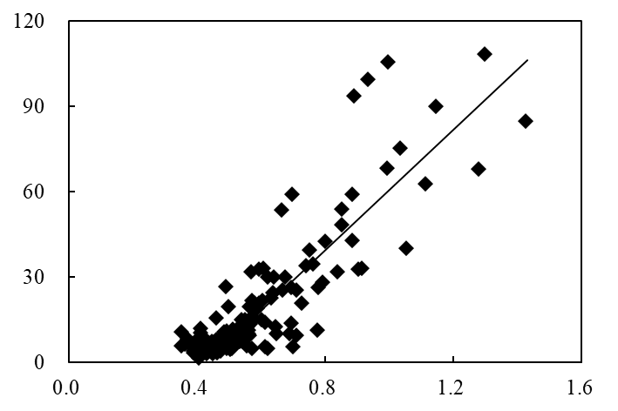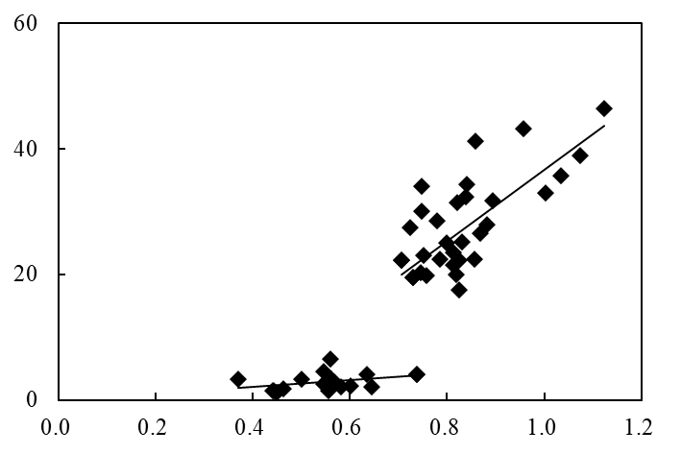

y1=5.3x-0.05 x<0.73

R12=0.12 n1=17

y2=57.0x-20.3 x≥0.73

R22=0.49** n2=33

y1=20.7x-2.0 x≤0.51

y2=105.9x-45.2 x>0.51

R2=0.76** n=151

(C)

Olsen-P (mg kg-1)

(D)

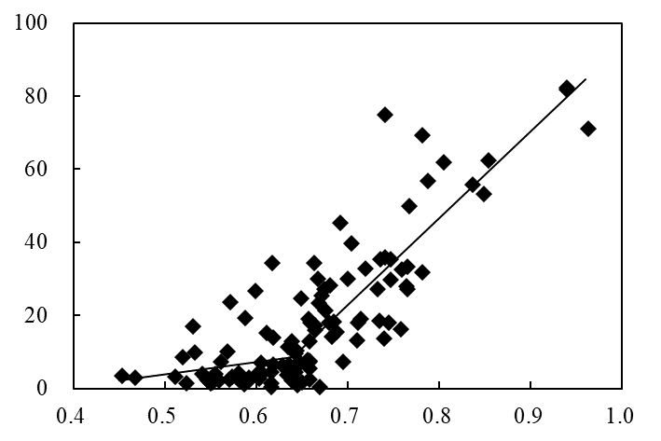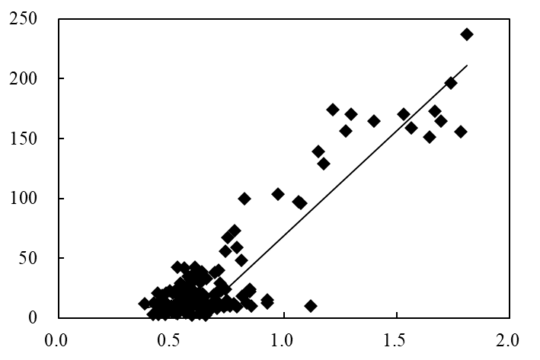

y1=44.4x-9.1 x<0.74

y2=175.2x-106.1 x≥0.74

R2=0.84** n=170

y1=34.3x-13.3 x≤0.64

y2=237.1x-143.1 x>0.64

R2=0.75** n=117

TP (g kg-1)

Figure S1. The relationship between soil TP and soil Olsen-P at Jinxian (A), Chongqing (B), Zhengzhou (C) and Gongzhuling (D) sites. The arrows mean the change-point of the response curve.

(B)

(A)

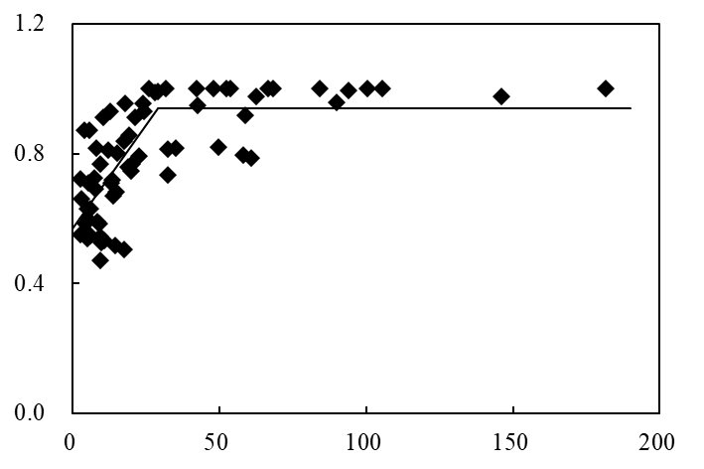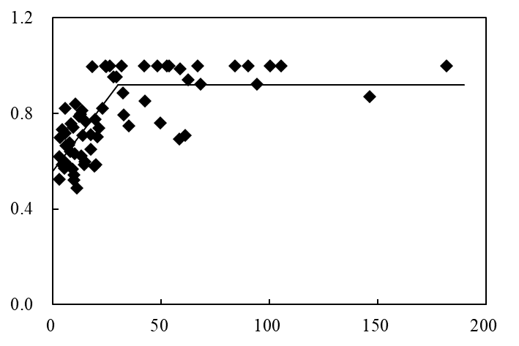

y1=0.01x+0.56 x<30.0

y2=0.92 x≥30.0

R2=0.56**， n=68

y1=0.01x+0.57 x<29.2

y2=0.94 x≥29.2

R2=0.55**， n=68

(C)

(D)

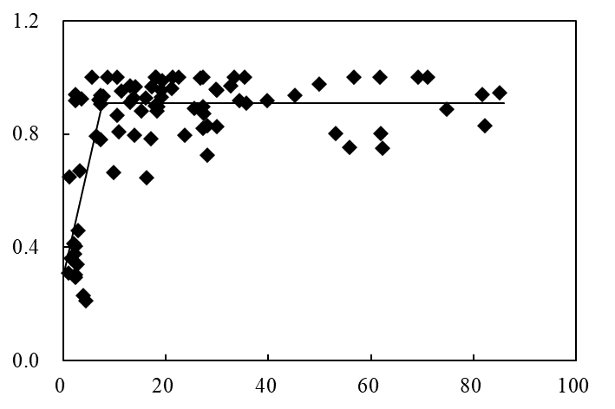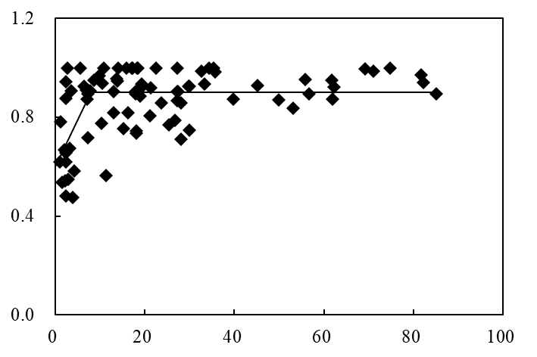

y1=0.04x+0.60 x<8.0

y2=0.90 x≥8.0

R2=0.36**， n=84

y1=0.08x+0.30 x<7.6

y2=0.91 x≥7.6

R2=0.57**， n=84

Olsen-P (mg kg-1)

(E)

Relative yield

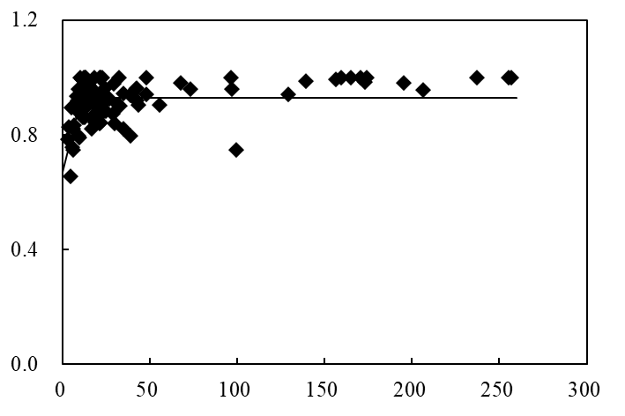

y1=0.03x+0.67 x<10.4

y2=0.93 x≥10.4

R2=0.27**， n=108

Olsen-P (mg kg-1)

Figure S2. The crop relative yield response to soil Olsen-P of early rice (A) and late rice (B) in Jinxian, wheat (C) and maize (D) in Zhengzhou and maize (E) in Gongzhuling.

(B)

(A)

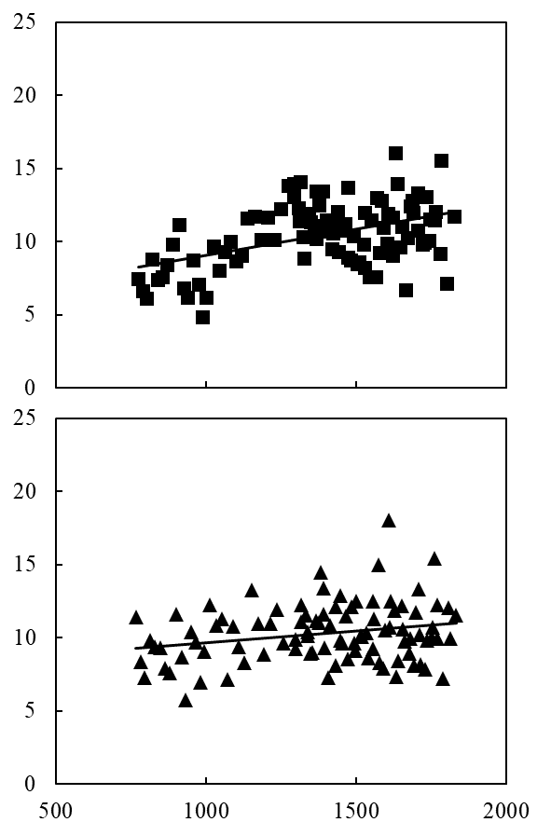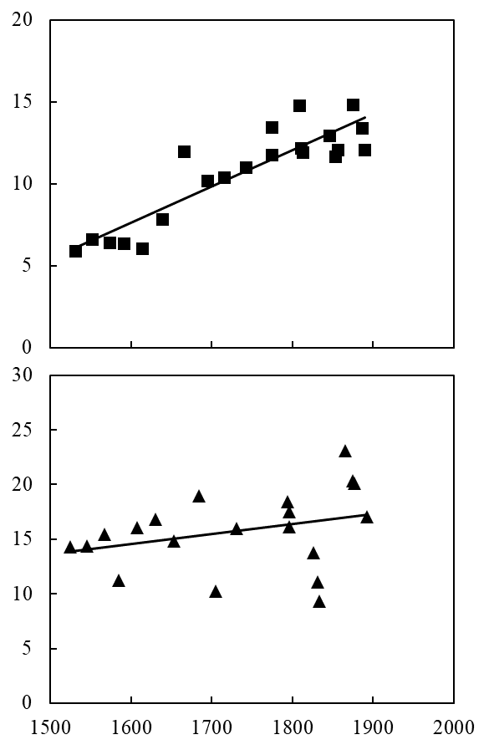

PA (kg P ha-1)

y=0.0016x+8.0522

R2=0.06*, P=0.0215

y=0.0222x-27.851

R2=0.80**, P<0.0001

y=0.0035x+5.5331

R2=0.21**, P<0.0001

(E)

(F)

(D)

(C)

y=0.0093x-0.2541

R2=0.10, P=0.1690

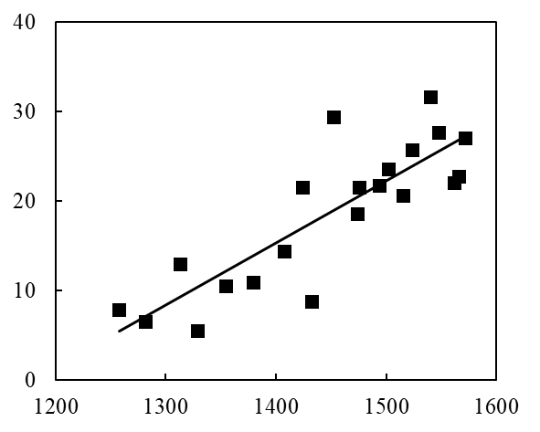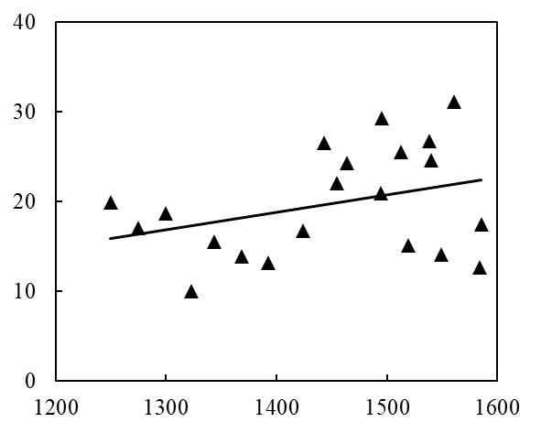

y=0.0693x-81.696

R2=0.71**, P<0.0001

TPA (kg P ha-1)

y=0.0195x-8.4064

R2=0.12, P=0.1310

Figure S3. The correlation between TPA and PA of early rice (A) and late rice (C) in Jinxian, wheat (B) and rice (D) in Chongqing and wheat (E) and maize (F) in Zhengzhou.

(B)

(A)

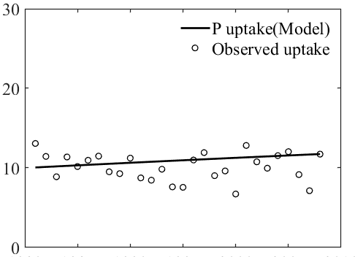 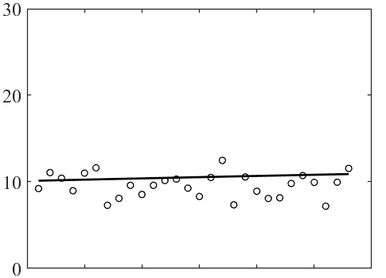

Crop P uptake (kg ha-1 yr-1)

NP

(D)

(C)

NP

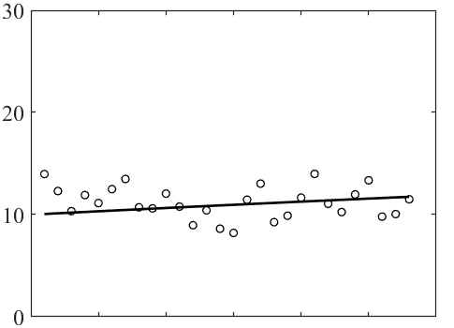 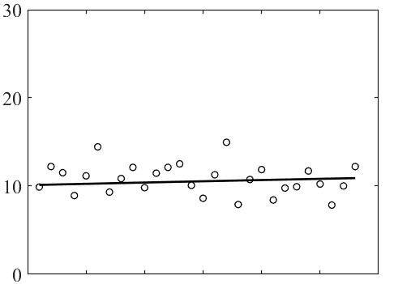

NPK

(E)

(F)

NPK

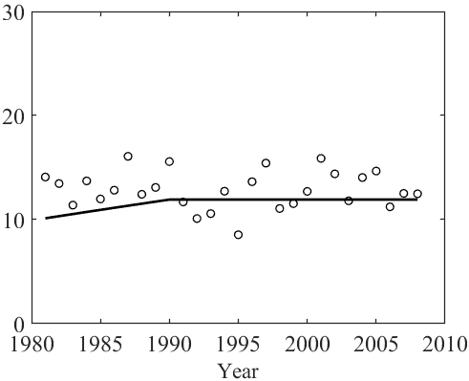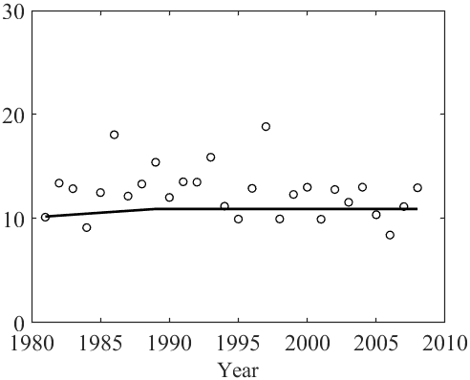

HNPK

HNPK

Fig S4. Simulated and observed P uptake of early rice (A and C, E) and late rice (B and D, F) by the LePA model in the NP, NPK, and HNPK treatments at Jinxian site (1981–2008).

(B)

(A)

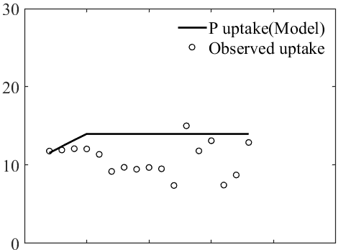 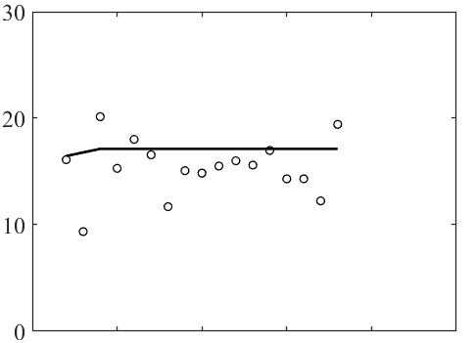

(D)

(C)

NP

NP

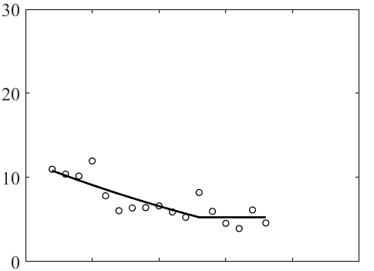 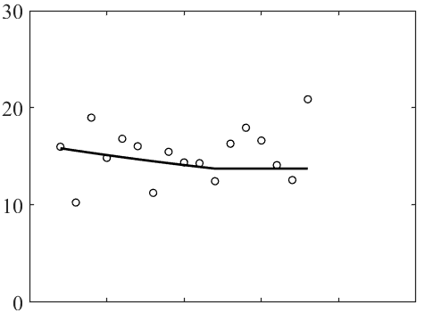

(F)

(E)

NK

NK

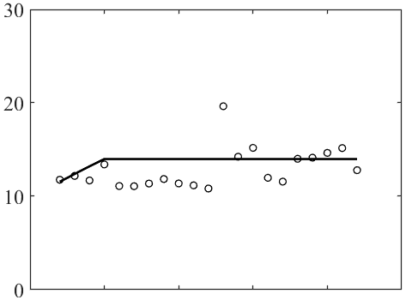 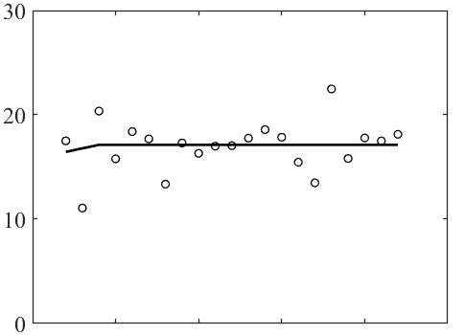

Crop P uptake (kg ha-1 yr-1)

(H)

(G)

NPK

NPK

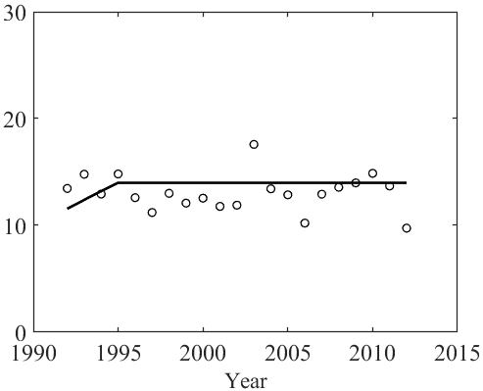 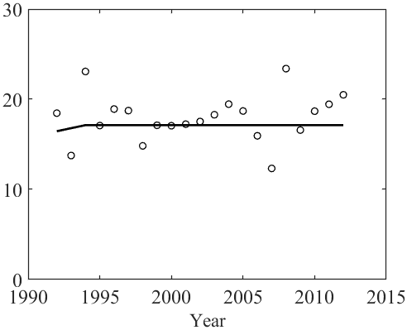

NPKS

NPKS

Fig S5. Simulated and observed P uptake of wheat (A and C, E, G) and rice (B and D, F, H) by the LePA model in the NP, NK, NPK, and NPKS treatments at Chongqing site (1992–2012).

(B)

(A)

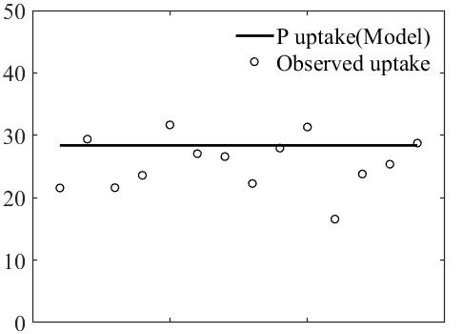 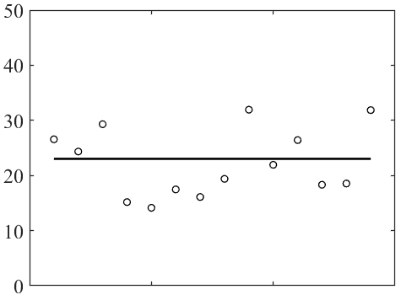

(D)

(C)

NP

NP

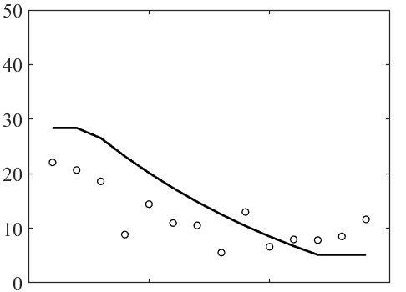 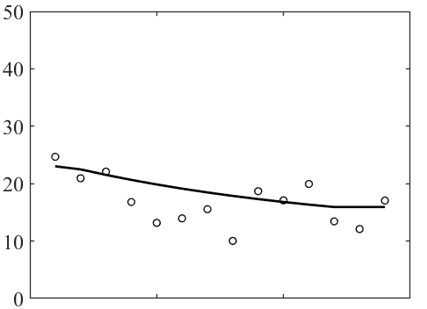

Crop P uptake (kg ha-1 yr-1)

(E)

(F)

NK

NK

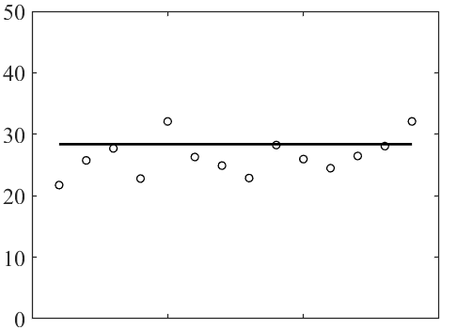 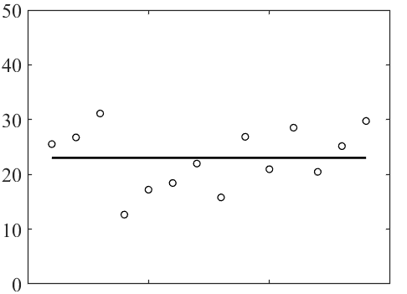

(H)

(G)

NPK

NPK

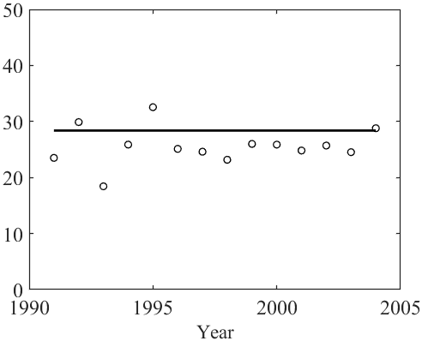 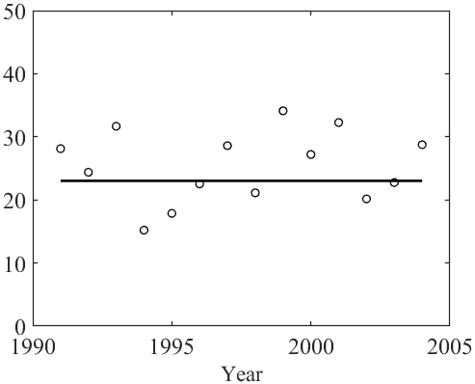

NPKS

NPKS

Fig S6. Simulated and observed P uptake of wheat (A and C, E, G) and maize (B and D, F, H) by the LePA model in the NP, NK, NPK, and NPKS treatments at Zhengzhou site (1991–2004).

(B)

(A)

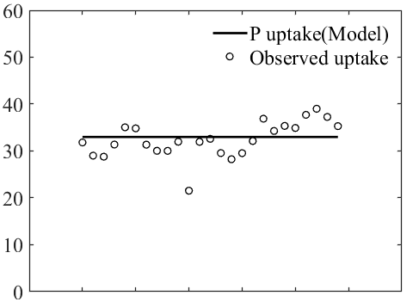 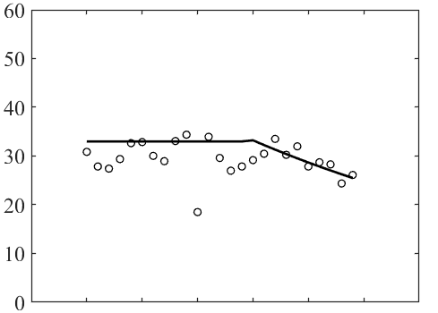

(D)

(C)

Crop P uptake (kg ha-1 yr-1)

NK

NP

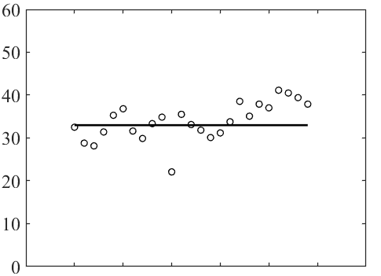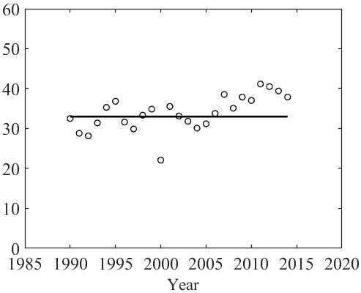 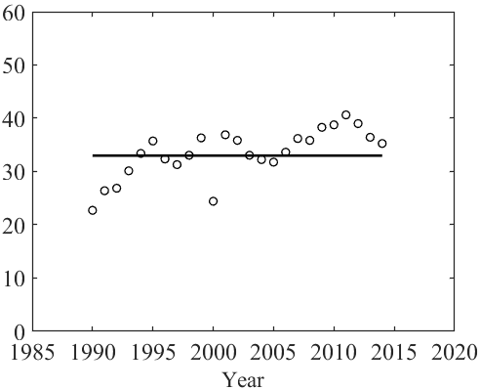

NPKS

NPK

Fig S7. Simulated and observed P uptake of maize (A-D) by the LePA model in the NP, NK, NPK, and NPKS treatments at Gongzhuling site (1990–2014).

(B)

(A)

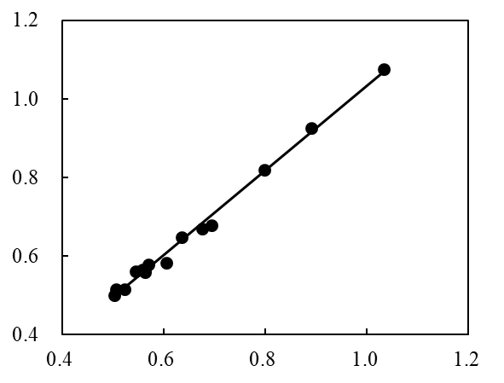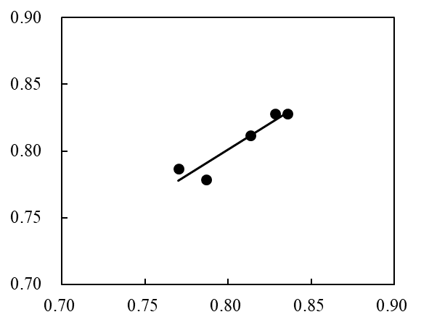

Modelled total P (g kg-1)

(D)

(C)

y=0.8x+0.2, R2=0.88

RMSE=0.01

y=1.1x-0.04, R2=0.99

RMSE=0.02

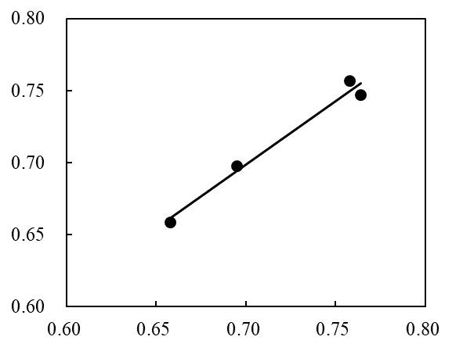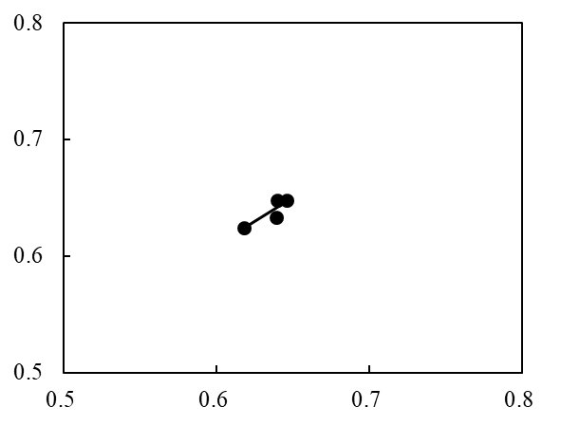

y=0.8x+0.1, R2=0.78

RMSE=0.01

Observed total P (g kg-1)

y=0.9x+0.1, R2=0.98

RMSE=0.01

Figure S8. Correlation of modelled and observed soil total P in the NP, NPK and HNPK treatments of Jinxian (A) and in the NP, NPK and NPKS treatments of Chongqing (B), Zhengzhou (C) and Gongzhuling (D). The grey dashed lines were the 1:1 lines. Correlation of modelled and observed soil total P in the NP, NPK, NPKS treatments of Yangling and Qiyang was shown in Yu et al. (2021).

(B)

(A)

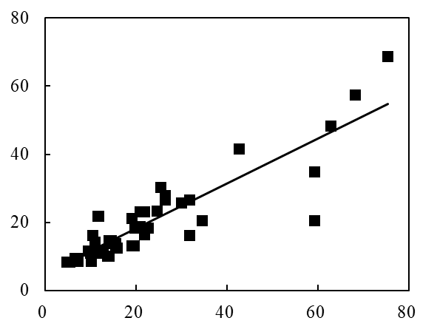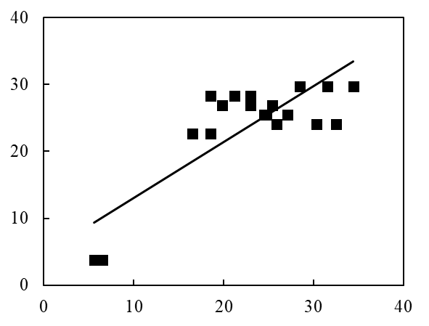

(D)

(C)

Modelled Olsen-P (mg kg-1)

y=0.8x+4.6, R2=0.69

RMSE=4.87

y=0.7x+5.1, R2=0.78

RMSE=8.58

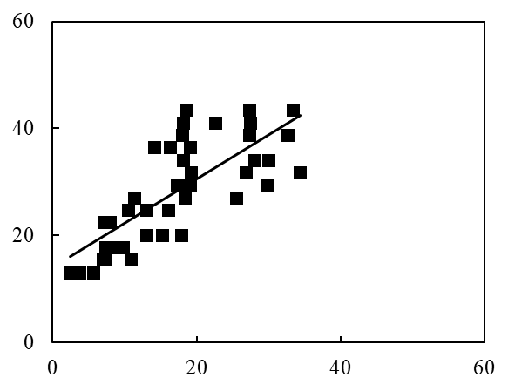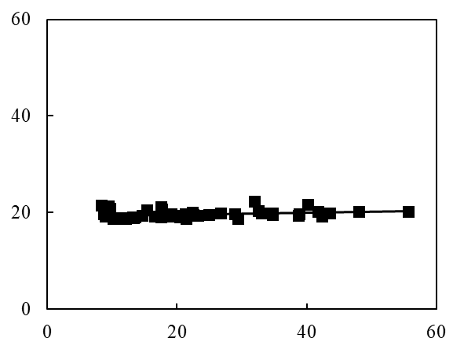

Observed Olsen-P (mg kg-1)

y=0.02x+19.2, R2=0.08

RMSE=11.26

y=0.8x+14.1, R2=0.58

RMSE=12.68

Figure S9. Correlation of modelled and observed soil Olsen-P in the NP, NPK and HNPK treatments of Jinxian (A) and in the NP, NPK and NPKS treatments of Chongqing (B), Zhengzhou (C) and Gongzhuling (D). The grey dashed lines were the 1:1 lines. Correlation of modelled and observed soil Olsen-P in the NP, NPK, NPKS treatments of Yangling and Qiyang was shown in Yu et al. (2021).

**References**

Cai, Z., Sun, N., Wang, B., Xu, M., Huang, J., and Zhang, H. (2011). Effects of long-term fertilization on red soil pH, crop yield and nutrient absorption of nitrogen, phosphorus and potassium. *Plant Nutrition and Fertilizer Science* 17(1)**,** 71-78.

Khan, A., Lu, G., Ayaz, M., Zhang, H., Wang, R., Lv, F., et al. (2018). Phosphorus efficiency, soil phosphorus dynamics and critical phosphorus level under long-term fertilization for single and double cropping systems. *Agriculture, Ecosystems & Environment* 256**,** 1-11. doi: 10.1016/j.agee.2018.01.006.

Li, D., Wang, B., Huang, J., Zhang, Y., Xu, M., Zhang, S., et al. (2019). Change of phosphorus in red soil and its effect to grain yield under long-term different fertilizations. *Scientia Agricultura Sinica* 52(21)**,** 3830-3841. doi: 10.3864/j.issn.0578-1752.2019.21.012.

Liu, J. (2015). Phosphorus accumulation characteristics and environmental risks of purple soil under long-term fertilization.

Wu, Q., Zhang, S., Feng, G., Zhu, P., Huang, S., Wang, B., et al. (2020). Determining the optimum range of soil Olsen P for high P use efficiency, crop yield, and soil fertility in three typical cropland soils. *Pedosphere* 30(6)**,** 832-843. doi: 10.1016/s1002-0160(20)60040-6.

Xu, M., Zhang, W., Huang, S., Yang, X., Lu, C., and He, Y. (2015). *Evolution of soil fertility in China. Second edition.* Beijing: China Agricultural Science and Technology Press.

Zhao, B., Li, X., Li, X., Li, X., Shi, X., and Bao, D. (2012). *Fertilization system and sustainable use of soil.* Beijing: Science Press.

Yang, X.-y., Sun, B.-h., and Zhang, S.-l. (2014). Trends of Yield and Soil Fertility in a Long-Term Wheat-Maize System. *Journal of Integrative Agriculture* 13(2)**,** 402-414. doi: 10.1016/s2095-3119(13)60425-6.

Yang, X., Sun, B., Gu, Q., Li, S., and Zhang, S. (2009). Effect of long-term fertilization on phosphorus status in rainfed loess soil. *Plant Nutrition and Fertilizer Science* 15(4)**,** 837-842.

Yang, Y., Zhang, S., and Yang, X. (2018). Effects of long-term fertilization on winter wheat yield and soil nutrients in rainfed loess soil. *Chinese Journal of Soil Science* 49(2)**,** 402-408. doi: 10.19336/j.cnki.trtb.2018.02.20.

Yu, W. J., Li, G. H., Hartmann, T., Xu, M. G., Yang, X. Y., Li, H. G., et al. (2021). Development of a novel model of soil legacy P assessment for calcareous and acidic soils. *Frontiers in Environmental Science* 8, 1-12. doi: 10. 3389/fenvs.2020.621833.

Zhu, Q. C., de Vries, W., Liu, X. J., Hao, T. X., Zeng, M. F., Shen, J. B., et al. (2017). Enhanced acidification in Chinese croplands as derived from element budgets in the period 1980-2010. *Sci. Total Environ.* 618, 1497-1505. doi: org/10.1016/j.scitotenv.2017.09.289.