**Supplemental Figure 1.**

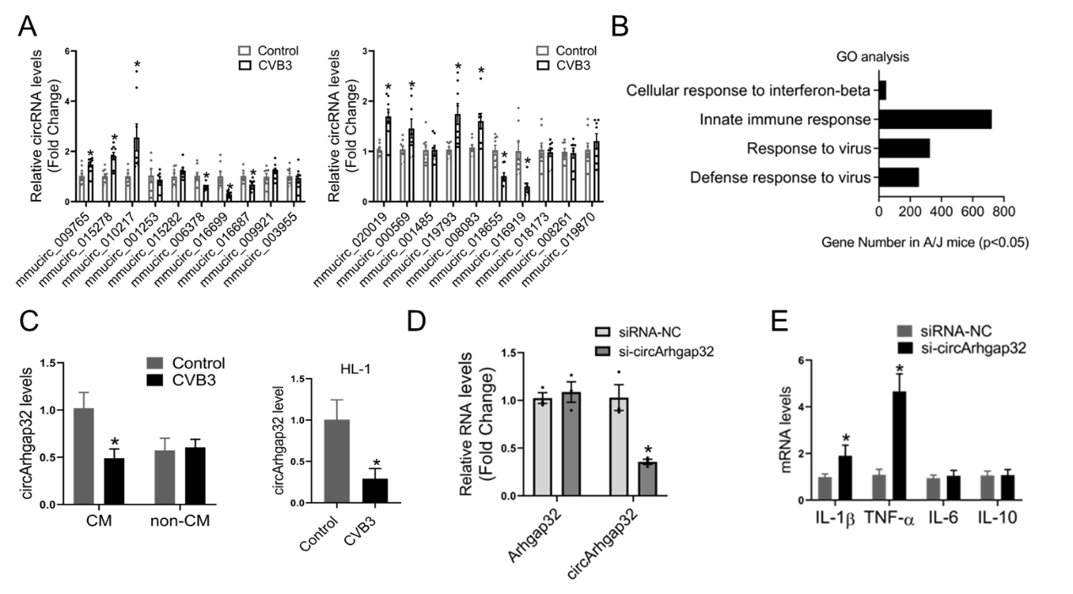

**Supplemental Figure 1.** (A) The expression levels of circRNAs were detected by qRT-PCR in HL-1 cells upon CVB3 infection; *P<0.05 VS. Control. (B) GO analysis for source genes of circRNAs in A/J mice. (C) The expression of circArhgap32 was detected by qRT-PCR; *P<0.05 VS. Control. (D) The expression of Arhgap32 and circArhgap32 were detected by qRT-PCR; *P<0.05 VS. siRNA-NC. (E) The expression levels of inflammatory factors were detected by qRT-PCR; *P<0.05 VS. siRNA-NC.