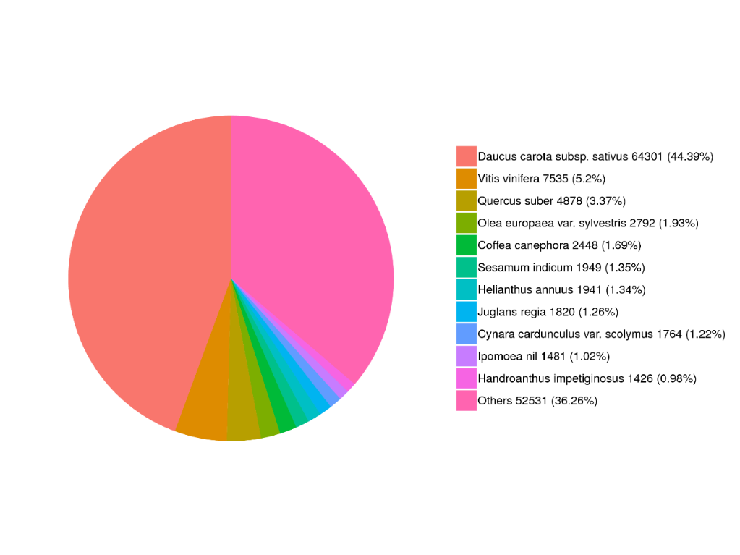

Fig. S1 Species distribution of the top BLAST hits of *P. notoginseng* unigeneswhen the encoded proteins were queried against the NCBI nonredundant protein database.

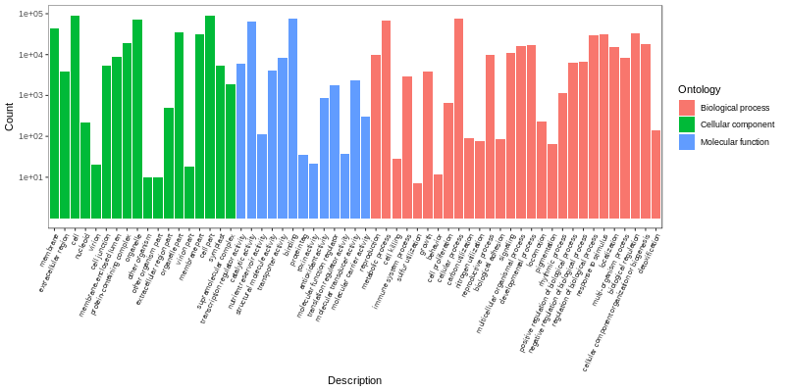

Fig. S2 Gene ontology classification of the *P. notoginseng* unigenes

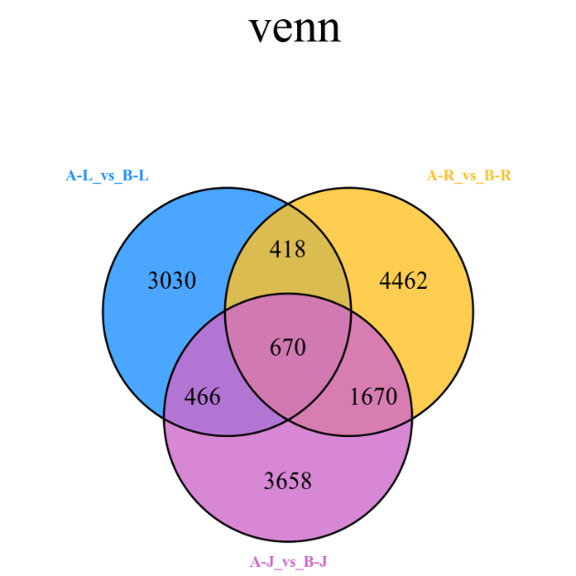

Fig. S3 Venn diagram of differentially expressed genes (DEGs).

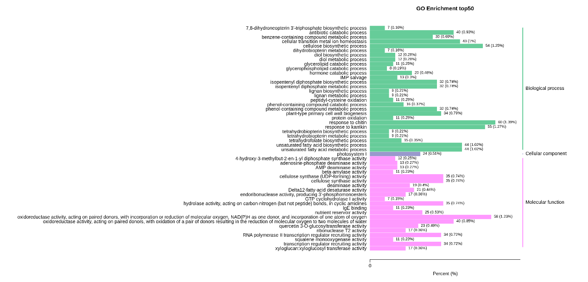

Fig. S4 Gene ontology (GO) functional classifications of differentially expressed genes (DEGs) of A-R vs. B-R

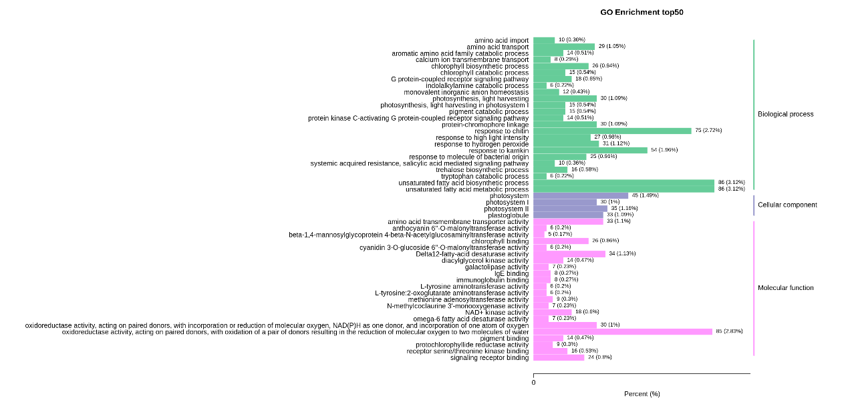

Fig. S5 Gene ontology (GO) functional classifications of differentially expressed genes (DEGs) of A-L vs. B-L

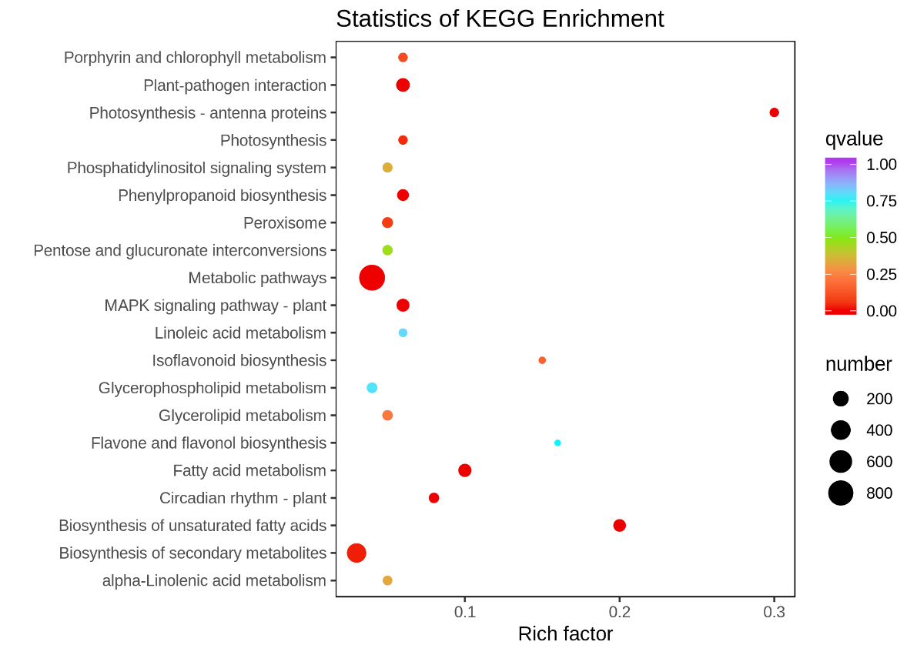

Fig. S6 Statistics of KEGG enrichment of A-L vs. B-L

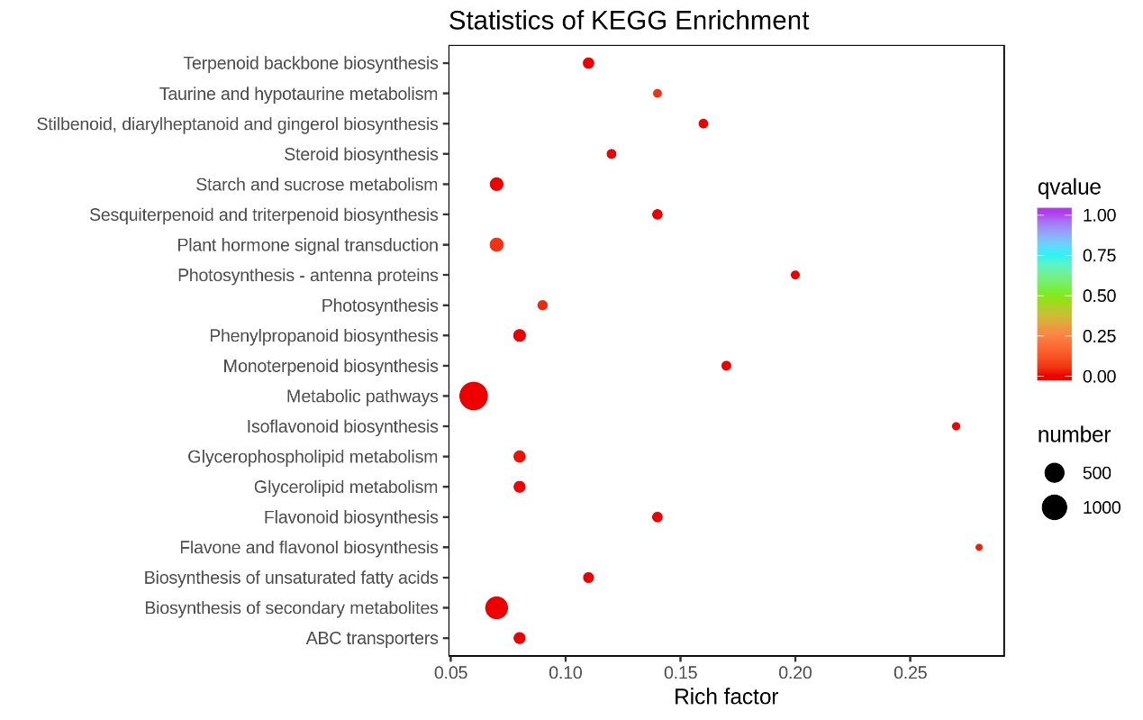

Fig. S7 Statistics of KEGG enrichment of A-R vs. B-R

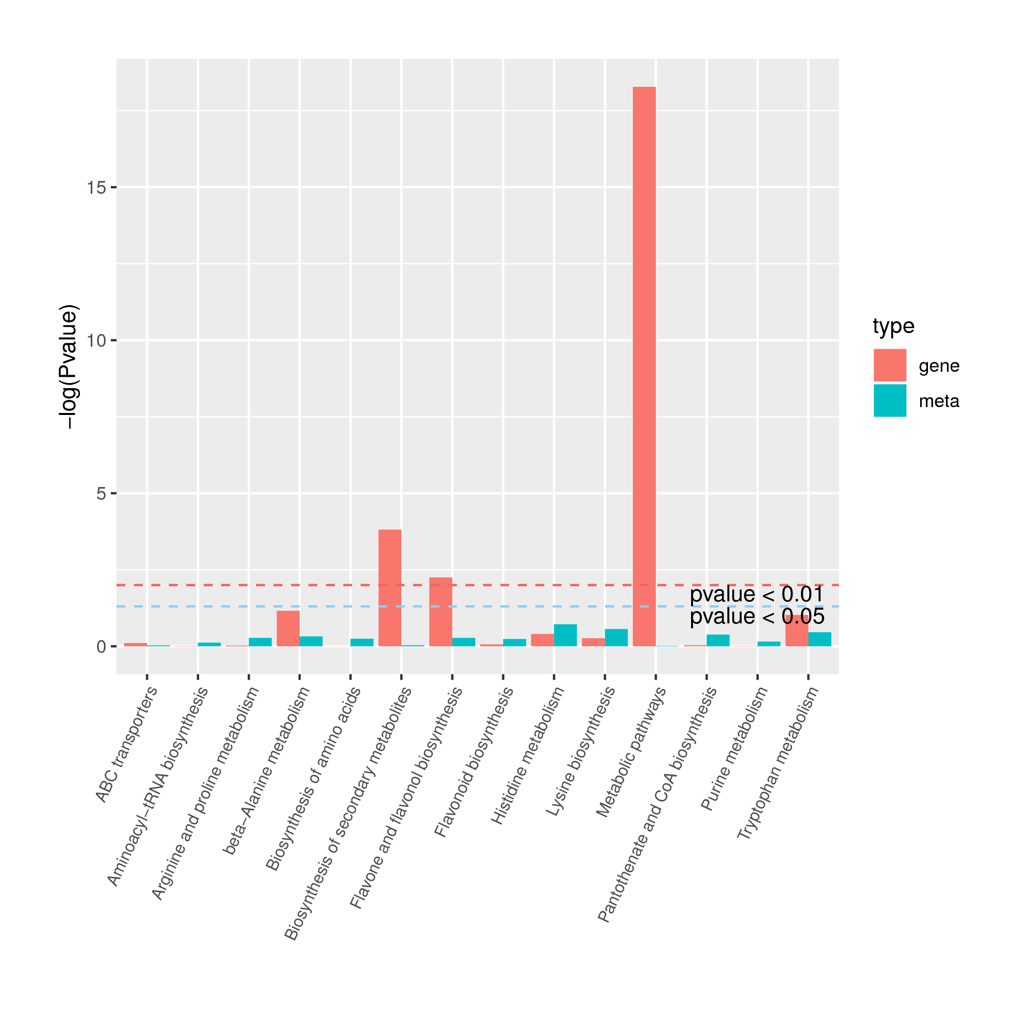

Fig. S8 Joint KEGG enrichment p-value histogram of A-L vs. B-L

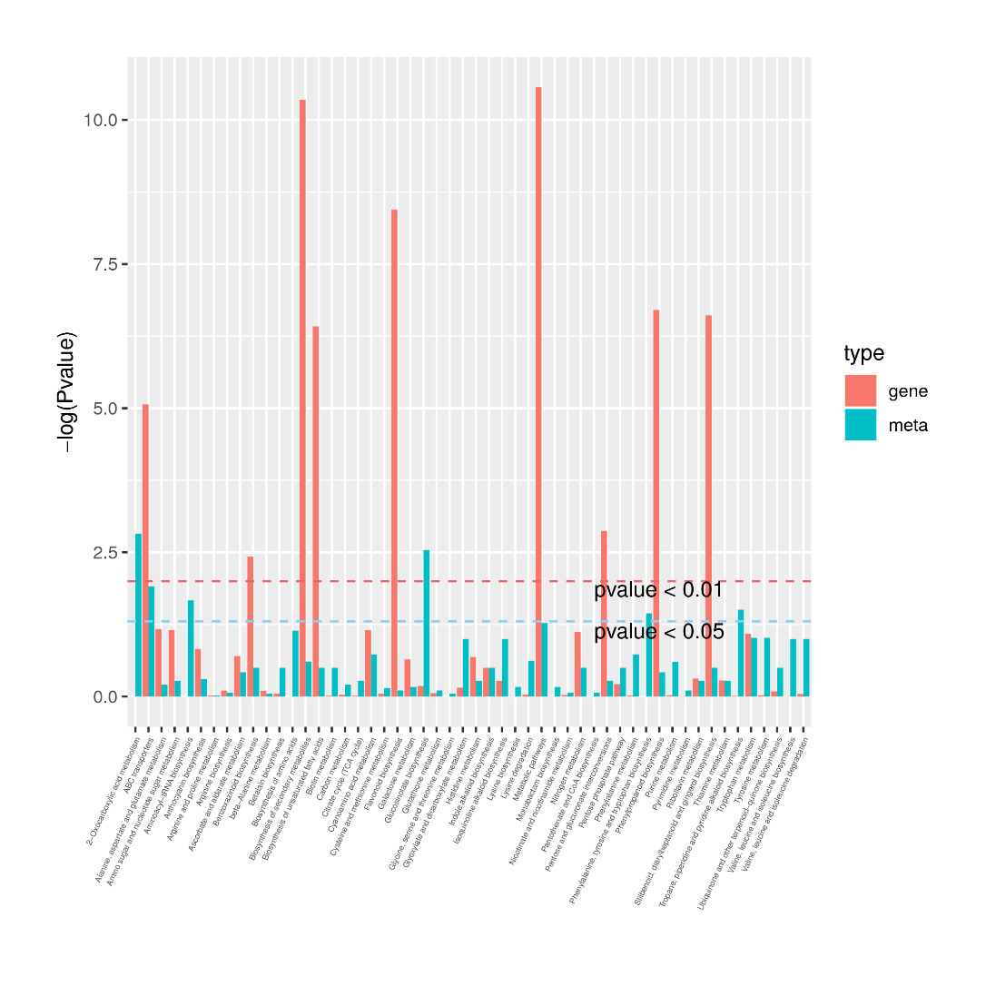

Fig. S9 Joint KEGG enrichment p-value histogram of A-R vs. B-R

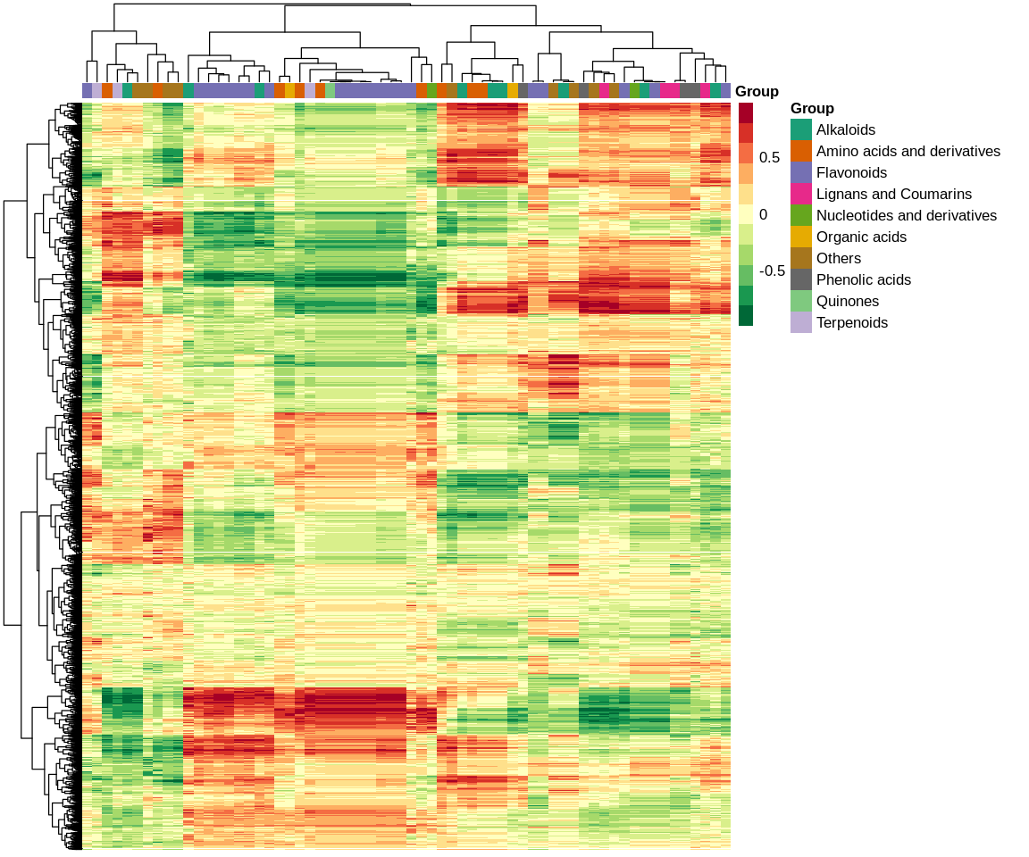

Fig. S10 Correlation coefficient cluster heat map of A-J vs. B-J

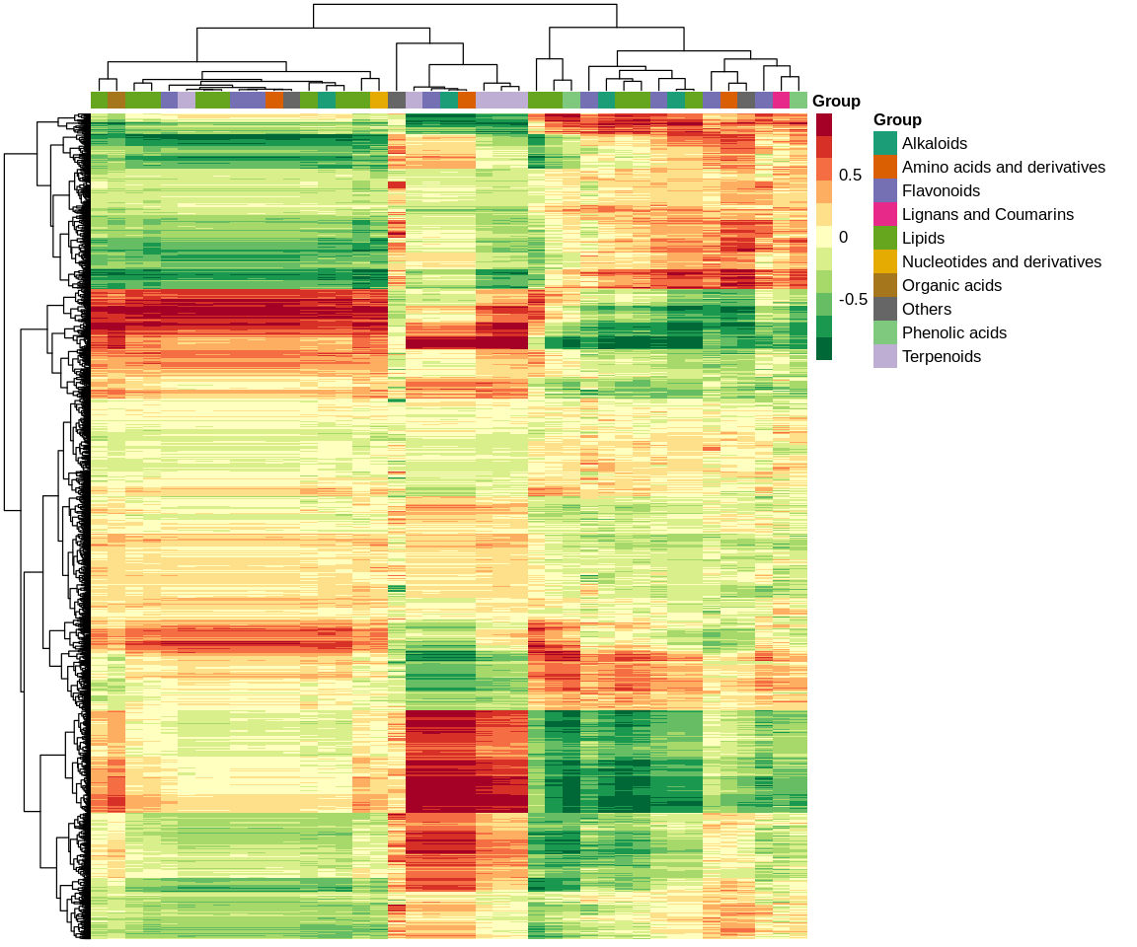

Fig. S11 Correlation coefficient cluster heat map of A-L vs. B-L

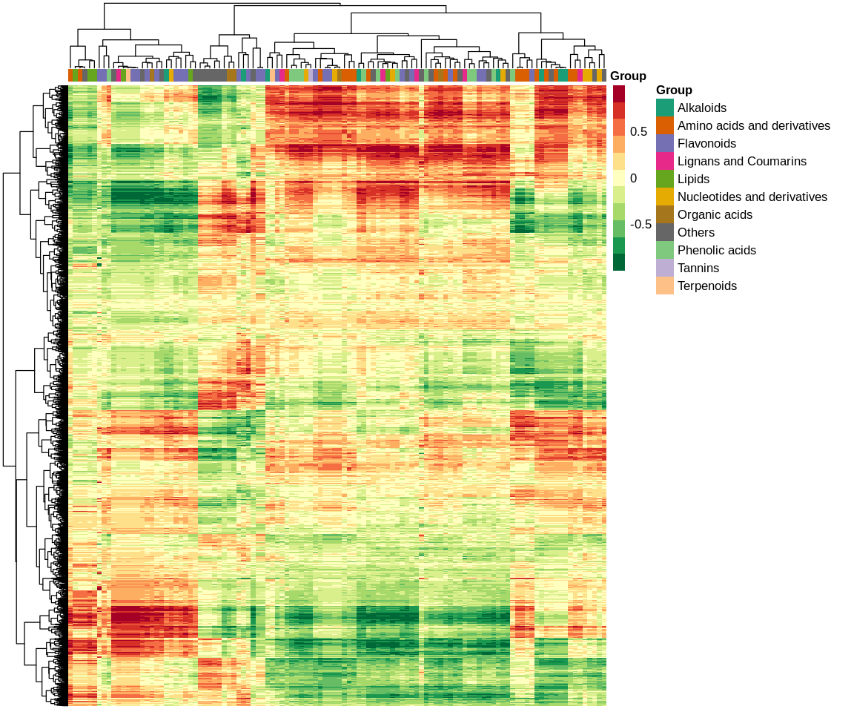

Fig. S12 Correlation coefficient cluster heat map of A-R vs. B-R