**Supplementary Material**

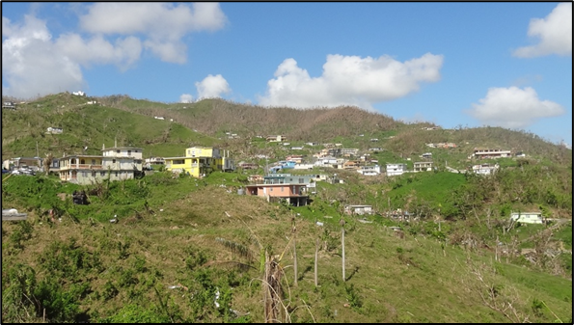

**Figure S1.** Example of topographic wind speed damage observed in Yabucoa, Puerto Rico after Hurricane Maria

|  |  |
| --- | --- |
|  |  |
| (a) Aerial Photo | (b) Urban Areas |
|  |  |
| (c) DEM in meters | (d) Slope in degrees |
|  |  |
| (e) Curvature in degrees | (f) Rugosity |
|  |  |

**Figure S2.** Aibonito region images: (a) aerial photo, (b) urban areas, (c) elevation, (d) slope, (e) curvature, and (f) rugosity

|  |  |
| --- | --- |
|  |  |
| (a) Aerial Photo | (b) Urban Areas |
|  |  |
| (c) DEM in meters | (d) Slope in degrees |
|  |  |
| (e) Curvature in degrees | (f) Rugosity |

**Figure S3.** Culebra region images: (a) aerial photo, (b) urban areas, (c) elevation, (d) slope, (e) curvature, and (f) rugosity

|  |  |
| --- | --- |
|  |  |
| (a) Aerial Photo | (b) Urban Areas |
|  |  |
| (c) DEM in meters | (d) Slope in degrees |
|  |  |
| (e) Curvature in degrees | (f) Rugosity |
|  |  |

**Figure S4.** Humacao region images: (a) aerial photo, (b) urban areas, (c) elevation, (d) slope, (e) curvature, and (f) rugosity

|  |  |
| --- | --- |
|  |  |
| (a) Aerial Photo | (b) Urban Areas |
|  |  |
| (c) DEM in meters | (d) Slope in degrees |
|  |  |
| (e) Curvature in degrees | (f) Rugosity |

**Figure S5.** Utuado region images: (a) aerial photo, (b) urban areas, (c) elevation, (d) slope, (e) curvature, and (f) rugosity

|  |  |
| --- | --- |
|  |  |
| (a) Aerial Photo | (b) Urban Areas |
|  |  |
| (c) DEM in meters | (d) Slope in degrees |
|  |  |
| (e) Curvature in degrees | (f) Rugosity |

**Figure S6.** Vieques region images: (a) aerial photo, (b) urban areas, (c) elevation, (d) slope, (e) curvature, and (f) rugosity

|  |  |
| --- | --- |
|  |  |
| (a) Aerial Photo | (b) Urban Areas |
|  |  |
| (c) DEM in meters | (d) Slope in degrees |
|  |  |
| (e) Curvature in degrees | (f) Rugosity |

**Figure S7.** Yabucoa region images: (a) aerial photo, (b) urban areas, (c) elevation, (d) slope, (e) curvature, and (f) rugosity