Supplementary Material

# Supplementary Tables

**TABLE 1|** Experimental instruments.

| **Instruments** | **Simulation/ test content** | **Units** |
| --- | --- | --- |
| Microclimate warehouse | Air temperature | °C |
| Relative humidity | % |
| Wind speed | m/s |
| Illuminance | Lux |
| ECG measuring instrument | PR (Pulse rate) | Bmp |
| HR (Heart rate) | Bmp |
| SpO2 (Pulse oxygen saturation) | % |
| NIBP (Blood pressure) | mmHg |
| RR (Respiratory rate) | rpm |
| Running platform | Activity speed | m/s |

**TABLE 2|** Examples of tourism scenarios under different activity intensities.

| **Activity intensities of the experimental design** | **Common scenarios in virtual tourism activities** | **Literature Sources** |
| --- | --- | --- |
| Sitting | 360° 3D panoramic desktop display browsing of tourism cities, tourism scenes, and virtual attractions. | (Chen, 2013)  (Griffon et al., 2011) |
| Preview the hotel accommodation conditions by moving the screen and pointer. | (Lee and Oh, 2007) |
| Slow Walking | A panoramic walking tour of VR theme park scenic spots through helmet-mounted displays or omni-directional monitors. | (Yu, 2017)  (Lin and Zhang, 2007) |
| Watch the set underwater world, volcanoes, etc. through the mobile screen in the special cabin. | (Huang et al., 2020) |
| Brisk Walking | Interactive sports such as running or climbing in naked-eye 3D virtual tourism scenes. | (Lewis and Rosie, 2020) |
| Perform virtual game operations as a pilot, astronaut, etc. on the advanced simulator. | (Jiang and Zhu, 2007) |

**TABLE 3|** Experimental design.

| **Activity Intensity**  **Temperature℃** | | **Sitting** | **Slow Walking** | | **Brisk Walking** | |
| --- | --- | --- | --- | --- | --- | --- |
| A:13.1-18.0 | A1:13.1-14.7 | A11 | A12 | A13 | |
| A2:14.8-16.3 | A21 | A22 | A23 | |
| A3:16.4-18.0 | A31 | A32 | A33 | |
| B:18.1-23.0 | B1:18.1-19.7 | B11 | B12 | B13 | |
| B2:19.8-21.3 | B21 | B22 | B23 | |
| B3:21.4-23.0 | B31 | B32 | B33 | |
| C:23.1-29.0 | C1:23.1-25.0 | C11 | C12 | C13 | |
| C2:25.0-27.0 | C21 | C22 | C23 | |
| C3:27.1-29.0 | C31 | C32 | C33 | |

Note(s): Controlled conditions: relative humidity (70%), wind speed(2m/s), illuminance(4200lux).

**TABLE 4|** Socio-demographic profile of the interviewees.

|  |  |  |  |
| --- | --- | --- | --- |
| **Demographic** | | **Frequency** | **Percentage** |
| **Gender** | Male | 30 | 50.00 |
| Female | 30 | 50.00 |
| **Age** | <18 | 13 | 21.67 |
| 18-30 | 32 | 53.33 |
| 30-40 | 13 | 21.67 |
| >40 | 2 | 3.33 |
| **Education** | Bachelor’s Degree or Under | 25 | 41.67 |
| Master’s Degree | 24 | 40.00 |
| Doctor’s Degree | 11 | 18.33 |
| **Climate zone of residential place** | Tropical | 11 | 18.33 |
| Subtropical | 21 | 35.00 |
| Temperate | 28 | 46.67 |
| **Virtual tourism experience times** | 0 | 6 | 10.00 |
| 1-5 | 30 | 50.00 |
| 6-10 | 18 | 30.00 |
| More than 10 | 6 | 10.00 |

**TABLE 5|** ANOVA: environmental temperature, activity intensity, and perceived thermal comfort.

|  |  |  |  |  |
| --- | --- | --- | --- | --- |
|  | **Temperature** | **Activity intensity** | **Temperature*Activity intensity** | |
| *F* | 25.74*** | 1.91 | 6.96*** |
| *P* | 0.000 | 0.126 | 0.000 |

Note(s): *p <0.05; **p <0.01; ***p <0.001.

**TABLE 6|** ANOVA: The resting physiological indexes in the pre-test.

| **Groups** | **HR** | **PR** | **SPO2** | **NIBP-**  **Dia** | | **NIBP-**  **Sys** | | **NIBP-**  **Mean** | | **RR** | |
| --- | --- | --- | --- | --- | --- | --- | --- | --- | --- | --- | --- |
| Group 1 | 77.88 | 75.83 | 98.00 | | 107.94 | | 68.06 | | 76.24 | | 17.24 |
| Group 2 | 78.02 | 76.00 | 98.15 | | 110.50 | | 72.75 | | 83.95 | | 16.55 |
| Group 3 | 78.00 | 76.15 | 98.24 | | 113.29 | | 74.53 | | 83.65 | | 16.82 |
| F  P | 1.381  0.219 | 1.824  0.191 | 0.849  0.428 | | 7.874***  .000 | | 33.081***  .000 | | 51.089***  .000 | | 2.004  0.136 |

**TABLE 7|** Homogeneity test of interaction under different activity intensities.

| **Activity Intensity** | **Statistics** | ***HRresting*temperature*** | ***PRresting*temperature*** | ***SPO*2*resting*temperature*** | ***RRresting*temperature*** |
| --- | --- | --- | --- | --- | --- |
| Sitting | *F* | 80.13*** | 254.96*** | 629.30*** | 2.41 |
| *P* | 0.000 | 0.000 | 0.000 | 0.123 |
| Slow walking | *F* | 54.73*** | 0.21 | 0.17 | 1.88 |
| *P* | 0.000 | 0.657 | 0.683 | 0.172 |
| Brisk walking | *F* | 67.50*** | 11.28*** | 0.51 | 0.22 |
| *P* | 0.000 | 0.001 | 0.475 | 0.642 |

**TABLE 8|** Results of the analysis of covariance.

| **Activity Intensity** | **Statistics** | ***HR*** | ***PR*** | ***SPO*2** | ***RR*** |
| --- | --- | --- | --- | --- | --- |
| Sitting | *F* | - | - | - | 0.120 |
| *P* | - | - | - | 0.998 |
| Slow walking | *F* | - | 2.272* | 3.337** | 0.16 |
| *P* | - | 0.025 | 0.001 | 0.996 |
| Brisk walking | *F* | - | - | 2.390* | 0.59 |
| *P* | - | - | 0.018 | 0.787 |

# Supplementary Figures

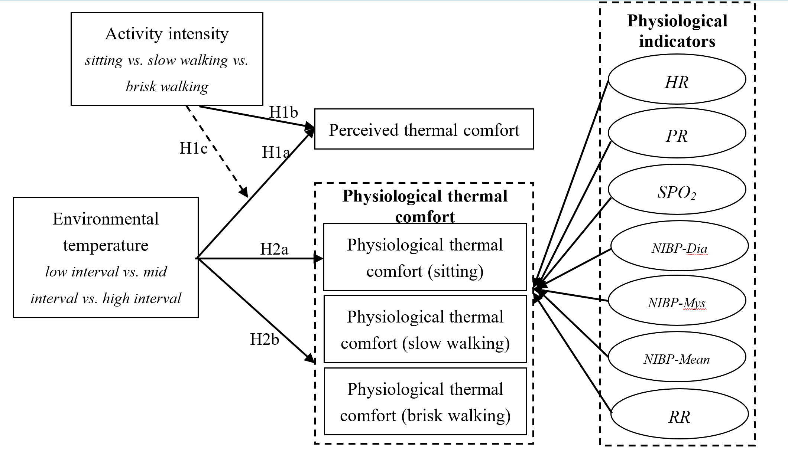

**FIGURE 1|** Conceptual model and hypotheses.

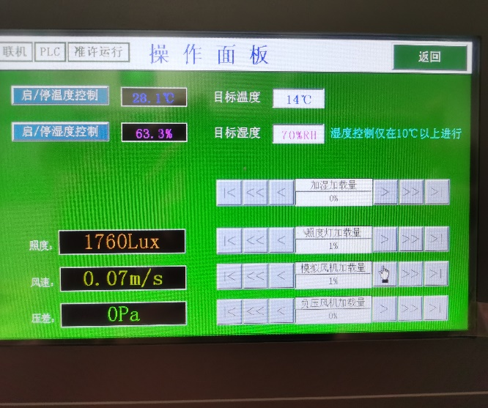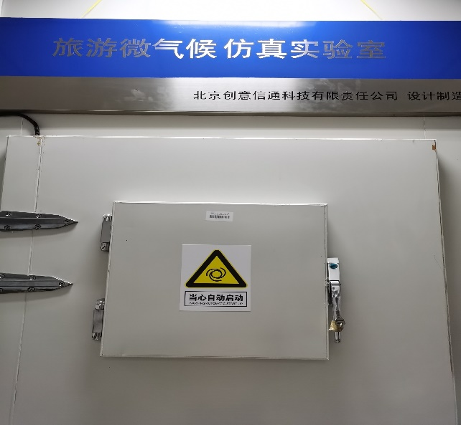

(a) (b)

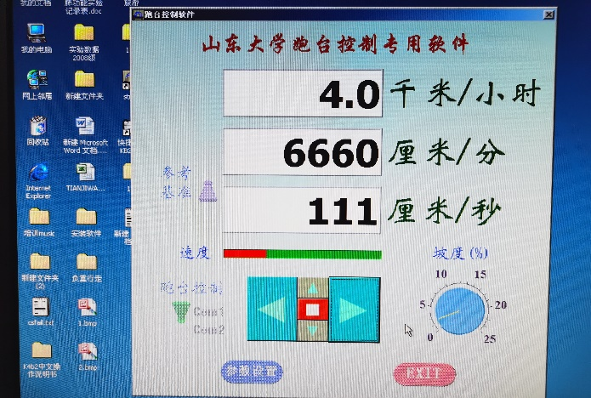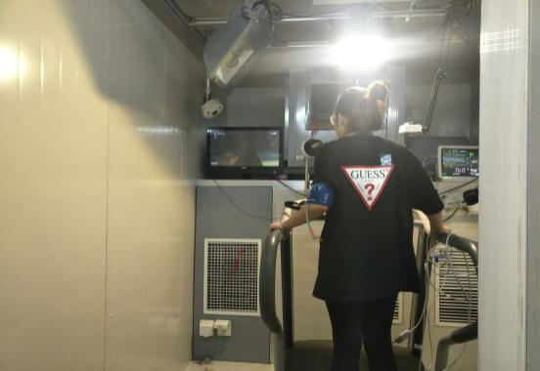

(c) (d)

**FIGURE 2|** Experimental instruments （a. The appearance of microclimate warehouse; b. The operation panel of microclimate warehouse; c. Running platform, LED screen, ECG measuring instrument; d. Running platform control center）.

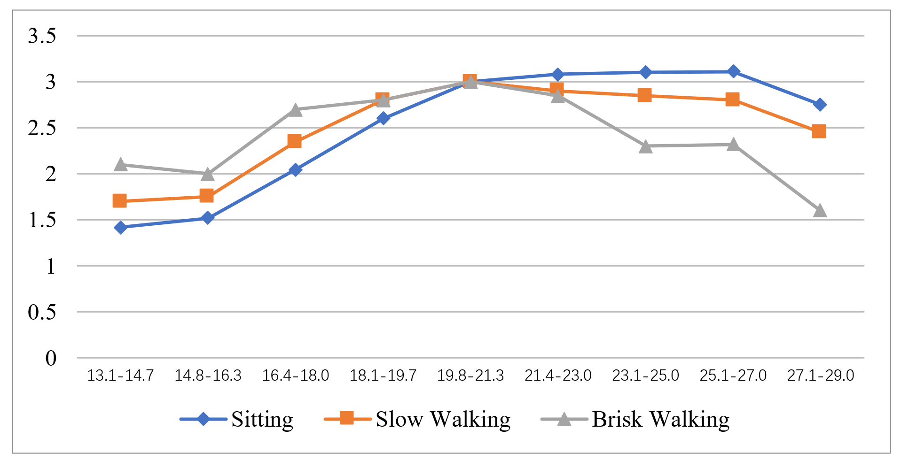**FIGURE 3|** Virtual tourist’s comfort level-temperature under different activity intensities.

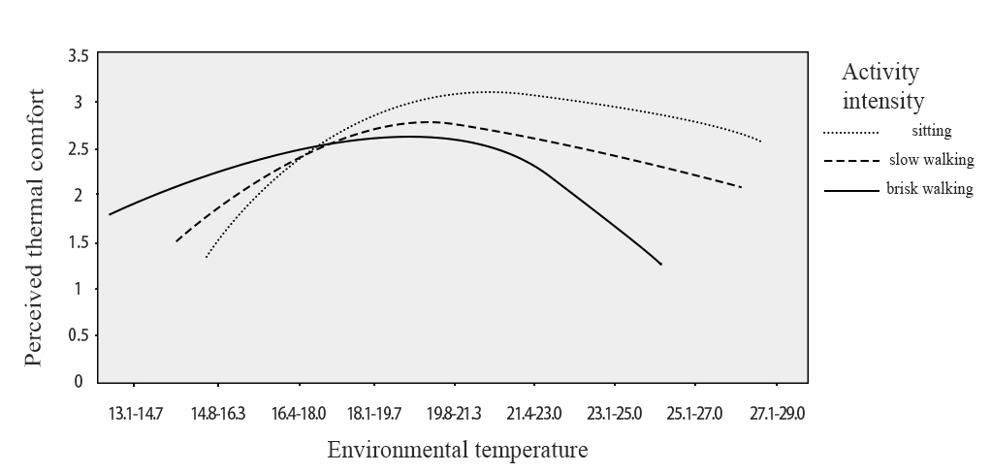**FIGURE 4|** Moderating effect of activity intensity on the relationship between environmental temperature and perceived thermal comfort.