Supplementary Material for
Pseudospin-dependent acoustic topological insulator by sonic crystals with same hexagonal rods
Ding Jia,^{1,2} Shuai Gu,¹ Shuai Jiang,¹ Shou-qi Yuan¹ and Hong-xiang Sun^{1,3*}
¹Research Center of Fluid Machinery Engineering and Technology, School of Physics and Electronic Engineering, Jiangsu University, Zhenjiang 212013, China
²School of Computer Science and Communications Engineering, Jiangsu University, Zhenjiang 212013, China
³State Key Laboratory of Acoustics, Institute of Acoustics, Chinese Academy of Sciences, Beijing 100190, China
*Correspondence: Hong-xiang Sun jsdxshx@ujs.edu.cn

Note 1 Calculations of Chern numbers based on Wilson-loop method….....................2
Note 2 Experimental set-up…...…..........................................................................…...2

Note 1 Calculations of Chern numbers based on Wilson-loop method

We simulate the Berry phases of SC-II and SC-III based on the Wilson-loop method [New J. Phys., 2019, 21(9): 093029], which is shown in Figure S1. For the triangle lattice, the first Brillouin zone can be deformed from a hexagon to a rhomb (see inset in Figure S1A). For a certain value of k₁, the Berry phase along a closed loop (red dashed line) can be numerically simulated by changing k₂ from −π to π, and the Chern numbers can be calculated by the Berry phase. Here, taking the bands 3 and 4 of SC-II and SC-III (Figure S1A, B) as an example, we can simulate the Berry phase of SC-II and SC-III (Figure S1C, D), and their corresponding Chern numbers are calculated as C_{s}=±1 and 0 for SC-II and SC-III, respectively.

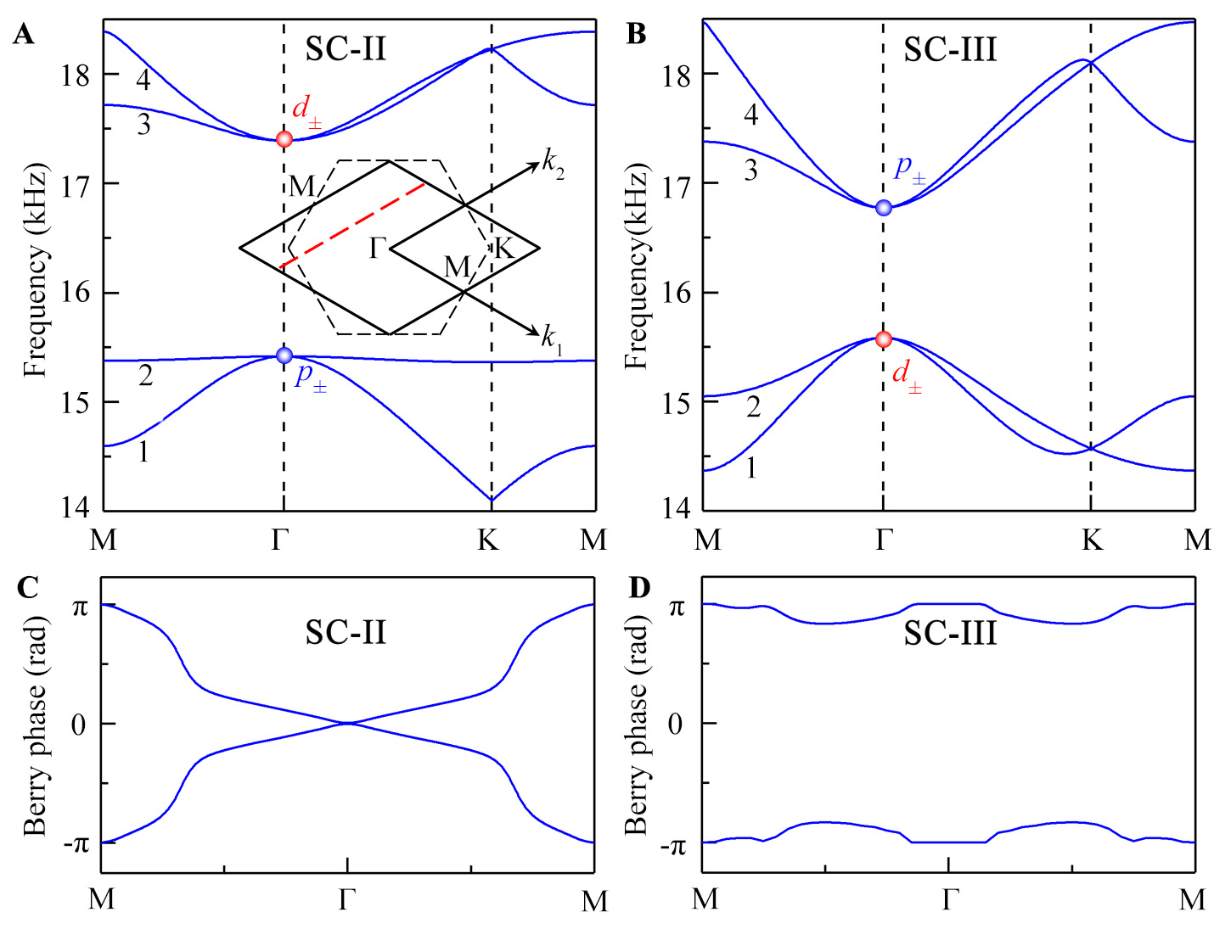

FIGURE S1 | Dispersion relations of (A) SC-II (θ₀=30º and θ=0º) and (B) SC-III (θ₀=0º and θ=30º). Berry phases of (C) SC-II (C_{s}=±1) and (D) SC-III (C_{s}=0).

Note 2 Experimental set-up
Figure S2 shows the experimental set-up, in which the sample with the height of 8mm is placed into a planar waveguide composed of two paralleled plates (dimension 2m×2m). The wedge-shaped sound absorbing sponges are placed around the sample to avoid sound reflections and realize a quasi-anechoic environment. A balanced armature speaker (Knowles, 7.2×9.5×4.1 mm³) is located at the left side of the sample as a point sound source and driven by a power amplifier. In the intensity mapping measurement, a 1/4 inch microphone (Brüel & Kjær-4961) is used to detect transmitted sound signals in the green open rectangle (shown in Figure 5A), and acoustic amplitudes at each position in the green open rectangle can be retrieved by using the PULSE Labshop software. In the measurement of the transmission spectra, the microphone is placed 5 mm away from the right side of the sample and scans along the green dashed line to measure sound signals with and without the sample.

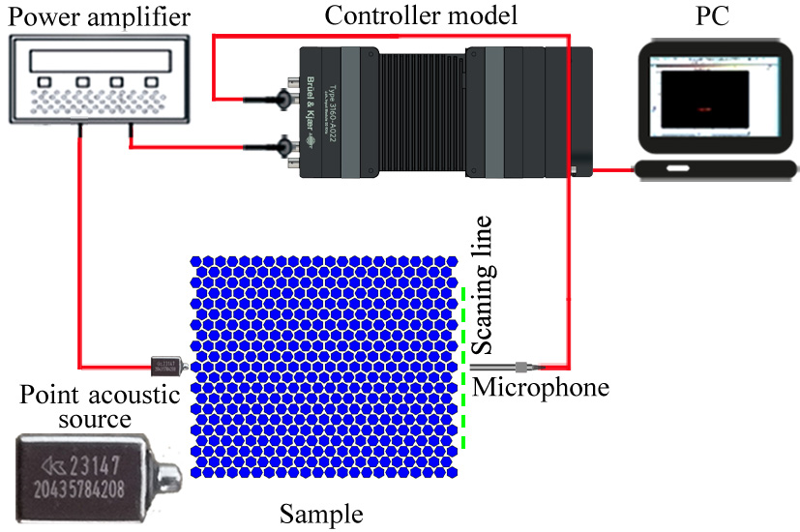
FIGURE S2 | Experimental set-up.

