Online Supplemental Materials
Antihypertensive Treatments and Central Arterial Hemodynamics:
a Meta-analysis of Randomized Controlled Trials
Running Title: Antihypertensive treatments and central hemodynamics
Yi-Bang Cheng, Jia-Hui Xia, Ji-Guang Wang.
Correspondence:
Ji-Guang Wang, MD, PhD
The Shanghai Institute of Hypertension
Ruijin 2nd Road 197,
Shanghai 200025, China
Phone: +86-21-64370045-610911
Fax: +86-21-64662193
Email:jiguangwang@aim.com

Table of Contents

Table S1 Sensitivity analysis of the weighted mean difference in central systolic blood pressure and augmentation index according to several prespecified characteristics of trials
Table S2 The weighted mean differences in central and peripheral hemodynamics for diuretics or β-blockers versus newer antihypertensive drugs
Table S3 The weighted mean differences in central and peripheral hemodynamics for vasodilating or nonvasodilating β-blockers versus newer antihypertensive drugs
Figure S1 Effects of renin-angiotensin-aldosterone system inhibitors and calcium-channel blockers versus diuretics, β-blockers, and α-blockers on peripheral systolic blood pressure and pulse pressure

Table S1
. Sensitivity analyses of the weighted mean differences in central systolic blood pressure and augmentation index according to several prespecified characteristics of trials
 |  | Central Systolic Blood Pressure |  |  |  |  | Central Augmentation Index (%)
 |  | Nº of arms | Nº of patients | WMD (95% CI, mmHg) | P |  | Nº of arms | Nº of patients | WMD (95% CI, %) | P
Jadad scores ≥ 3 |  | 19 | 2240 | -4.22 (-5.64 to -2.79) | <0.001 |  | 17 | 1673 | -6.90 (-9.26 to -4.55) | <0.001
SphygmoCor radial approach |  | 17 | 1420 | -4.07 (-5.55 to -2.60) | <0.001 |  | 17 | 1420 | -5.57 (-7.76 to -3.38) | <0.001
Diagnosis of hypertension |  | 21 | 2369 | -5.59 (-6.47 to -4.70) | <0.001 |  | 22 | 1881 | -5.50 (-7.34 to -3.66) | <0.001
The weighted mean differences (WMD) and confidence intervals (CI) were computed for active antihypertensive treatment versus placebo or no-treatment or for newer versus older antihypertensive drugs. Weights are from the fixed- and random-effects models for central systolic blood pressure and augmentation index, respectively.

Table S2
. The weighted mean differences in central and peripheral hemodynamics for diuretics or β-blockers versus newer antihypertensive drugs
 |  | Diuretics |  |  |  | β-Blockers |  |  | P for heterogeneity between groups
 |  | Nº of arms | Nº of patients | WMD (95% CI, mmHg) |  | Nº of arms | Nº of patients | WMD (95% CI, %) | P for heterogeneity between groups
Central
Systolic blood pressure (mm Hg) |  | 10 | 1122 | -6.24 (-7.31 to -5.18) |  | 15 | 1402 | -4.25 (-5.80 to -2.70) | 0.17
Pulse pressure (mm Hg) |  | 7 | 781 | -1.27 (-3.25 to 0.72) |  | 12 | 1075 | -4.55 (-6.85 to -2.45) | 0.002
Peripheral
Systolic blood pressure (mm Hg) |  | 10 | 1122 | -2.27 (-3.84 to -0.70) |  | 14 | 1314 | -1.52 (-2.89 to -0.14) | 0.32
Pulse pressure (mm Hg) |  | 6 | 918 | -0.76 (-2.38 to 0.87) |  | 10 | 805 | -0.99 (-2.31 to 0.33) | 0.83
Central-to-peripheral pulse pressure amplification (mm Hg) |  | 3 | 131 | 0.01 (-0.07 to 0.10) |  | 4 | 612 | 0.21 (0.13 to 0.29) | 0.001
Central augmentation index (%) |  | 9 | 643 | -4.60 (-7.23 to -1.48) |  | 15 | 1393 | -7.37 (-9.50 to -5.23) | <0.001
The weighted mean differences (WMD) and confidence intervals (CI) were computed for diuretics or β-blocker versus placebo, no-treatment or newer antihypertensive drugs. Weights are from the fixed-effects models for central and peripheral systolic blood pressure, peripheral pulse pressure, and central-to-peripheral pulse pressure amplification, and from the random-effects models for central pulse pressure and augmentation index.

Table S3
. The weighted mean differences in central and peripheral hemodynamics for vasodilating or nonvasodilating β-blockers versus newer antihypertensive drugs
 |  | Vasodilating β-blockers |  |  |  | Nonvasodilating β-blockers |  |  | P for heterogeneity between groups
 |  | Nº of arms | Nº of patients | WMD (95% CI, mmHg) |  | Nº of arms | Nº of patients | WMD (95% CI, %) | P for heterogeneity between groups
Central
Systolic blood pressure (mm Hg) |  | 4 | 319 | -2.69 (-5.31 to -0.06) |  | 11 | 1083 | -5.08 (-7.00 to -3.16) | 0.15
Pulse pressure (mm Hg) |  | 4 | 319 | -3.03 (-4.92 to -1.13) |  | 8 | 756 | -6.32 (-10.17 to -2.47) | 0.47
Peripheral
Systolic blood pressure (mm Hg) |  | 4 | 319 | -1.41 (-3.94 to 1.11) |  | 10 | 927 | -1.56 (-3.20 to 0.08) | 0.92
Pulse pressure (mm Hg) |  | 3 | 137 | 0.57 (-2.03 to 3.18) |  | 7 | 668 | -1.52 (-3.05 to 0.002) | 0.17
Central-to-peripheral pulse pressure amplification (mm Hg) |  | 4 | 612 | 0.21 (0.13 to 0.29) |  | - | - | - | -
Central augmentation index (%) |  | 4 | 319 | -7.68 (-10.56 to -4.81) |  | 11 | 1074 | -7.52 (-10.24 to -4.80) | 0.85
Vasodilating β-blockers included nebivolol and carvedilol. Nonvasodilating β-blockers included atenolol, bisoprolol and labetalol. The weighted mean differences (WMD) and confidence intervals (CI) were computed for diuretics or β-blocker versus placebo, no-treatment or newer antihypertensive drugs. Weights are from the fixed-effects models for central and peripheral systolic blood pressure, peripheral pulse pressure, and central-to-peripheral pulse pressure amplification, and from the random-effects models for central pulse pressure and augmentation index.

Figure S1
. Effects of renin-angiotensin-aldosterone system inhibitors and calcium-channel blockers versus diuretics, β-blockers, and α-blockers on peripheral systolic blood pressure and pulse pressure
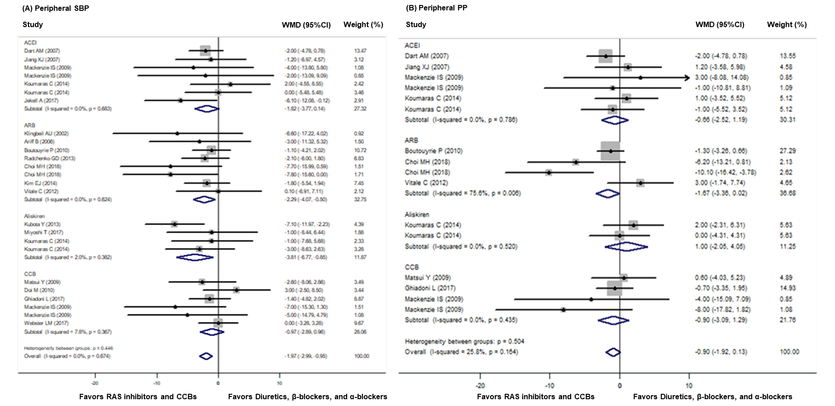
Dots represent mean difference of each study. The size of the squares is proportional to the sample size. Horizontal lines represent the 95% confidence intervals. Open diamonds represent the weighted mean difference (WMD) with 95% confidence intervals (CI). Weights are from the random effects analysis.

