Supplementary Material

**Supplementary Figure 1.** The structural formula and linkage of monomers in LJPS molecule.

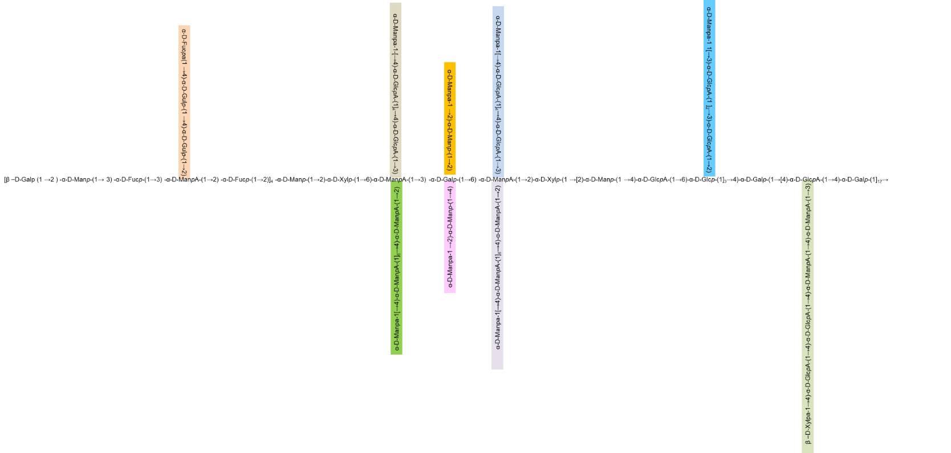

**Supplementary Figure 2. The 32-potential molecular conformation of LJPS with different folding angles**

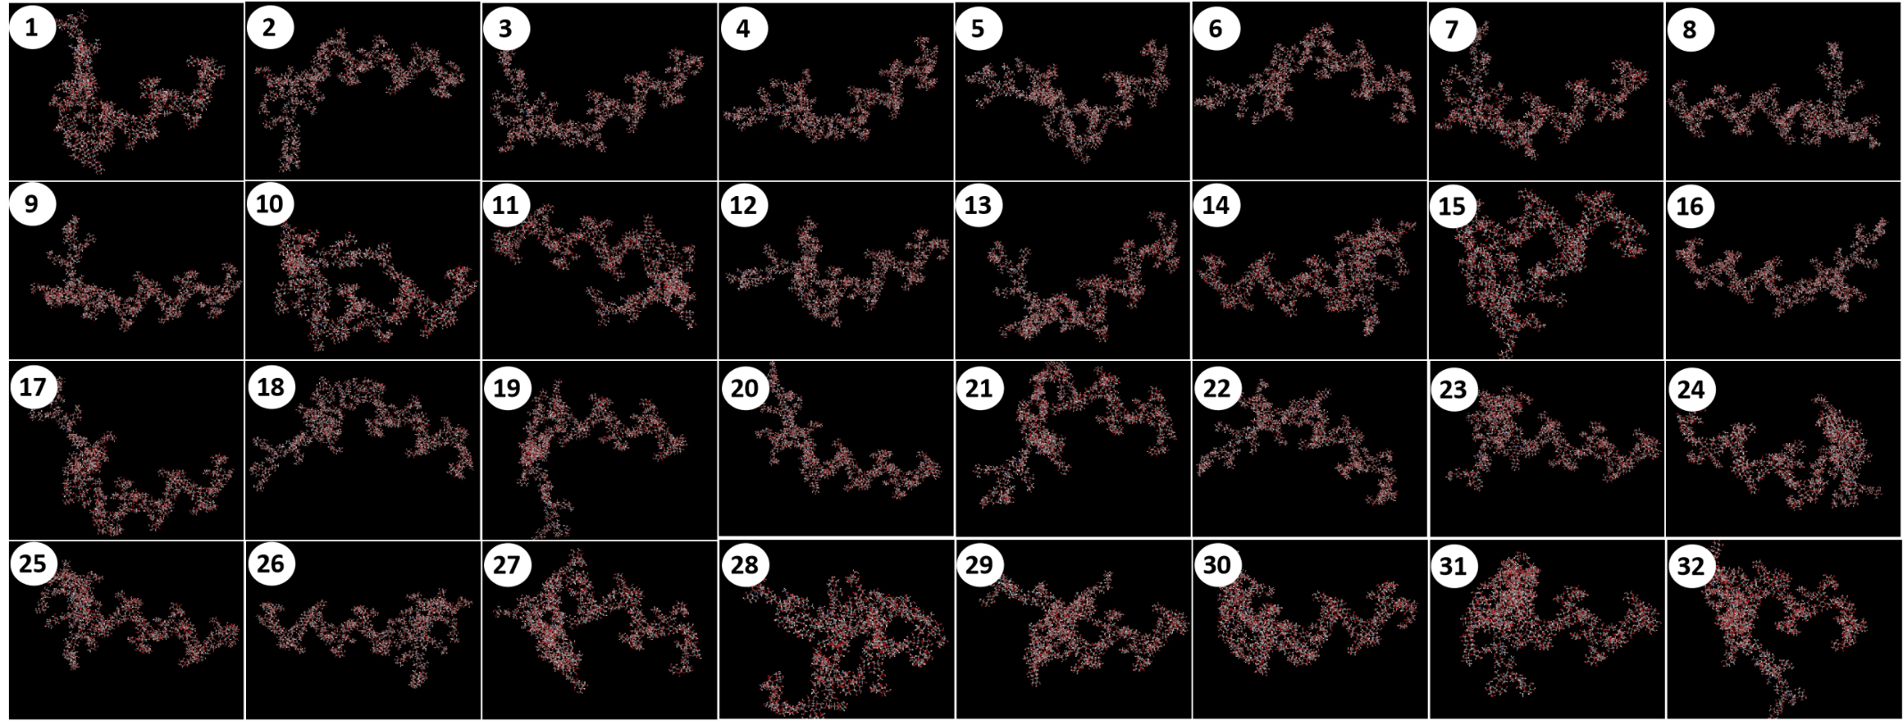

**Supplementary Video 1.**  The 3-d conformation of LJPS molecule.

The rotating 3 directional conformation molecule of LJPPS clearly shown the highly branched long-chain with branched and helix domain

*Please refer to the submitted video (mp4) file.*