Supplementary materials

Table 1 Inhibition rate and growth rate of 400-1-8, 400-2-16 and T334
Samples | Inhibition rate | Growth rate (compared to the parental generation) | Growth rate (compared to the original strain)
Original strain | 63% | -- | --
400-1-8 | 69% | 9.52% | 9.52%
400-2-16 | 74% | 7.25% | 17.46%
T334 | 78% | 5.41% | 23.81%

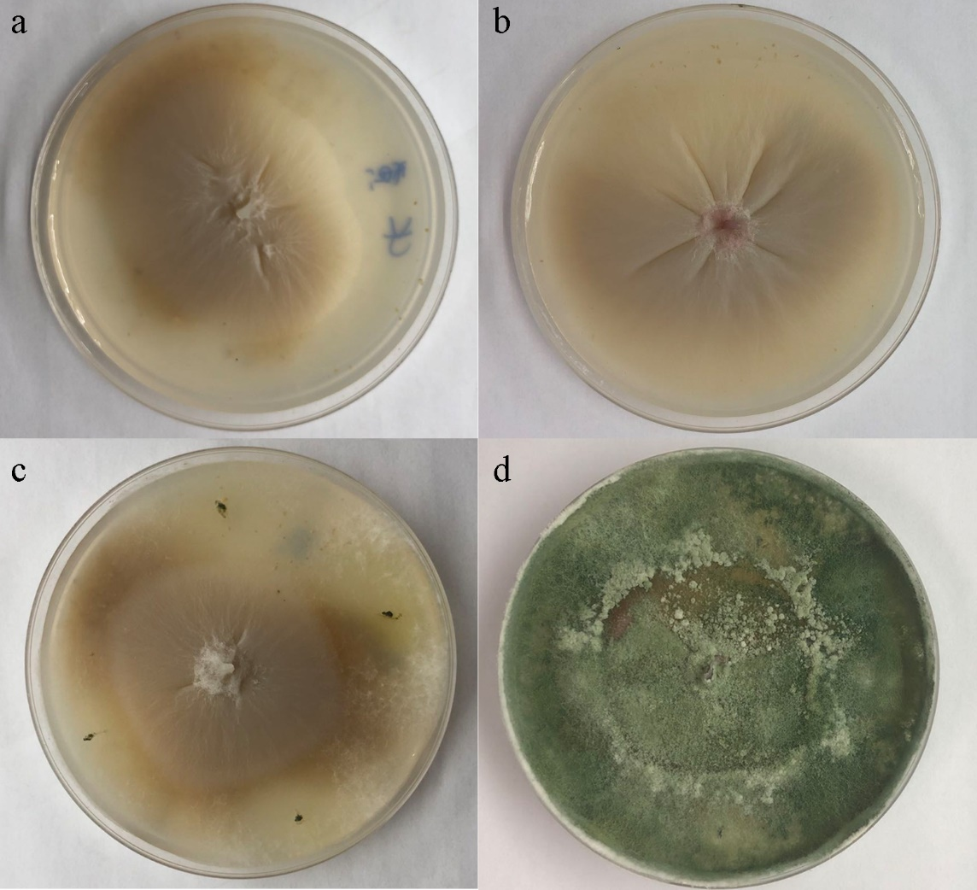

a: Single colony of Fusarium oxysporum f. sp. cucumerinum (CICC 2532) cultured for 48 h;
b: Single colony of Trichoderma harzianum T334 cultured for 48 h;
c: Antimicrobial experiment cultured for 48 h;
d: Antimicrobial experiment cultured for 144 h;

Table 2 Inhibition rate of T. harzianum on Fusarium oxysporum f. sp. cucumerinum
Time | 48h | 72h | 96h
Inhibition rate (%) | 12% | 37% | 73%

