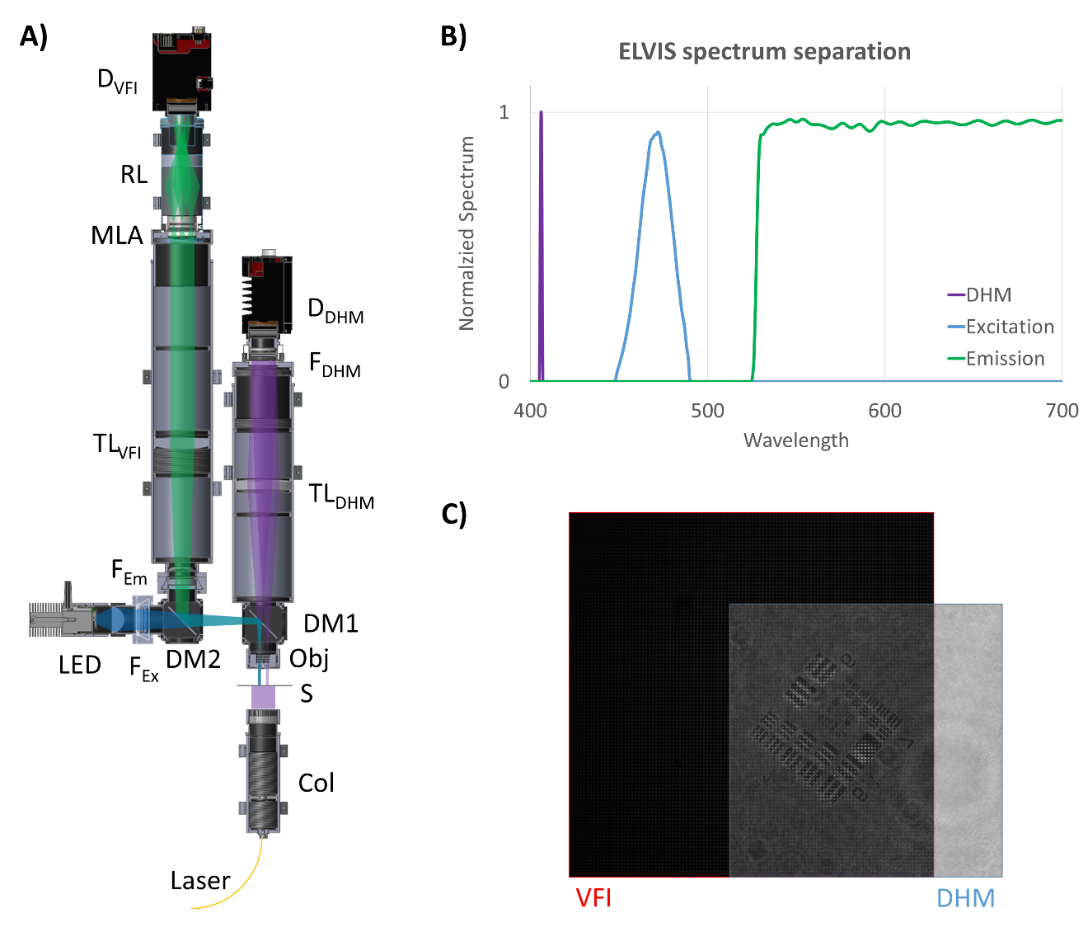
  - Figure 1. Combined DHM-VFI system. A) Schematic of the combined system. Laser: Thorlabs S1FC405; Col: Laser collimator; S: Sample; Obj: Objective lenses (Edmund Optics, #47-689); DM1: Dichroic mirror (Thorlabs, DMSP425R); TL_{DHM}: 150 mm tube lens (Thorlabs, AC508-150-A); F_{DHM}: 405 nm spectral filter (Thorlabs, FB405-10); D_{DHM}: DHM detector (Allied Vision, Prosilica GT 2450); LED: LED source (Thorlabs M470L3); F_{Ex}: Excitation filter (Thorlabs, MF469-35); DM₂: Dichroic mirror (Thorlabs, DMSP490R); F_{Em}: Emission filter (Thorlabs, FELH0500); TL_{VFI}: 200 mm tube lens (Thorlabs, AC508-200-A); MLA: Microlens array (RPC Photonics, MLA-S125-f30); RL: 0.528X Relay lens array (Opto Engineering, OPTC23016); D_{VFI}: VFI detector (Allied Vision, Prosilica GT 2450). B) Theoretical spectrum separation between DHM, VFI excitation and VFI emission. C) Shared FOV between DHM and VFI.

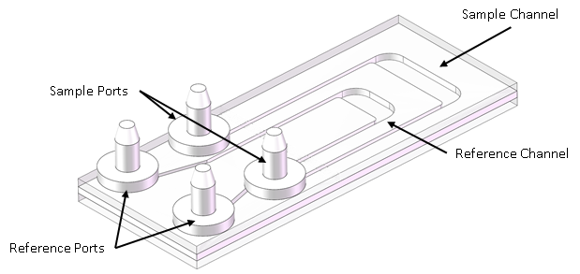
  - Figure 2, Sample aliquot chamber (SAC): The SAC consisted of two channels, a larger sample channel and a smaller reference channel. These channels were connected to the SPU via tubing, itself connected to the SAC via barbed connectors. Image credit Mineh Badalians.

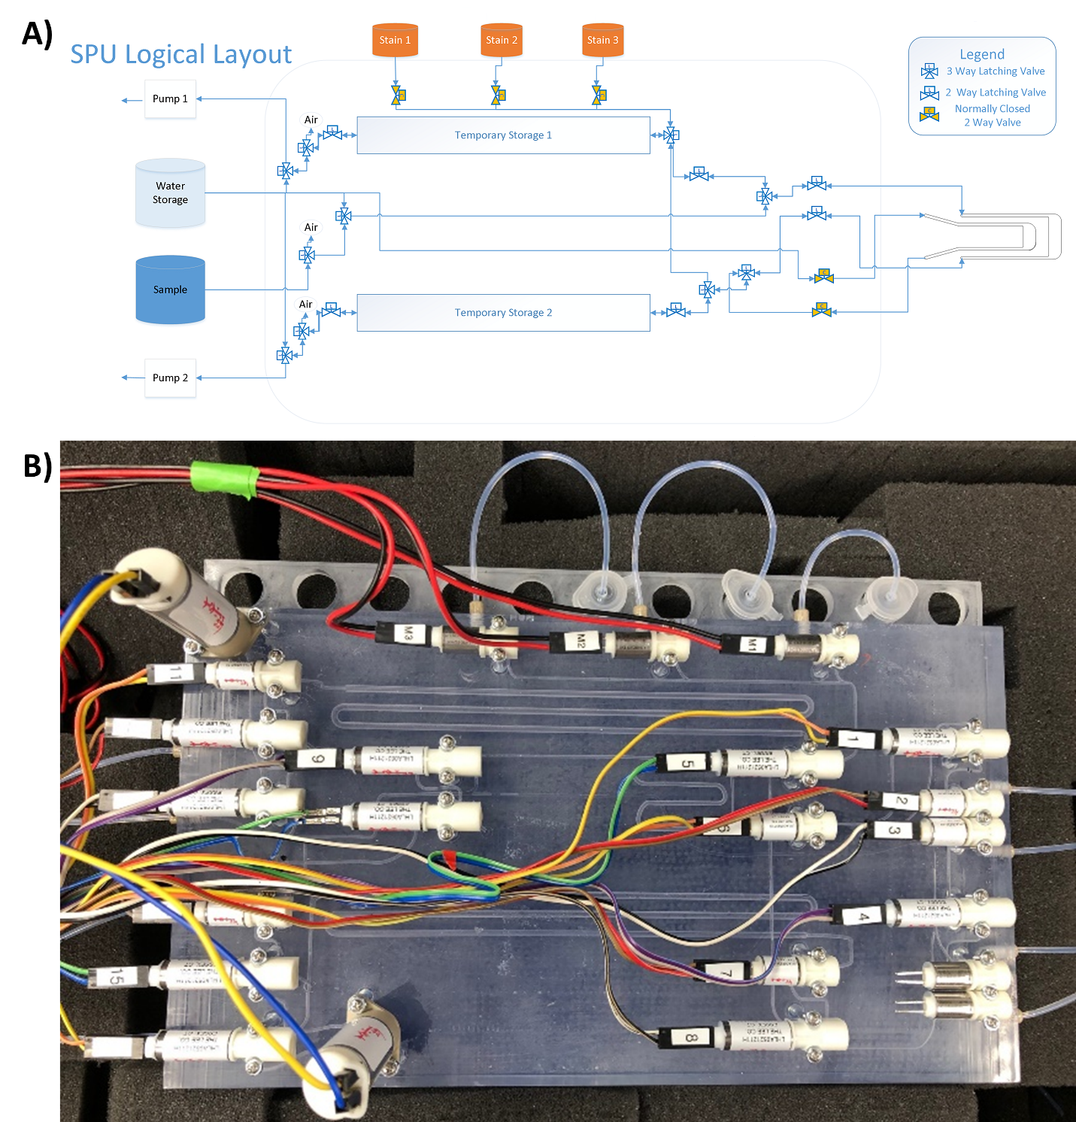
  - Figure 3. Sample Processing Unit. A) Image of the SPU in schematic view connected to the SAC. The SPU consisted of 10 three-way latching valves, 6 two-way latching valves, and 5 normally closed solenoid valves. Fluid motion through the system was accomplished via coordinated action of pump choice and valve state. Latching valves were used where their state lasted for extended periods. Normally closed solenoid valves were used where preventing fluid motion the majority of the time was important. B) A top-down view of the SPU: The SPU was 3D printed using a clear polymer marketed as Watershed (Protolabs, Maple Plain, MN). Not shown, the SAC was connected to the right side via tubing.
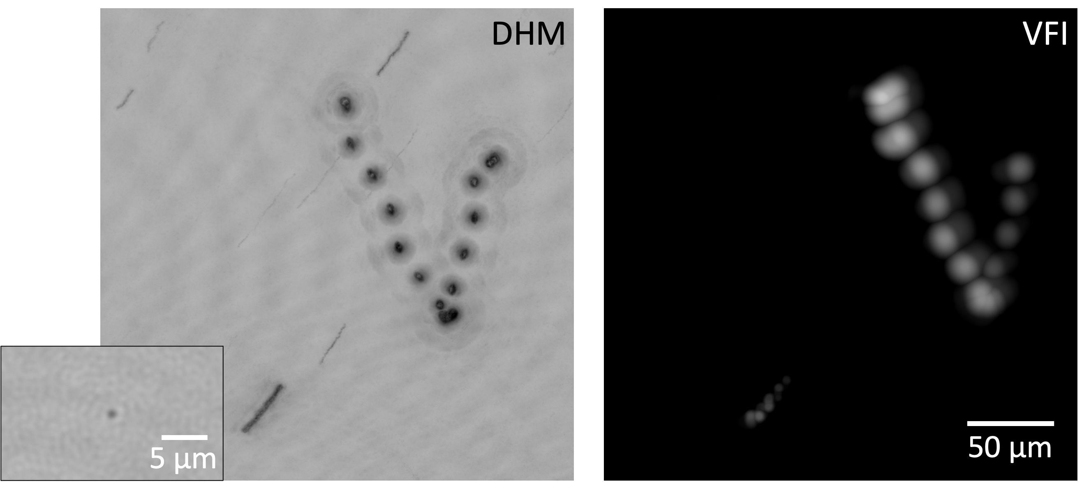
  - Figure 4. Correlative images of a eukaryotic cell expressing native fluorescence captured by DHM amplitude and VFI intensity. The images are captured over 4 seconds (60 frames) and volume reconstructed. The DHM amplitude reconstructions are minimum projected in the z-direction and then overlaid over time. The VFI intensity reconstructions are maximum projected in the z-direction and then overlaid over time. (Inset) 1 um bacteria-sized object detected by DHM. The image was obtained from one frame of a series of images showing the bacterial motility.
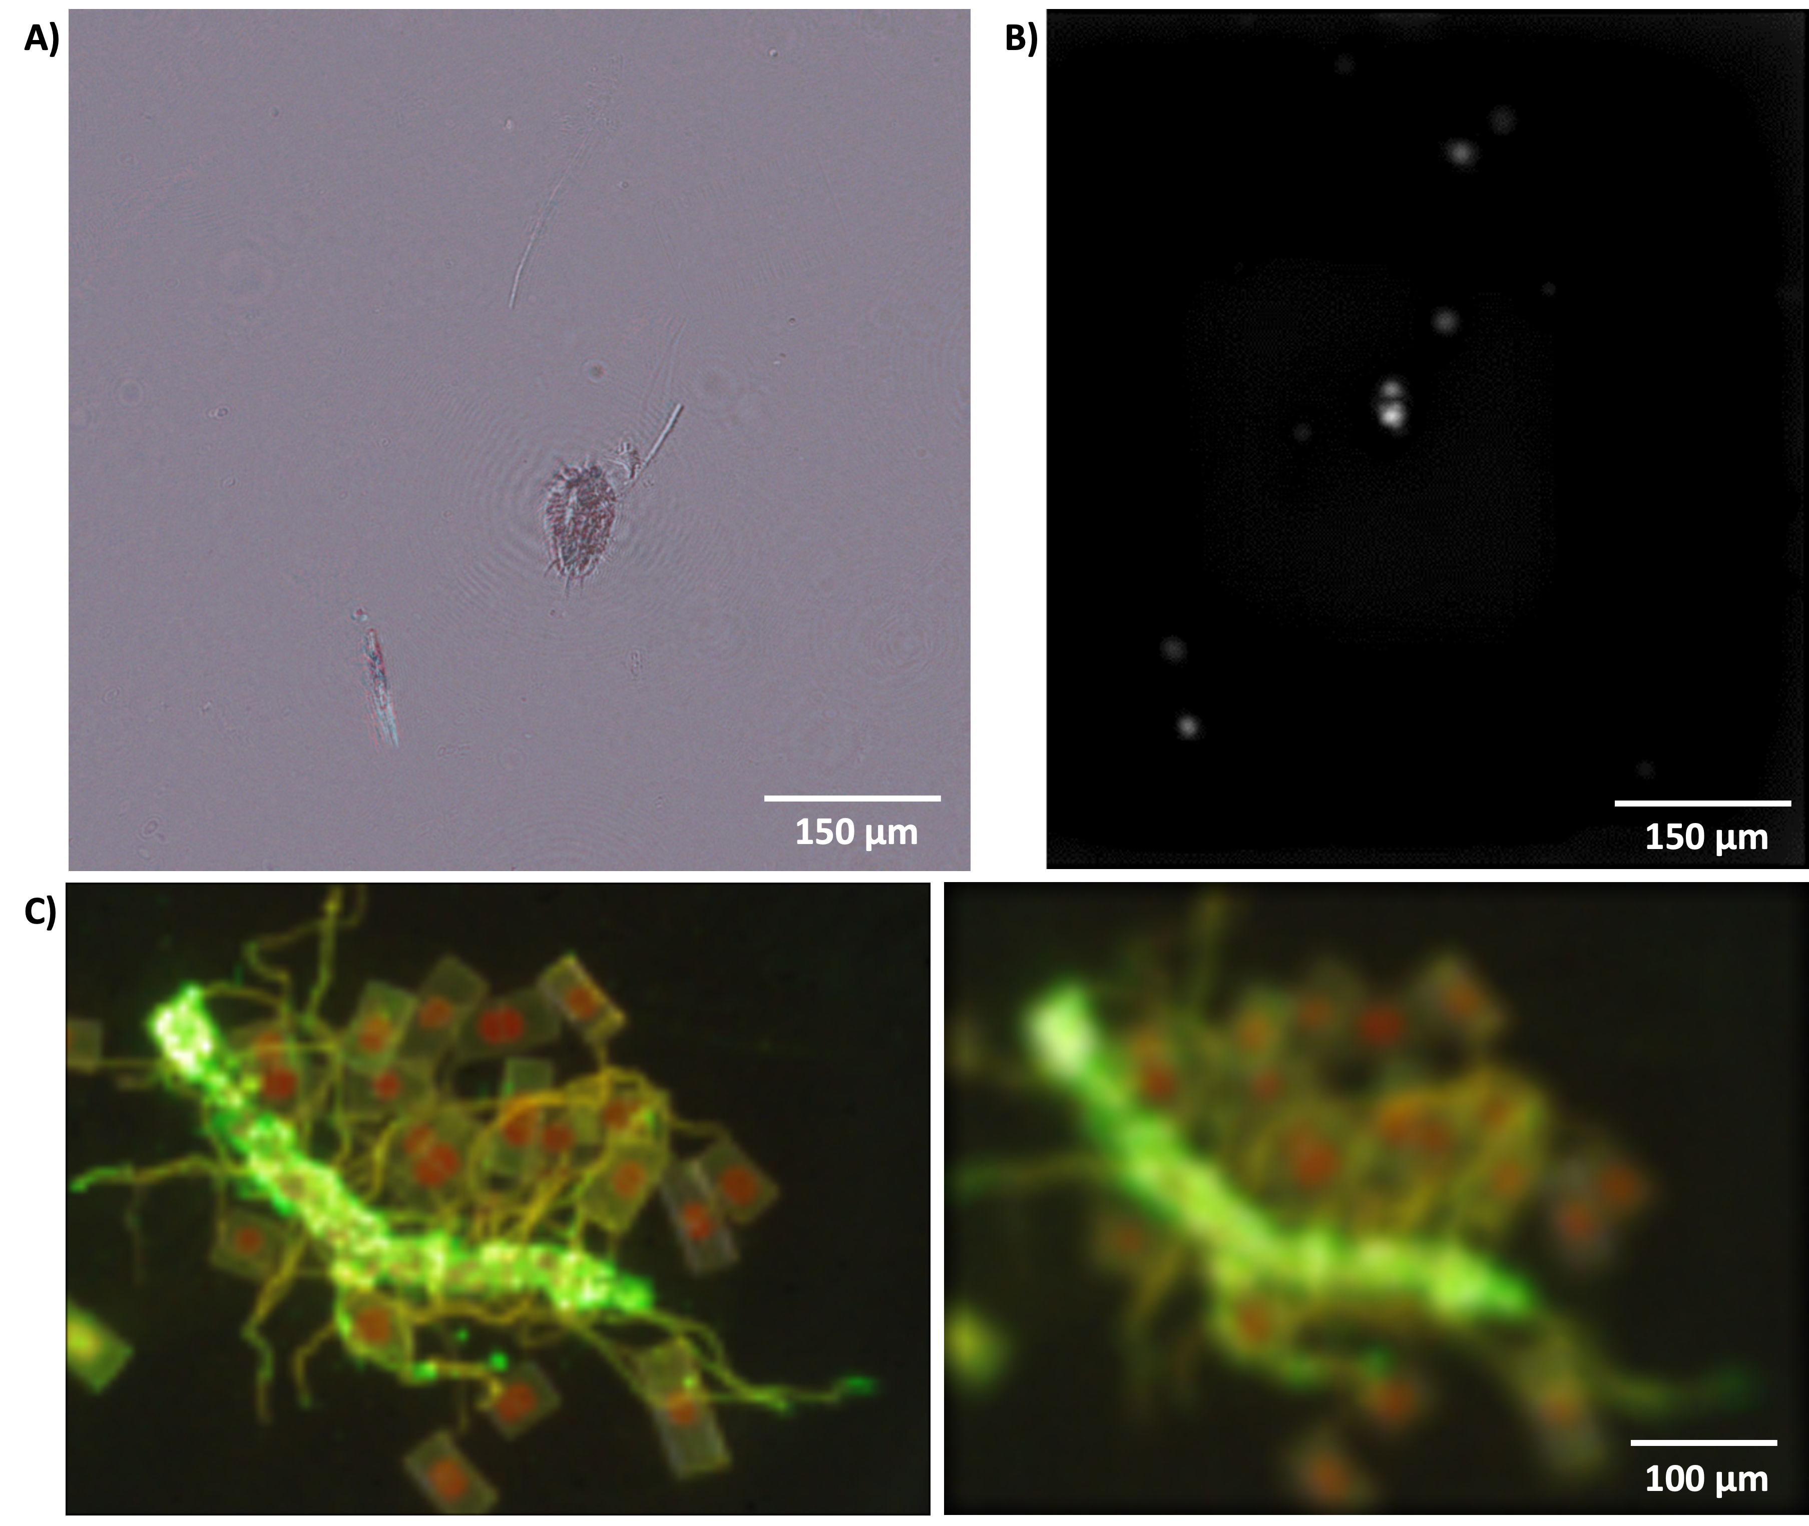

  - Figure 5. A) A reconstructed multi-wavelength DHM amplitude image of a water flea captured at Newport Beach. B) High-sensitivity VFI image of 1 µm sized single bacteria (Serratia marcescens) stained with 50 nM Syto-9. C) Multi-color VFI images of FM1-43 stained ocean algae reconstructed at two different z-planes. Green color is from FM1-43 and red is from native Chlorophyll.

