Supplementary Material

# Supplementary Figures

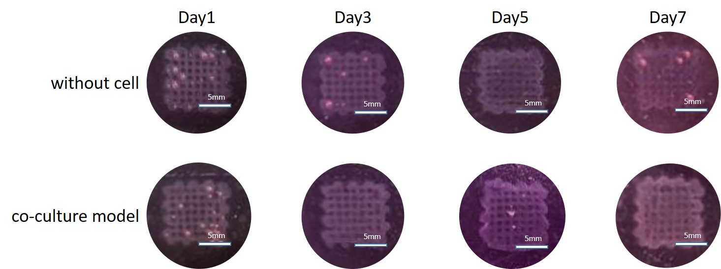

**Supplementary Figure 1.** Top view of 3D scaffolds on day 1, 3, 5, 7. Scale bar, 5mm.