Supplementary Material For

Ultra-thin metasurface-based absorber of low-frequency sound with bandwidth optimization
Yi-jun Guan^{1,2,3},Yong Ge¹, Hong-xiang Sun^{1,3}＊, Shou-qi Yuan¹＊, Yun Lai²＊and Xiao-jun Liu^{2,3}＊
¹Research Center of Fluid Machinery Engineering and Technology, School of Physics and Electronic Engineering, Jiangsu University, Zhenjiang 212013, China
²Key Laboratory of Modern Acoustics, National Laboratory of Solid State Microstructures, Department of Physics and Collaborative Innovation Center of Advanced Microstructures, Nanjing University, Nanjing 210093, China
³State Key Laboratory of Acoustics, Institute of Acoustics, Chinese Academy of Sciences, Beijing 100190, China

Note 1 Dipolar and quadrupolar Mie resonances…….................................................. 2
Note 2 Eigenfrequencies of units with different number of surrounding cavities…..……............................................................................................................. 2
Note 3 Experimental set-up………………..……......................................................... 4
Note 4 Sound absorption performance for oblique sound incidence............................ 5
Note 5 Sound absorption created by second MMR mode……..................................... 6
Note 6 Sound absorption spectra created by units with different number of surrounding cavities…….............................................................................................. 7
Note 7 Sound absorption spectra of 4 types of compound units................................... 8

Note 1 Dipolar and quadrupolar Mie resonances
In addition to the two types of MMR modes, the dipolar and quadrupolar Mie resonances can be obtained at 1111.9 and 2457.0 Hz, respectively (shown in Figure S1). Thus, the proposed unit has rich Mie resonant modes.
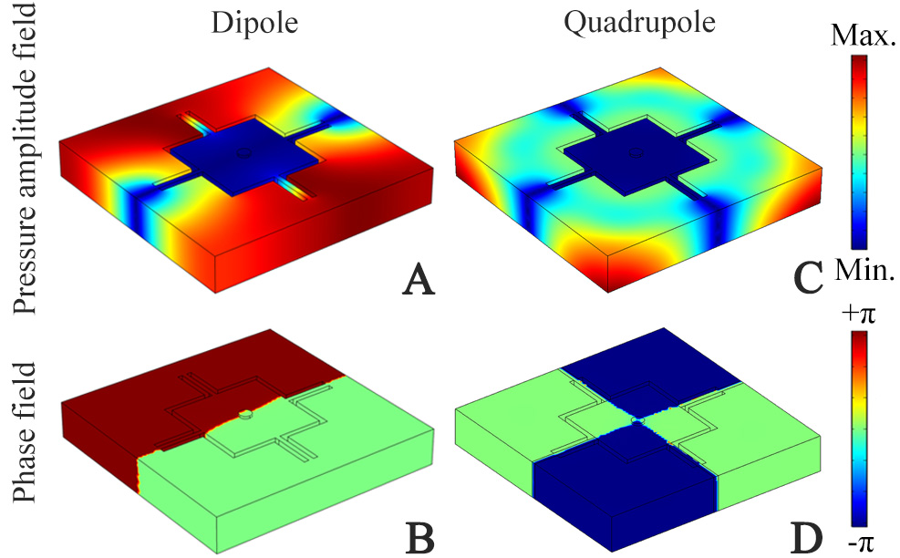
FIGURE S1 | Simulated pressure amplitude and phase eigenfunctions of Mie resonance modes of the unit for (A), (B) dipole at 1111.9 Hz and (C), (D) quadrupole at 2457.0 Hz.
Note 2 Eigenfrequencies of the units with different number of surrounding cavities
To show the mechanism of the two types of eigenmodes in Figure 2, we make a further analysis for both MMR modes of the unit. Figure S2 shows the simulated pressure and phase eigenfunctions of the MMR mode created by the unit with different number of surrounding cavities, in which the other cavities are filled with epoxy resins. By decreasing the number of surrounding cavities, the MMR mode still exists, and its characteristics almost remain unchanged, which are the same as those in Figs. 2(a) and 2(b). However, the eigenfrequency of the MMR mode increases gradually with the decrease of cavity number, showing that the eigenmode is determined by the overall structure of the unit.
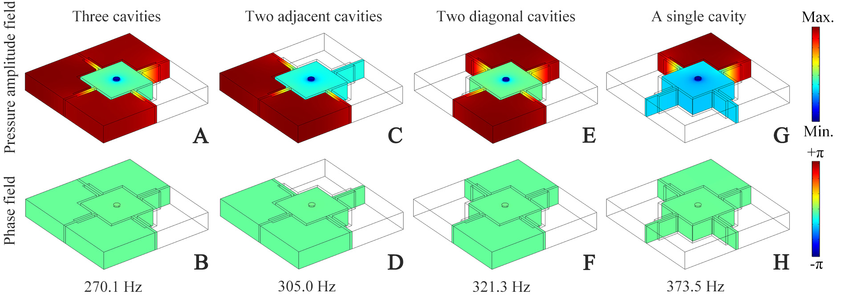
FIGURE S2 | Simulated pressure amplitude and phase eigenfunctions of the MMR mode created by the unit composed of the central square cavity and (A),(B) three cavities at 270.1Hz, (C),(D) two adjacent cavities at 305.0 Hz, (E),(F) two diagonal cavities at 321.3 Hz, and (G),(H) a single cavity at 373.5 Hz. The other cavities (white solids) are filled with epoxy resin.
As shown in Figure S3, with different number of cavities, the characteristics of the second MMR mode also remain unchanged, and their eigenfrequencies still change, especially for the cases of a single cavity and two adjacent cavities. However, with the existence of two diagonal cavities (shown in Figures S3A,B,E,F), the eigenfrequencies of the second MMR mode change slightly. Thus, we deduce that the second type of eigenmode also arises from the MMR, and is closely related to the diagonal cavities in the unit.
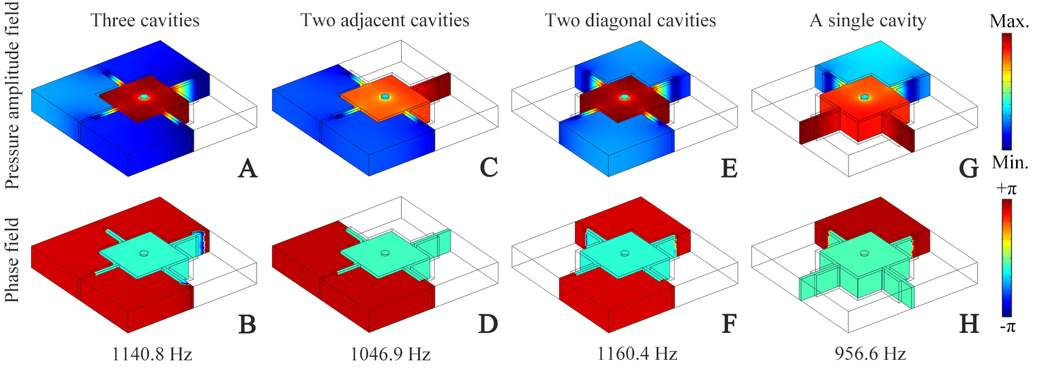
FIGURE S3 | Simulated pressure amplitude and phase eigenfunctions of the second MMR mode created by the unit composed of the central square cavity and (A),(B) three cavities at 1140.8 Hz, (C),(D) two adjacent cavities at 1046.9 Hz, (E),(F) two diagonal cavities at 1160.4 Hz, and (G),(H) a single cavity at 956.6 Hz. The other cavities (white solids) are filled with epoxy resins.

Note 3 Experimental set-up
As shown in Figure S4, the experiment is carried out in a straight waveguide (dimension: 0.1 m×0.1 m×1.5m). The incident plane wave is generated from a square loudspeaker (length: 3.5cm) driven by a power amplifier. Two 0.25-inch microphones (Brüel&Kjær type-4954) marked as Mic 1 and Mic 2 are placed into the waveguide from two holes 1 and 2 with the same sizes, which are adopted to measure sound pressures p₁ and p₂ at the positions 1 and 2 in the waveguide. The measured data is recorded by the Brüel&Kjær 3160-A-022 module and is analyzed by the software PULSE Labshop.
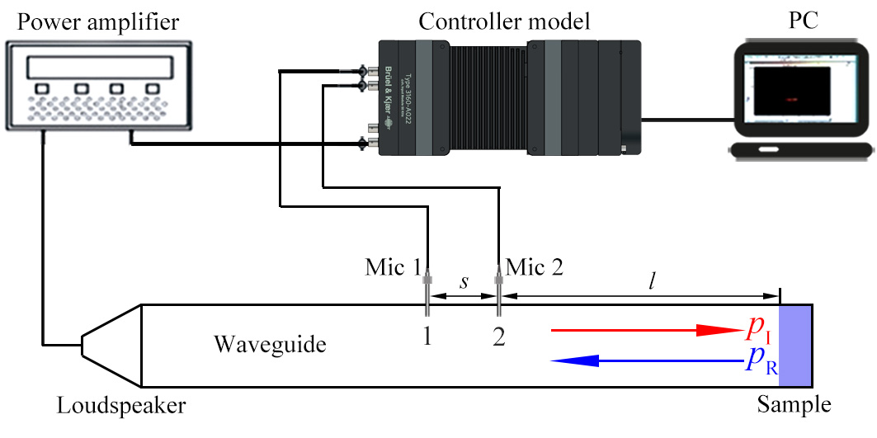
FIGURE S4 | Experimental set-up.
In the waveguide, the transmitted sound energy is neglected due to the sample backed with an acrylic plate. Thus, the sound pressure distribution inside the waveguide is the superposition of the incident and reflected waves, and the pressures at the positions 1 and 2 are given as
$p_{1}=p_{I}e^{\text{ik}(s+l)}+p_{R}e^{−\text{ik}(s+l)}$, (S1)
$p_{2}=p_{I}e^{\text{ikl}}+p_{R}e^{−\text{ikl}}$, (S2)
where k is the wave number of air, p_{I} and p_{R} are the incident and reflected sound pressures on the surface of the sample respectively, s=30 cm is the distance between Mic 1 and Mic 2, and l=60 cm is the distance between Mic 2 to sample surface. Based on Eqs. (S1) and (S2), we can obtain p_{I} and p_{R} as
$p_{I}=\frac{p_{2}e^{−\text{ik}(s+l)}−p_{1}e^{−\text{ikl}}}{e^{−\text{iks}}−e^{\text{iks}}}$, (S3)
$p_{R}=\frac{p_{1}e^{\text{ikl}}−p_{2}e^{\text{ik}(s+l)}}{e^{−\text{iks}}−e^{\text{iks}}}$. (S4)
Thus, we can calculate the reflection coefficient as$R=\left|p_{R}/p_{I}\right|$, and the absorption coefficient is obtained as α=1-R².
Note 4 Sound absorption performance for oblique sound incidence
Figure S5 shows the simulated absorption spectra for oblique sound incidence, in which θ is the incident angle of sound. We find that the absorption spectra are relatively stable below θ=60°. But for the case θ=75°, the absorption coefficient around the peak decreases obviously.
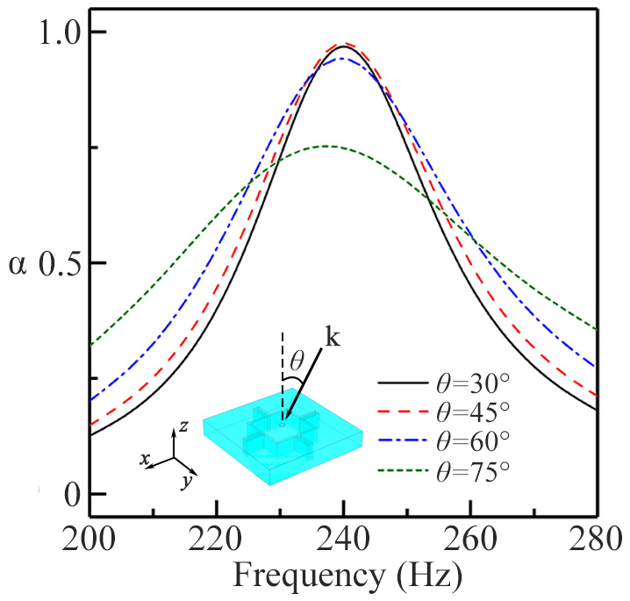
FIGURE S5 | Simulated sound absorption spectra created by the MMR mode of the unit for oblique sound incidence. The parameter θ is the incident angle of sound.
Note 5 Sound absorption created by second MMR mode
Figure S6A shows the simulated sound absorption spectra created by the second MMR mode of the unit. It is found that there exists an absorption peak at 1145 Hz, and its absorption coefficient is only about 0.52, which is much lower than that of the absorption peak at 239 Hz. The simulated real and imaginary parts of Z_{r} around 1145 Hz are shown in Figure S6B. Note that the real part of Z_{r} is larger than 5.0 at 1145 Hz, which indicates that the sound impedance is not well matched between the proposed unit and air by comparing with that around 239 Hz, and thus part of sound energy is reflected. Figures S6C,D show the simulated distributions of the pressure amplitude and total thermal-viscous power loss density fields in the unit excited by the normal incidence of sound at 1145 Hz, respectively. Similar to the characteristics in Figures 3D,E, the second MMR mode of the unit is excited at 1145 Hz, and the thermal-viscous power loss density is still obvious around the central circular hole and 4 narrow slits. However, by comparing with that in Figure 3E, the thermal-viscous power loss density around the central circular hole decreases greatly due to the reflection of sound energy created by the impedance mismatch. Therefore, we deduce that the sound absorption can also be created by the second MMR mode, but its corresponding performance is reduced greatly.
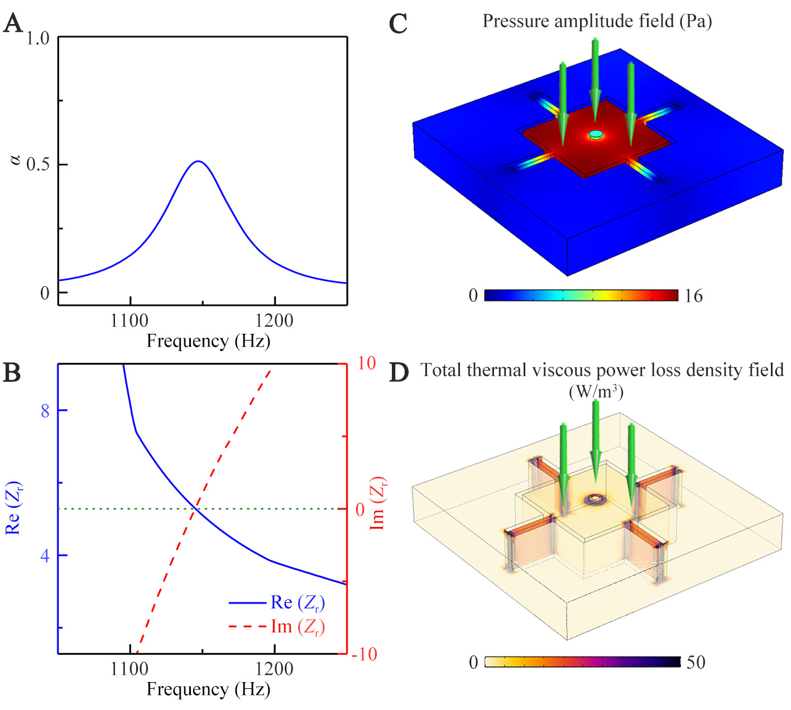
FIGURE S6 | (A) Simulated sound absorption spectra created by the second MMR mode of the unit. (B) Real and imaginary parts of relative acoustic impedance Z_{r} of the unit. Distributions of (C) the pressure amplitude field and (D) total thermal viscous power loss density field in the unit excited by a normal incidence of sound at 1145Hz.
Note 6 Sound absorption spectra created by units with different number of surrounding cavities
Figures S7A,B show the simulated sound absorption spectra of the units with different number of surrounding cavities for the MMR and second MMR modes, respectively. We find that the performances of sound absorption are almost the same for different number of surrounding cavities in Figures S7A,B. However, the frequency of the absorption peak changes greatly, which is similar to those in Figures S2,S3. Thus, it is further demonstrated that the sound absorption of the unit arises from the excitation of both MMR modes.
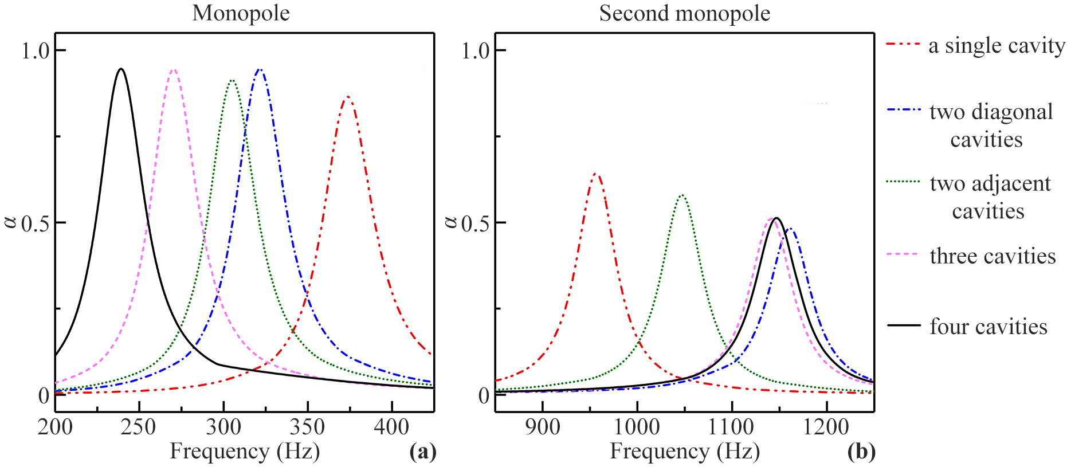
FIGURE S7 | Simulated sound absorption spectra created by the (A) MMR and (B) second MMR modes of the units with different number of surrounding cavities
Note 7 Sound absorption spectra of 4 types of compound units
The absorption performance is closely related to the configuration of the compound units. To clearly show it, we simulate the sound absorption spectra of another two types of compound units C and D (shown in Figure S8), and those of the compound units A and B are also displayed for comparison. As shown in Figure S8, the compound units A and C consist of two types of units. Compared with the absorption spectrum of the compound unit A, the bandwidth of the compound unit C becomes wider, but absorption coefficient decreases greatly, especially around 285 Hz. Additionally, the compound units B and D are composed of three types of units. It is found that the bandwidths of both compound units are almost the same, but the sound absorption of the compound unit B is more stable than that of the compound unit D. Therefore, it is demonstrated that the absorption performance of the compound unit is closely related to its configuration.
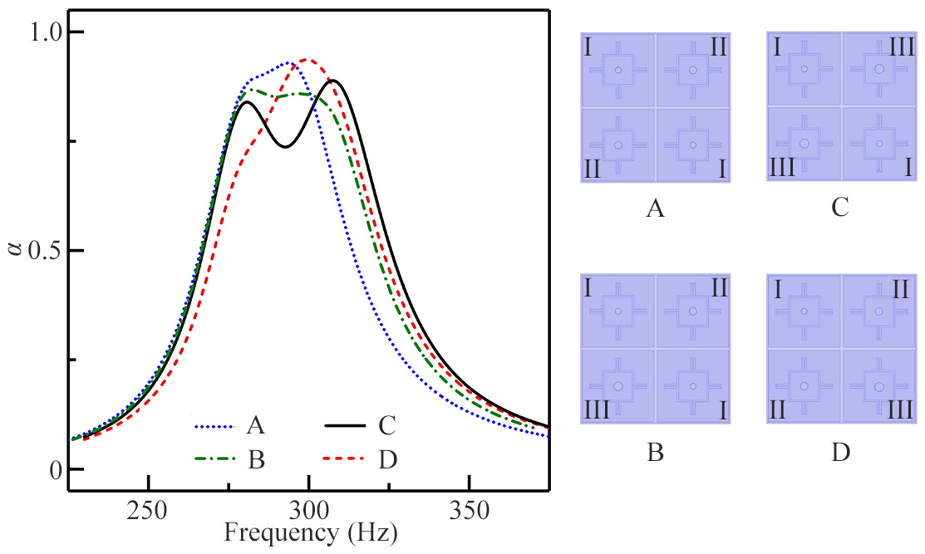
FIGURE S8 | Simulated sound absorption spectra of the compound units A, B, C, and D.

＊Correspondence: Hong-xiang Sun jsdxshx@ujs.edu.cn, Shou-qi Yuan shouqiy@ujs.edu.cn, Yun Lai laiyun@nju.edu.cn, Xiao-jun Liu liuxiaojun@nju.edu.cn

