Table S1 MR imaging parameters
 | TR/TE  (ms) | Field of  view(cm) | Number  of slices | Slice  thickness | Slice  gap(mm) | NEX | Bandwidth  (HZ/px) | Matrix | b Value  (sec/mm2)
Fs-T2WI | 3429/68 | 32 | 20 | 5 | 0.2 | 2 | 125 | 512*256 | N
DWI | 2400/20 | 32 | 20 | 5 | 0.2 | 2 | 125 | 128*256 | 0, 1000
T1C | 2.8/1.3 | 36 | 20 | 5 | 0.2 | 2 | 125 | 320*192 | N

Note: The MR scan parameters for DCE imaging of the pelvis on the 3.0-T scanner were performed after the injection of 0.1 mmol/kg body weight of gadolinium chelate (Gadovist; Bayer). The image was acquired at postcontrast enhancement 120 seconds in the axial plane.

Table S2. Predictive performance of FS-T2WI, DWI, DCE-MRI, radiomics combined model and clinical model, nomogram
Feature number | Method | AUC(95%CI) | ACC(95%CI) | SEN(95% CI) | SPE(95% CI) | PPV(95% CI) | NPV(95%CI)
2 | T2 | 0.762(0.662-0.861) | 0.698(0.589-0.792) | 0.974(0.717-1.000) | 0.468(0.127-0.617) | 0.603(0.528-0.609) | 0.957(0.857-0.967)
3 | DWI | 0.830(0.745-0.914) | 0.756(0.651-0.842) | 0.872(0.640-0.949) | 0.660(0.382-0.787) | 0.680(0.610-0.698) | 0.861(0.782-0.881)
3 | T1C | 0.807(0.717-0.898) | 0.767(0.664-0.852) | 0.769(0.410-0.872) | 0.766(0.532-0.872) | 0.732(0.592-0.756) | 0.800(0.735-0.820)
3 | Radiomics | 0.846(0.765-0.927) | 0.779(0.677-0.861) | 0.846(0.589-0.949) | 0.723(0.468-0.830) | 0.717(0.639-0.740) | 0.850(0.786-0.867)
2 | Clinical | 0.858(0.779-0.938) | 0.814(0.716-0.890) | 0.872(0.563-0.974) | 0.766(0.553-0.872) | 0.756(0.666-0.776) | 0.878(0.839-0.891)
5 | Nomogram | 0.944(0.901-0.988) | 0.884(0.797-0.943) | 0.795(0.614-0.923) | 0.957(0.744-1.000) | 0.939(0.923-0.947) | 0.849(0.814-0.855)

Note: AUC: area under curve; SEN: sensitivity; SPE: specificity; ACC: accuracy; PPV: positive predictive value; NPV: negative predictive value

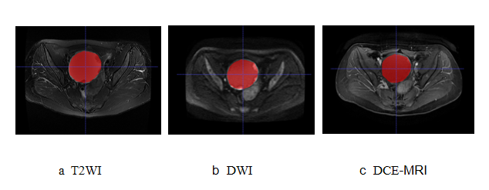

Fig. S1 VOI drawing method. Two radiologists performed 3D manual segmentation of the primary tumor along the edge of the lesion at each layer of DWI (b=1000s/mm2), ROI covered the whole tumor, and finally, the volume of interest (VOI) of the whole tumor was obtained.

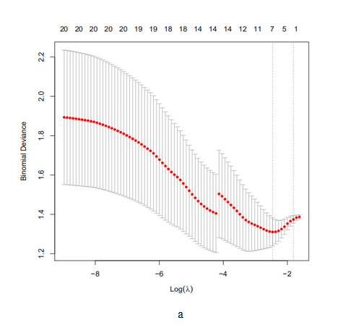
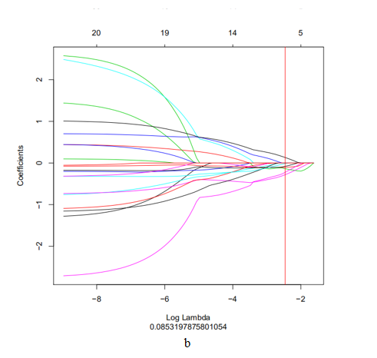
Figure S2. Use minimum absolute shrinkage and selection operator (lasso) regression method for radiomic feature selection. (a) Determine the optimal penalty coefficient λ(λ) in the lasso model with 10 times of cross-validation and the minimum criterion. In this study, the λ value was set to 0.08531979. (b) Draw a dashed vertical line at the selected λ value, resulting in 5 non-zero coefficient features.

Fig. S3 Multivariate Logistic regression analysis to obtain 3 radioomics characteristics. The middle black line is the median, the middle white thick bar represents the interquartile range, and the thin black line extending from the thick white bar represents 95 % Confidence interval. Lable represents the label, red is negative for peritoneal metastasis, and green is positive for peritoneal metastasis

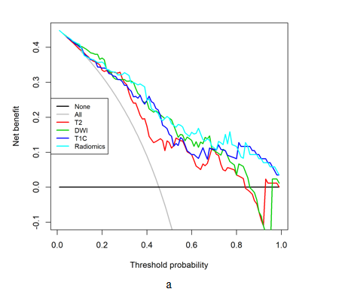
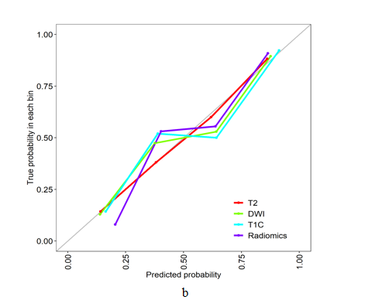

Fig. S4 DCA curve and a calibration curve of four models. (a) DCA Curves of Four Models. (b) Scale curves of four models.

