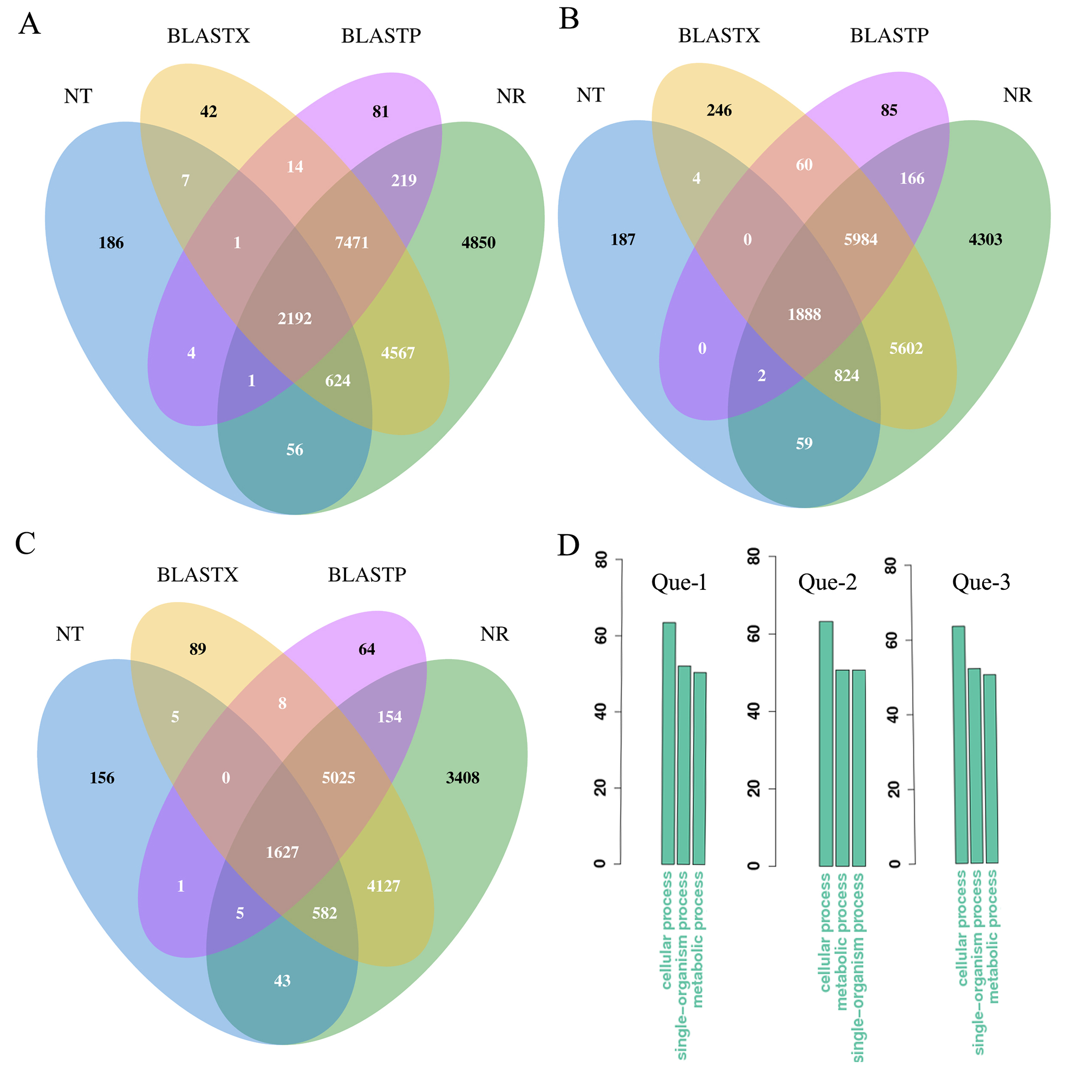

Supplementary Figure 1. Venn diagrams of the annotated sequences and the top 3 GO terms for category Biological Process. Venn diagrams of all ORFs and unigenes annotated by blast program (A, B and C) in the Que-1-VD (A), Que-2-VD (B) and Que-3-VD (C). D, Distribution of the top3 functional terms (GO terms) for category Biological Process.

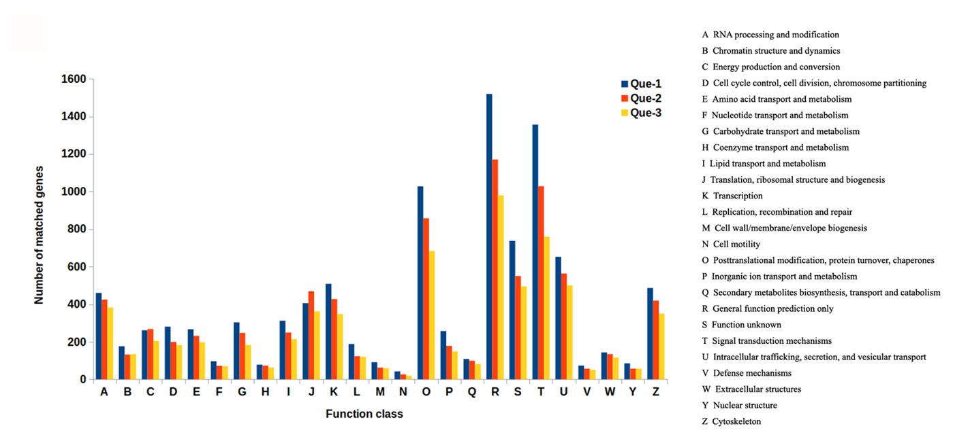
Supplementary Figure 2. KOG annotation of the venom duct ORFs of C. quercinus.
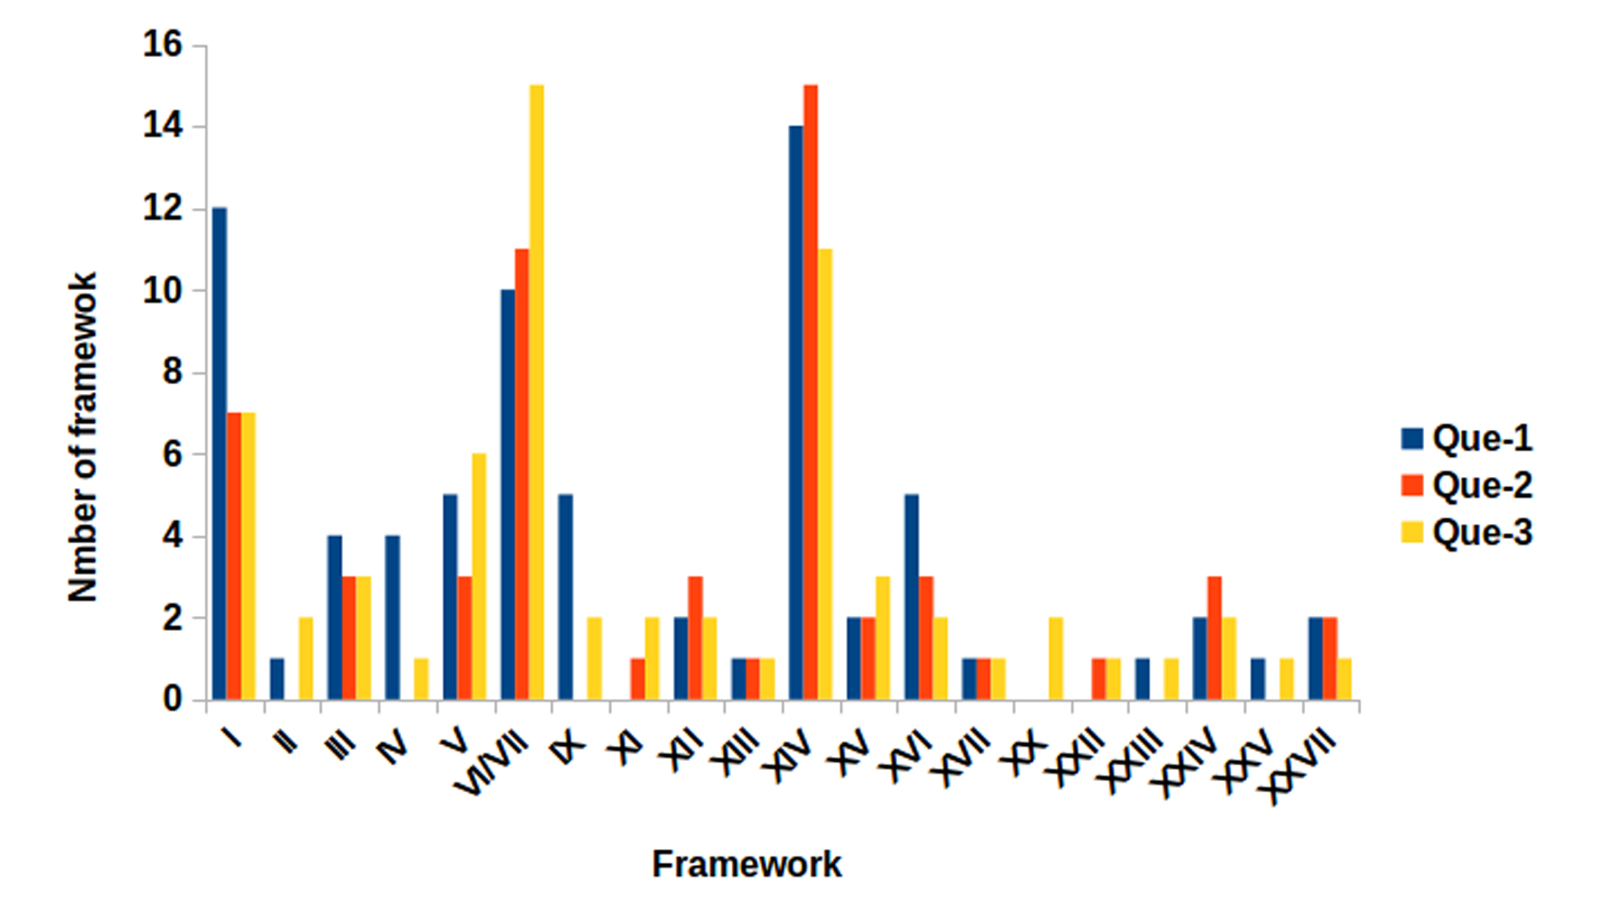
Supplementary Figure 3. Statistics for cysteine frameworks from venom ducts of the three individuals of C. quercinus referring the ConoServer.

