***Supplementary Material***

**Determining the Precipitation Correction Factor (PCF)**

For a 323-glacier subset of geographically and gynomorphically representative glaciers, we calibrated the model’s mass balance to within 10% of the geodetic mass balance values of Shean et al. (2020) by adjusting the precipitation. The 323 calibrated PCFs then formed the basis of the calculation of PCF values for all 13,912 modeled Upper Indus Basin (UIB) glaciers based on the PCFs for calibrated glaciers within 20 km (or, if this number was fewer than 10, the 10 closest glaciers). We chose this algorithm out of the nine considered because it minimized both the mean and median magnitude of calibrated – calculated PCF difference for the 323 glaciers in the calibration subset.

|  |  |  |  |  |  |  |  |  |  |
| --- | --- | --- | --- | --- | --- | --- | --- | --- | --- |
| **calibrated - calculated PCFs** | **5 closest** | **20 km radius with a minimum of 5 glaciers** | **15 km radius with a minimum of 5 glaciers** | **7 closest** | **20 km radius with a minimum of 7 glaciers** | **15 km radius with a minimum of 7 glaciers** | **10 closest** | **20 km radius with a minimum of 10 glaciers** | **15 km radius with a minimum of 10 glaciers** |
| **mean** | 0.0207 | 0.0338 | 0.1387 | 0.0317 | 0.0164 | 0.1008 | 0.0291 | 0.0135 | 0.0533 |
| **median** | 0.0055 | 0.0392 | 0.1192 | 0.0107 | 0.0092 | 0.0794 | 0.0122 | 0.0048 | 0.0434 |

**Table S1: The nine algorithms explored for using the calibrated PCFs (of the n=323 sample) to calculate PCFs for the UIB population (n=13,912 glaciers).**

The 323 glaciers in the calibration subset were modeled not with the calibrated PCFs but rather with PCFs calculated via the same algorithm. Therefore, the calibrated value was only one of 10 or more values averaged to compute the PCF given to the model. Our modeling method, then, does not run the risk of generating over-calibrated results.

**Figure S1: (a) UIB PCFs for all glaciers, with the locations of the 323 calibration glaciers marked with circles. (b) The calibrated PCFs for the calibration glaciers and the PCFs calculated for those same glaciers using the averaging method outlined above (and in Table S1). Averaging the nearby calibrated values dampens the PCF variability. (c) The difference between the values shown in (b).**

We performed a k-fold cross-validation to determine any bias introduced by the choice of glaciers that were calibrated—and then used for calculating all PCFs. A 10-fold cross-validation showed minimal bias ($μ$ =0.02 m w.e. yr-1, Figure S2a). The small sensitivity to the exact choice of training data reveals that the local averaging estimate (i.e., calculation) of PCF can be somewhat sensitive. However, this is a reflection of the fact that the training data (n=323) is regionally and geomorphically representative while the cross-validation subsets are not. These findings of expected small sensitivity but only minimal systemic bias support our calibration method. If a different randomly selected set were used, the calculated PCFs would not have varied significantly, a conclusion that is emphasized in Figure S2b which shows histograms of the 323-glacier calibration set used in this study and set of 95 completely different glaciers with PCFs calibrated the same way.

**Figure S2: (a) Calculated biases under all cross-validation tests. The 10-fold cross-validation confirms the lack of any significant bias introduced by the specific glaciers in the calibration subset (it yields a small average bias of 0.02 m w.e. yr-1). (b) The calibrated PCFs for the 323-glacier set were comparable to calibrated PCFs from an independent 95-glacier set.**

The k-fold cross-validation also yielded a mean absolute error (MAE) = 0.36 m w.e. yr-1 for the precipitation calculation—a quantification of the uncertainty for inlying glaciers whose uncertainty was, in part, affected by the PCF (in other words, glaciers in category 2). We assume melt uncertainty to be a linear function of mass balance bias, as described above. The MAE from the 10-fold cross validation is consistent with the uncertainty value calculated by the method summarized in Figure 3. It is the value at glacier 5,624 as ordered in the figure; the consistency lends credibility to the method of uncertainty assessment that we use.

**Melt Uncertainty Analysis**

Here we provide detail on our uncertainty assessment using a 12-glacier set that represented the size range of UIB glaciers and all subbasins.This approach to quantifying uncertainties in melt, while not exhaustive and not accounting for all potential uncertainties, is computationally feasible. We make some assumptions, most importantly the linear relationship between mass balance bias and melt uncertainty. Through this first-order estimate, we can assess sources of melt uncertainties and their relative differences across the UIB.

**Figure S3: Melt uncertainty depicted as a function of the model** – **geodetic mass balance difference (“MB bias”), based on sensitivity analysis of a 12-glacier set that represented UIB subbasins and glacier sizes. The vertical lines show where the mass balance difference is 0.03 and 1.37 m w.e. yr-1 and melt uncertainty type transitions from category 1 to 2 and 2 to 3, respectively. This figure is identical to Figure 3 but with values labeled for the explanation of their derivations in the accompanying text.**

(1) The largest range in mass balance observed when the 12 glaciers were modeled with different parameter sets (Tables 3 and A1) was 0.03 m w.e. yr-1, and this value was used as the maximum that the modeled mass balance could deviate from the geodetic mass balance with a melt uncertainty entirely attributed to parameter selection. When mass balance (MB) biases were 0.03 m w.e. yr-1 or less, melt uncertainty was assumed to be independent of MB bias since parameter choice affects all glaciers the same amount. That amount (2) was determined by the mean melt range of the calibrated glaciers under three possible parameter sets: 0.16 m w.e. yr-1. Half of this value gave uncertainty for category 1, halved because uncertainty is applied both above and below melt results (melt uncertainty = $±$ 0.16/2 = 0.08 m w.e. yr-1).

For the 96% of glaciers whose MB biases exceeded 0.03 m w.e. yr-1, melt uncertainty stemmed from both model parameter choice and calibration method and application. The large range of values exceeding 0.03 m w.e. yr-1 necessitated distinguishing between melt uncertainty categories 2 and 3. This threshold (3) was at a MB bias of 1.37 m w.e. yr-1, which is where MB biases become outliers as defined by Hubert and Vandervieren (2008) for skewed distributions. Slope and intercept values were computed separately for categories 2 and 3 (inlying and outlying glaciers, respectively), where melt uncertainty was assumed to be a linear function of MB bias: melt uncertainty = $m\left(MB_{mdl}-MB_{geo}\right)+b.$ (4) For inlying glaciers, m = 0.54 and b = 0.07, because the melt uncertainty at MB deviation = 1.37 m w.e. yr-1 was set equal to half of the maximum melt range observed in model runs with the 12-glacier set (1.61/2 = 0.81). Glaciers with statistically outlying differences in model – geodetic mass balance values comprised only 14% of the glaciers with melt uncertainty from calibration as well as parameters. (5) Using half the melt variation of the glacier having the largest model – geodetic MB deviation (-13.85/2 = -6.92), we found an uncertainty relationship with m = 0.48 and b = 0.14. Specifying the MB bias, melt values of (1.37, 0.81) and (14.05, 6.92) gave the maximum melt uncertainty because melt values of 0.81 and 6.92 m w.e. yr-1 were the greatest simulated by the model for the 12-glacier test set and for the population’s largest outlier, respectively. Such an approach is a conservative one and ensures encapsulating all lesser values of uncertainty.

For all glaciers in categories 2 and 3—those whose uncertainties derived from both parameter selection and calibration of the PCF—precipitation adjustments affect both accumulation and ablation. Figure S2 shows that the two are equally sensitive to the perturbations in precipitation introduced by the calibration (melt range / MB range has a mean of 49.85% for the 12-glacier set). The same variation in PCF gives the mass balance ranges in red and the melt ranges in blue.

For every glacier in the UIB, we use one of the three categories of melt uncertainty calculated above to determine that glacier's melt uncertainty. For example, if the mass balance bias for a given glacier falls within Category 2, that glacier's melt uncertainty will be 0.48( $Δ$ MB) + 0.14. A neighboring glacier may fall in Category 1, and its melt uncertainty will be equal to 0.08. The uncertainty in integrated melt within each subbasin (whiskers in Figure 5) is the propagation of error from each glacier within the subbasin.

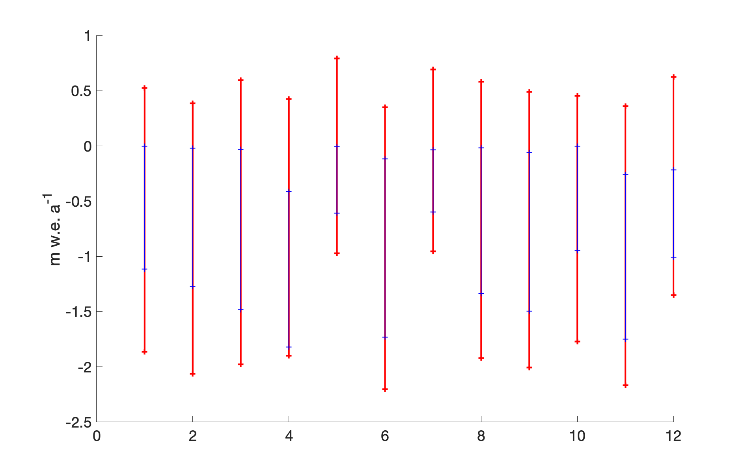

**Figure S4: The effects of calibrating the model through precipitation: impacts of a shift in precipitation correction factor (PCF) by a standard deviation (+/- 1 sigma) of all 323 calibrated PCFs. This figure demonstrates that glacier-to-glacier variability is small and that the same PCF variation elicits twice the response in MB as it does to the melt (mean melt proportion = 49.85%).**

Hubert, M., and Vandervieren, E. (2008). An Adjusted Boxplot for Skewed Distributions. Comput. Stat. Data Anal. 52 (12), 5186–5201. doi:10.1016/j.csda.2007.11.008

Shean, D. E., Bhushan, S., Montesano, P., Rounce, D. R., Arendt, A., and Osmanoglu, B. (2020). A Systematic, Regional Assessment of High Mountain Asia Glacier Mass Balance. Front. Earth Sci. 7, 363. doi:10.3389/feart.2019.00363