Supplementary Material

# Supplementary Data

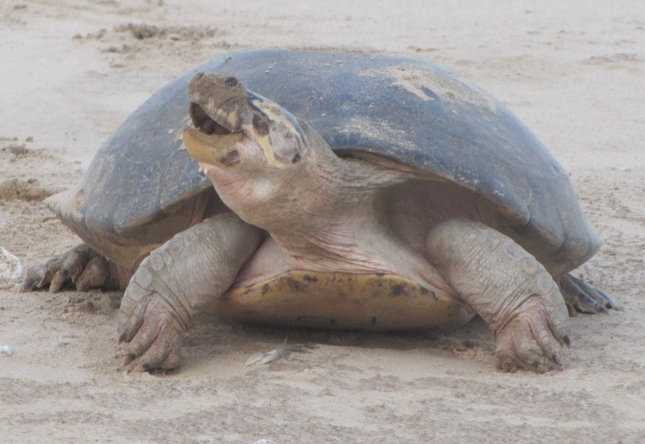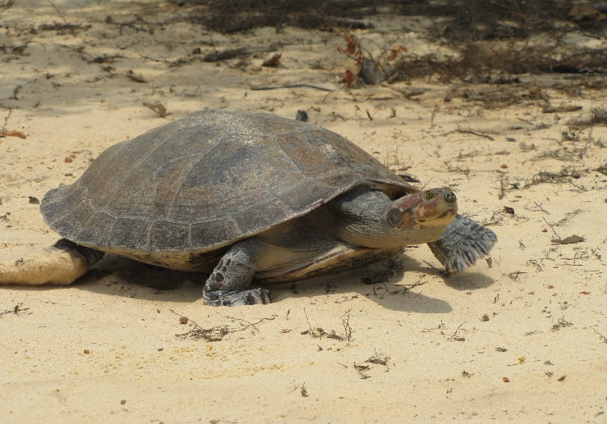

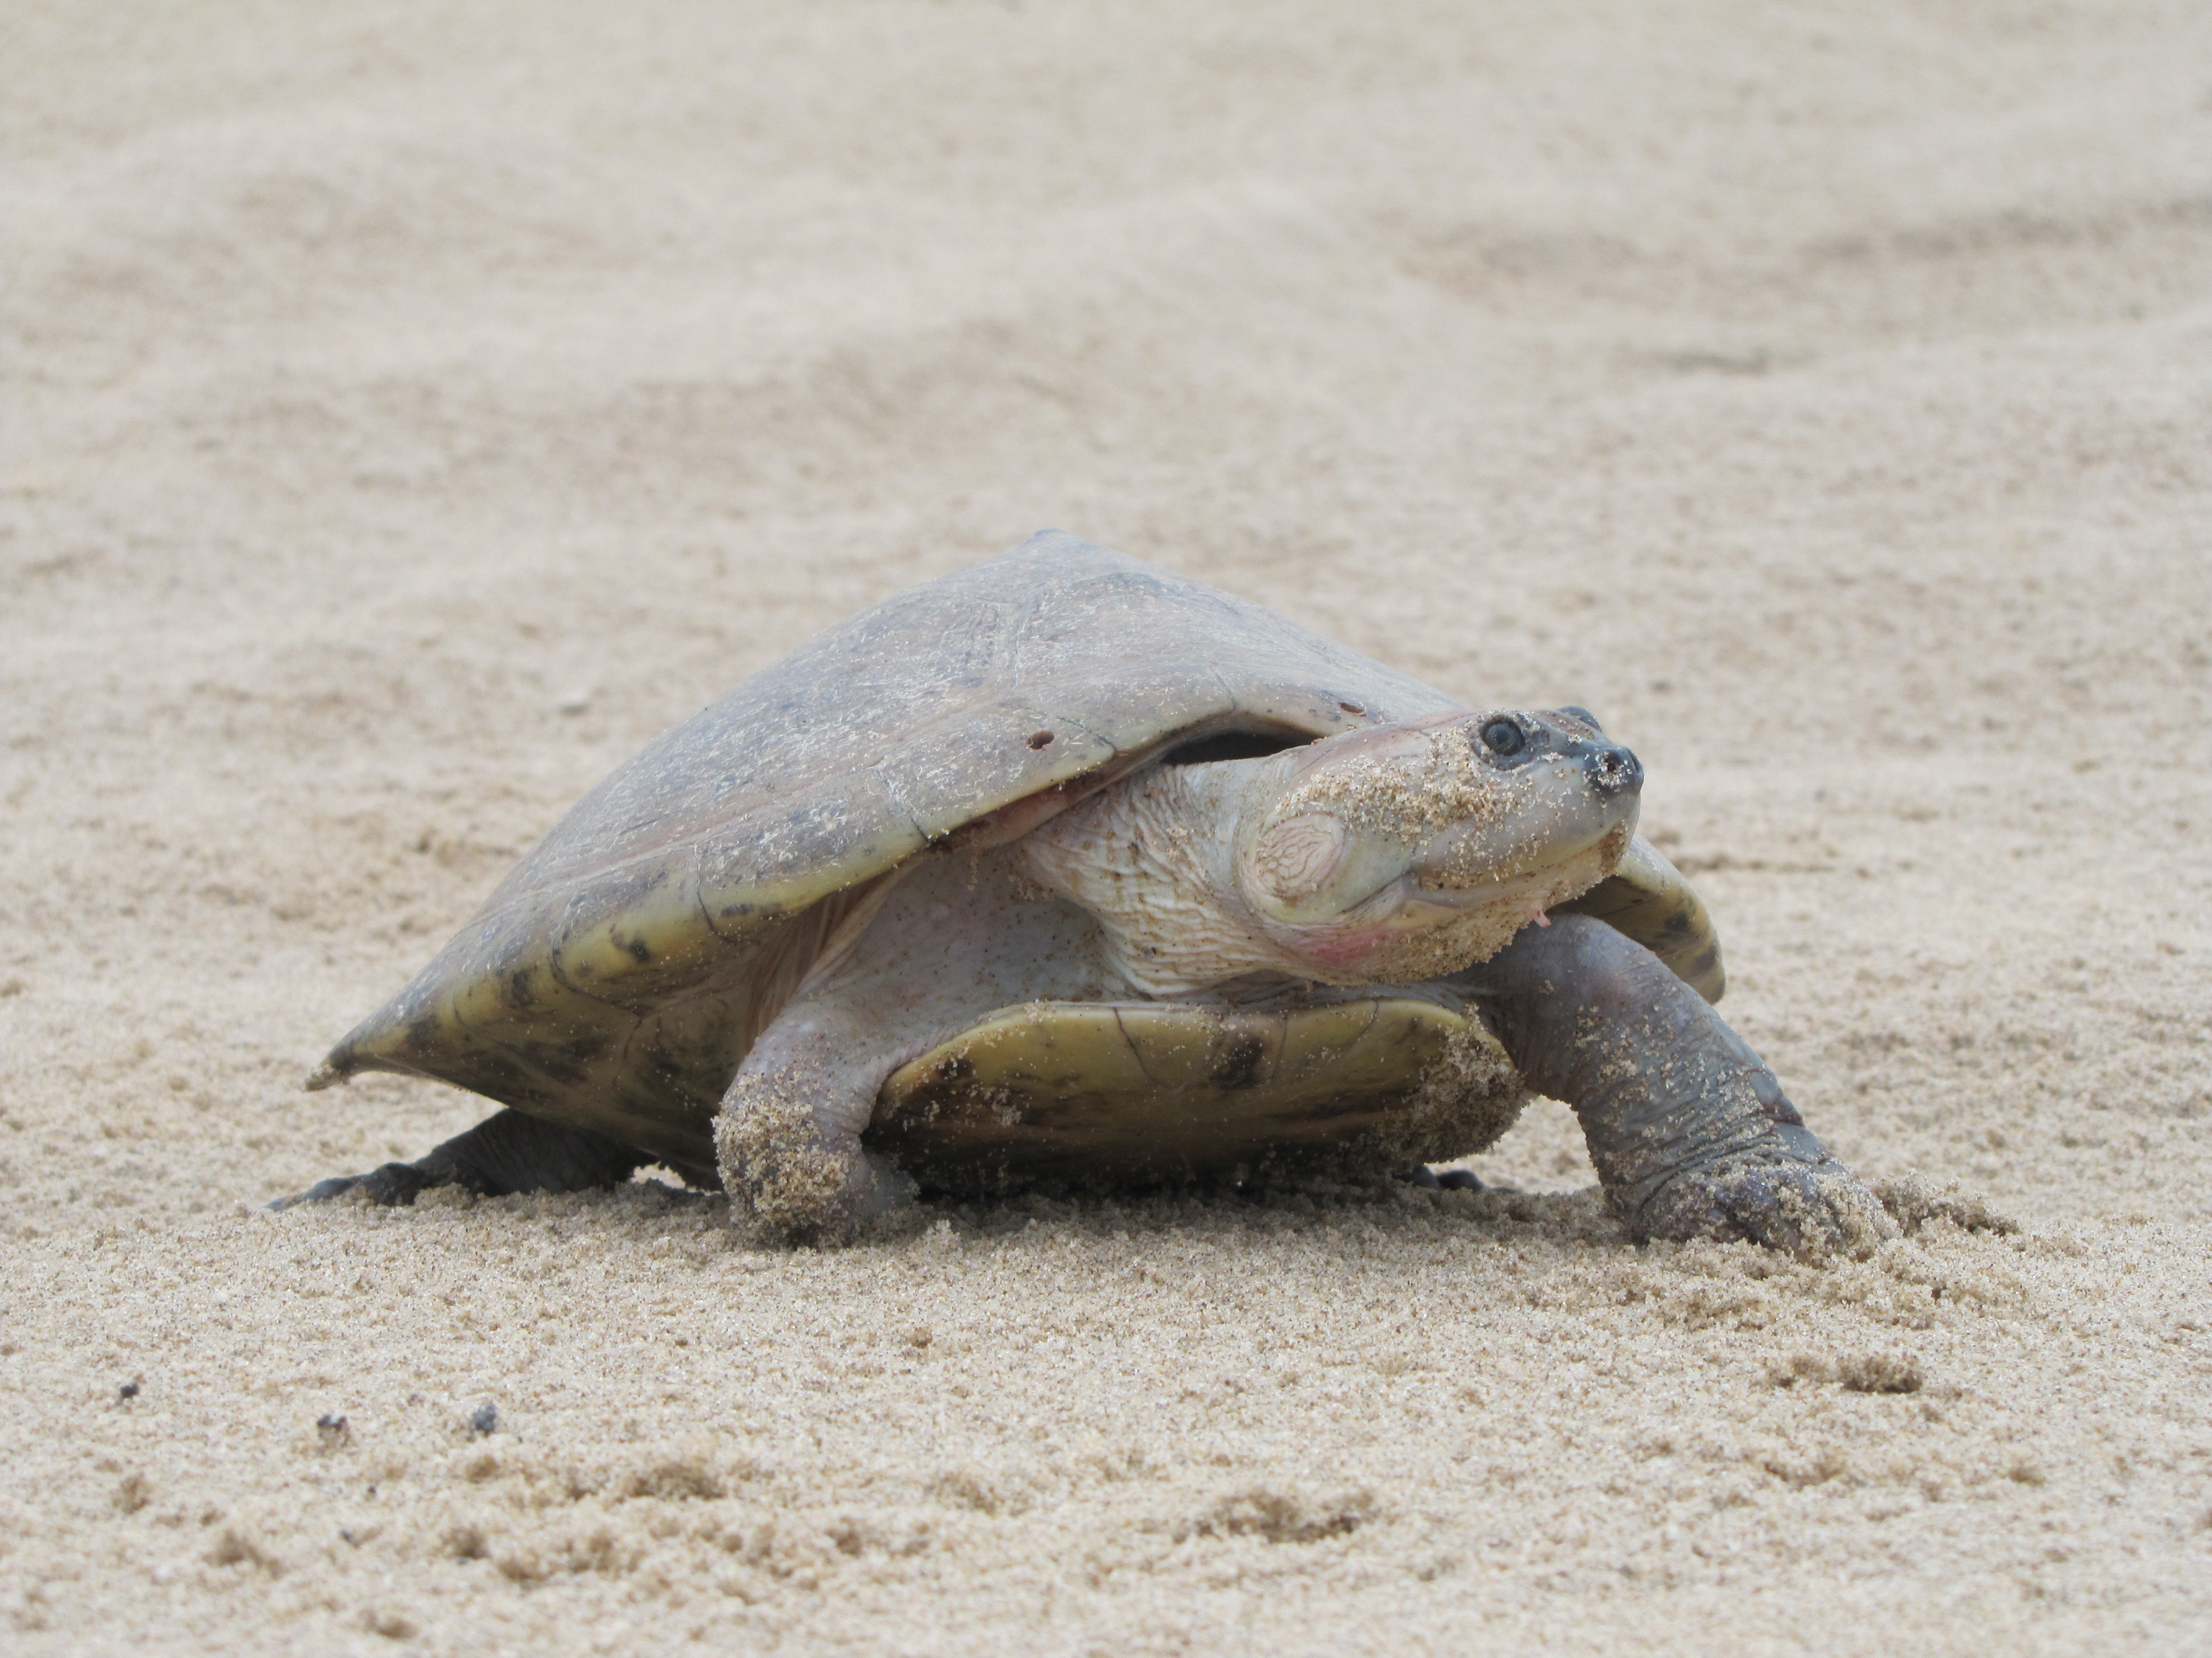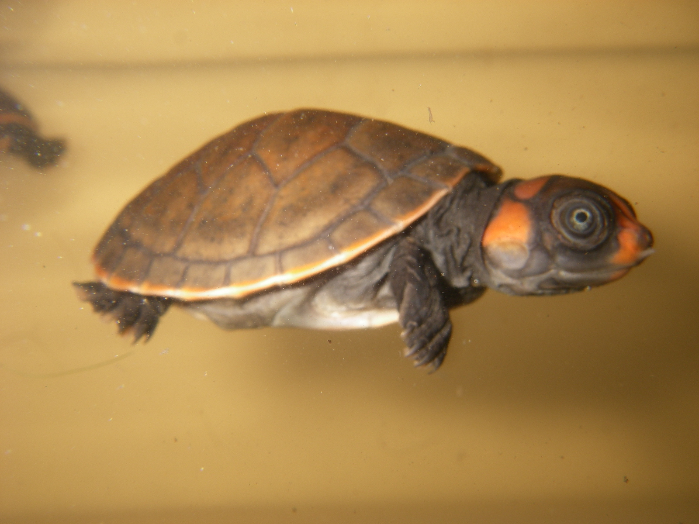

**Figure A:** I) *Podocnemis expansa*; II) *Podocnemis unifilis*; III) *Podocnemis sextuberculata*; IV) Hatchling of *Podocnemis erythrocephala.* **Images:** Pé-de-pincha Program.

**Table I:** *Podocnemis expansa, P. unifilis, P. sextuberculata* and *P. erythrocephala* nests and hatchlings protected in the Amazonas state and the northwestern section of the Pará state, Brazil, between 1974 and 2019.

|  |  |  |  |  |  |  |  |  |  |
| --- | --- | --- | --- | --- | --- | --- | --- | --- | --- |
|  |  |  | Nests |  |  |  |  | Hatchlings |  |
| Year | No. of Beaches | *P. expansa* | *P. unifilis* | *P. sextuberculata* | *P.erythro cephala* | *P. expansa* | *P. unifilis* | *P. sextuberculata* | *P. erythro cephala* |
| 1974 | 14 | 2,447 | 66 | 2,800 |  | 205,230 | 1,650 | 28,000 |  |
| 1976 | 3 | 676 | 445 |  |  | 74,741 | 9,767 |  |  |
| 1977 | 10 | 2,036 | 8,087 | 29,076 |  | 172,512 | 179,648 | 253,735 |  |
| 1978 | 5 | 1,044 |  |  |  | 89,917 |  |  |  |
| 1979 | 9 | 3,020 | 1,247 | 1,129 |  | 299,377 | 28,886 | 9,807 |  |
| 1980 | 4 | 1,227 | 20 | 1,500 |  | 115,628 | 510 | 15,000 |  |
| 1981 | 4 | 1,736 |  |  |  | 136,467 |  |  |  |
| 1982 | 7 | 2,328 | 2,630 | 200 |  | 213,435 | 61,740 | 3,210 |  |
| 1983 | 5 | 1,197 |  |  |  | 113,452 |  |  |  |
| 1984 | 8 | 1,972 |  |  |  | 150,529 |  |  |  |
| 1985 | 6 | 1,058 | 1,202 | 3,000 |  | 93,509 | 30,445 | 29,325 |  |
| 1986 | 6 | 598 | 1,084 | 2,151 |  | 56,110 | 22,022 | 93,453 |  |
| 1987 | 2 | 756 | 5 | 7,198 |  | 60,479 | 146 | 77,734 |  |
| 1988 | 3 | 1,802 | 15 | 5,315 |  | 138,868 | 413 | 57,407 |  |
| 1989 | 3 | 1,106 | 135 | 10,807 |  | 131,735 | 292 | 122,854 |  |
| 1990 | 2 | 51 | 25 | 2,559 |  | 5,230 | 500 | 25,200 |  |
| 1991 | 4 | 401 | 52 | 1,075 |  | 36,446 | 1,040 | 10,000 |  |
| 1992 | 11 | 3,550 | 156 | 10,070 |  | 325,659 | 2,870 | 99,658 |  |
| 1993 | 2 | 3,004 | 93 | 2,151 |  | 141,520 | 1,860 | 20,000 |  |
| 1994 | 15 | 3,461 | 1,824 | 37,711 |  | 319,742 | 42,982 | 400,377 |  |
| 1995 | 17 | 3,961 | 1,627 | 33,876 | 2,953 | 319,302 | 46,561 | 350,941 | 29,530 |
| 1996 | 11 | 3,743 | 835 | 3,994 |  | 353,973 | 8,788 | 37,935 |  |
| 1997 | 14 | 3,554 | 705 | 15,377 |  | 336,531 | 15,925 | 150,711 |  |
| 1998 | 20 | 3,499 | 2,197 | 25,492 |  | 348,323 | 60,946 | 247,568 |  |
| 1999 | 41 | 4,992 | 4,799 | 45,504 | 14 | 466,552 | 104,913 | 448,063 | 117 |
| 2000 | 40 | 5,141 | 3,718 | 42,975 | 16 | 527,399 | 88,539 | 432,159 | 15 |
| 2001 | 77 | 5,831 | 7,693 | 69,012 | 2,761 | 520,080 | 159,464 | 506,931 | 31,649 |
| 2002 | 54 | 4,314 | 3,396 | 24,815 | 21 | 405,832 | 74,676 | 261,970 | 152 |
| 2003 | 75 | 6,247 | 7,573 | 18,491 | 214 | 657,228 | 158,569 | 196,679 | 1,382 |
| 2004 | 73 | 4,705 | 6,188 | 44,486 | 120 | 444,789 | 130,533 | 372,371 | 924 |
| 2005 | 99 | 7,425 | 7,095 | 25,622 | 640 | 793,034 | 139,311 | 252,066 | 3,003 |
| 2006 | 94 | 4,606 | 1,881 | 10,401 | 860 | 416,357 | 72,565 | 72,939 | 4,391 |
| 2007 | 89 | 4,953 | 5,547 | 1,360 | 1,473 | 451,343 | 80,875 | 11,390 | 9,093 |
| 2008 | 79 | 5,451 | 5,073 | 452 | 1,260 | 497,081 | 77,325 | 4,656 | 8,248 |
| 2009 | 93 | 6,261 | 5,673 | 5,844 | 1,218 | 573,959 | 80,676 | 51,823 | 5,750 |
| 2010 | 140 | 12,260 | 8,079 | 17,237 | 1,521 | 1,298,046 | 132,879 | 190,004 | 8,701 |
| 2011 | 159 | 9,150 | 6,968 | 14,911 | 1,731 | 841,527 | 117,848 | 176,287 | 8,261 |
| 2012 | 170 | 8,676 | 8,051 | 9,516 | 1,658 | 772,000 | 125,692 | 68,378 | 9,468 |
| 2013 | 127 | 11,011 | 8,089 | 19,423 | 2,762 | 1,174,235 | 132,565 | 222,336 | 16,470 |
| 2014 | 142 | 10,252 | 9,944 | 10,406 | 2,046 | 1,014,068 | 177,699 | 98,940 | 12,906 |
| 2015 | 131 | 14,898 | 12,140 | 38,861 | 1,622 | 1,323,848 | 213,471 | 376,721 | 9,010 |
| 2016 | 96 | 11,019 | 7,842 | 19,969 | 536 | 1,065,583 | 136,643 | 253,316 | 3,236 |
| 2017 | 112 | 15,134 | 10,797 | 12,886 | 507 | 1,324,868 | 187,368 | 158,377 | 2,481 |
| 2018 | 114 | 11,832 | 8,797 | 11,643 | 400 | 983,271 | 157,725 | 127,786 | 2,611 |
| 2019 | 101 | 18,002 | 5,677 | 8,357 | 216 | 1,543,387 | 151,091 | 93,986 | 1,458 |

**Source**: PQA/IBDF/IBAMA CPPQA and Pé-de-pincha program technical reports.

**Table II:** Summary of production and protection data for *P. expansa, P. unifilis, P. sextuberculata* and *P. erythrocephala* between 1974 and 2019 in the Amazon state and the northwestern of the Pará state, Brazil.

|  |  |  |  |  |  |  |  |  |  |  |  |
| --- | --- | --- | --- | --- | --- | --- | --- | --- | --- | --- | --- |
| **Species** | **Nests** | **Eggs** | **Hatchlings** | **Faulty hatch lings** | **Still born hatch lings** | | **Unviable Eggs** | **Hatching rate (%)** | **Preda ted nests** | **Dama ged Nests1** | **Seizu res2** |
| *Podocnemis expansa* (N=842) | | | | | | | | | | | |
| Total | 230,444 | 23,691,062 | 21,350,201 | 23,818 | 39,362 | 261,070 | | - | 300 | 3,122 | 20,915 |
| Mean ± SD | 5,121 ± 4,417 | 526,381 ± 434,568 | 474,449 ± 411,488 | 366 ± 551 | 261 ± 521 | 1,319 ± 3,443 | | 89,9 ± 7,5 | 9 ± 11 | 130 ± 349 | 557 ± 179 |
| Maximum | 18,002 | 185,9950 | 1,543,387 | 3,323 | 4,249 | 37,555 | | 100 | 41 | 1,519 | 1,699 |
| Minimum | 51 | 130 | 5.230 | 1 | 1 | 3 | | 71,3 | 0 | 1 | 1 |
| *Podocnemis unifilis* (N=816) | | | | | | | | | | | |
| Total | 170,076 | 4,085,233 | 3,229,821 | 1,054 | 5,604 | 33,476 | | - | 558 | - | 14,505 |
| Mean ± SD | 3,779 ± 3,660 | 91,011 ± 85,114 | 71,774 ± 66,699 | 53 ± 74 | 60 ± 96 | 272 ± 678 | | 79,1 ± 15,8 | 17 ± 33 | - | 552 ± 356 |
| Maximum | 12,140 | 28,0053 | 213,471 | 255 | 841 | 4,738 | | 100 | 156 | - | 3,579 |
| Minimum | 5 | 162 | 146 | 1 | 0 | 4 | | 6,2 | 1 | - | 2 |
| *Podocnemis sextuberculata* (N=561) | | | | | | | | | | | |
| Total | 647,715 | 7,153,847 | 6,410,092 | 172 | 8,792 | 98,727 | | - | 447 | - | 52,067 |
| Mean ± SD | 14,394 ± 15,901 | 162,563 ± 163,405 | 142,446 ± 144,283 | 17 ± 29 | 275 ± 924 | 2,821 ± 7,477 | | 88,9 ± 9,4 | 25 ± 26 | - | 1,927 ± 446 |
| Maximum | 69,012 | 556,116 | 506,931 | 76 | 5,226 | 30,500 | | 100 | 81 | - | 13,952 |
| Minimum | 200 | 3600 | 3.210 | 2 | 0 | 6 | | 56,3 | 1 | - | 1 |
| *Podocnemis erythrocephala* (N=131) | | | | | | | | | | | |
| Total | 24,617 | 220,384 | 168,856 | - | - | - | | - | - | - | 1,480 |
| Mean ± SD | 1,116 ± 942 | 9,995 ± 9,402 | 7,675 ± 8,648 | - | - | - | | 76,6 ± 19,4 | - | - | 82 ± 51 |
| Maximum | 2,953 | 32,758 | 31,649 | - | - | - | | 100 | - | - | 442 |
| Minimum | 0 | 0 | 0 | - | - | - | | 10,4 | - | - | 1 |

**Source**: PQA/IBDF/IBAMA CPPQA and Pé-de-pincha program technical reports.

1. Flooding and erosion; 2. IBAMA; Nascimento (2011). SD = Standard deviation.

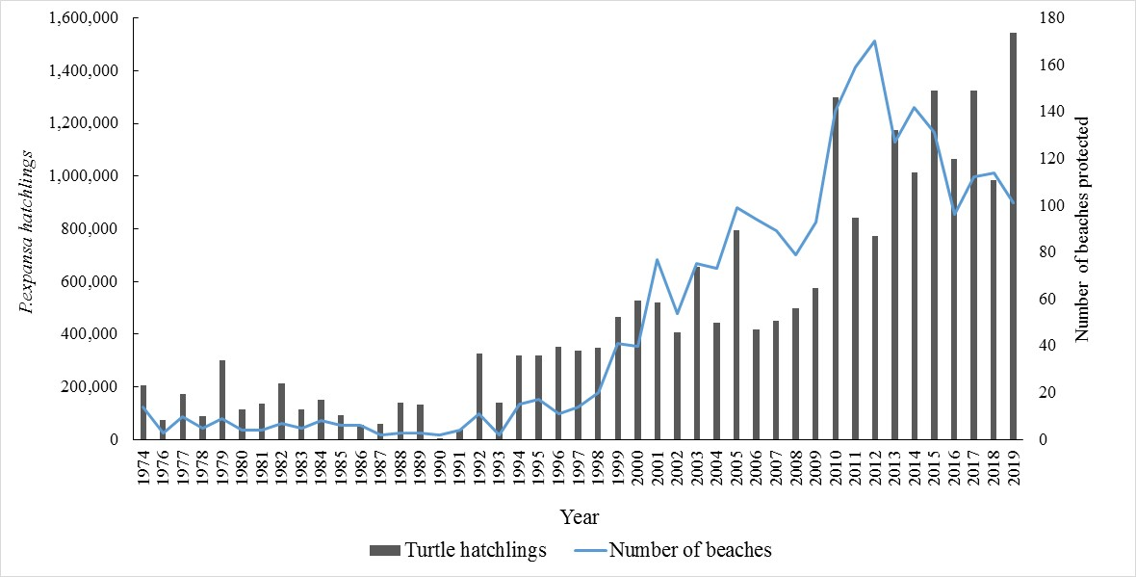

Figure B: Hatchlings of Giant South American turtle (*P. expansa*) protected in the Amazonas state and the northwestern section of the Pará, Brazil, state between 1974 and 2019. Source: PQA/IBDF/IBAMA CPPQA and Pé-de-pincha Program technical reports.

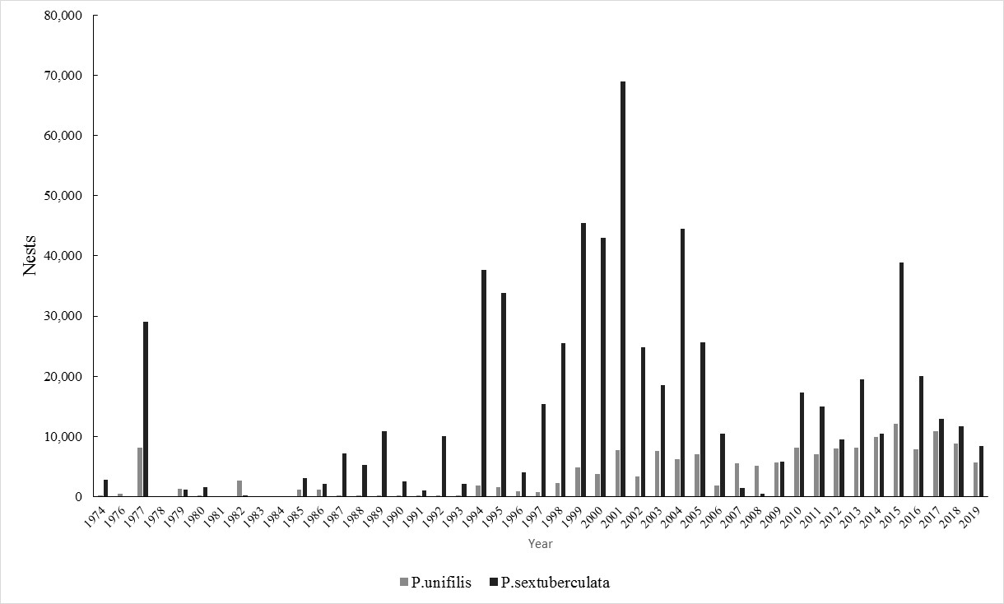

Figure C: Yellow-spotted river turtle (*P. unifilis*) and six-tubercled river turtle (*P. sextuberculata*) nests protected between 1974 and 2019 in the Amazonas state and the northwestern section of the Pará state, Brazil. Source: PQA/IBDF/IBAMA CPPQA and Pé-de-pincha Program technical reports.

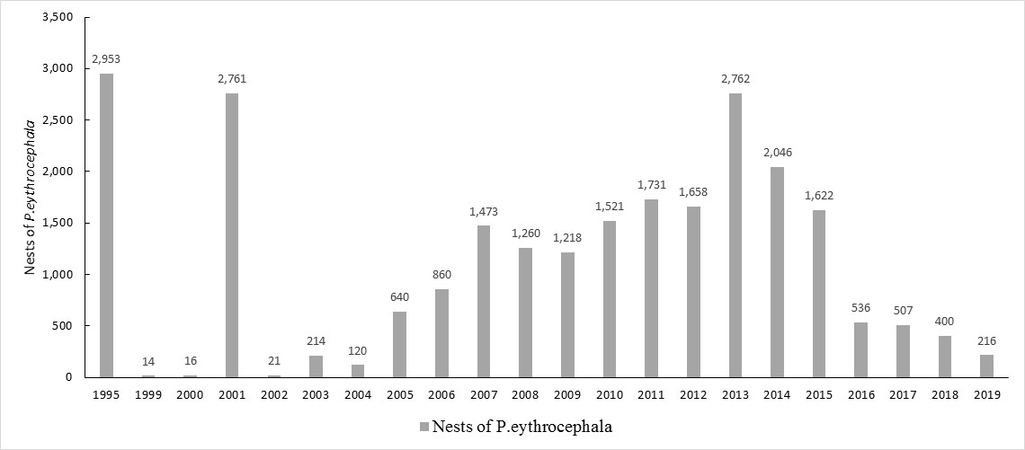

**Figure D:** Nests of Red headed river turtle (*P. erythrocephala*) protected between 1974 and 2019 in the Amazonas state and the northwestern section of the Pará state, Brazil. Source: PQA/IBDF/IBAMA CPPQA and Pé-de-pincha Program technical reports.

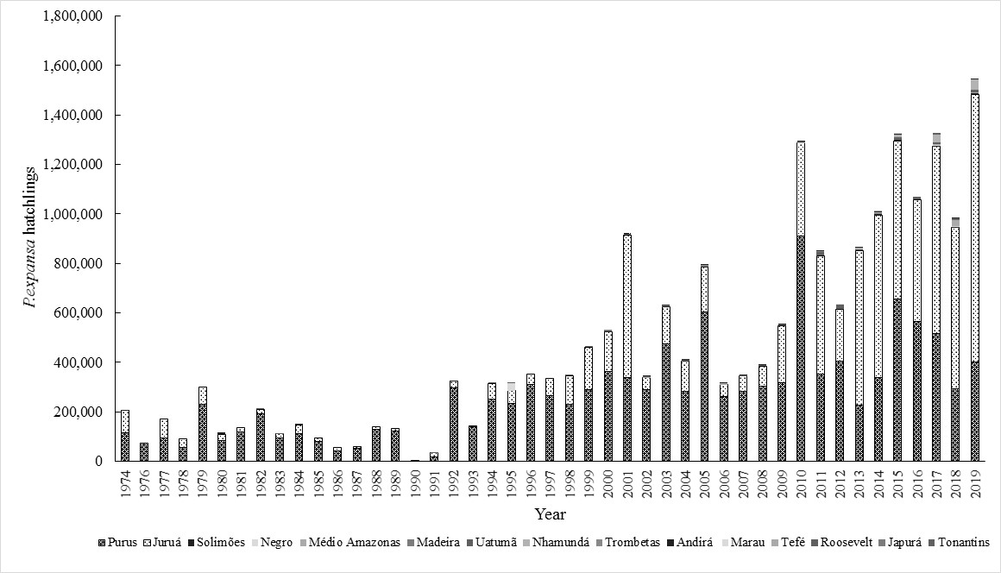

Figure E: Hatchlings of Giant South American turtle (*P. expansa*) protected in different rivers in the Amazonas state and the northwestern section of the Pará state, Brazil, between 1974 and 2019. Source: PQA/IBDF/IBAMA CPPQA and Pé-de-pincha Program technical reports.

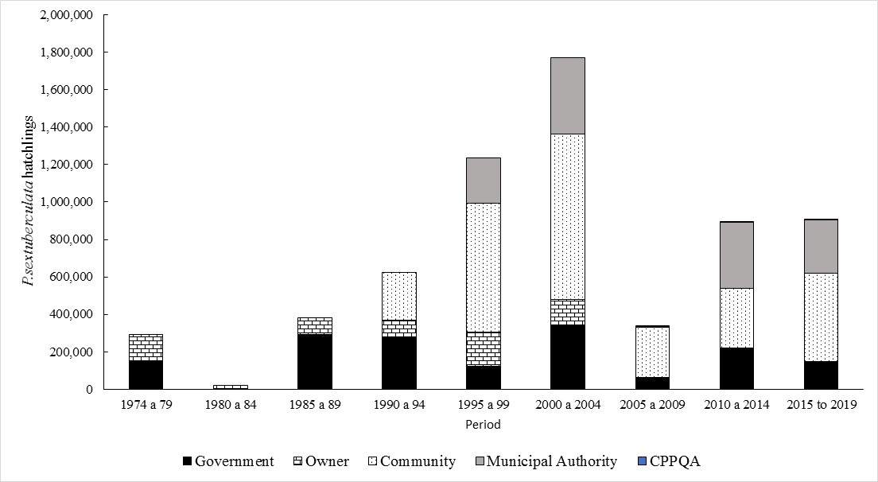

**Figure F:** Participation of the different systems of protection of chelonians in the Amazonas state and the northwestern section of the Pará state, Brazil, between 1974 and 2019 in the production of hatchlings of six-tubercled river turtle (*P. sextuberculata*). Source: PQA/IBDF/IBAMA CPPQA and Pé-de-pincha Program technical reports.