Appendices

Appendix A - Chromatograms

The nomenclature used for identification of the chromatograms is shown in Figure A.1.
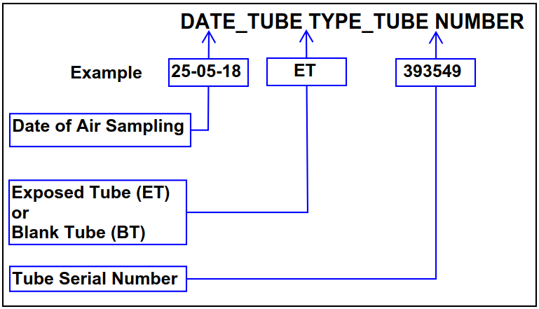
Figure A.1. Chromatogram identification coding

The chromatograms produced as a result of the different VOC measurement scenarios (Table 2) are shown below in Figures A.2-A.4.

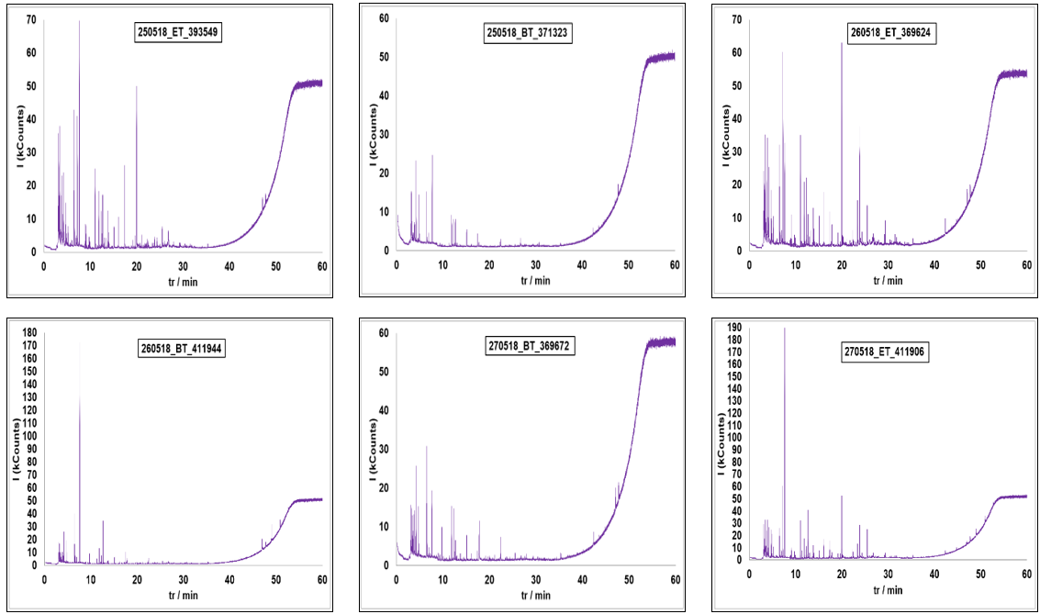
Figure A.2 – Chromatograms for measurement scenario 1 (unoccupied, night-time, ventilation system OFF)

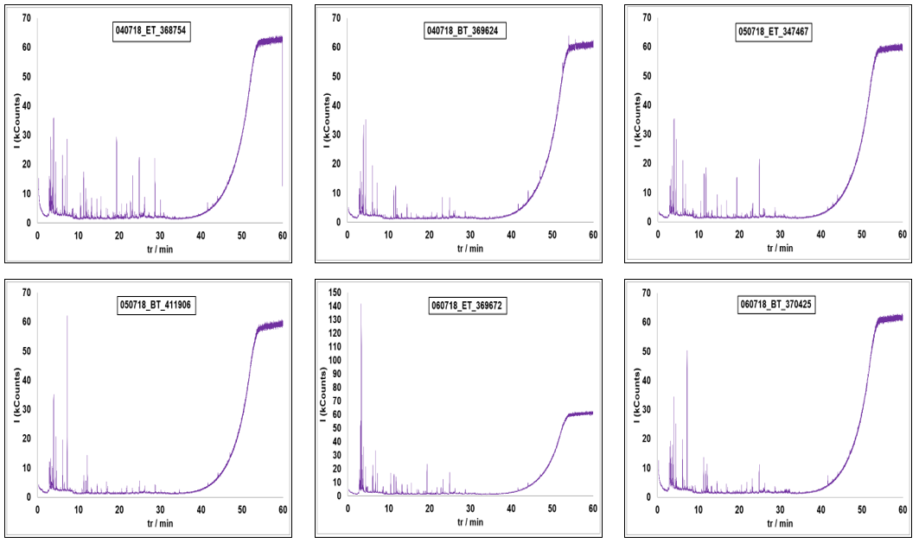
Figure A.3 – Chromatograms for measurement scenario 2 (unoccupied, daytime, ventilation system OFF)

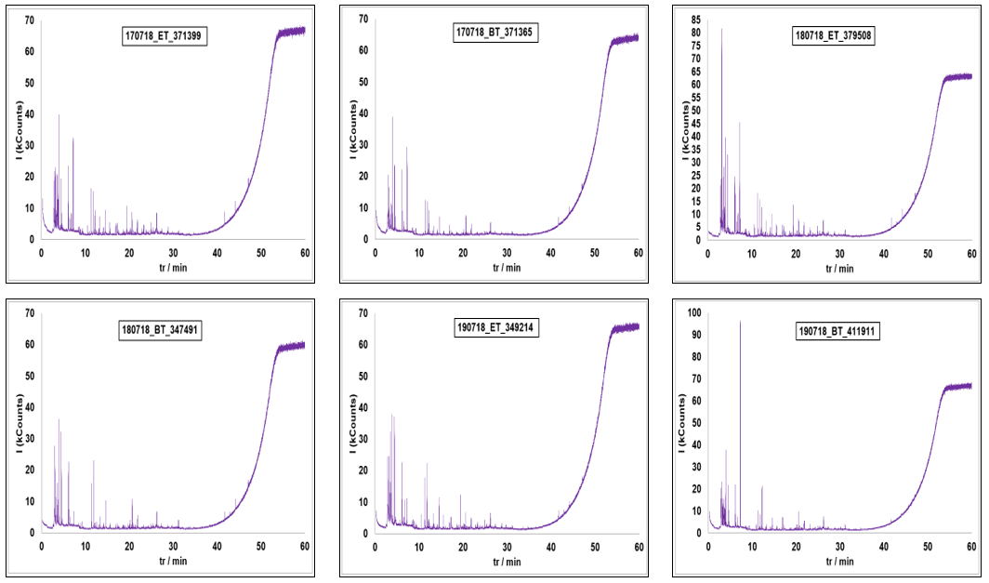
Figure A.4 – Chromatograms for measurement scenario 3 (unoccupied, daytime, ventilation system ON)

