**Dynamic interaction between mucosal immunity and microbiota drives nose and pharynx homeostasis of common carp (*Cyprinus carpio*) after SVCV infection**

Zheng-Ben Wu1, Kai-Feng Meng1, Li-Guo Ding1, Sha Wu1, Guang-Kun Han1, Xue Zhai1, Ru-Han Sun1, Yong-yao Yu1, Wei Ji1*, Zhen Xu2,1*

1Department of Aquatic Animal Medicine, College of Fisheries, Huazhong Agricultural University, Wuhan, Hubei 430070, China

2State Key Laboratory of Freshwater Ecology and Biotechnology, Institute of Hydrobiology, Chinese Academy of Sciences, Wuhan, Hubei, 430072, China

*Corresponding Author: [zhenxu@ihb.ac.cn](mailto:zhenxu@ihb.ac.cn); wei-ji@mail.hzau.edu.cn.

**Supplementary materials**

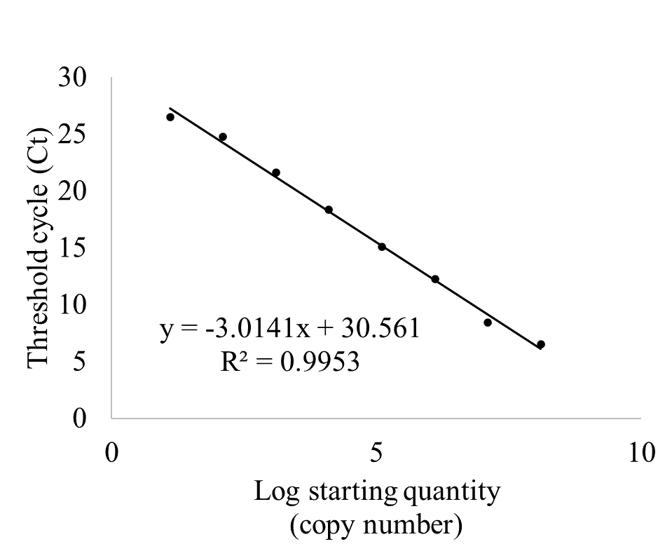

**FIGURE S1** | Standard curve for SVCV load used in this study.



**FIGURE S2** | The width of the OE of nose in control fish and SVCV-infected fish at 1, 4, 7, 14, and 28 dpi (n = 6 fish per group).

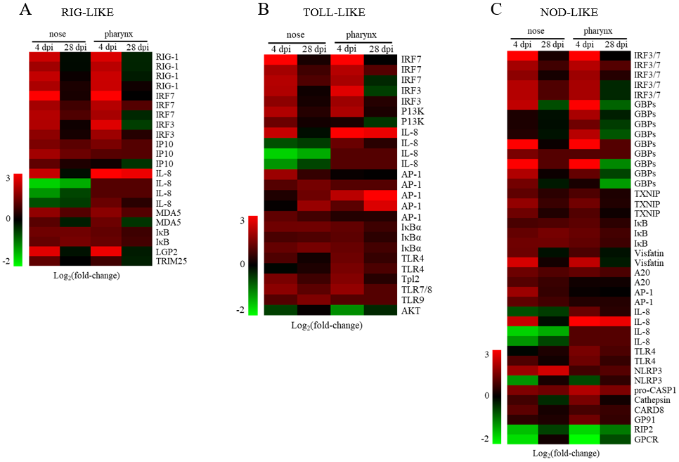

**FIGURE S3** | Heatmap illustrates results from RNA-seq of the mRNA expression levels of genes in RIG-like receptor signaling pathway (A), Toll-like receptor signaling pathway (B), and NOD-like receptor signaling pathway (C) in nose and pharynx of SVCV-infected fish versus control fish measured at 4 and 28 dpi (n = 3 fish per group). Data are expressed as logFC. FC, fold changes.

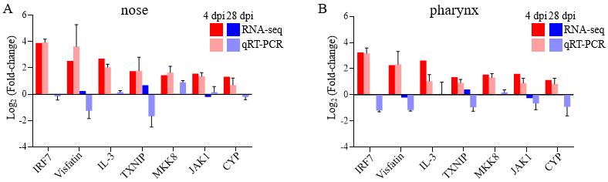**FIGURE S4** | Transcriptomic differential expressed genes in experimental groups were detected using qRT-PCR to validate RNA-seq. Positive numbers in the Y axis mean up-regulated, while negative values mean down-regulated.

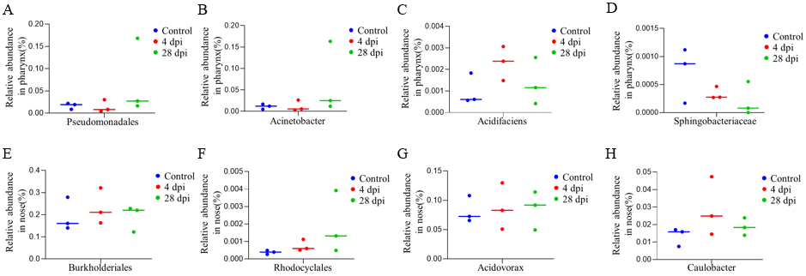**FIGURE S5** | (A-B) Relative abundance of Pseudomonadales (A), Acinetobacter (B), Acidifaciens (C), and Sphingobacteriaceae (E) in the pharynx of common carp in control and SVCV-infected at days 4 and 28. (I-L) Relative abundance of Burkholderiales (E), Rhodocyclales (F), Acidovorax (G), and Acidovorax (H) in the pharynx of common carp in control and SVCV-infected groups at days 4 and 28.

**TABLE S1 |** Primers used in this study.

|  |  |  |  |  |  |  |  |
| --- | --- | --- | --- | --- | --- | --- | --- |
| **Gene** | **Full name** | **GenBank**  **accession no.** | **Primer Sequence (5’-3’)** | **Tm**  **(◦C)** | | | **Amplicon**  **Length (bp)** |
| **Reference gene** | | | | | |
| 40S | 40S ribosomal protein | AB_012087.1 | F: CCGTGGGTGACATCGTTACA  R: TCAGGACATTGAACCTCACTGTCT | | 58 | | 69 |
| **Spring viremia of carp virus** | | | | | |
| SVCV-N | Spring viremia of carp virus | DQ_491000.1 | F: CTCTGCCAAATCACCATACTC  R: GCGGTTTTCTGTATGTGTCTC | | 58 | | 224 |
| **Anti-viral genes** | | | | | |
| ISG15 | Interferon-stimulated gene 15 | KP_115358.1 | F: AAGCCATATTCAGCGAAGC  R: AACCGTTATCGGCAGACAG | | 58 | | 185 |
| IRF3 | Interferon regulatory factor 3 | JQ_478481.1 | F: GGAGACCACTCTGTTTGGAAG  R: CGGCATCGTTCTTGTTGTC | | 58 | | 88 |
| PKR | Protein kinase R | EX_880666.1 | F: CCAACATCGTCCGCTACTACTC  R: GCGTGTCTCCCTCACAAAG | | 58 | | 147 |
| MX1 | Myxovirus resistance 1 | KP_115357.1 | F: GGCTGGAGCAGGTGTTGGTATC  R: TCCACCAGGTCCGGCTTTGTTAA | | 58 | | 255 |
| ADAR | Adenosine deaminase that acts on RNA | EC_392392.1 | F: GCAGGACGAGGTGTCAGAG  R: GGCAAAGGGAGCATAACTTC | | 58 | | 200 |
| TLR7 | Toll-like receptor 7 | AB_553573.1 | F: AAAGTCTTCGTCAGCACCAGCG  R: CTCTCCGAAGCACAGGTAGATGGT | | 58 | | 104 |
| IFN a1 | Interferon a1 | AB_376666.1 | F: CAGAGTCAATGCTCCGCTTG  R: CAAGAAACCTCACCTGGTCCTC | | 58 | | 178 |
| **AMPS genes** | | | | | |
| Hepcidin | Hepcidin | KC_795559.1 | F: GCATGCGTCTGCATCCTCC  R: CTGGTTCTCCTGTGGTGCTT | | 58 | | 96 |
| NKL2 | Natural killer lysin 2 | KX_034213.1 | F: GTCCTGATCACCCTGCTGAT  R: AGCACTTTCCAGGGAGTTGT | | 58 | | 130 |
| APOA1 | Apolipoprotein A-Ⅰ | AJ_308993.1 | F: CCATCTCCGCCTCCTTTC  R: ATGTGTTAGTGTGTGTGTGCTTC | | 58 | | 123 |
| APOA14 | Apolipoprotein A-Ⅱ | JQ_038773.1 | F: CACCAACAGGAGGACAAGCCAAAG  R: GCCATAAGCACCAAGAAGAGCCAAG | | 58 | | 149 |
| **Igs genes** | | | | | |
| IgM | Immunoglobulin M | AB_004105.1 | F: TAGTGCCTCCCTCCCTTGA  R: AGTGCCGTTGCTCCATTCT | | 58 | | 200 |
| IgZ1 | Immunoglobulin Z1 | AB_598367.1 | F: CCAAGAAGGCAACATCATCA  R: AGTGAGGTTCCTGGGGTAGA | | 58 | | 211 |
| IgZ2 | Immunoglobulin Z2 | AB_598368.1 | F: CCATGTGCGTATCAGTAAAAGT  R: CTCTAGTGAGGTGCCTTCAGA | | 58 | | 276 |
| pIgR | Polymeric immunoglobulin receptor | GU_338410.1 | F: GATGACCCAGAATCACCCCC  R: GTCAGACACCCACATTCCCC | | 58 | | 157 |
| IgD | Immunoglobulin D | AB_774152.1 | F: TTGGTTGTTGGTCAGAGT  R: TTGGATTGTGAACGATGC | | 58 | | 70 |
| **Inflammatory genes** | | | | | |
| IL1β | Interleukin 1β | AB_010701.1 | F: CAGAGCAACAAACTAAGTGACGAG  R: ACCATCTAACTGGGTACAAGCAAG | | 58 | | 189 |
| IL6 | Interleukin 6 | AY_102632.1 | F: GTTTACACCCACCTGAAGGAGTT  R: GATTTCTAAGATACAGTTCACCCTCAC | | 58 | | 159 |
| IL2 | Interleukin 2 | AF_486820.1 | F: CGAACGGGACGAGAAATGG  R: TGATAAAGAGCTGCTGTGAATG | | 58 | | 152 |
| IL8 | Interleukin 8 | KU_881637.1 | F: GGGTGTAGATCCACGCTGTC  R: AGGGTGCAGTAGGGTCCAGA | | 58 | | 167 |

F: Forward primer; R: Reverse primer.