**Supplementary Material (SM)**

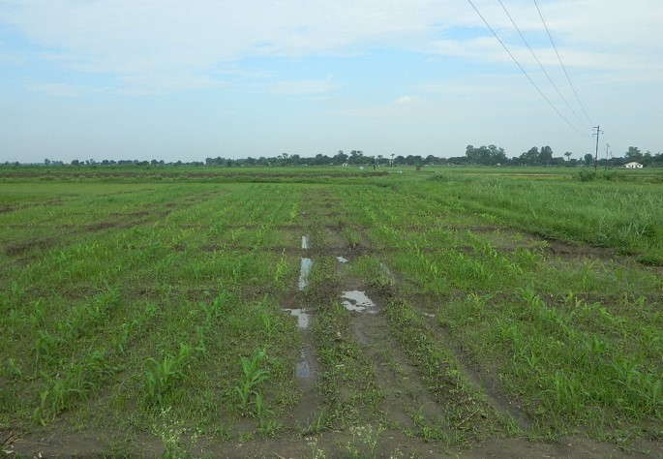

**SM1:** Overview of field layout

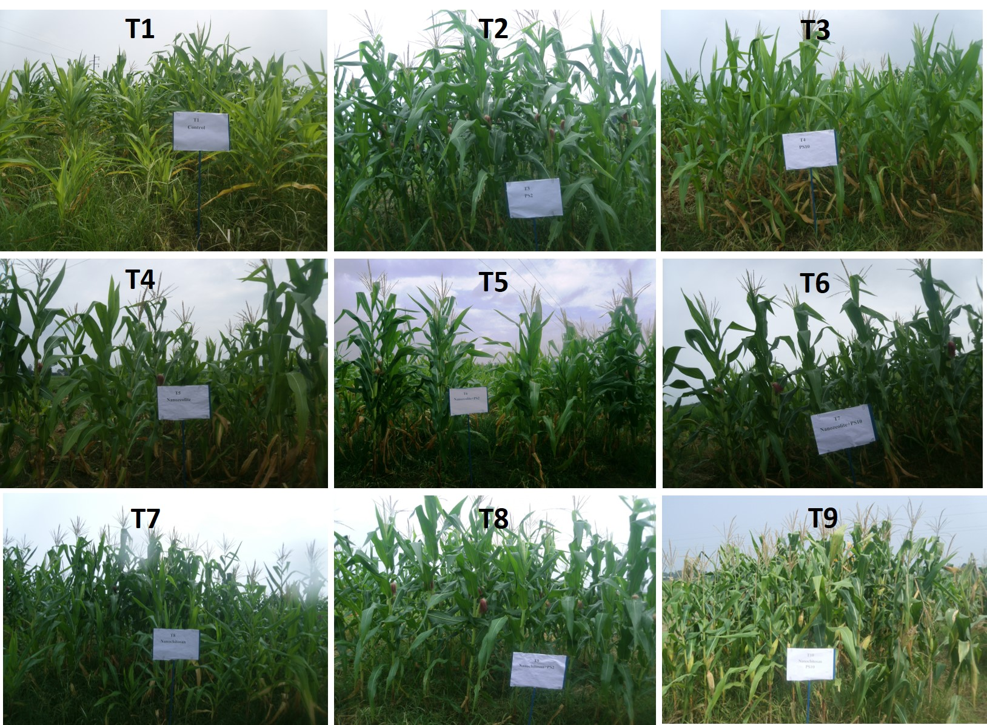

**SM2:** Plant growth in nanocompounds and *Bacillus* spp. treated soil under field condition

**SM3:** Physicochemical properties of the experimental site

|  |  |  |  |  |  |
| --- | --- | --- | --- | --- | --- |
| **Treatments** | pH (1:2.5) Soil: water ratio | Organic carbon (%) | Available nitrogen (Kg ha-1) | Available P2O5 (Kg ha-1) | Available K2O (Kg ha-1) |
| **T1** | 7.2 | 0.75 | 212.89 | 20 | 133.20 |
| **T2** | 7.4 | 0.76 | 213.78 | 21 | 134 |
| **T3** | 7.5 | 0.77 | 214.66 | 23 | 136.88 |
| **T4** | 7.44 | 0.77 | 214 | 23.30 | 135.20 |
| **T5** | 7.6 | 0.79 | 220 | 24.99 | 136 |
| **T6** | 7.9 | 0.79 | 219 | 25.12 | 139.23 |
| **T7** | 7.6 | 0.77 | 218.77 | 24 | 137 |
| **T8** | 7.7 | 0.78 | 223 | 25 | 138 |
| **T9** | 7.8 | 0.78 | 224.12 | 25.55 | 140.12 |